Static and Functional approach

1. Use Static pose (5 s motorcycle pose+ 5 s OpenSim Pos) data
2. add Real Lab_Full_Body template and pick a name

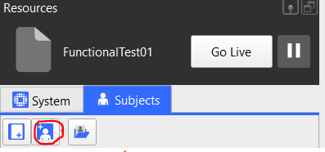

1. Go to the last frame
2. Run Real VST Calibration pipeline

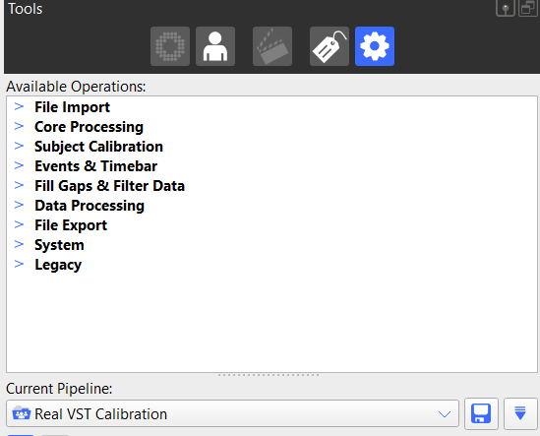

1. Save subject or if you want to save the template

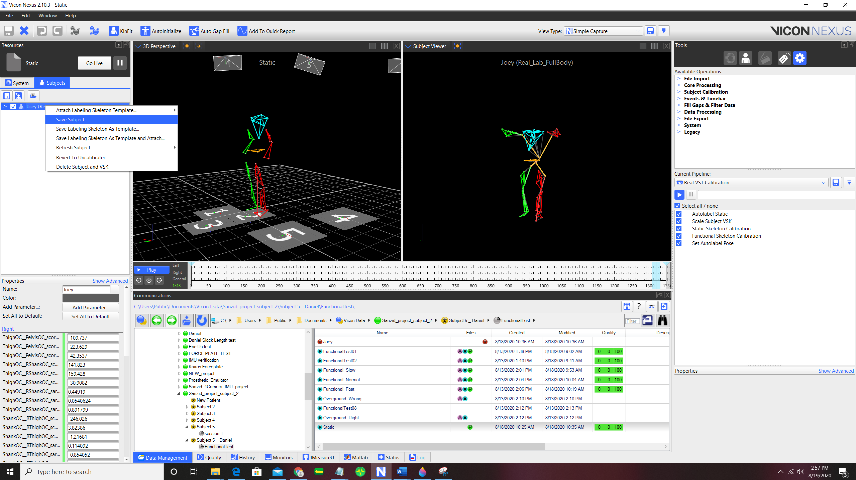

1. Load functional Test data

Functional Test: Star shape movement

1. Run Real Labeling pipeline

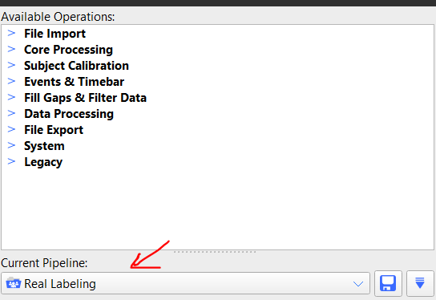

1. Go to quality tab and Fill gaps using the label tool



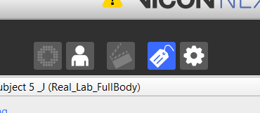

1. use rigid body fill when there are 3 other markers on segment (select all markers on the segment), use pattern fill when not (select 1 marker)

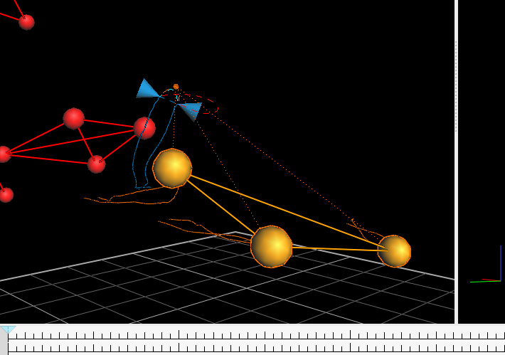

1. Go to graph (picture) and check the marker numbers remove all unlabeled trajectories (right-click any marker)

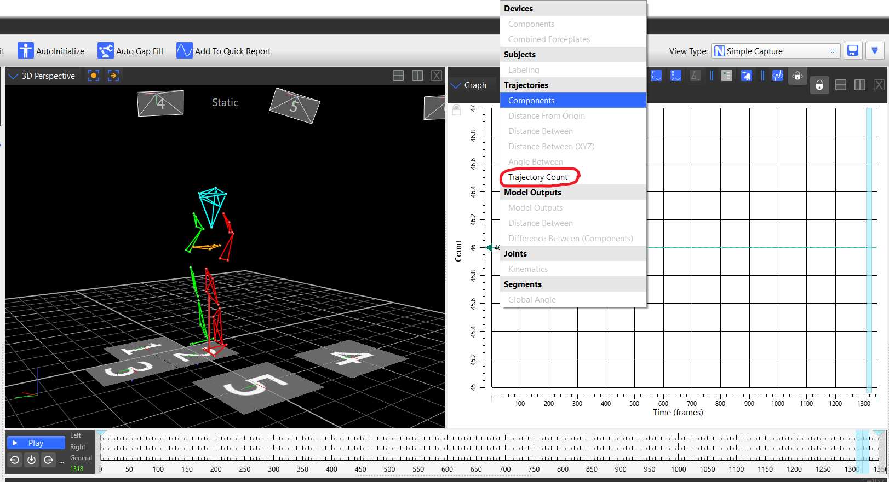

1. Run "Real Find Joint Center" pipeline

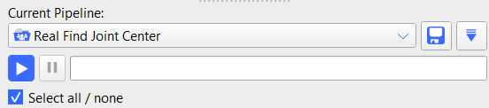

1. Rename Joint Center markers to (RHJC,LHJC,RSJC,LSJC) by selecting each of the added markers

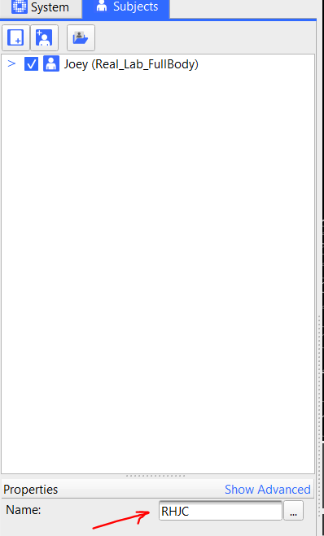

1. Save

**Dynamic trails**

1. Real Labeling
2. Fill the gaps
3. Look at the graph to check issues
4. Remove all unlabeled trajectories
5. Save