# 15.1 Networking

**Types of Networks**

**Internet Connections**

**Packet Switching**

# 15.2 Open Systems and Protocols

**Open Systems**

**Network Protocols**

**TCP/IP**

**High-Level Protocols**

**MIME Types**

**Firewalls**

# 15.3 Network Addresses

**Domain Name System**

**Who Controls the Internet?**

# 15.4 Cloud Computing

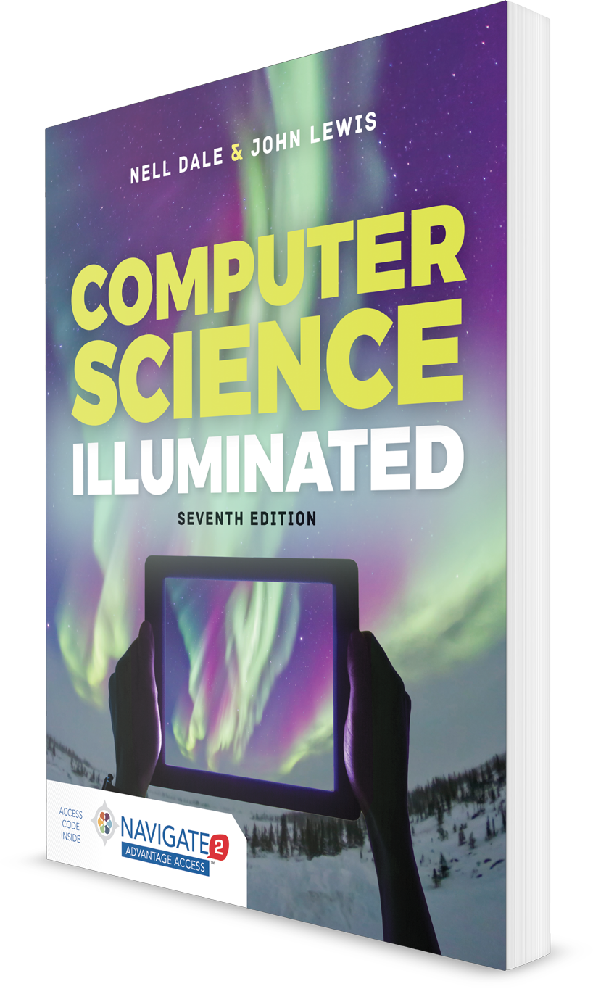

**Computer Science Illuminated, Seventh Edition**

Nell Dale, PhD; John Lewis, PhD

**CHAPTER 15**

LECTURE OUTLINE

**Networks**

# 15.5 Blockchain

Copyright © 2020 by Jones & Bartlett Learning, LLC, an Ascend Learning Company