# 16.1 Spinning the Web

**Search Engines**

**Instant Messaging** **Weblogs**

**Cookies Web Analytics**

# 16.2 HTML and CSS

**Basic HTML Elements**

**Tag Attributes**

**More About CSS More HTML5 Elements**

# 16.3 Interactive Web Pages

**16.4 XML**

**16.5 Social Network Evolution**

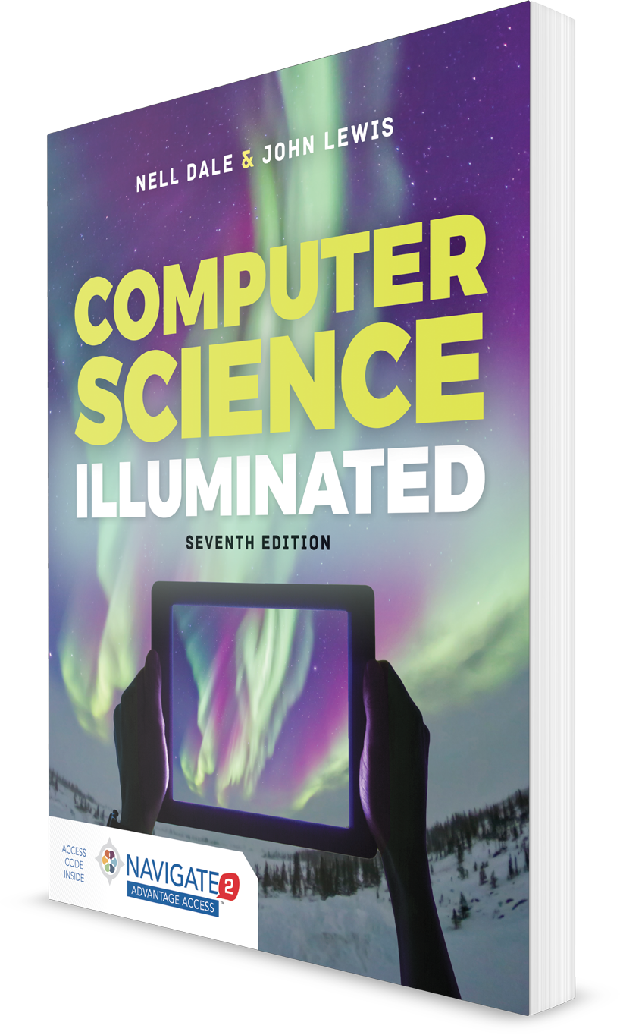

**Computer Science Illuminated, Seventh Edition**

Nell Dale, PhD; John Lewis, PhD

**CHAPTER 16**

LECTURE OUTLINE

**The World Wide Web**

Copyright © 2020 by Jones & Bartlett Learning, LLC, an Ascend Learning Company