**17.1 Security at All Levels**

**Information Security**

# 17.2 Preventing Unauthorized Access

**Passwords**

**CAPTCHA**

**Fingerprint Analysis**

# 17.3 Malicious Code

**Antivirus Software**

**Security Attacks**

# 17.4 Cryptography

# 17.5 Protecting Your Information Online

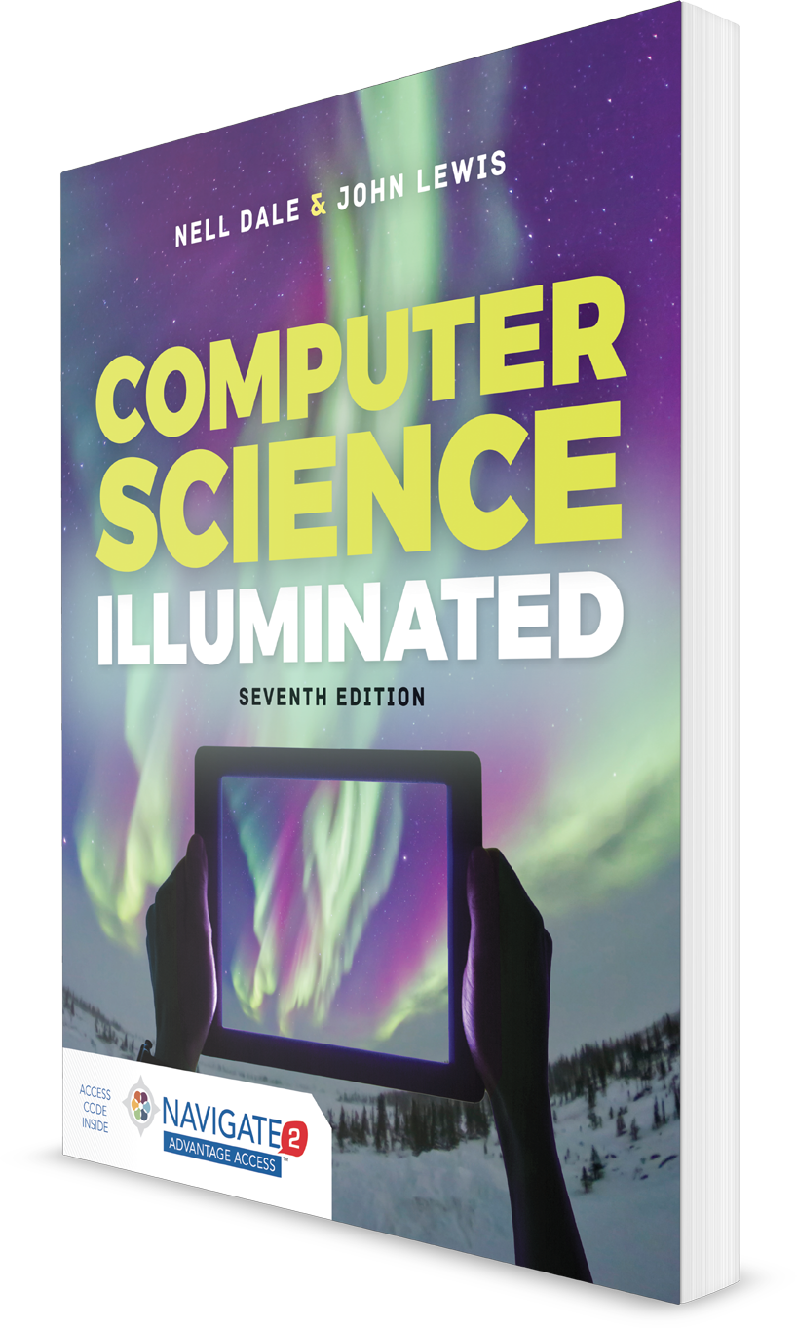

**Computer Science Illuminated, Seventh Edition**

Nell Dale, PhD; John Lewis, PhD

**CHAPTER 17**

LECTURE OUTLINE

**Computer Security**

Copyright © 2020 by Jones & Bartlett Learning, LLC, an Ascend Learning Company