**CS 245: Object-Oriented Programming**

**Homework #4**

**Tiles**

In this program, you are to create a Java application that produces a colored mosaic of tiles. The form your application produces should look like this:

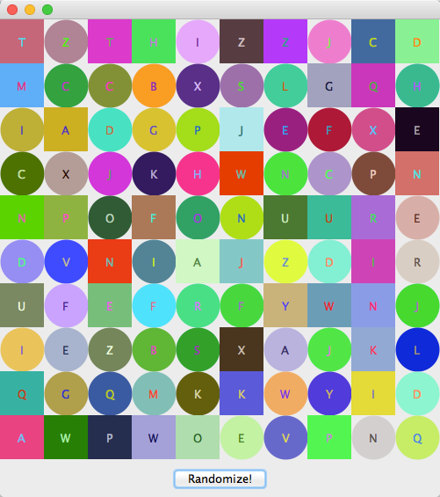

Whenever the user presses the button, the arrangement of tiles must change at random.

You will need to define the following classes.

|  |  |
| --- | --- |
| Tile | Represents one of the shapes shown in the picture. Each tile can be circular or square. Each tile will have a color and a letter that it shows. Each tile will be placed in a particular row or column, so each tile object must keep track of those values, too. The Tile class must have a toString function that lists the various attributes of the tile, including its type, row, column, associated letter, and the red, green, and blue components of its color. |
| TileFrame | The heavyweight component that houses the panel of tiles as well as another panel that features the Randomize button. |
| TilePanel | The panel that occupies most of the TileFrame and paints and displays the set of tiles. Its paintComponent function will be responsible for rendering each tile in its proper place. |
| TilePrinter | A class that has a function called print that takes in an array of Tiles and prints them to System.out by calling toString on each Tile. |
| TileRandomizer | A class that has functions for building a tile with random parameters, for changing an existing tile’s attributes to random values, and for changing the attributes of an entire array of tiles. You could call those functions buildTile, changeTile, and changeTiles, respectively. |

The Randomize Button could be a run-of-the-mill JButton, or it could be a JButton descendant. You must write an ActionListener either as an anonymous class or a named one that will randomize the tiles in the mosaic when the button is pressed.

The program will be graded as follows:

|  |  |
| --- | --- |
| The Tile class has all necessary parameters properly declared, at least two constructors, all necessary get and set functions, and a toString function that returns a comma-separated String that shows the tile’s shape, row, column, letter, and color components. | 5 points |
| The TilePrinter class has a function called print that writes the toString representation of each tile to System.out. | 2 points |
| The TileRandomizer class has functions buildTile, changeTile, and changeTiles. buildTile creates a new Tile with random parameters. changeTile takes an existing tile and changes its letter, color, and shape. | 3 points |
| The TileFrame class holds two panels, a TilePanel and another panel that contains the “Randomize” button. It has a BorderLayout to arrange them. | 3 points |
| The TilePanel’s paintComponent function draws all the tiles in the proper location with the proper colors and with the correct letters. The letters must be centered and rendered in a color that makes them visible. | 4 points |
| When the Randomize button is clicked, the tiles are shuffled so that a new pattern emerges. This is accomplished using TileRandomizer’s changeTiles function. | 3 points |
| The main function creates an array of 100 tiles. It creates and uses a TilePrinter to print the tiles to System.out. It creates and shows the TileFrame to display the tiles. | 3 points |
| The code is sufficiently commented. | 1 point |
| Your program is submitted as Tiles_LastName.java. | 1 point |

So, this is worth a total of 25 points.

**YOU MUST DO THIS GRADUALLY, A LITTLE AT A TIME, or you will not finish it.**

Do not copy other people’s code. I will check with MOSS, and, if it determines that you have copied the code, you will be give a 0 on this assignment, and your final grade will be lowered one who letter at the end of the term.

Please let me know if and when you need help with this. **AGAIN, DO IT GRADUALLY, STARTING ON THE FIRST DAY OF THE WEEK.**