**CS 245 – Object-Oriented Programming**

**Week 6 Assignment – 25 points**

**Part 1 – Short Answer**

**8 points**

1. Which of the following is not an advantage of an interpreted language?
   1. It is easier to debug.
   2. It runs more quickly.
   3. It enables you to try out code before you add it to the source code.
   4. It is easier to make cross-platform than a compiled language is.
2. Which of the following is a false statement?
   1. Python is an interpreted language.
   2. Python has a large number of libraries for specialized applications.
   3. Python is ideally suited for applications that need to run quickly, like video games.
   4. Python development is taking place with both version 2 and 3 of the language.
3. Python is a loosely typed language. What does that mean?
   1. You don’t explicitly declare the type of the variables you use in your program.
   2. There are no data types in the Python language.
   3. You can perform any arithmetic operation you want with any variable.
   4. You never need to type-cast variables, as the Python interpreter is able to determine the required data type automatically.
4. Suppose I have a list of integers called numbers. Write code to compute and print the sum of the numbers in the list (2 points)
5. Write code that will ask the user to enter two integers and then print their sum and difference. (2 points)
6. Suppose I have list of integers called numbers. Write a single statement to add the numbers 17 and 22 to the end of the list.

**Part 2 - Programming Assignment**

**Value: 17 points**

Runners, walkers, and cyclists like to keep track of how far they’ve gone and how fast. Many apps are available for Android and iOS that help exercisers keep track of their distance and pace. These apps use GPS to track their progress, and they report the person’s pace and overall performance both as they work out and when they have finished their workout. In this homework, we will build a tool that takes the GPS data and produces a report showing the person’s interval-by-interval progress and overall pace.

Assume that the GPS data is stored in a file that looks like this:

10:57:32 38.898556 -77.037852

11:00:45 38.897147 -77.043934

11:03:28 38.896432 -77.052102

11:05:34 38.897411 -77.047212

11:08:58 38.898999 -77.040000

11:13:54 38.909032 -77.036894

11:19:24 38.920011 -77.029782

11:25:47 38.931111 -77.025432

Each line of the file lists the time (hh:mm:ss) and the person’s position at that time in latitude and longitude. Both the latitude and longitude are expressed in degrees. Your program must read this file and produce a report that looks like this:

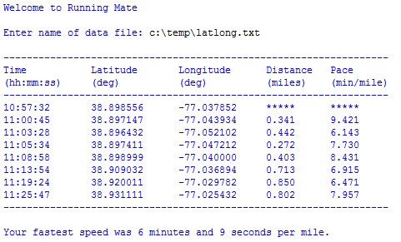

This report tabulates the person’s time, latitude, and longitude. For each interval, it also lists the miles traveled and pace during that interval. (We don’t list the distance and pace for the very first interval, because that is the person’s starting point.) At the end of the report, the program indicates the person’s best pace in minutes and seconds per mile.

You must submit your solution as a file named gps_lastname.py, where you are to replace lastname with, umm, your last name.

Your grade will be determined as follows:

1 point You submit your homework as a Python file with the requested name.

1 point Your code is commented well and is understandable

1 point You read the GPS data from a text file whose name the user enters

4 points You have a class called GPS_Calculator that includes a function

called calc_distance that takes in the latitude and longitude of two

points and returns the distance between the points. You may also choose

to include other functions in this class that you find helpful. You

create an object of the GPS_Calculator class to actually calculate

the distance and other quantities you might choose to include in that

class.

4 points You have a class called Report_Printer that includes functions for

printing a nicely formatted report identical to the one printed above,

and you create an object of the Report_Printer class to actually

produce the report.

2 points Your interval distances are computed correctly

2 points Your interval paces are computed correctly

2 points You determine and report the best pace in minutes and seconds

So, this homework is worth 17 points.

You can learn how to compute distances from latitude and longitude from a number of sources online. For example, here’s one of them, which requires all latitudes and longitudes to be converted to radians first using math.radians:

http://andrew.hedges.name/experiments/haversine/

Please contact me when you need help.