**V.4**

**May 18, 2016**

**Team Almost Good**

**Griffin DZiok**

**Hyungjin Lee**

**Cyrus Sarkosh**

**Eric Soler**

# Table of Contents

Version History

Overview

Game Details

Audience, Platform, Marketing

Feature Set

The Game World

Camera

Game Characters

User Interface

Objects

Visual

Sound

Single-Player Game

Backlog

Additional Resources

Future Ideas

# Version History

## 1.0 - 4/28/16

* Initial game designs details

## 2.0 - 5/4/16

* Take out switch that reverses gravity
* Take out 8 rooms, there will be 2 rooms
* Backlog added
* Take out level editor section
* Fix typos and grammar

3.0 - 5/12/16

* Take out plot of the mysterious house
* The goal of the game remains same: need to bring electricity
* Tasks added and completed from backlog
* Draft of Ellie Art added

4.0 - 5/18/16

* Update on the backlog
* Sound effect for Ellie entering field is taken out, will be same as Ellie getting pulled/pushed
* Explanation of plot revised to fully take out the “house” concept

# Overview

Ellie is a 2D platform game comprised of different obstacle courses each level. Player will run through the world with different obstacles that will either push or pull (repel or attract) the hero. Hero will evade the obstacles by its own ability to create magnetic fields that can push or pull objects or itself. The goal of the game is to get through all the levels as fast as you can.

# Game Details

Ellie combines features of puzzle and adventure in the single-player, 2D platform. Ellie the electron will be the hero that the player will enter the game world as. Ellie’s ultimate goal is to clear all levels. There will only be one character offered for the player to control.

Mechanics of Ellie was inspired by atomic charges, magnets, and circuits. The obstacle course of each levels are to utilize the push and pull forces of different objects.

## Genre

Puzzle/Adventure

## 2D or 3D

2d

## Single-player or Multiplayer?

Single player only

## World

The game takes place inside a mysterious house. Zooming in further into microscopic level, the player enters the world as Ellie, the negatively charged electron, in the electric wires inside each rooms of the house. Everything in the world is positive, negative, or neutral charge with varying strength value.

## Main Focus

Main focus of the game is to creatively use push and pull forces that the world or Ellie provides. The game uses a simple concept to create a world full of puzzles to solve.

## Game Length

Each level should take about 3 min, no more than 5 minutes. There will be ~~8~~ 2 rooms. Currently, we have set each level per room.

As the game development funding increases, we hope to have multiple levels to clear a room.

## Comparison

### Super Mario Bros

Similar to Super Mario Bros, Ellie will support the adventurous feel, having different background themes for different levels.

Ellie is different from Super Mario Bros because Ellie is played strictly through obstacle course and avoiding enemies, and does not support enemy combat. Ellie also doesn’t support character jump.

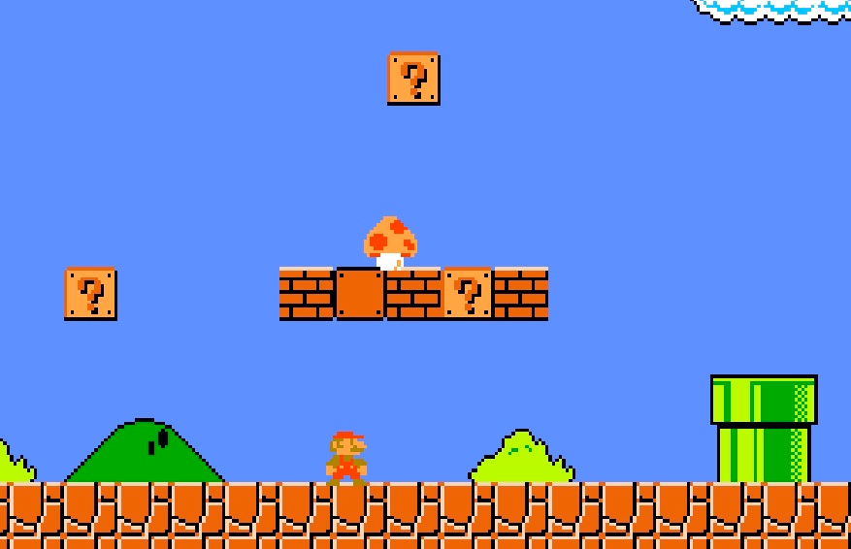

### VVVVVV

VVVVVV is a 2D Platform game that allows the hero to alter gravity. The hero does not jump, but reverses gravity to avoid any obstacles such as spikes, shown in figure below.

Ellie is different from VVVVVV, by not allowing the hero to reverse gravity but rather manipulate its position through push and pull mechanisms. Ellie must use positive magnetic field or negative magnetic field to reverse its gravity, but it can also use it on enemies to change their gravity instead.

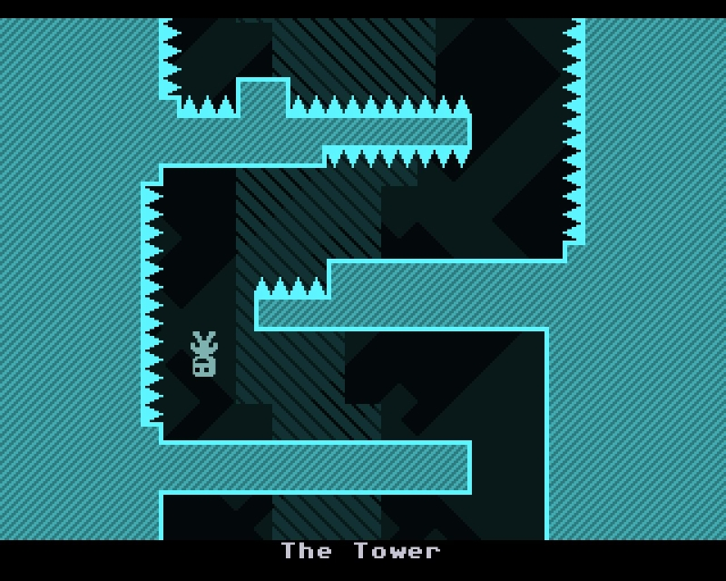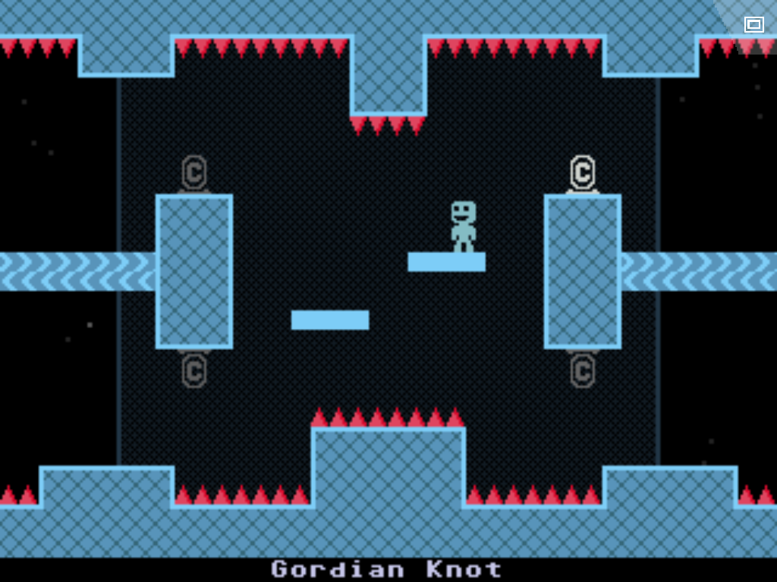

### Portal

Portal is a 3D puzzle game using portals, while Ellie is a 2D puzzle game using positive magnetic field and negative magnetic field.

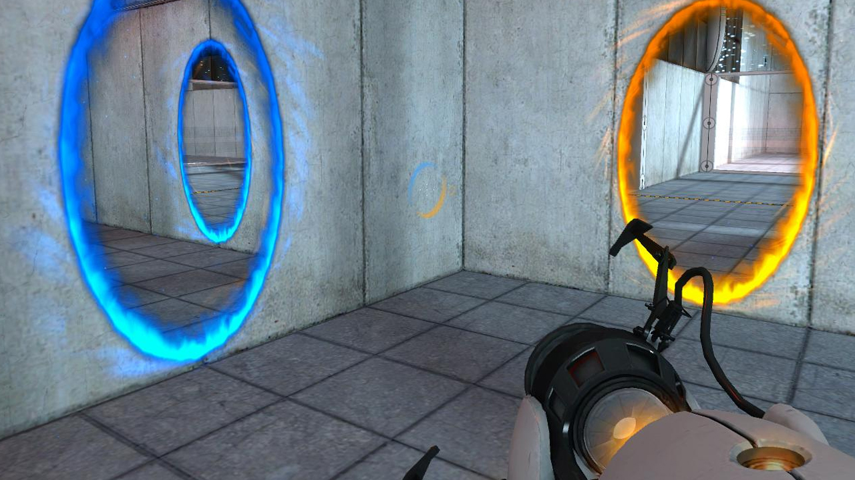

## Unique Value

Ellie is the first game that utilizes simple concept of attraction and repulsion to create a simple, yet engaging 2D platform puzzle/adventure experience.

## Purpose

Ellie provides challenging puzzles that is simple to play, but hard to master. It will attract those who want games that enjoy challenging brain-teasers and improvement of the game-play.

# Audience, Platform, Marketing

## Target Audience

The target audience for Ellie is players who enjoy puzzle-solving and want a game that will constantly challenge them. It is playable by anyone who enjoy gaming casually since it is easy to learn, and more competitive players who want to master the game. We want the game to reach players of any age.

## Platform

* Puzzles are challenging and there are multiple ways to clear levels
* Story of the house and rest of the world is not known, until the player finishes the game
* It is easy to play but hard to master-- Ellie supports competition with self.
* Keyboard is supported for game control.

## Top Performers

* Gravity Den
* Ibb & Obb
* VVVVV

# Feature Set

## General Features

* Detection mechanic for the enemies
* Push/pull of the positive magnetic field or negative magnetic field and enemies
* Throwing positive magnetic field or negative magnetic field
* Spiked floors and holes
* ~~Reverse gravity~~
* Extra Lives/Hits
* Automatic Save Game once a level is cleared

## ~~Level Editor~~

~~[Coming Soon]~~

## Gameplay

The player navigates through each level and figure out how to get around different obstacles. The obstacles include enemies, magnetic fields, spiked floors, and holes. ~~Enemies will spawn pseudo-randomly to create some variety for repeat play.~~ Ellie has two options for tools, positive magnetic field or negative magnetic field that the player may use to help avoid the obstacles. The game keeps track of the time taken to clear each level to challenge the players to find the most efficient way to get to the end of the level.

# The Game World

~~There is a big house standing alone in the middle of a field. You can feel the gloom and mystery that surrounds this house. It seems abandoned, no one is around. The weather is overcast, and seems to understand this mystery of the house. Then, you hear someone walking, then a metal box opening. The person turns on some switch-- maybe an electric generator or a circuit board. It isn’t known to the player.~~

You enter the microscopic circuit world ~~inside the house~~ as Ellie the electron. ~~Ellie is the only one with power to bring power to this mysterious house. Each level will be connected to a particular room (maybe more level/room) Ellie’s goal is to bring power to every room in the house. To do so,~~ Ellie’s goal is to bring electricity to every level of the game. Ellie has to zip through obstacles that will pull and push Ellie, to prevent clearing the level.

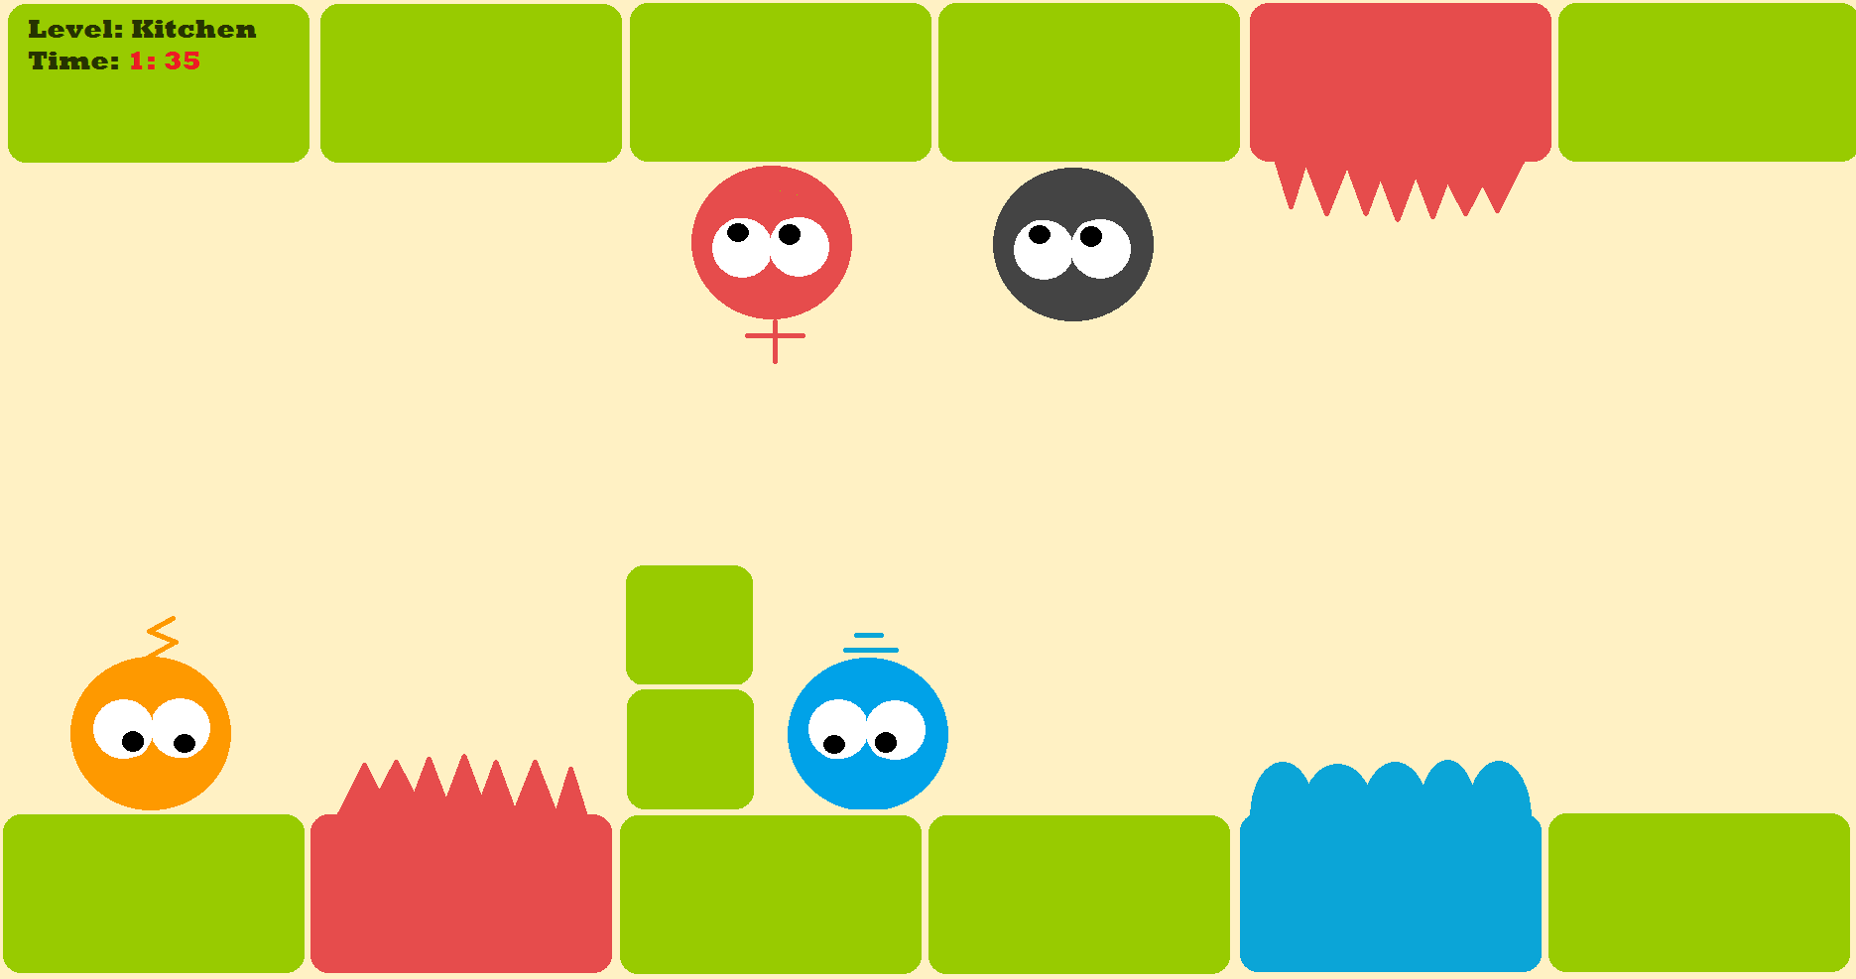

## Key Locations

Ellie will get spawned in the left of the screen, grounded by the bottom floor -- normal gravity setting.

There will be a distinct location for Ellie to exit the level, which will be indicated by an image of battery-end. Once Ellie finishes the level, the background will light up, which will give the player indication of level completion.

## Travel

The player controls the Ellie left and right but cannot jump or go down. Ellie will show a hover/walking movement. The player can also throw positive magnetic field or negative magnetic field that will either push or pull Ellie in the opposite direction. There are world-generated positive magnetic fields or negative magnetic fields that the player can use to jump, go down, and reverse gravity.

## Scale

The world a combination of micro and normal. The setting switches from normal to micro level. Ellie explores the world in a micro level, but it will affect the normal world.

## Objects

These are stationary objects the world generates for obstacles, aside from enemies. More details of the object mechanisms are described in theObjectssection.

* Positive magnetic field
* Negative magnetic field
* Positive charge trap
* Negative charge trap
* ~~Switch~~
* blocks

## Weather

It is gloomy and overcast. There is no sun nor any lights on, but it is not too dark.

## Day and night

It will be unknown whether the game world takes place in the day or night. There will be no changes of day and night cycle in the game world, nor game time setting.

# Camera

Camera will initially start by having Ellie on the left. Once Ellie passes the center, the camera will trace the Ellie to keep Ellie centered in the screen.

# Game Characters

The game features Ellie as the hero, which will be controlled by the player. There are 2 enemy characters, proton and electron that the player will interact with. Additionally, there is a Neutron NPC that may block or help Ellie complete the level.

## Third Draft of Ellie



## Second Draft

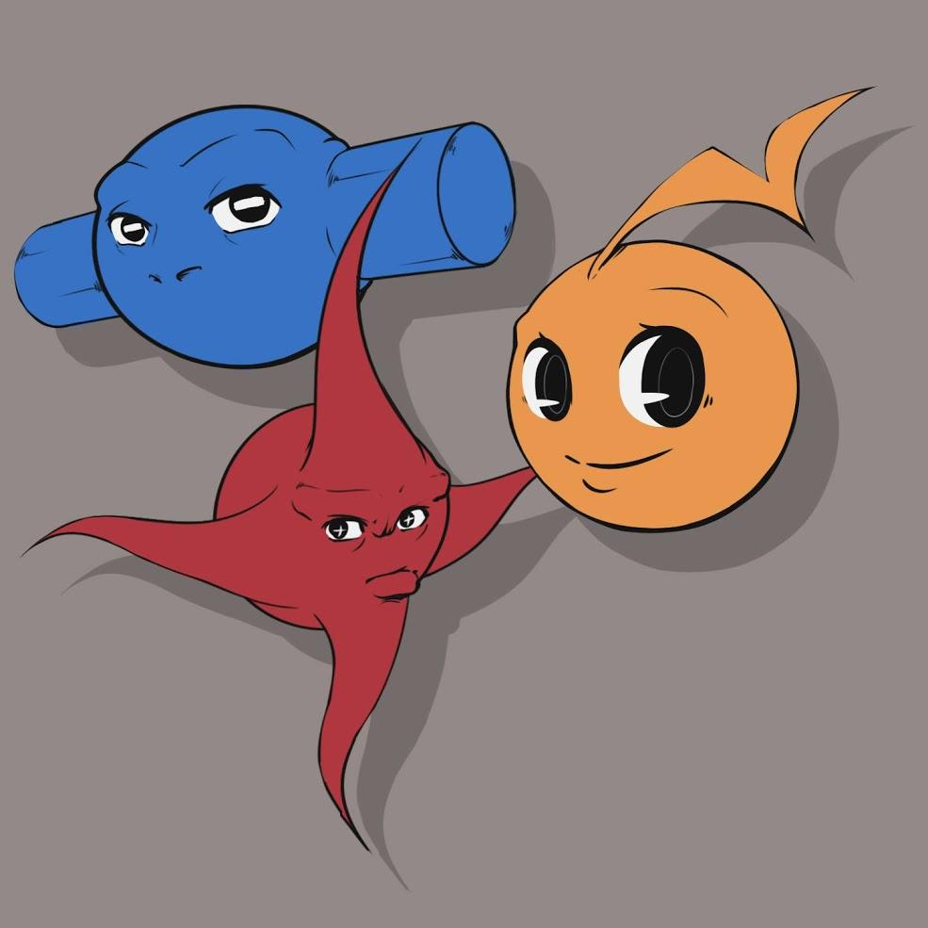

## First Draft



## Hero -- Ellie

Ellie, the electron, is the hero the player controls. It is a negatively charged particle that can take 3 hits from an enemy before dying. Ellie cannot jump, it will mainly walk the surface it’s on-- Ellie is a particle that does not always follow the earth’s gravitational pull. It will assume the closest surface will be the ground it can walk on.

It can throw 2 different objects -- positive magnetic field and negative magnetic field. The player will have to use these objects to avoid colliding with enemies or walking into traps.

We make no assumptions on the gender of Ellie.

## Proton Enemy -- Prottie

Proton Enemy is a positively charged moving objects. There will be varying strengths of these objects, differentiable by size and color of the enemy. Bigger size and darker red hue will indicate a stronger proton enemy; stronger enemy will have greater radius to inflict its push/pull force.

* Pull Ellie toward itself, causing a hit damage for Ellie
* Push other proton enemies away from each other
* Neutralize and disappear when in contact with Electron enemy
* Neutralize and disappear when in contact with negative magnetic field
* Neutralize and disappear when in contact with negative charged trap
* Get pushed by positive magnetic field
* Cannot jump

## Electron Enemy -- Eddie

Electron Enemy is a negatively charged moving objects. There will be varying strengths of these objects, differentiable by size and color of the enemy. Bigger size and darker blue hue will indicate a stronger electron enemy; stronger enemy will have greater radius to inflict its push/pull force.

* Push Ellie away itself, possibly causing Ellie to fall into traps
* Push other electron enemies away from each other
* Neutralize and disappear when in contact with Proton enemy
* Neutralize and disappear when in contact with positive magnetic field
* Neutralize and disappear when in contact with positive charged trap
* Get pushed by negative magnetic field
* Cannot jump

## Neutron NPC -- Nubbie

These are neutral charged moving objects. They cause no damage to Ellie or the enemies, but they can block paths of the other characters. They may become stationary blocks that can either help Ellie by blocking enemies, or become another obstacle for Ellie to get through.

# User Interface

The game does not require extensive user interface. There will be menus and hero and game status on the upper left corner of the screen. There will be short credits screen at the end of the game.

### Start Menu

Start menu will be the first screen the user will see once the game starts. In this menu, there will be 4 options:

* New Game: starts a new game
* Saved Game: starts the last saved game
* Best Times: display best times for each level
* Quit Game

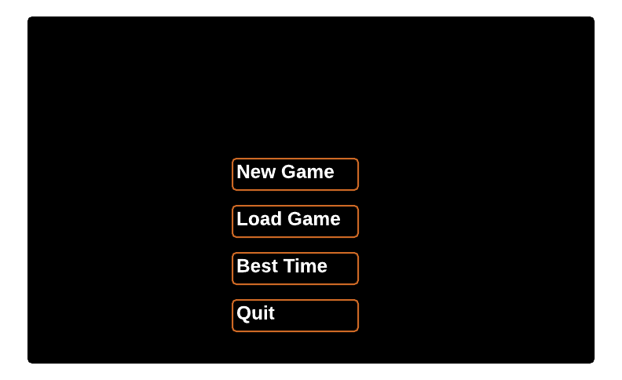

### Game Status

Game status will be on the upper left corner of the game screen, and it includes the several hero and game information:

* ~~Button for Scroll down Menu~~
* Current Level/Room
* Health/Hit status of Ellie
* Time spent in the level.

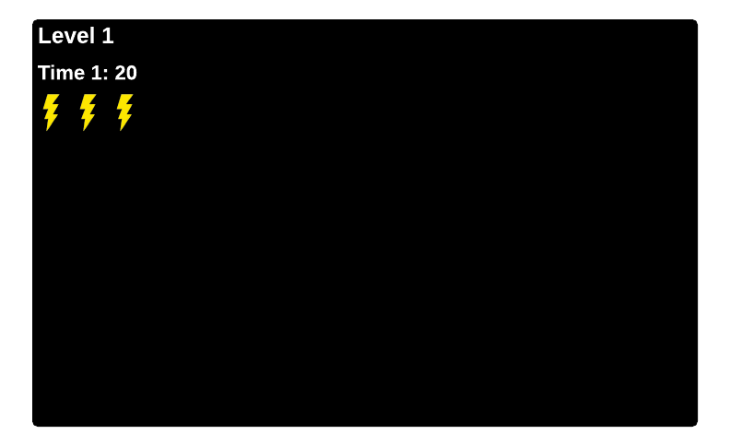

### ~~Scroll Down Menu~~ Popup Menu

Menu pops up when ESC key is pressed. The game will be paused when this menu pops up.

* go back to Start Menu
* Resume game
* ~~Quit game~~

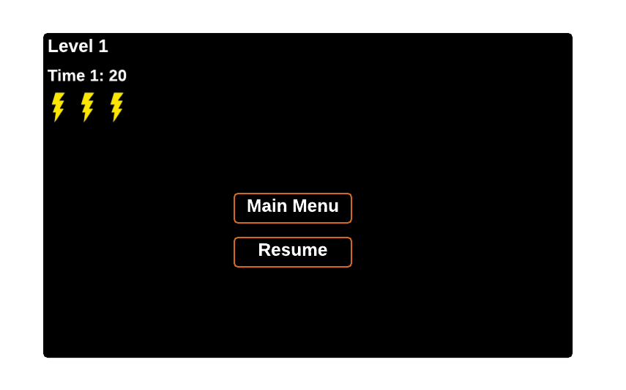

# Objects

## Positive Magnetic Field

* Throwable: thrown by Ellie, disappears after
* World object: Spawned by level generator, will not disappear

There are two types of negative magnetic fields, but their mechanics are exactly the same. Once activated, positive magnetic field will push any positively charged objects toward the opposite direction. It will pull any negatively charged objects closer, and cause delay of the object’s movement. Magnetic fields do not interact with each other.

## Negative Magnetic Field

* Throwable: thrown by Ellie
* World object: Spawned by level generator, will not disappear

There are two types of negative magnetic fields, but their mechanics are exactly the same. Once activated, negative magnetic field will push any negatively charged objects toward the opposite direction. It will pull any positively charged objects closer, and cause delay of the object’s movement. Magnetic fields do not interact with each other.

## Positive Charge Trap

This object is identical to spikes, with attraction/repulsion power. It will pull any negatively charged objects within proximity of its power, and cause damage. Ellie will take damage if it gets too close to the trap, and will lose a charge/life. There will be various lengths of the traps.

## Negative Charge Trap

This object will act similar to the negative magnetic field. However, Ellie can use this trap to attract the Prottie (positive charged character) to eliminate them. There will be various lengths of the traps.

## ~~Switch~~

~~Ellie can interact with the switch, which will reverse the effect of magnetic field, or turn off the trap the switch is attached to.~~

## Blocks

Blocks are stationary neutrally charged objects. Ellie will need to go around these objects with surrounding charged objects or throwable magnetic fields. There will be various sizes of these blocks, but all will be rectangular shapes.

## Charge

Once Ellie consumes this object, it gets an extra hit/life.

# Visual

The art for Ellie will be minimalistic shapes with cartoon or clip-art feel. All the positive charged objects will have red hue and be spikey. All the negative charged objects will have blue hue and be lumpy. The distinction will help easily distinguish the ability of the objects.

## Color Palette

The game will adhere to this color palette, but should have more “glowy” feel to it. Refer to

<https://vimeo.com/104094320> for additional visualization.



* #ef5322: (239,83,34)
* #ffc90d: (255,201,13)
* #fe9900: (254,153,0)
* #98cb00: (152,203,0)
* #0ba5d7: (11,165,215)

## Building models

* ~~Mysterious House~~
* ~~Different sizes of~~ blocks
* Positive magnetic field:
* Negative magnetic field
* Positive ~~Spike~~ trap
* Negative trap
* Charge object -- extra life

## Scenery models

* ~~House background intro: gloomy, cloudy, hill~~
* ~~House background ending: sunny, blue sky, hill~~
* Game world background: dark, metallic texture
* ~~Room backgrounds~~
  + ~~Bathroom~~
  + ~~Living room~~
  + ~~Kitchen~~
  + ~~Master bedroom~~
  + ~~Kid’s bedroom~~
  + ~~Attic~~
  + ~~Study/Office~~
  + ~~Rec room~~

## Character models

* Ellie
* Proton Enemy
* Electron Enemy
* Neutron NPC

## Particle effects/Animations

* Characters getting pushed by magnetic fields
* Characters getting pulled by magnetic fields
* Magnetic field device opening up
* Proton Enemy hurts on Ellie
* Electron Enemy hurts on Ellie
* Ellie walking
* Ellie dying
* Ellie getting hurt by traps/spikes
* Ellie throwing magnetic fields

# Sound

The theme of the music and sound will be collaboration of looping adventure music with “electric” sounds.

## Music tracks

* Intro background music
* Game world background music ~~-- different track for each room~~
* Game end background music

## Sound effects

* Ellie hits stable ground
* Ellie throws positive magnetic field and negative magnetic field
* ~~Ellie enters positive magnetic field or negative magnetic field sound~~ (same as getting pulled/pushed)
* Ellie getting pushed
* Ellie getting pulled
* Positive charge trap sound
* Negative charge trap sound
* ~~Switch sound~~
* Proton enemy within proximity
* Electron enemy within proximity
* Ellie finishing level
* Ellie getting spawned

# Single-Player Game

This game will support only the single-player. The player will control Ellie, the electron

## Story

~~For an unknown reason, the power is out in the mysterious house. Ellie needs to run through the obstacles in each level to bring back power in the room. Ellie’s goal is to go through all the levels to light up the whole house, and possibly uncover why the power has gone out.~~ The plot of the game is very abstract. Ellie is an electron, and it travels through different obstacles to bring back electricity.

## Victory conditions

The player wins the game if they light up all the rooms in the house. The game will end with a scene of the house with every room lights lit.

For replay value, we are adding a timed component. Player can replay the game after they have already gone through it once, and try to improve their time for different levels.

# Backlog

|  |  |  |
| --- | --- | --- |
| Task | Priority | Assigned To |
| Camera Smoothing: Ellie slightly left/right instead of centered | done | Griffin |
| Throwing: aiming and path of projection | done but taken out | Cyrus |
| Main Menu | done | Jin |
| Positive and Negative traps | done | Eric |
| UI | done | Jin |
| Nubbie | done | Jin |
| Autosave/load | done | Eric |
| Charge: extra life | done | Jin |
| Best Time | done | Jin |
| Prottie | done | Jin/Eric |
| Eddie | done | Jin/Eric |
| Levels | 1 | Eric |
| Pause Game for enemies | 2 | Jin |
| Ellie Hurt Animation | 1 | Griffin |
|  |  |  |

# Additional Resources

* <http://store.steampowered.com/app/95400/>
* <https://vimeo.com/104094320>

# Future Ideas

* Multiplayer support with a positive charged hero