**NOTE**: currently the demo is using email as account id to login server. Later will generate an unique fixed length number as account id. Due to the time limitation, the transaction history list is not ready for use.

Environment: EntityFramework 4.7.2

Setup the demo environment:

1. get db creation file from ~\OpenSystemDemoOCBC\OCBC.DataAccess\DBFiles and run in sql server

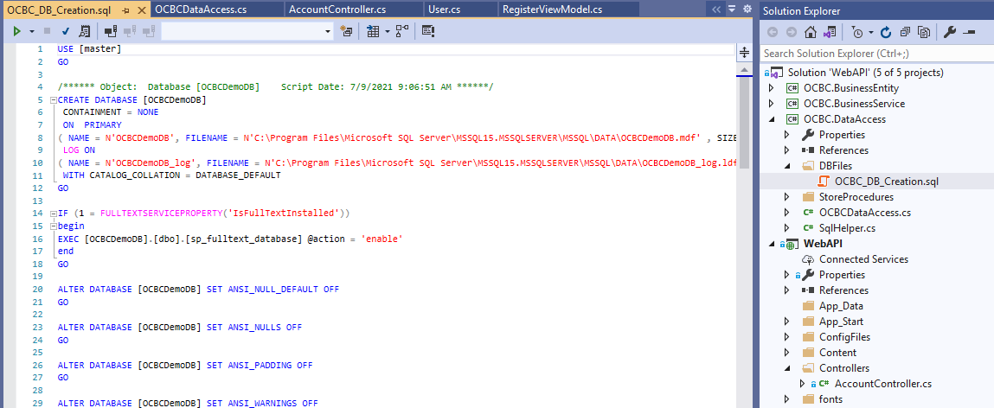

2: find connection string named as “OCBCDemoDB” in web.config and update accordingly.

3: deploy the demo app in iis server.

4: home page:

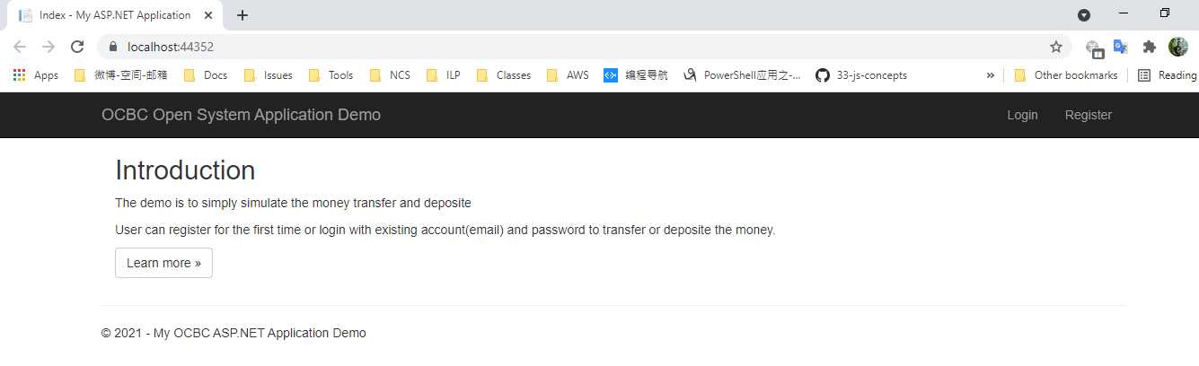

5: register page:

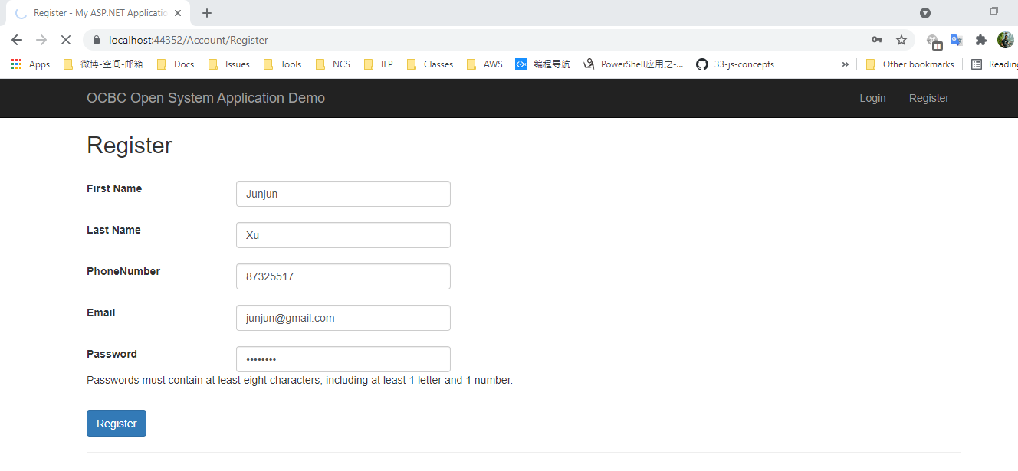

6: login page

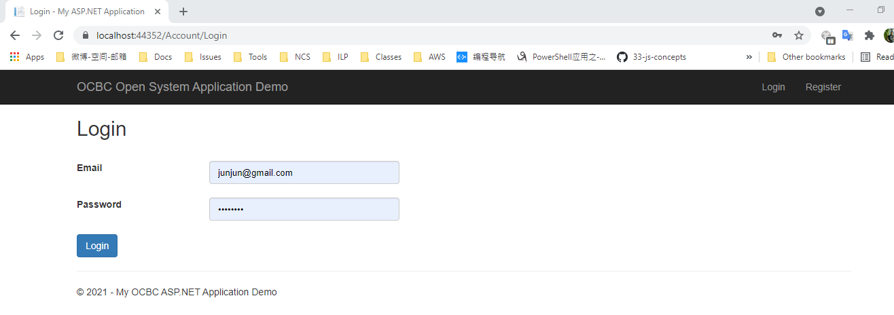

7： detail page:

