**AIM:-** TO GENERATE AN AMPLITUDE MODULATED SIGNAL AND ANALYSE THE CRITICAL, UNDER AND OVER MODULATION

clc;

Clear;

fc = 1000000;

fm = 1000;

fs = 10000000; % sampling frequency

k = 0.5; % modulation index

Ac = 1/k; % assuming Am = 1

opt = -Ac;

t = 0:1/fs:(2/fm) - (1/fs);

x = cos(2*pi*fm*t);% + sin(2*pi*fm*t);

subplot(311)

plot(x);

title('Message Signal');

y = modulate(x,fc,fs,'amdsb-sc');

subplot(312)

plot(y);

title('Amplitude Modulation');

z = Ac*(1+k.*x).*cos(2*pi*fc*t);

subplot(313)

plot(z);

title('AM modulation');

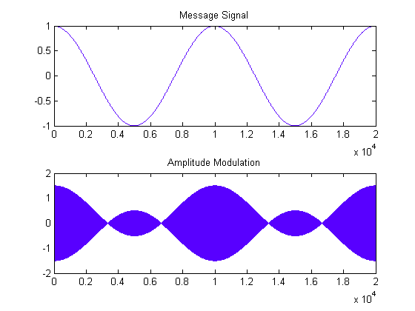

**a) OVER MODULATION**

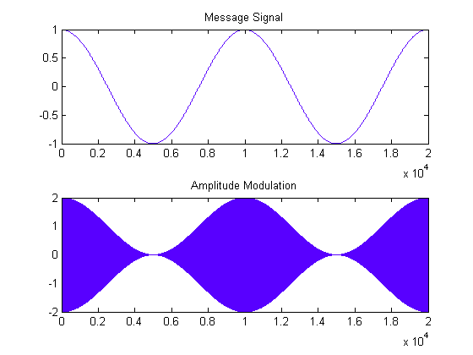

**b) CRITICAL MODULATION**

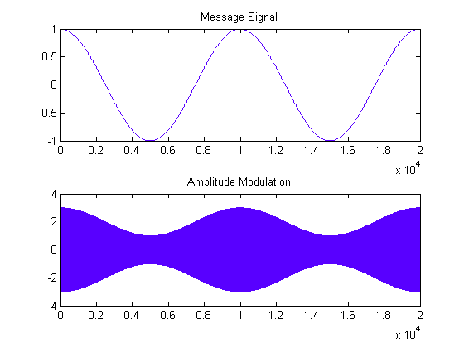

**c) UNDER MODULATION**