Eric Keep

CS 4561

January 20, 2017

The target feature to be tested by Eric in the next milestone is the scrolling mini-game shown in the previous demo to the class as well as the client, as shown in [PerlSquad](https://github.com/Sagerune/PerlSquad)/[javascripts](https://github.com/Sagerune/PerlSquad/tree/master/javascripts)/**scrollgame.js** on the github PerlSquad. The goal by the milestone is to implement a relatively simple difficulty option in-game (potentially also in the options menu as well). The overall goal is to make it easy for the student and teacher to adjust the difficulty based on student’s reaction time and knowledge base, with flexibility for potential future changes the client may request.

Step 1: Load the html file index.html

Step 2: Click the “Start” button once you see the screen below:

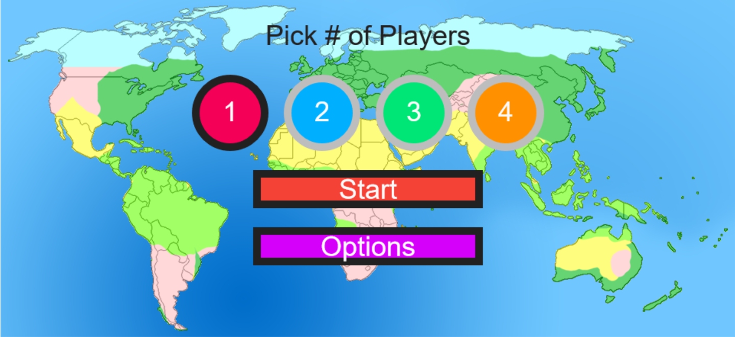

Step 3: Follow onscreen instructions regarding clicking on the player avatar

Step 4: Click on each circle of biome information, clicking on OK after each one to proceed to the minigame (This step may change as the overall structure of the game in general changes in the development process – as of the moment of writing this is how you proceed to the minigame)

Step 5: Click on options button to adjust difficulty, and check to see if overall speed of objects has any noticeable difference – a console log is unnecessary as difficulty is not easily quantified, and more of a “feeling” than a quantifiable value.

Step 6: Close web browser when satisfied, or refresh if not satisfied.