# Welcome to the Complete Copy Writing Course

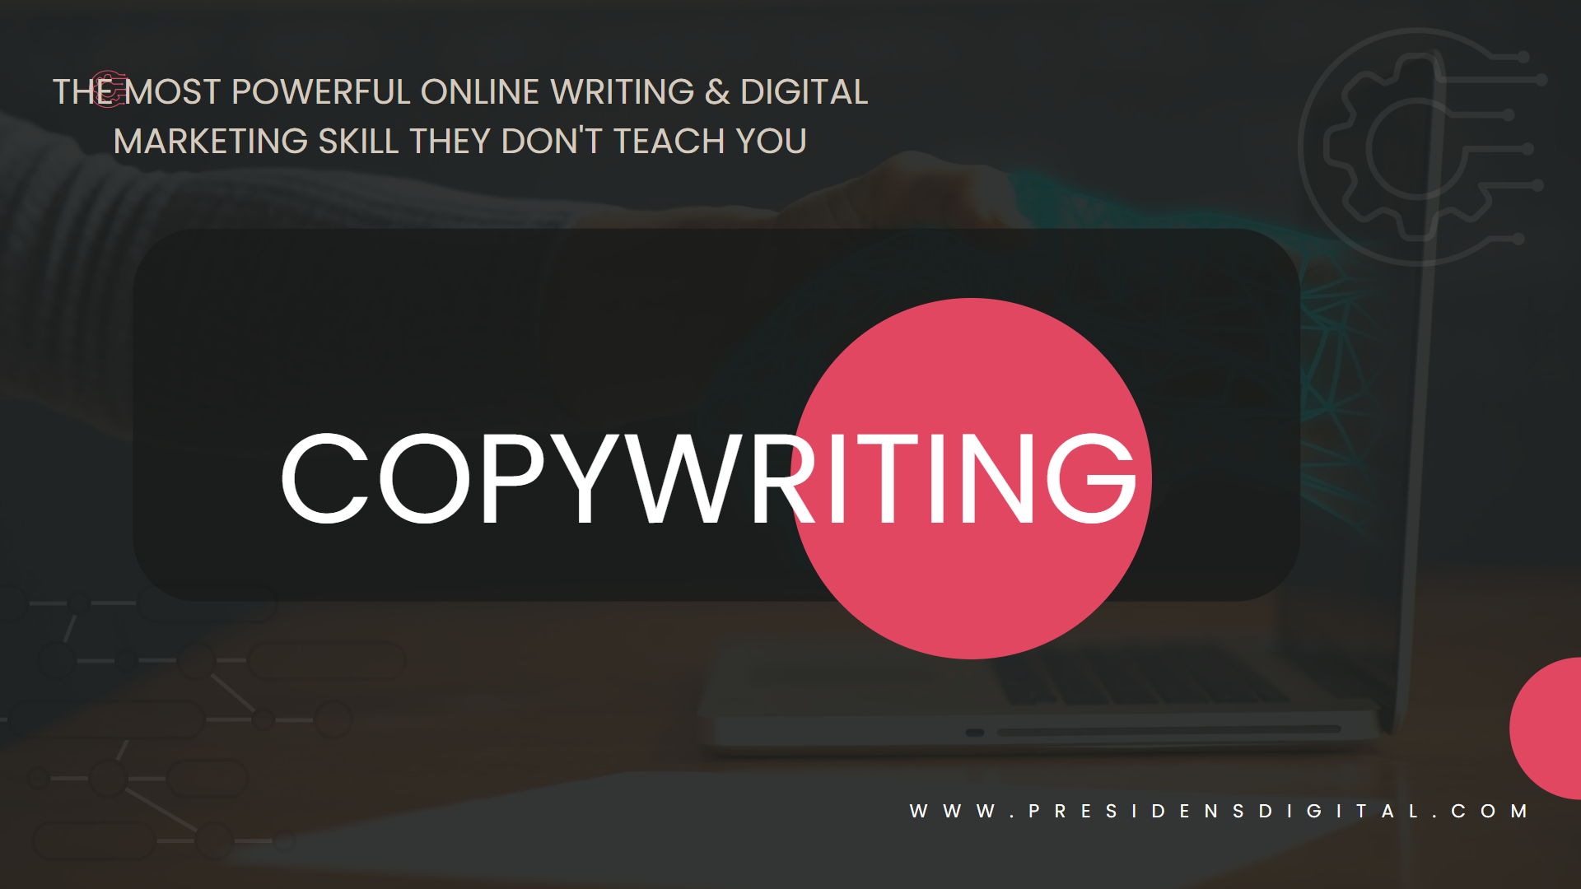

# Hello, welcome to the complete copywriting course, the only course you need to become a great copywriter and start your journey towards becoming a well sought-after marketer.

# If you are a good student and a person who is able to think outside the box just a little bit, what you’ll learn here, has a proven record of making people and businesses earn millions.

# Now, I know that claim sounds something like a corny advertisement, but these skills as I have said, do have a long proven track record of helping people become financially free. In fact, many businesses will pay up to $10,000 (ksh1,000,000+) for an experienced copywriter to write their Sales Page (yes, these are FACTS).

# However, this is not a GET RICH QUICK SCHEME. It is also very different from claiming that everyone who takes this course will be become a millionaire or financially free. That is not the goal of this course.

# The goal of this course is to teach you:

* What Copywriting is.
* How to write the best copy for anything.
* How to make money out of Copywriting
* Be able to get clients
* Know the different places you can get clients
* Know the various way in which you can make money from copywriting
* Take your online and offline marketing to the next level.
* Tons of writing tips to make you a better copywriter.
* How to gently + ethically persuade people to act NOW and IMMEDIATELY!
* How to understand the market and competition to write better copy
* How to build a great portfolio – fast.
* Publish an article in 5days from now.
* How to use social media to earn money.
* Write better copy for website landing pages.
* Writing better headlines that catch more attention
* Writing killer first sentences.
* Tell a compelling story to make your writing more persuasive.
* Learn copywriting secrets normally reserved for the pros.
* Learn formatting tips that make your copy a joy to read.

# These with the right action will make you financially free. Not this course. Action! Action is the currency of success.

# It is my hope you will not only read but you will take action. I want to see you succeed!

# With that said, let me introduce myself.

# WHO I AM AND WHAT TO EXPECT

# Who I am

# My name is Eric Kyalo, I’m a Strategic manager, a web developer, a digital marketer, and a professional copy and content writer with over 5 years’ experience.

# My entire life has been based around helping people and small medium businesses become better, realize their full potential, scale, and learn new skills. I've been a strategist, a writer for numerous people and agencies, and a marketer for both myself and other small medium enterprises. My knowledge, experience, and expertise have not only gotten me to where I am but also gone a long way to help numerous individuals and small medium enterprises realize more profits and make life changing amounts of cash.

# It is in this journey

So I bring all of this up not just to blow my own trumpet, I promise, but because this course is based directly on my experience and failures and from helping other people successfully.

Thank you again for enrolling to this course. You’re journey towards a high income has just began.

**What to expect**

IMPORTANT!

Unlike other online courses, we have ensured you won't just learn passively – you'll be practicing what you learn. However, that is not enough. You will have to continue taking action even after you finish the course. Action is the currency of succeeding. There’s no shortcut. There’s no other way. If you take this course and don’t take action you’ll be left saying you were duped, you were robbed and that the course was worthless which will not be true. So ensure you take action because that’s the only way you’ll succeed and I want to see you succeed.

Hopefully, as you already know, this will be a 5-week course in which you’ll learn all the ins and outs of copywriting. You’ll also learn how this great skill can be employed in digital marketing and opportunities you have. During the 5-week period you’ll receive active 24/7 support on any related query from me personally, and my team. It is my belief that by the end of the course I’ll have taken you from zero to hero.

Some lessons as you’ll see, will be quite long and others as short as the weekend. I’ve done my best in each lesson to give you all the necessary content and information you need to succeed.

However, this doesn’t mean that after the end of the five weeks that will be it. You can always log in and learn from the course content forever. The only thing that won’t be available is the active 24/7 support. Although we’ll still assist you if you request. Use the 5 weeks effectively to become a professional copywriter and see a world of opportunities open before you.

**PS:** If you have any questions, simply WhatsApp to 0778335722 and one of our team member will gladly assist you. We send free updates via email, but for training-related stuff, strictly send queries to WhatsApp 0778335722 so that you don't have to wait for ages for assistance.

Now, go ahead and get right into it. Make sure you do all the exercises in the course. This is the single most important piece of advice I have.