Title

author

date

# Heading 1

First paragraph.

Table caption

|  |  |  |  |  |
| --- | --- | --- | --- | --- |
| compact | sequence | submitted_by | depo.date | DOI |
| 2LEE | TAGGGCGGGAGGGAGGGAA | EL | 2020-04-23 | 10.1021/ja208483v |

# Heading 1

## Heading 2

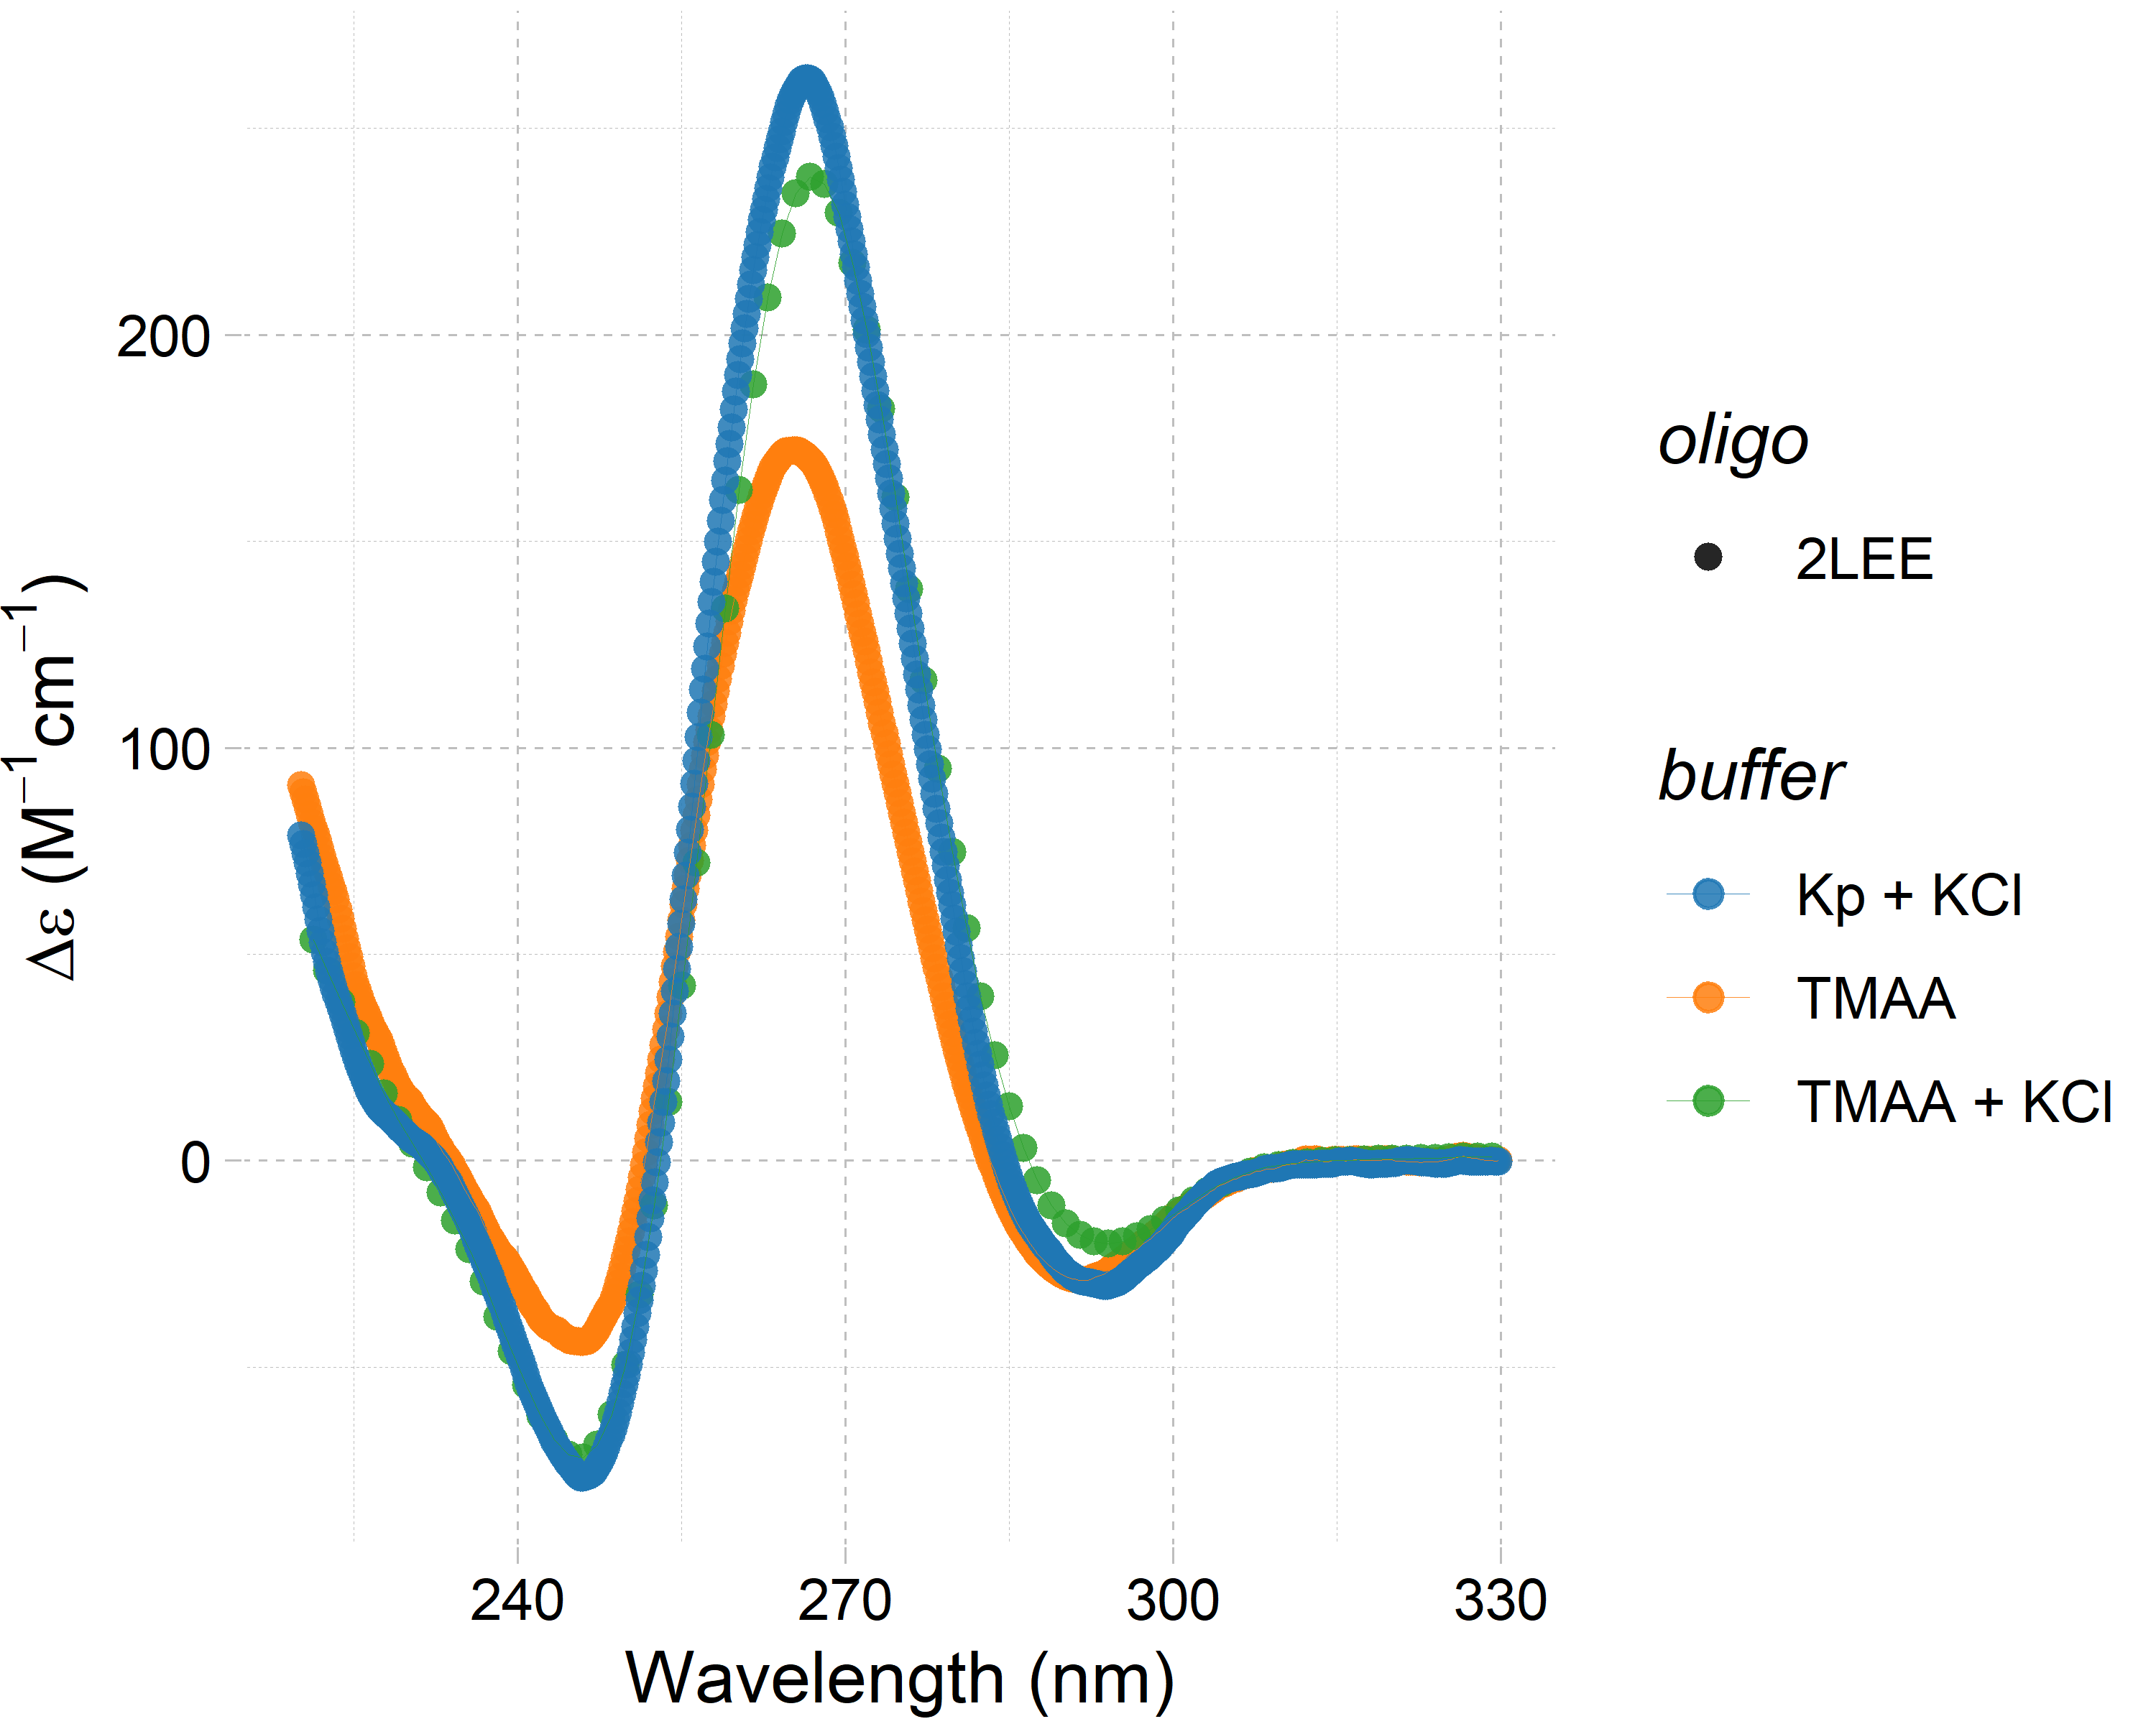

Image Caption