Title

Author

Date

*Block Text*

# Heading 1

## Heading 2

First paragraph

Body text

### Heading 3

KeywordTok

* Compact,

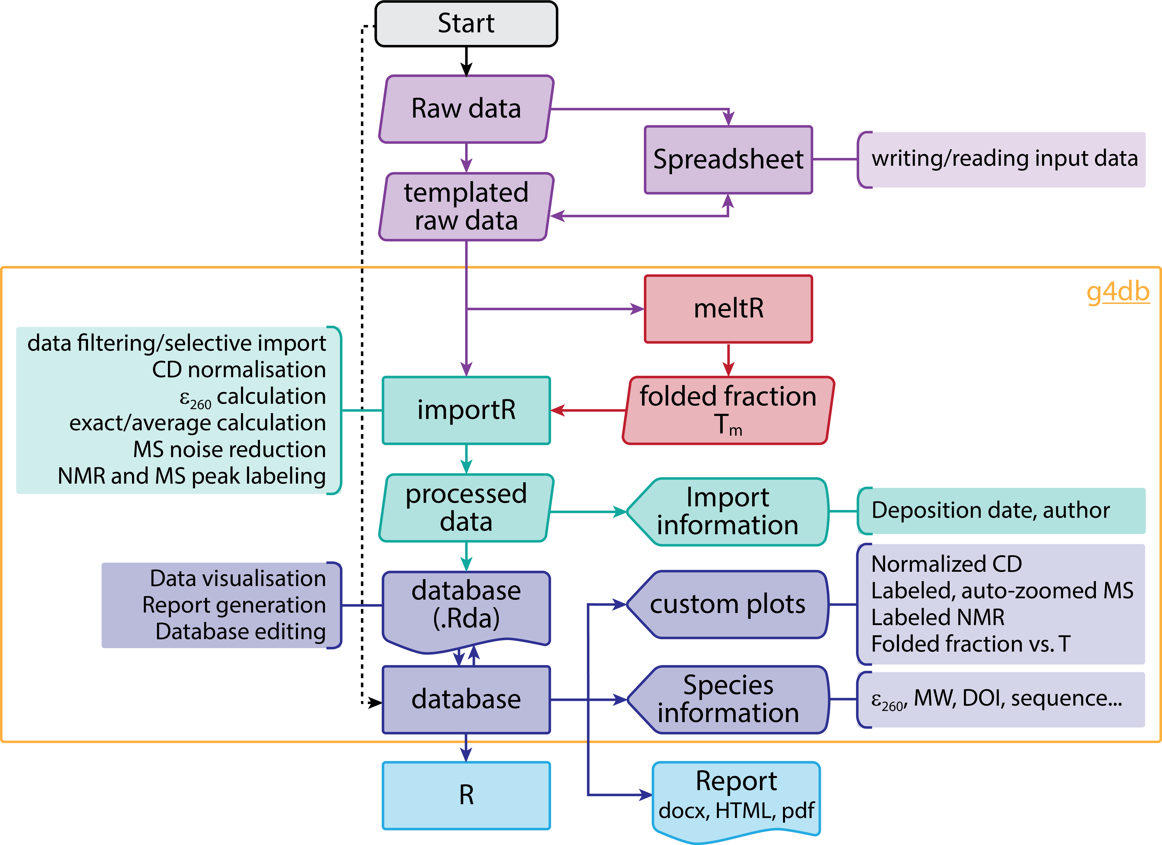

Image Caption

#### Heading 4

[Hyperlink](https://a2.typepad.com/6a0105360ba1c6970c01b7c7187af2970b-pi),

(1) Bibliography.