**PokerBot Documentation**

**Table of Contents:**

Overview 1

Something pg#

Something pg#

Something pg#

**Overview**

This program is designed to allow the user to engage in a Texas Hold ‘Em poker game against artificially intelligent opponents. The main objectives of this program are to provide entertainment value to the user, allow the user to review various statistics gathered from their playing style, and also to be an effective learning tool for those just starting to learn about the game as well as those looking to strengthen their skillset. There are two main modes of play: Poker Training and The Pits.

Poker Training begins with a skip-able introduction to the game that teaches the hand ranking system, the mechanics of play and gives tips as to which hands are wise to play and which are not. This is only run through the first time a new user plays this mode however there is also an option to view it again at any time in the player menu. Once this mode is selected there is no options given to customize gameplay (i.e. number of players, stack sizes, etc.) as they are all predetermined in order to ensure a simple, quick start. There is a bar that represents the strength of the player’s hand as a guide for the beginning player. The statistics gained in this mode are recorded separate from those in The Pits.

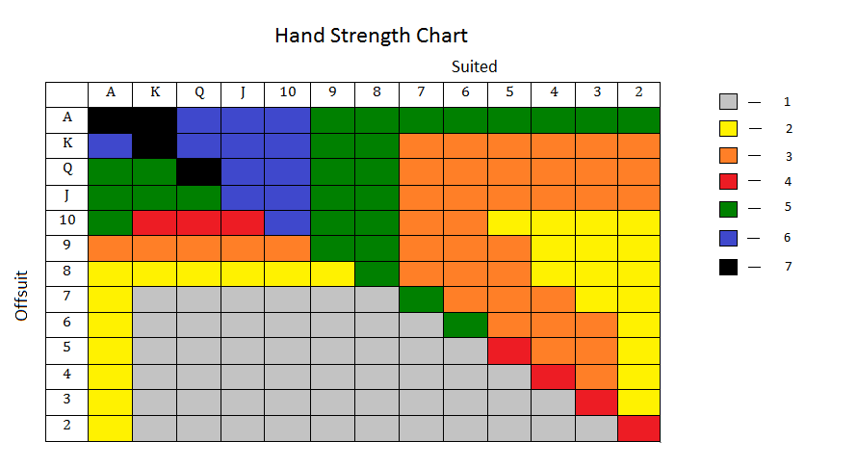 The Pits is essentially just diving into poker against computer(s) that is meant to be as realistic as possible. The user is given the option to customize various components of gameplay including: the amount of opponents, the size of the starting stacks, the size of the Big Blind, and the speed of increasing blinds (or if they prefer, for the blinds to be static). The player can choose to exit to the player menu at any time and will be returned upon completion of the hand in progress.