信号与系统第七次作业
证明题(二维信号的傅里叶变换及反变换公式)：
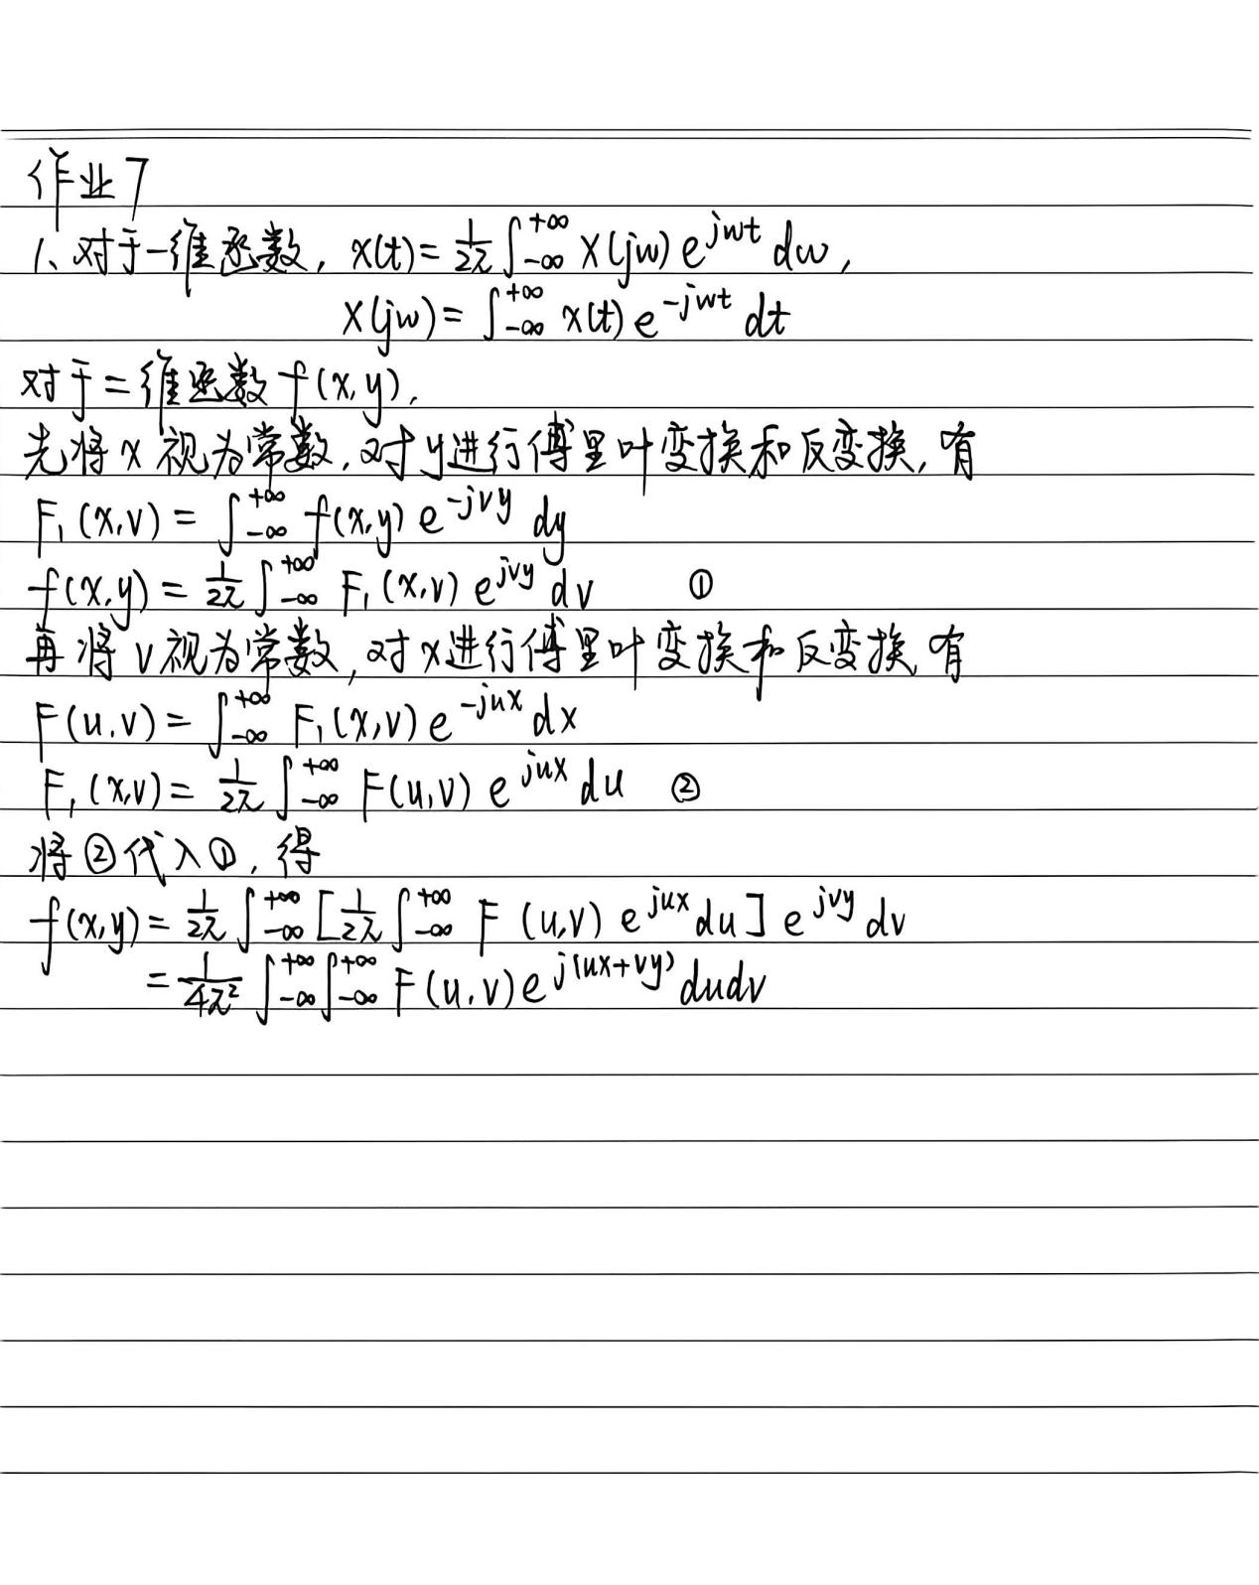

编程题
（1）请录制一段自己的声音，并利用学在浙大第三章程序1打印自己声音的频谱。
打印出的频谱如下：
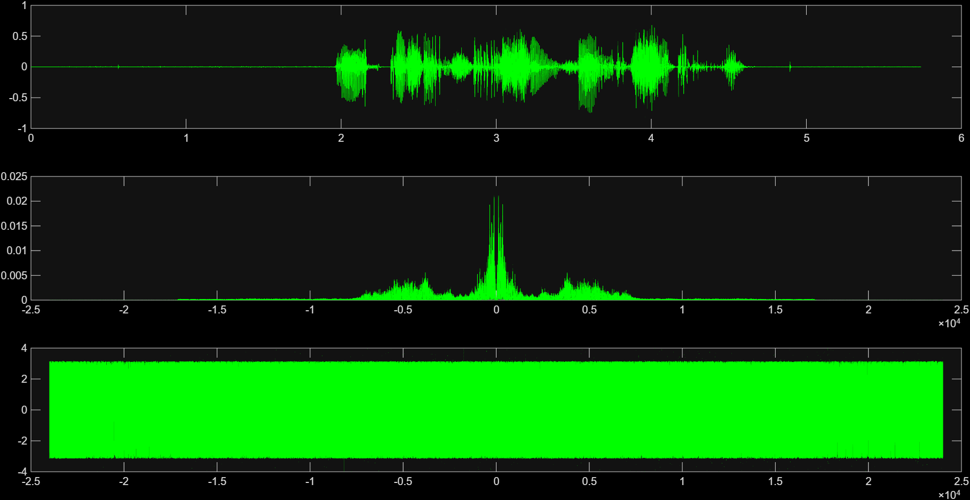

（2）请编程实现4个声音信号的调制与解调(就是把课堂上演示的调制解调程序由两个声音变成4个声音)。
要求：（a）先将每个声音进行低通滤波，截止频率为4000Hz。
（b）4个声音的载波频率分别是fc1=9000Hz，fc2=18000Hz，fc3=27000Hz, fc4=36000Hz。
（c）请调低载波频率的间距，观察声音信号之间的相互干扰现象。
修改后的程序如下：
[x1,fs] = audioread('voice1.wma');
[x2,fs] = audioread('voice2.wma');
[x3,fs] = audioread('voice3.m4a');
[x4,fs] = audioread('voice4.m4a');

%只取左声道
x1 = x1(:,1);
x2 = x2(:,1);
x3 = x3(:,1);
x4 = x4(:,1);

%统一信号的长度。
len1 = length(x1);
len2 = length(x2);
len3 = length(x3);
len4 = length(x4);

len_min=len1;
if len_min>len2
len_min=len2;end;
if len_min>len3
len_min=len3;end;
if len_min>len4
len_min=len4;end;

x1 = x1(1:len_min);
x2 = x2(1:len_min);
x3 = x3(1:len_min);
x4 = x4(1:len_min);

derta_fs = fs/length(x1);

%低通滤波（FIR滤波器），在《数字信号处理》中要专门讲滤波器设计。
fp = 4000;
N1 = 2*pi*0.9/(0.1*pi);
wc1 = 2*pi*fp/fs;
if rem(N1,2)
N1 = N1+1;
end
Window = blackman(N1+1);
b1 = fir1(N1,wc1/pi,Window);%低通滤波器，b1只有19个数，精度不算高。
figure(1);
freqz(b1,1,512);
title('低通滤波器的频率响应');
x1_low = filter(b1,1,x1);%将x1低通滤波
x2_low = filter(b1,1,x2);%将x2低通滤波
x3_low = filter(b1,1,x3);%将x3低通滤波
x4_low = filter(b1,1,x4);%将x4低通滤波

audiowrite('voice1AfterLowpassFilter.wav', x1_low, fs);
audiowrite('voice2AfterLowpassFilter.wav', x2_low, fs);
audiowrite('voice3AfterLowpassFilter.wav', x3_low, fs);
audiowrite('voice4AfterLowpassFilter.wav', x4_low, fs);%把低通滤波结果保存

%调制
x5 = zeros(1,len_min);
fc1 = 9000;
fc2 = 18000;
fc3 = 27000;
fc4 = 36000;
for i =1:length(x5)
x5(i) = x1_low(i)*cos(2*pi*fc1*(i-1)/fs)+x2_low(i)*cos(2*pi*fc2*(i-1)/fs)+x3_low(i)*cos(2*pi*fc3*(i-1)/fs)+x4_low(i)*cos(2*pi*fc4*(i-1)/fs);%两个加起来
end
audiowrite('voiceAfterModulation.wav', x5, fs);

%解调
x1_afterModulation = zeros(1,len_min);
x2_afterModulation = zeros(1,len_min);
x3_afterModulation = zeros(1,len_min);
x4_afterModulation = zeros(1,len_min);
for i =1:length(x5)
x1_afterModulation(i) = x5(i)*cos(2*pi*fc1*(i-1)/fs);
x2_afterModulation(i) = x5(i)*cos(2*pi*fc2*(i-1)/fs);
x3_afterModulation(i) = x5(i)*cos(2*pi*fc3*(i-1)/fs);
x4_afterModulation(i) = x5(i)*cos(2*pi*fc4*(i-1)/fs);
end;

x1_afterModulation = filter(b1,1,x1_afterModulation);
x2_afterModulation = filter(b1,1,x2_afterModulation);
x3_afterModulation = filter(b1,1,x3_afterModulation);
x4_afterModulation = filter(b1,1,x4_afterModulation);%低通滤波。

audiowrite('voice1AfterDemodulation.wav', x1_afterModulation, fs);
audiowrite('voice2AfterDemodulation.wav', x2_afterModulation, fs);
audiowrite('voice3AfterDemodulation.wav', x3_afterModulation, fs);
audiowrite('voice4AfterDemodulation.wav', x4_afterModulation, fs);
运行程序后输出的图像如下：
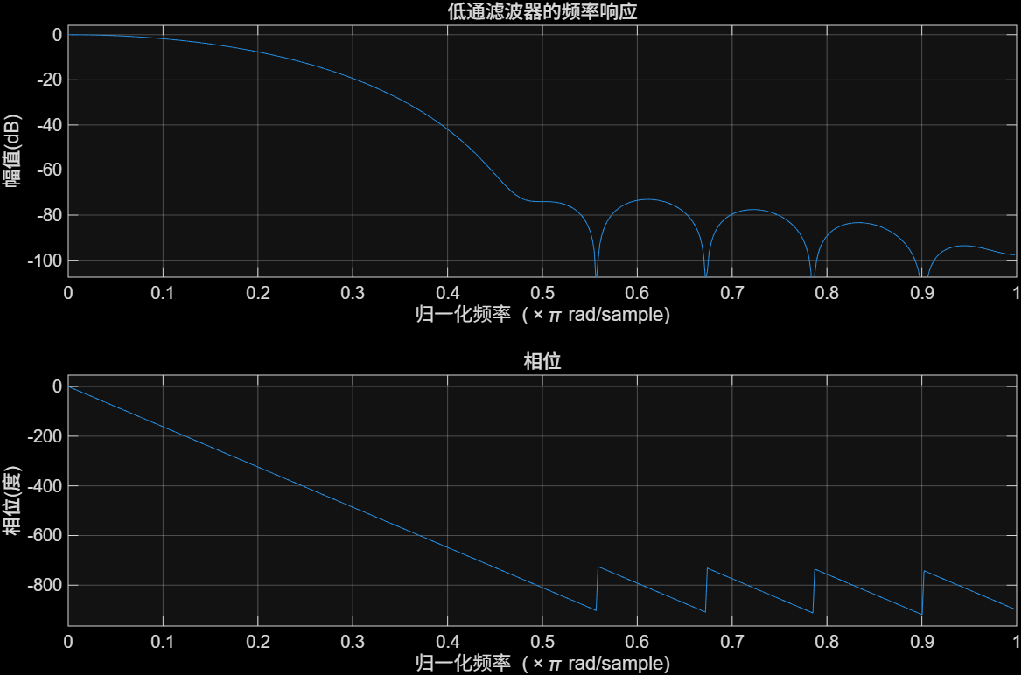
之后将载波频率调整为fc1=9000Hz，fc2=10000Hz，fc3=11000Hz, fc4=12000Hz。解调后，音频出现了明显的串音。

