Register page

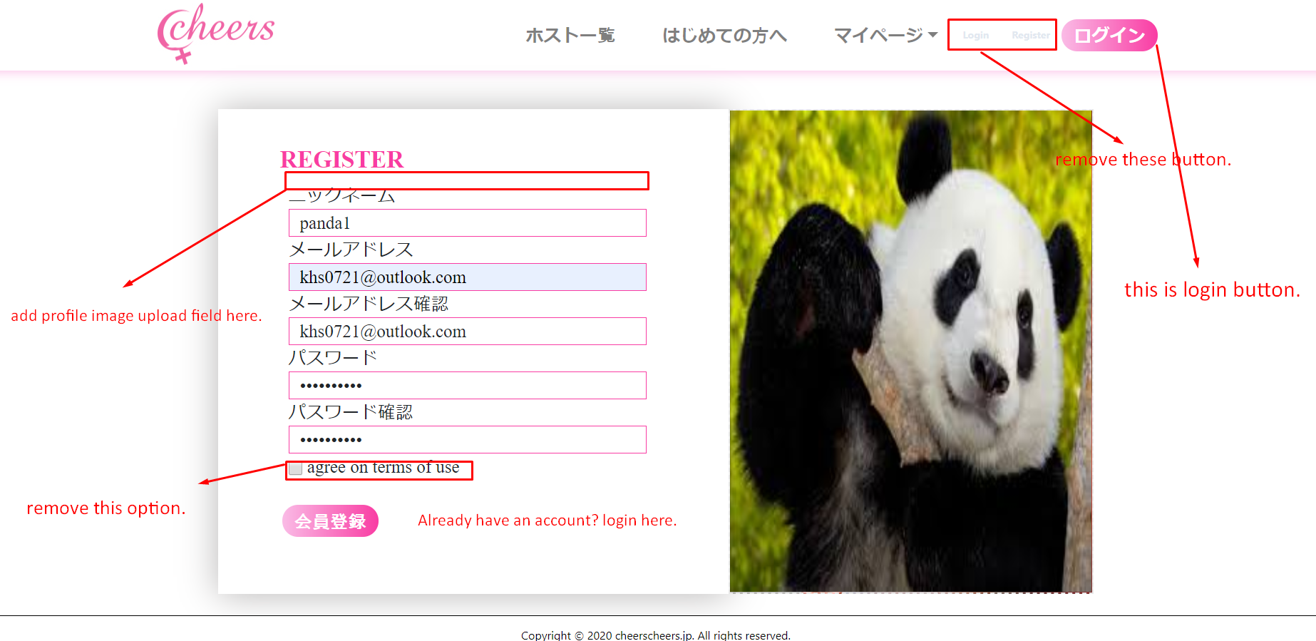

In the header, please remove login and register button because we already have login button next to it.

Place profile image upload input above nickname field.

Field name: プロフィール画像

Currently I can choose image by clicking right background image, but it is not good for UX.

Remove agree on terms of use option.

In the right of register button, please add link to login for users which already had account.

Text:

[ログインはこちら](https://supatla.com/user/login)

Email verification page

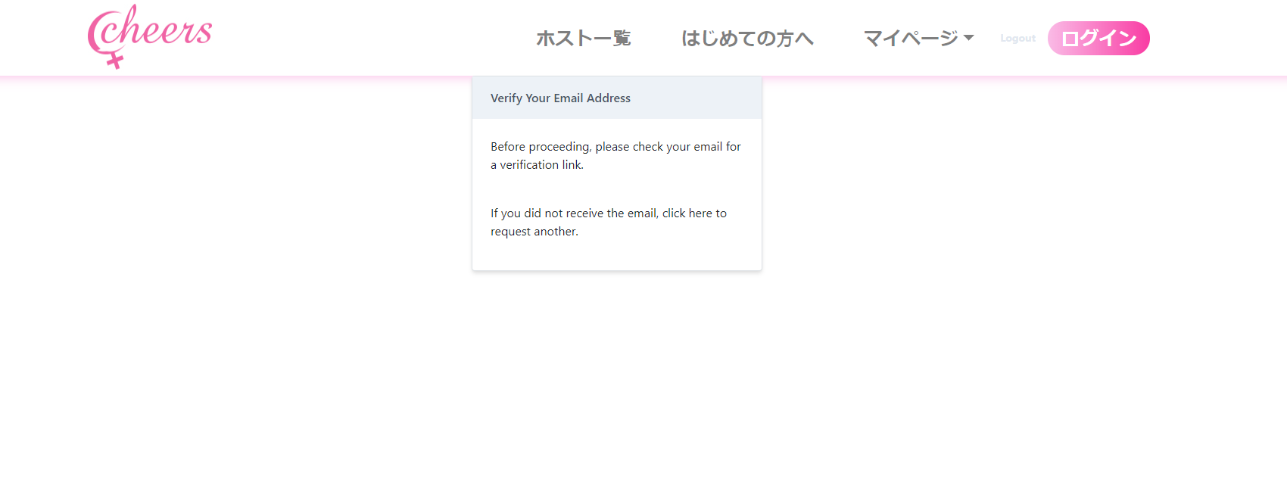

Change text:

Title: (red color and bold)

**ご登録のメールアドレスに確認メールをお送りしました**

Below title, display the email address which user registered.

And place following text:

**お届けしたメール内のURLをクリックして会員登録を続けてください**

まだ会員登録は完了しておりません

Verify email contents:

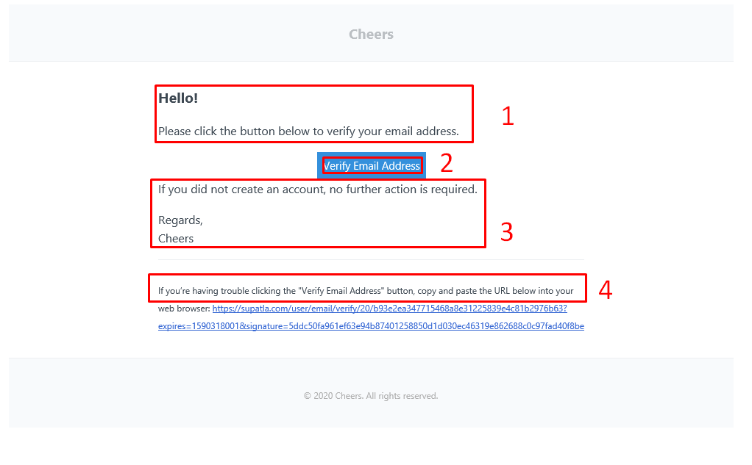

1: 下のボタンをクリックして会員登録を続けてください

2: メールアドレスを認証する

3: remove text

4: ボタンをクリックしてできない場合は、ブラウザで、以下のURLを訪問して、登録を完了して下さい。

Payment info registration page

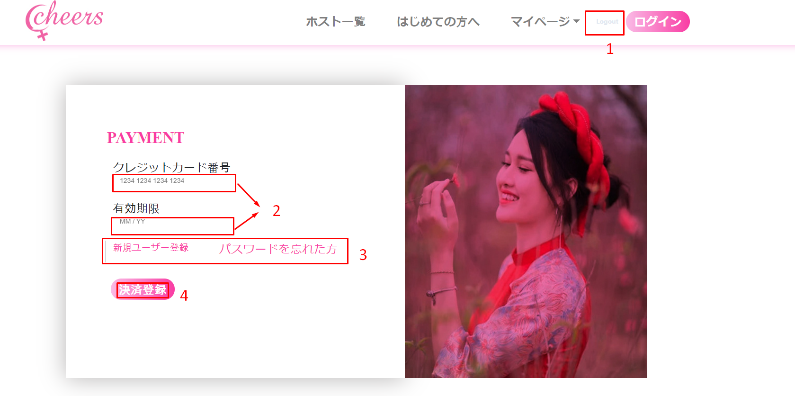

1:Change text toログアウト and move this inside my page menu.

2:Make styles same as register page input fields.

3: Remove link

4: Change text to支払い情報登録

Login page

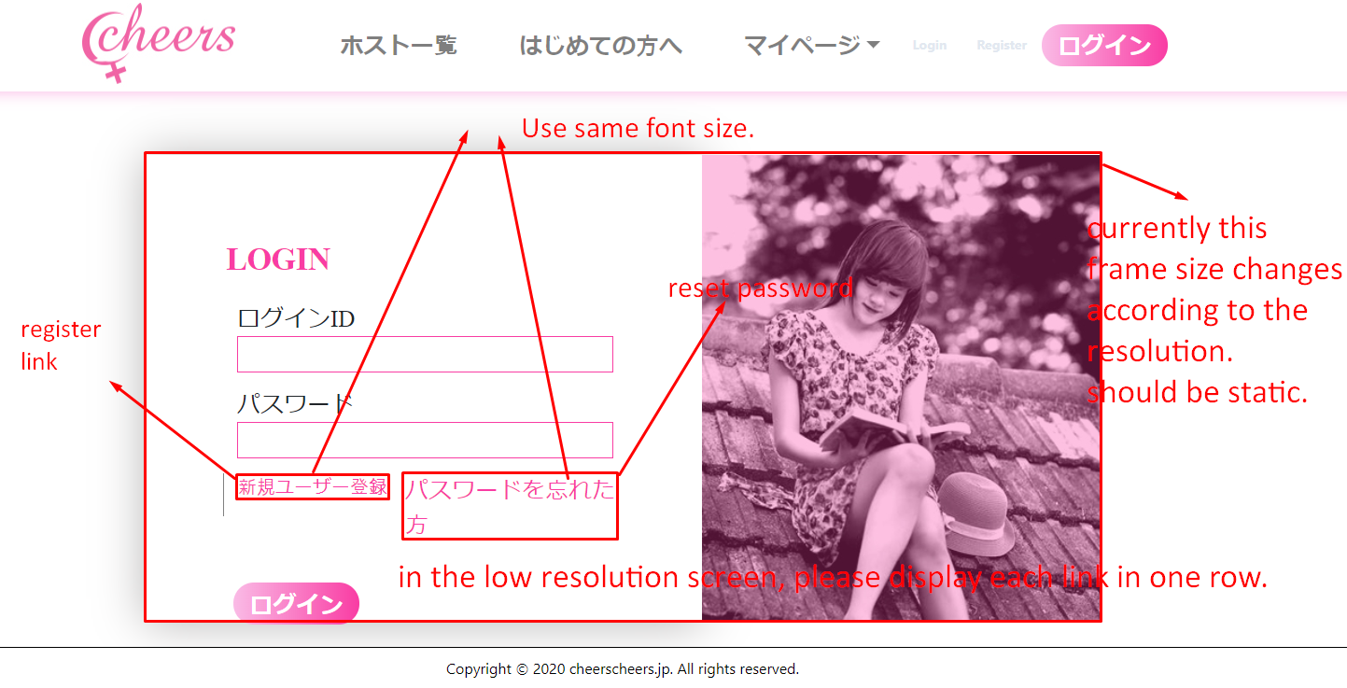

Register and reset password link are reversed.

Please translate it before you apply link.

Reset password page

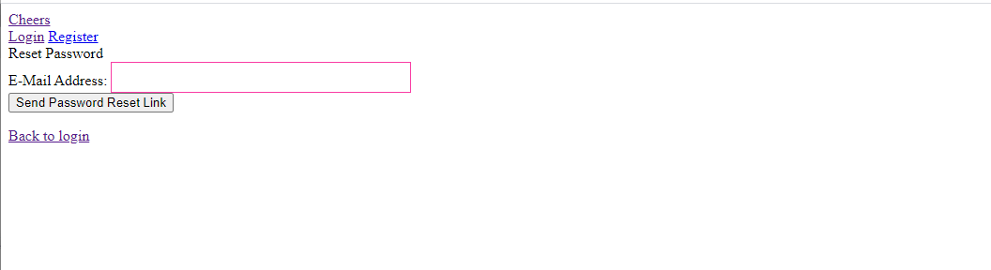

Use same layout as other pages.

Use Japanese text in all pages.

Reset password: パスワード再設定

E-Mail Address: メールアドレス

Send password Reset Link: パスワード再設定メールを送信する

Back to login: ログインページに戻る

Host menu page

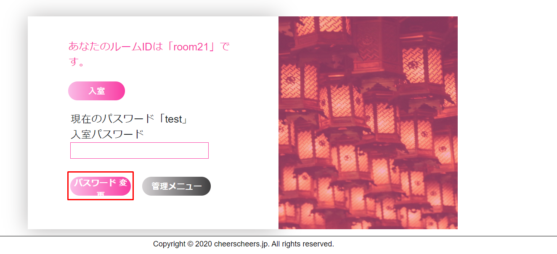

Adjust style in all resolutions.

Also currently I can enter room after enter pass in the password filed.

Actually password input is for to reset password.

Host should be able to enter room without enter password.

Mypage button is not working.

User chat screen

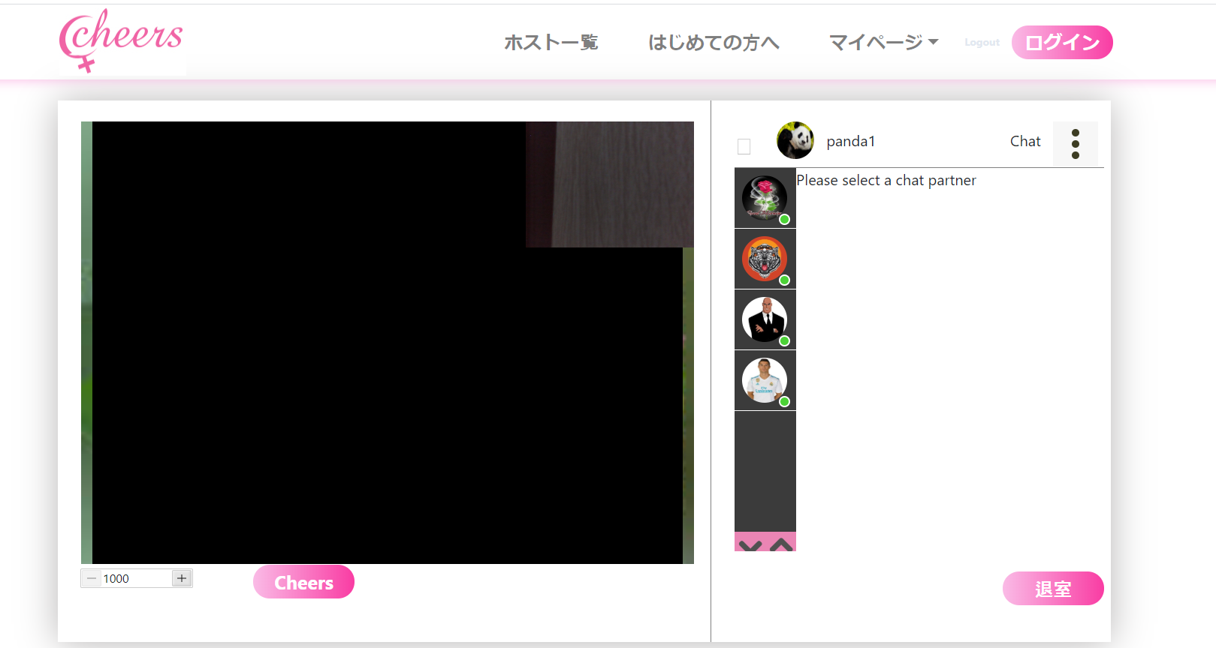

In the chat box, only display the user’s images which logged in.

Host image is not displayed on the chat box.

(I logged in with Host(host-test),but can’t see that profile image)

When user pay by clicking Cheers button, make notification as in the design.

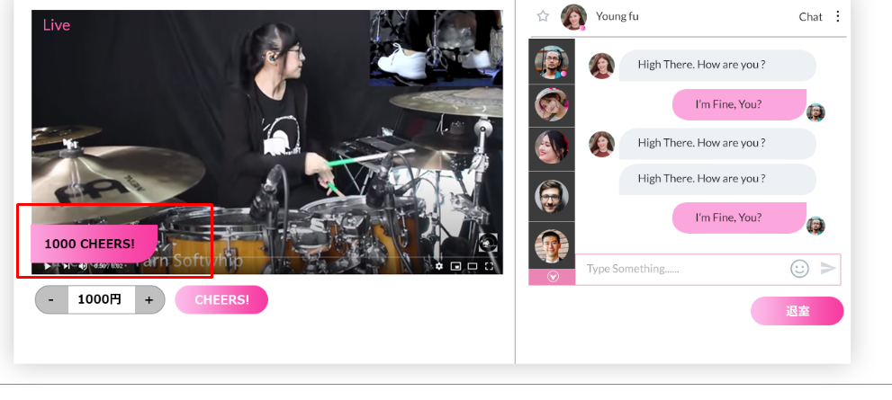

When click + or – button, should increase or decrease with 1000yen unit.

Yen symbol is missing after amount number.

Host chat screen

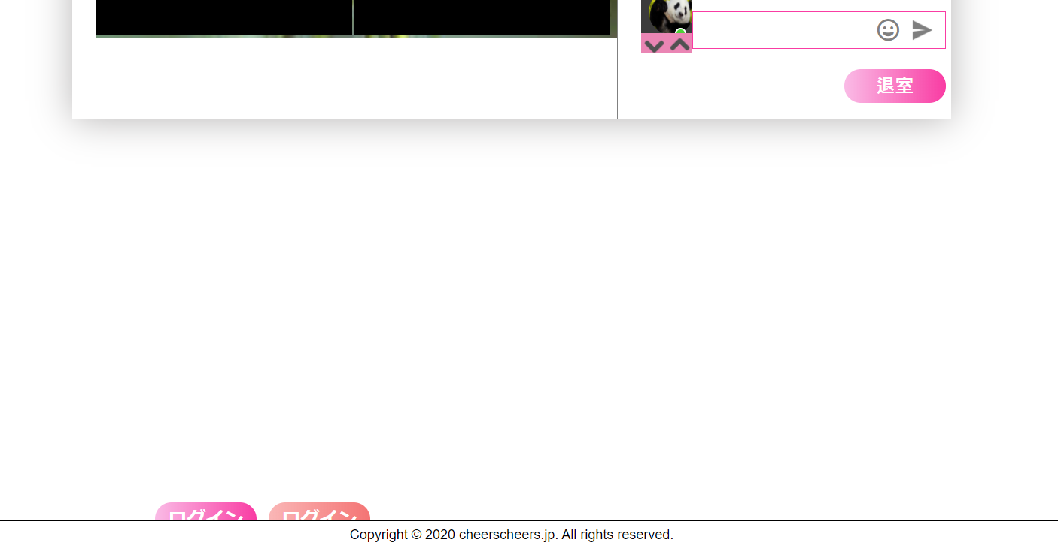

Please adjust styles.

Top page

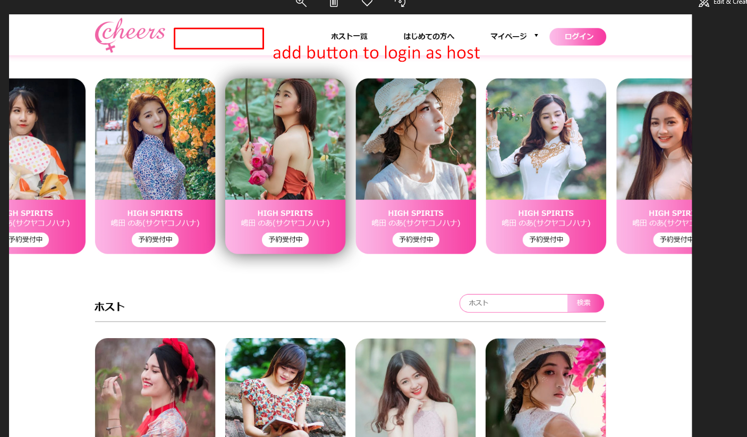

Add host login button next logo

Text: ホスト希望はこちら