The UK's Economic Outlook: A Forecast Amidst Uncertainty

The United Kingdom is a country that still shows it’s scars four years after the breakout of the COVID-19 Pandemic. However, this is not the only period of uncertainty in recent years. Since 2007, there have been quite a few such times. We are a little way down the road from the 2008 financial crisis (Hall, 2010), the 2016 Brexit referendum (Marsh et al., 2017), and the recent COVID-19 pandemic (Office for National Statistics, 2021). This report is an analysis of the UK’s Gross Domestic Product (GDP) growth and it’s forecast using a multiple linear regression (MLR) model. We explore the fiscal policy responses, potential implications, and propose effective policy alternatives to enhance economic resilience and growth.

The forecast uses several pieces of information (like year and quarter) to predict future GDP growth. MLR helps capture seasonality and long-term trends in the economy because we use data all the way back to 1955. The lower the RMSE (Root Mean Square Error) score - which is a value that represents the average difference between the actual GDP values and the predicted GDP values - the more accurate the forecast. We look ahead to 2030, giving us a glimpse of what might happen to the UK economy in the next few years. MLR models make assumptions of linearity in relationships and may not accurately capture the complexities of the UK economy, particularly during periods of significant economic shocks (Montgomery et al., 2015). Therefore, our model's RMSE of 19500.06 indicates to moderate accuracy, highlighting the inherent uncertainty in economic forecasting.

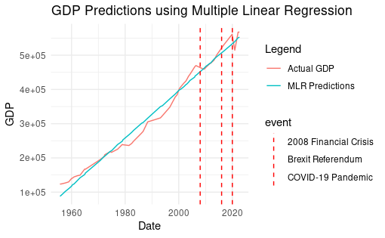

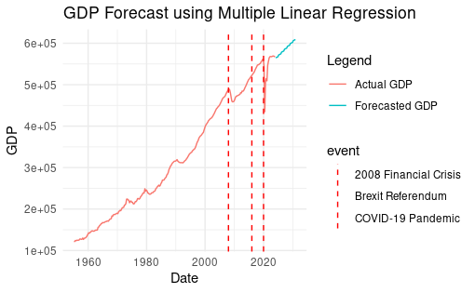

The forecast of UK’s GDP growth visualized in graph form provides a helpful talking point, but it shouldn't be taken as a definitive picture. The graph does suggest a potential for continued economic expansion within the next two years. This could be positive news for the government, businesses and consumers alike. However, for a more confident prediction, we'd need to a lot more. The UK can strive to achieve the forecasted growth as seen in the analysis and build a more resilient economy by closely monitoring economic data and adapting policies as needed.

The 2008 financial crisis led to a very severe recession in the UK, characterized by rising unemployment, a decline in output, and financial instability (Blanchard et al., 2010). The 2016 Brexit referendum brought with it the depreciation of the pound and trade disruptions (Debelle & Revillas, 2017). COVID-19 pandemic caused lockdowns, contraction in economic activity, and significant business closures (Office for National Statistics, 2021). These shocks highlight the vulnerability of the UK economy to external and internal economic forces.

The interpretation of the forecasted GDP growth trajectory based on the MLR model needs to be interpreted with cautiousness. One of the reasons for this is the current global economic climate. The war in Russia and Ukraine has caused disruptions in global trade and energy supplies (World Bank, 2022). Current supply chain delays and potential recessions in major economies such as the United States and China could negatively impact the UK's trade and investment, hence a lower GDP growth. Labor shortages and high inflation also pose huge challenges for the UK economy (ONS, 2022a, 2022b). They could hinder business activities and consumer spending. Moreover, ongoing political instability due to the development of Brexit could lessen economic investment and confidence.

The UK government's fiscal policy responses will be paramount in influencing the trajectory of the actual GDP growth. Typically, governments use fiscal policy to stimulate economic activity heading into downturns. Expansionary fiscal policy, which is a way of increasing government spending or reducing taxes is a way in which they can achieve this. However, it can lead to increased government debt levels, which might require future spending cuts or tax increases. Infrastructure, education, or renewable energy projects and increased investments in the same could boost productivity and long-term growth prospects (Blanchard et al., 2010). Tax cuts, particularly for businesses or low-income earners, could increase disposable income and consumer spending. If there’s inflation, the government might need to tighten things up (contractionary policy). This could mean spending less or raising taxes though this might slow down the economy in the short term. (Blanchard et al., 2010).

The UK government may need to look at approaches which are considered beyond traditional fiscal policy to promote sustainable economic growth. They could target specific industries that are crucial moving towards the future, such as AI, robotics, or green energy. To incentivize investment in these sectors they may be forced to provide subsidies, research and development funding or tax breaks (Mazzucato, 2013). Currently, the UK government is negotiating new deals involving trade post-Brexit. Striking such as the ones with Australia (December 2021), New Zealand (February 2022) and the Comprehensive and Progressive Agreement for Trans-Pacific Partnership (CPTPP) - July 2023 (not yet in force) are favorable trade deals with major economies that could foster economic growth, attract foreign investment, and boost exports (Baldwin, 2016).

Investing in skills training programs and even education equips the workforce with the qualifications needed to thrive in a changing economy and fosters adaptability (OECD, 2019). This can lead to innovation, increased productivity, and economic prosperity in the foreseeable future and serve the long-term objectives. Reduction of business costs is important as well. Upgrading communication, transportation, and energy infrastructure can should aim at doing this. It will improve productivity, and subsequently attract investment. Public investment in infrastructural projects aimed at stimulating economic activity and creating jobs in the short term, will eventually contribute to long-term economic growth (Aschauer, 1989).

The MLR model does offer a glimpse into the UK's future economic growth, however, it is important to understand that forecasts are but educated assumptions. As revised, domestic challenges as well as the global economic climate can significantly affect the true growth trajectory. Decision making within the UK government concerning fiscal policy and their broader economic strategies will play a crucial role in shaping the country's economic future. The UK can navigate current uncertainties and foster sustainable economic growth that benefit the country and all its citizens if they implement a combination of well-designed policies.

## References

Abraham, K.G., 2022. Big data and official statistics. Review of Income and Wealth, 68(4), pp.835-861.

Aschauer, D.A., 1989. Is public expenditure productive?. Journal of monetary economics, 23(2), pp.177-200.

Baldwin, R.E. and Giavazzi, F., 2016. How to fix Europe's monetary union: Views of leading economists.

Blanchard, O.J., Faruqee, H., Das, M., Forbes, K.J. and Tesar, L.L., 2010. The initial impact of the crisis on emerging market countries [with comments and discussion]. Brookings papers on economic activity, pp.263-323.

DeBell, M. and Iyengar, S., 2021. Campaign Contributions, Independent Expenditures, and the Appearance of Corruption: Public Opinion vs. the Supreme Court's Assumptions. Election Law Journal: Rules, Politics, and Policy, 20(3), pp.286-300.

Flynn, D., Moloney, E., Bhattarai, N., Scott, J., Breckons, M., Avery, L. and Moy, N., 2020. COVID-19 pandemic in the United Kingdom. Health Policy and Technology, 9(4), pp.673-691.

Hall, M.J., 2010. The Sub-Prime Crisis, the Credit Crunch, and Bank “Failure”: An Assessment of the UK Authorities’ Response. In Financial Institutions and Markets: The Financial Crisis—An Early Retrospective (pp. 93-125). New York: Palgrave Macmillan US.

Marsh, D., 2018. Brexit and the Politics of Truth. British Politics, 13, pp.79-89.

Mazzucato, M., 2013. Financing innovation: creative destruction vs. destructive creation. Industrial and corporate change, 22(4), pp.851-867.

Montgomery, D.C., Jennings, C.L. and Kulahci, M., 2015. Introduction to time series analysis and forecasting. John Wiley & Sons.

OECD, 2019. An OECD Learning Framework 2030. The Future of Education and Labor, pp.23-35.