How many tree species in French Guiana Tropical Moist Forest?

17 December 2021

Abstract of the article.

# 1 Introduction

# 2 Methods

Self-similarity (Harte, Kinzig, and Green 1999; Harte et al. 1999).

Estimation of the richness of an Indian forest (Krishnamani, Kumar, and Harte 2004).

## 2.1 Data

# Decrypt the vault  
library("secret") %>%  
 suppressMessages()  
name_project <- "GF-Richness"  
vault <- "vault"  
Sys.setenv(USER_KEY = usethis::proj_path(paste0(name_project,  
 ".rsa")))  
Plots <- get_secret("Plots", vault = vault)  
Abundances <- get_secret("Abundances", vault = vault)

# 3 Results

## 3.1 Plots

## 3.2 Random plot

One plot per location

# One plot per location...  
Plots %>%  
 mutate(Random = runif(n())) -> RandomizedPlots  
RandomizedPlots %>%  
 group_by(Location) %>%  
 summarize(MaxRandom = max(Random)) %>%  
 rename(Random = MaxRandom) %>%  
 inner_join(RandomizedPlots) %>%  
 select(Plot) -> SelectedPlots

## Joining, by = c("Location", "Random")

# ...or all plots SelectedPlots <- Plots['Plot']  
# Distances  
library("dbmss") %>%  
 suppressMessages()  
Plots %>%  
 inner_join(SelectedPlots) %>%  
 rename(PointName = Plot, X = X_UTM, Y = Y_UTM,  
 PointType = Location) %>%  
 mutate(PointWeight = 1) %>%  
 wmppp(unitname = c("meter", "meters")) %>%  
 pairdist() %>%  
 as.dist -> Distances

## Joining, by = "Plot"

## 3.3 Sorensen

library("ade4") %>%  
 suppressMessages()  
Abundances %>%  
 inner_join(SelectedPlots) %>%  
 select(-Plot) %>%  
 dist.binary(method = 5) -> Sorensen

## Joining, by = "Plot"

Sorensen <- 1 - Sorensen

## 3.4 Relation

tibble(Sorensen = as.numeric(log10(Sorensen)), Distance = as.numeric(log10(Distances))) %>%  
 filter(Distance > 3) -> dist_plots  
lm(Sorensen ~ Distance, data = dist_plots) -> regression  
regression %>%  
 summary()

##   
## Call:  
## lm(formula = Sorensen ~ Distance, data = dist_plots)  
##   
## Residuals:  
## Min 1Q Median 3Q Max   
## -1.02518 -0.09879 0.02880 0.15867 0.29373   
##   
## Coefficients:  
## Estimate Std. Error t value Pr(>|t|)  
## (Intercept) 0.27000 0.20849 1.295 0.197  
## Distance -0.23400 0.04088 -5.723 3.63e-08  
##   
## (Intercept)   
## Distance ***  
## ---  
## Signif. codes:   
## 0 '***' 0.001 '**' 0.01 '*' 0.05 '.' 0.1 ' ' 1  
##   
## Residual standard error: 0.1985 on 207 degrees of freedom  
## Multiple R-squared: 0.1366, Adjusted R-squared: 0.1325   
## F-statistic: 32.76 on 1 and 207 DF, p-value: 3.63e-08

(-regression$coefficients[2]/2 -> z)

## Distance   
## 0.1170003

dist_plots %>%  
 ggplot(aes(x = Distance, y = Sorensen)) + geom_point() +  
 geom_smooth(method = lm)

## `geom_smooth()` using formula 'y ~ x'

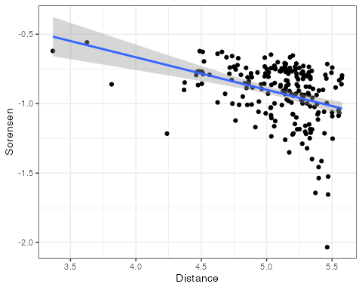

## Bootstrap

library("broom")  
estimate_z <- function() {  
 # Select one plot per location...  
 Plots %>%  
 mutate(Random = runif(n())) -> RandomizedPlots  
 RandomizedPlots %>%  
 group_by(Location) %>%  
 summarize(MaxRandom = max(Random)) %>%  
 rename(Random = MaxRandom) %>%  
 inner_join(RandomizedPlots) %>%  
 suppressMessages %>%  
 select(Plot) -> SelectedPlots  
 # Calculate distances  
 Plots %>%  
 inner_join(SelectedPlots) %>%  
 suppressMessages %>%  
 rename(PointName = Plot, X = X_UTM, Y = Y_UTM,  
 PointType = Location) %>%  
 mutate(PointWeight = 1) %>%  
 wmppp(unitname = c("meter", "meters")) %>%  
 suppressWarnings %>%  
 pairdist() %>%  
 as.dist -> Distances  
 # Calculate Sorensen divergence  
 Abundances %>%  
 inner_join(SelectedPlots) %>%  
 suppressMessages %>%  
 select(-Plot) %>%  
 dist.binary(method = 5) -> Sorensen  
 Sorensen <- 1 - Sorensen  
 # Regress  
 tibble(Sorensen = as.numeric(log10(Sorensen)),  
 Distance = as.numeric(log10(Distances))) %>%  
 dplyr::filter(Distance > 3) %>%  
 lm(Sorensen ~ Distance, data = .) %>%  
 tidy %>%  
 dplyr::filter(term == "Distance") %>%  
 select(estimate) %>%  
 pull -> z  
 z <- -z/2  
 return(z)  
}  
n_simulations <- 100  
pgb <- txtProgressBar(min = 0, max = n_simulations)  
sim_z <- rep(0, n_simulations)  
for (i in 1:n_simulations) {  
 sim_z[i] <- estimate_z()  
 setTxtProgressBar(pgb, i)  
}

## ==================================================

sim_z %>%  
 density %>%  
 plot

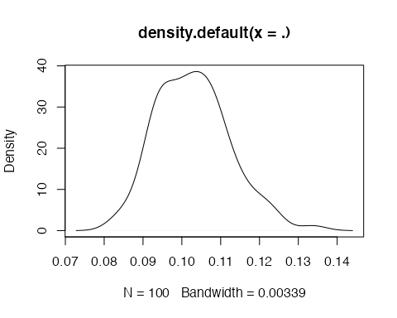

entropart::as.SimTest(mean(sim_z), sim_z) %>%  
 autoplot

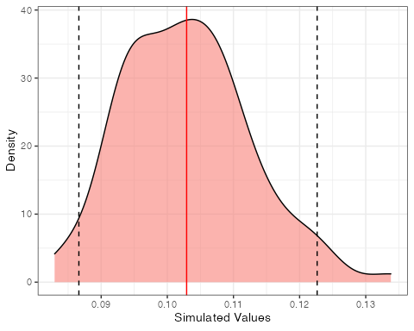

## 3.5 Extrapolation

# Extrapolation de Paracou : .625km², 604 sp >  
# c=631  
(c <- 600/0.625^z)

## Distance   
## 633.9184

# Nombre d'espèces total  
(spsim <- c * 80000^z)

## Distance   
## 2375.18

## 3.6 Fisher

# Nombre d'arbres  
Ntrees <- 8 * 10^6 * mean(colSums(Abundances[, -1]))  
# Taux de couverture par placette  
library("entropart") %>%  
 suppressMessages()  
C <- apply(Abundances[, -1], 1, function(X) Coverage(X))  
# Distribution de probabilités, corrigée par les  
# taux de couverture  
ObsProba <- C %*% as.matrix(Abundances[, -1]/rowSums(Abundances[,  
 -1]))/nrow(Abundances)  
plot(as.ProbaVector(ObsProba))

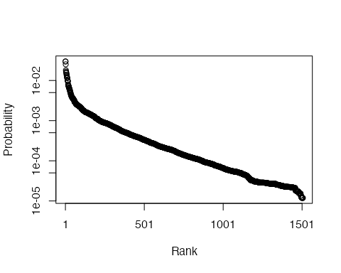

# Abondances  
EstimatedAbd <- as.AbdVector(round(ObsProba * Ntrees,  
 0))  
# 50% centraux  
EA50 <- as.AbdVector(sort(EstimatedAbd, decreasing = T)[round(length(EstimatedAbd)/4):round(length(EstimatedAbd) *  
 3/4)])  
x <- 1:length(EA50)  
y <- as.numeric(log(EA50))  
# Régression rang-abondance sur la partie  
# rectiligne de la courbe  
EA50lm <- lm(y ~ x)  
# Nombre d'espèces extrapolé  
NbSpecies <- round(-EA50lm$coefficients[1]/EA50lm$coefficients[2]) +  
 round(length(EstimatedAbd)/4) - 1  
# Régression de la partie rectiligne  
plot(y ~ x, ylim = c(0, max(y)))  
summary(EA50lm)

##   
## Call:  
## lm(formula = y ~ x)  
##   
## Residuals:  
## Min 1Q Median 3Q Max   
## -0.050607 -0.026011 -0.004327 0.017631 0.084264   
##   
## Coefficients:  
## Estimate Std. Error t value  
## (Intercept) 1.147e+01 2.303e-03 4981.6  
## x -3.208e-03 5.278e-06 -607.8  
## Pr(>|t|)   
## (Intercept) <2e-16 ***  
## x <2e-16 ***  
## ---  
## Signif. codes:   
## 0 '***' 0.001 '**' 0.01 '*' 0.05 '.' 0.1 ' ' 1  
##   
## Residual standard error: 0.03161 on 753 degrees of freedom  
## Multiple R-squared: 0.998, Adjusted R-squared: 0.998   
## F-statistic: 3.694e+05 on 1 and 753 DF, p-value: < 2.2e-16

abline(a = EA50lm$coefficients[1], b = EA50lm$coefficients[2],  
 col = "red")

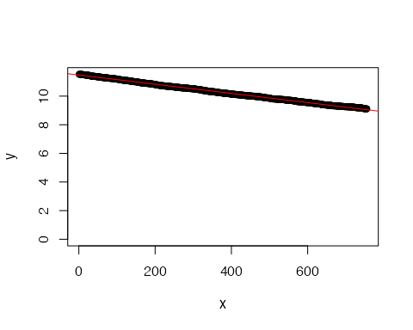

# Metacommunauté complète: partie observée  
EA75 <- sort(EstimatedAbd, decreasing = T)[1:round(length(EstimatedAbd) *  
 3/4)]  
plot(EstimatedAbd, ylim = c(1, max(EA75)), xlim = c(0,  
 NbSpecies), col = "grey")  
points(EA75, ylim = c(1, max(EA75)), xlim = c(0, -EA50lm$coefficients[1]/EA50lm$coefficients[2]))  
Extra <- exp(EA50lm$coefficients[1]) * cumprod(rep(exp(EA50lm$coefficients[2]),  
 NbSpecies - round(length(EstimatedAbd)/4) + 1))  
lines(x = round(length(EstimatedAbd)/4):NbSpecies,  
 y = Extra, col = "red")

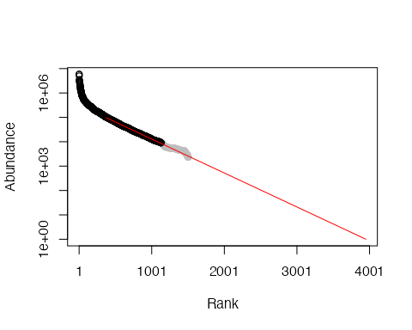

# Vérification : effectif total  
(Ntotal <- sum(EA75) + sum(Extra[(length(EA75) - NbSpecies +  
 length(Extra) + 1):length(Extra)]))

## [1] 197186462

# Ajustement d'une log-série  
plot(as.AbdVector(round(c(EA75, Extra[(length(EA75) -  
 NbSpecies + length(Extra) + 1):length(Extra)]))),  
 Distribution = "lseries")

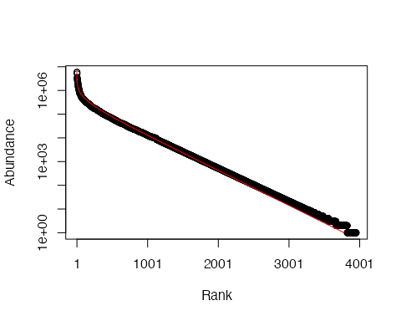

## $alpha  
## [1] 294.5374

# Nombre d'espèces estimées  
NbSpecies

## (Intercept)   
## 3951

## 3.7 Hyperdominance

# Hyperdominance  
EstimatedAbd <- sort(round(ObsProba * Ntrees, 0), decreasing = TRUE)  
plot(cumsum(EstimatedAbd), ylim = c(0, Ntrees))  
abline(h = Ntrees/2, lty = 2, col = "red")  
hdSpecies <- min(which(cumsum(EstimatedAbd) > Ntrees/2))  
abline(v = hdSpecies, lty = 2, col = "red")

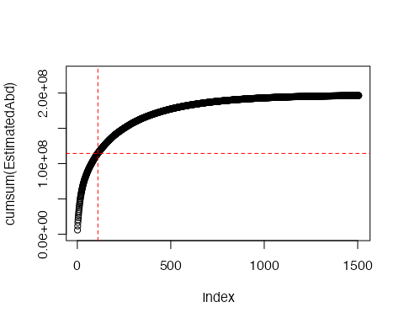

# References

Harte, John, Ann Kinzig, and Jessica Green. 1999. “Self-Similarity in the Distribution and Abundance of Species.” *Science* 284 (5412): 334–36. <https://doi.org/10.1126/science.284.5412.334>.

Harte, John, Sarah Mccarthy, Kevin Taylor, Ann Kinzig, and Marc L. Fischer. 1999. “Estimating Species-Area Relationships from Scale Plot to Landscape Data Using Species Spatial-Turnover.” *Oikos* 86 (1): 45–54. <https://doi.org/10.2307/3546568>.

Krishnamani, R., A. Kumar, and John Harte. 2004. “Estimating Species Richness at Large Spatial Scales Using Data from Small Discrete Plots.” *Ecography* 27 (5): 637–42. <https://doi.org/10.1111/j.0906-7590.2004.03790.x>.