Group 2

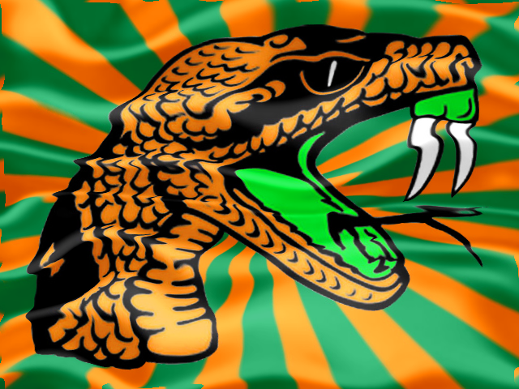

Diamond Beaton

Reginald Davis

Eric Mayberry

Chris Rivers

The website that group two has chosen to complete for the website project is an information hub for the Florida Agricultural and Mechanical University Rattler’s football team. This site, named “FAMU Rattler’s Football”, will provide a wide range of information about the team and the rattler community. The site will have pages for the team roster, coaches profiles, schedules, scores, photos, videos, social media links, along with the index page.

The logo that we chose is the Florida Agricultural and Mechanical University Rattler’s rattler logo with some personalized adjustments to fit the look of the website. We will be taking the classic rattler head, place it on an orange and green background, and with the help of Photoshop, transform this image into a flag waving in the wind.

The goal of the website is to inform the Rattler Nation with all available information regarding the Rattler’s football team. We chose this topic so we can design a website that delivers pertinent information to Rattler fans across the country.

We will be taking advantage of the upcoming football season in order to gain a readership for those looking for any information about the Rattler’s football team.

Some similar sites that we are using as a guide for our site are FAMU’s official athletic website, located at <http://www.famuathletics.com/>, Florida State University’s athletic site, located at <http://www.seminoles.com/>, and University of Florida’s athletic site, located at <http://www.gatorzone.com/>. We will be using these sites in order to determine what information and media is important for us to include.