Manuel
Preface: this is still in development and there are a lot of features I have in it that don’t operate yet due to me breaking the logic trying to implement a small SQL database into this.
To use the NPR switchblade there 4 input files.
- K:\_Products\Component Numbering System\Extracts ITEMS.xlsx
- K:\_Products\MiSys Product Listing REFRESH DATA ON OPENING FILE MiSysItemListConnected.xlsx
- K:\_Products\Component Numbering System Component Numbering System.xls
- A BOM or list of parts with the at least these two headers:
  - manufacturer_part_number
  - description
(Its set up that you can have any header under any of the alias’s that are set up in the data_loader.py file under the DEFAULT_NPR_ALIASES dictionary at the top of the file)
Grab a copy of these files and place them into the “input” folder in the root, not to get confused with the “input_data” folder in NPR_TOOL. Rename the component numbering system as “components.xlsx”. I call the items.xlsx ERPinventory and I call the alternates extract (Misysitemlistconnectes.xlsx) the master inventory. You don’t need to rename those, just have them exist.
After setting up your environment, run : python -m NPR_TOOL.main
It may take a minute or two to load. I have it set up to scrape through the component numbering system on start up.

You should see this UI follow up:

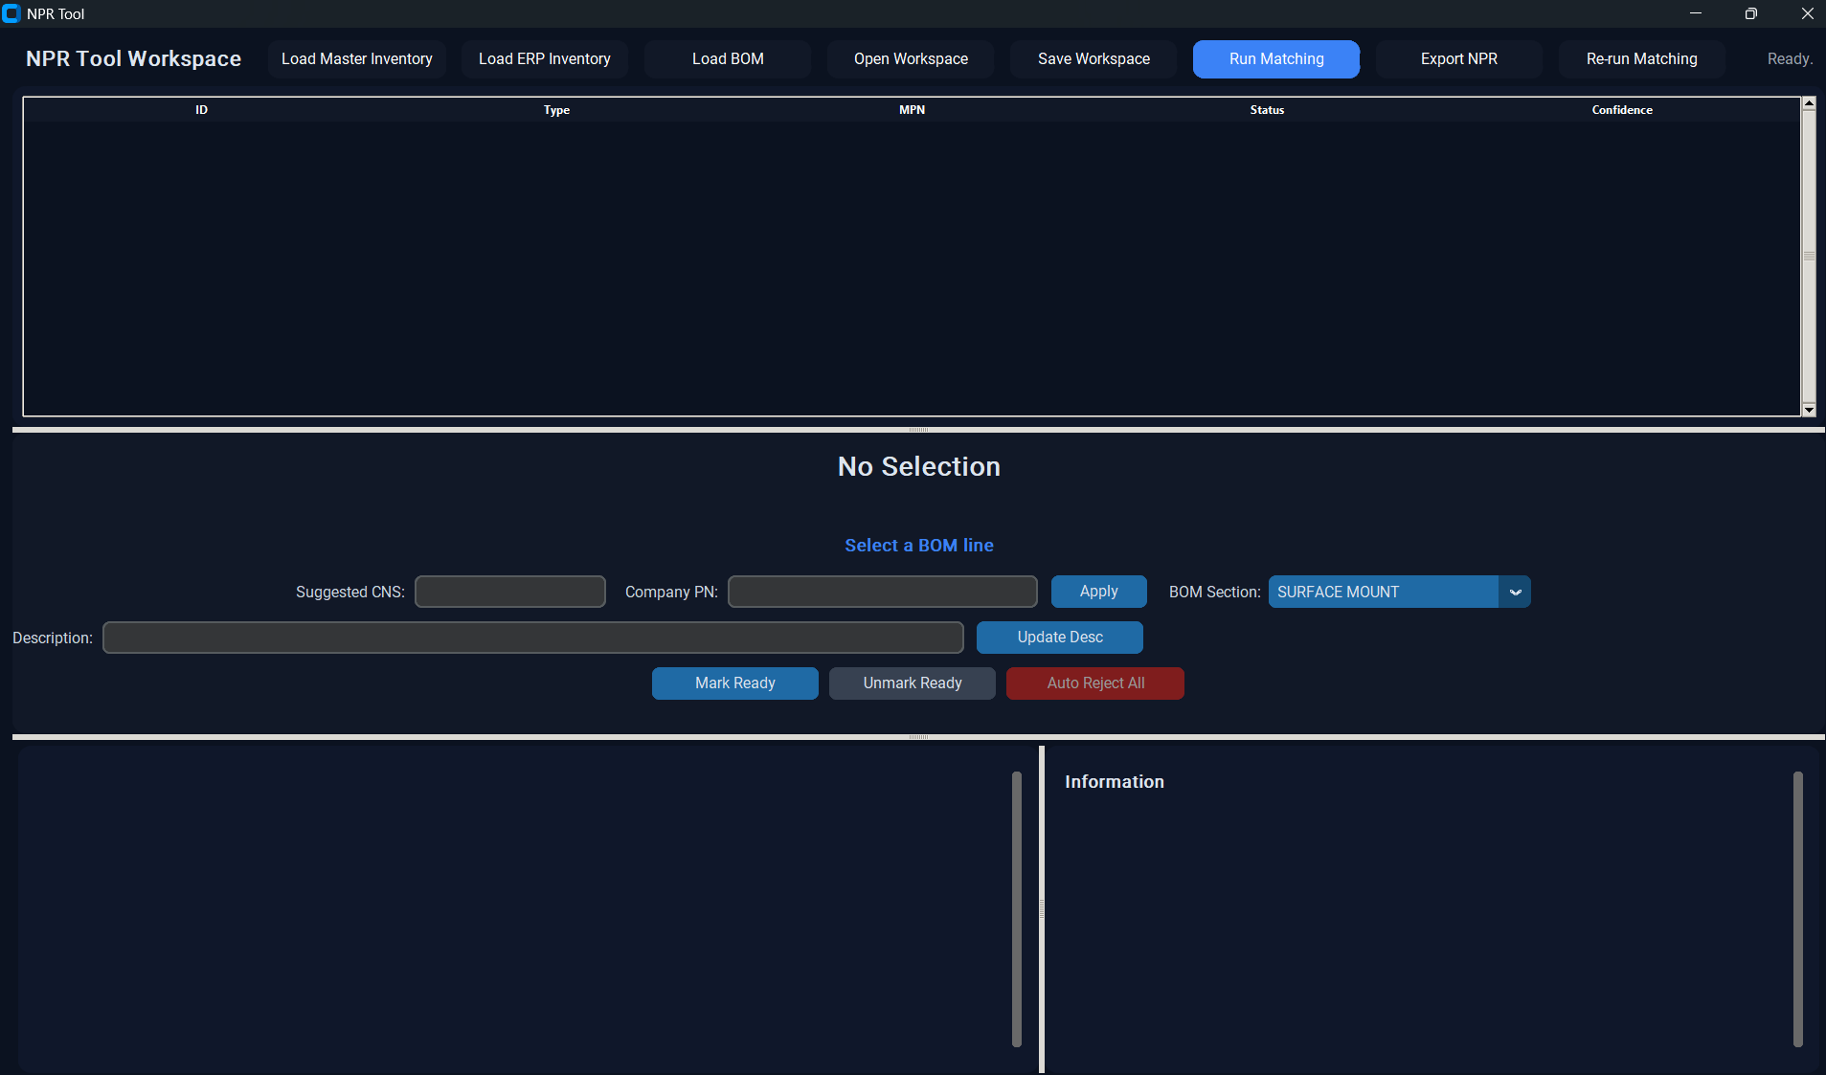

Click the button called load master inventory, then select the alternates inventory xlsx extract. Then click load ERP inventory. Then select the items xlsx extract. Click the load BOM button, then load your list of parts. Ignore open workspace and save workspace buttons for now. Click the light blue RUN MATCHING button. You will see in your terminal the matching loading. It may take a few moments. For it to fully load, because it is rerunning the AI across the descriptions on any of the non fully matched manufacturing part numbers. Your BOM list will appear in the top scrollable panel.

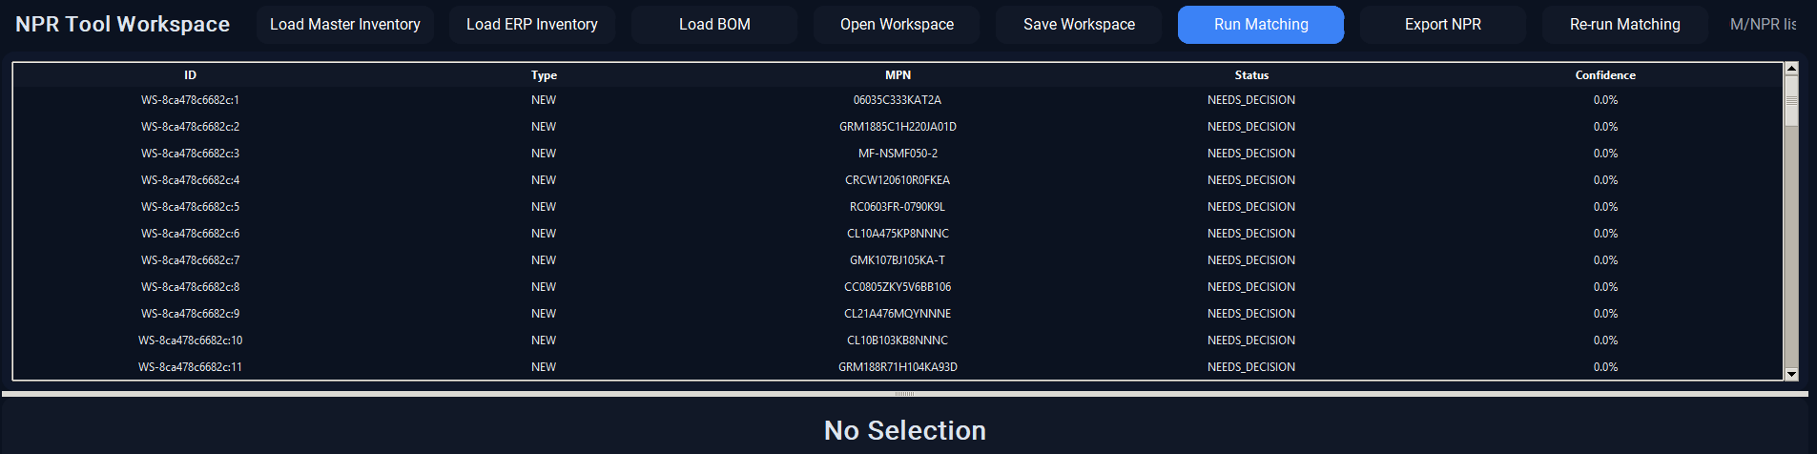

Click any of the BOM items.
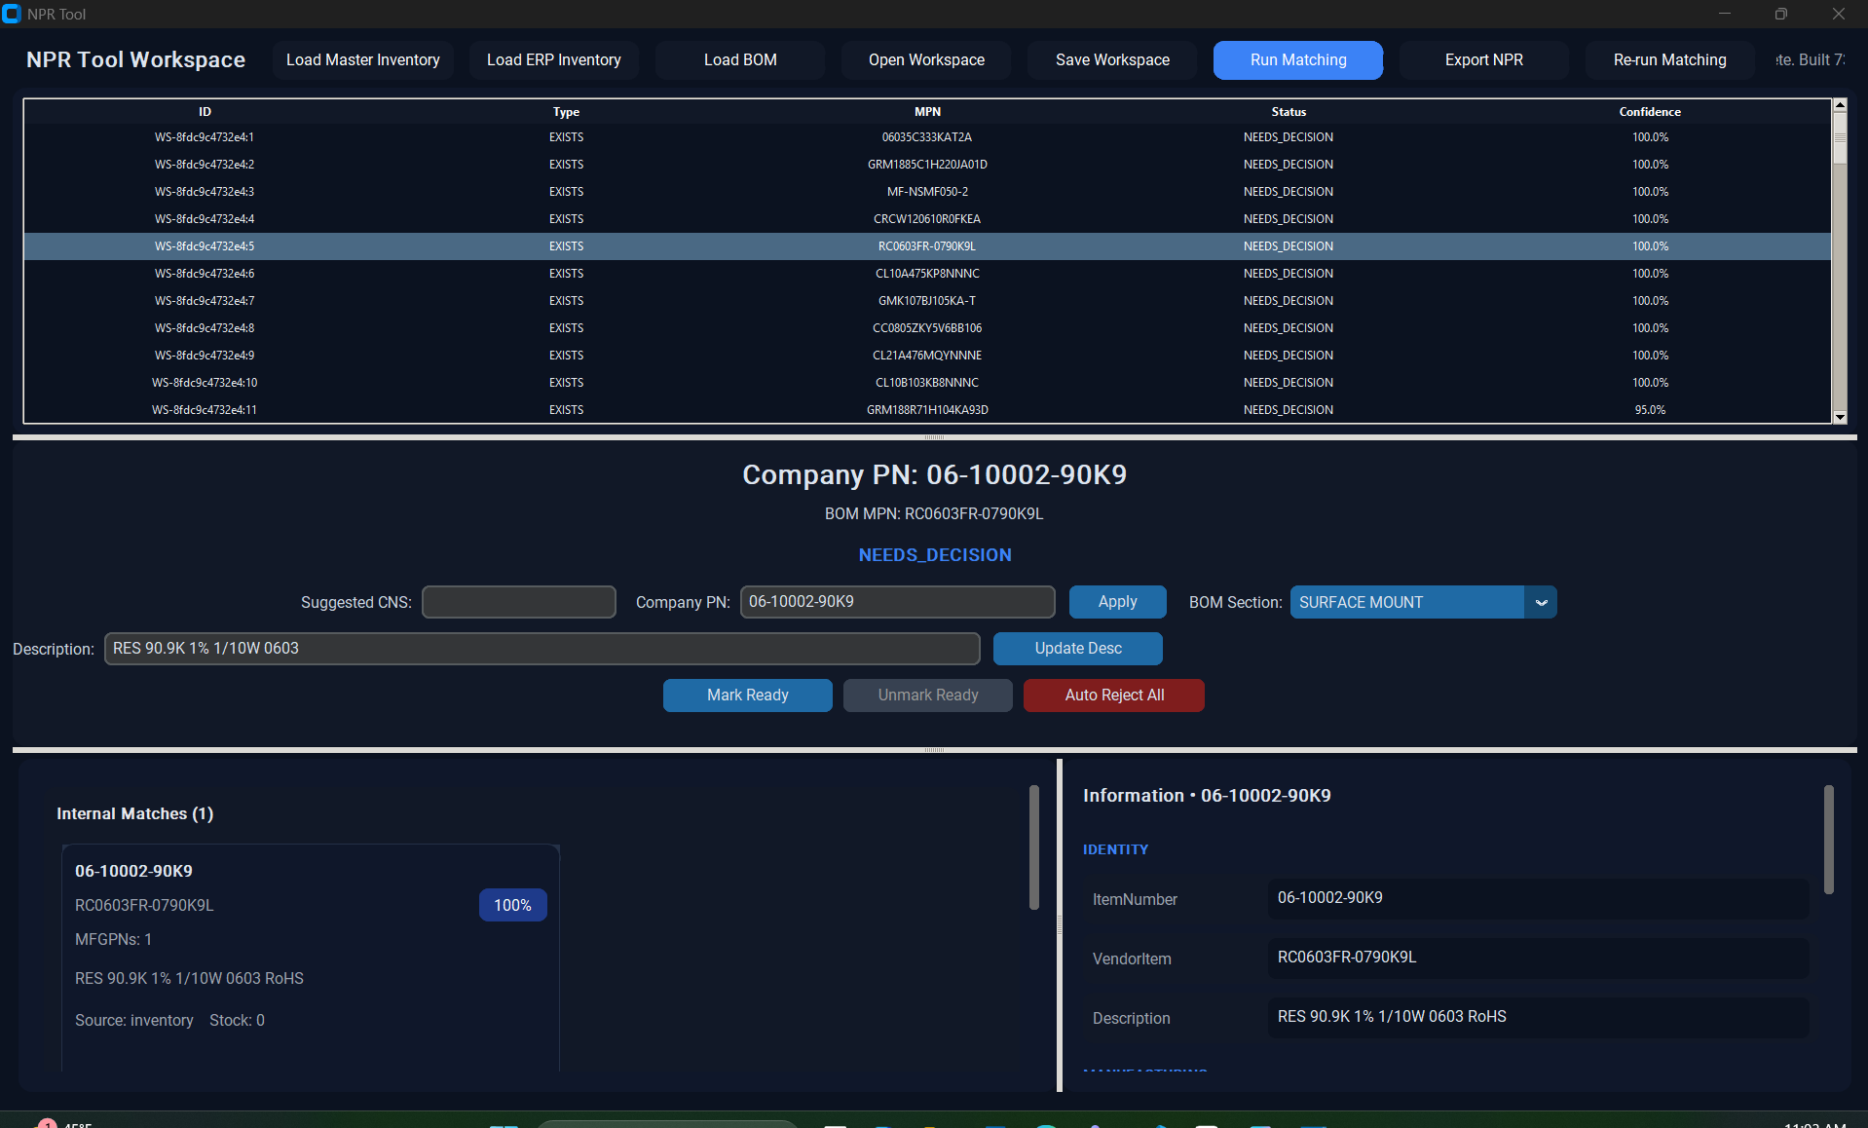

In the bottom left Panel, you will see a card. The card represents a company part number. Scroll down the panel to accept or reject this company part number for your matched BOM part. In the right panel, you will see all the information regarding this part number from the two extracts. Scroll down this panel to see the alternates under the company part number. You can select any of the alternates for an export or display their information in the panel instead (still super buggy).

After clicking add to the card, ignore the other cards. You can edit the company part number. The description editing is currently not implemented in the code yet; it just exists as a UI element right now so you can ignore that. Click apply to your company part number and then click Mark ready. You can select the component type from the drop down (not down to the right). The suggested CNS field is currently broken; I’m trying to get it work with the sql database I have this running program running off so you can also ignore that as well. You will see the part highlighted in the top panel.
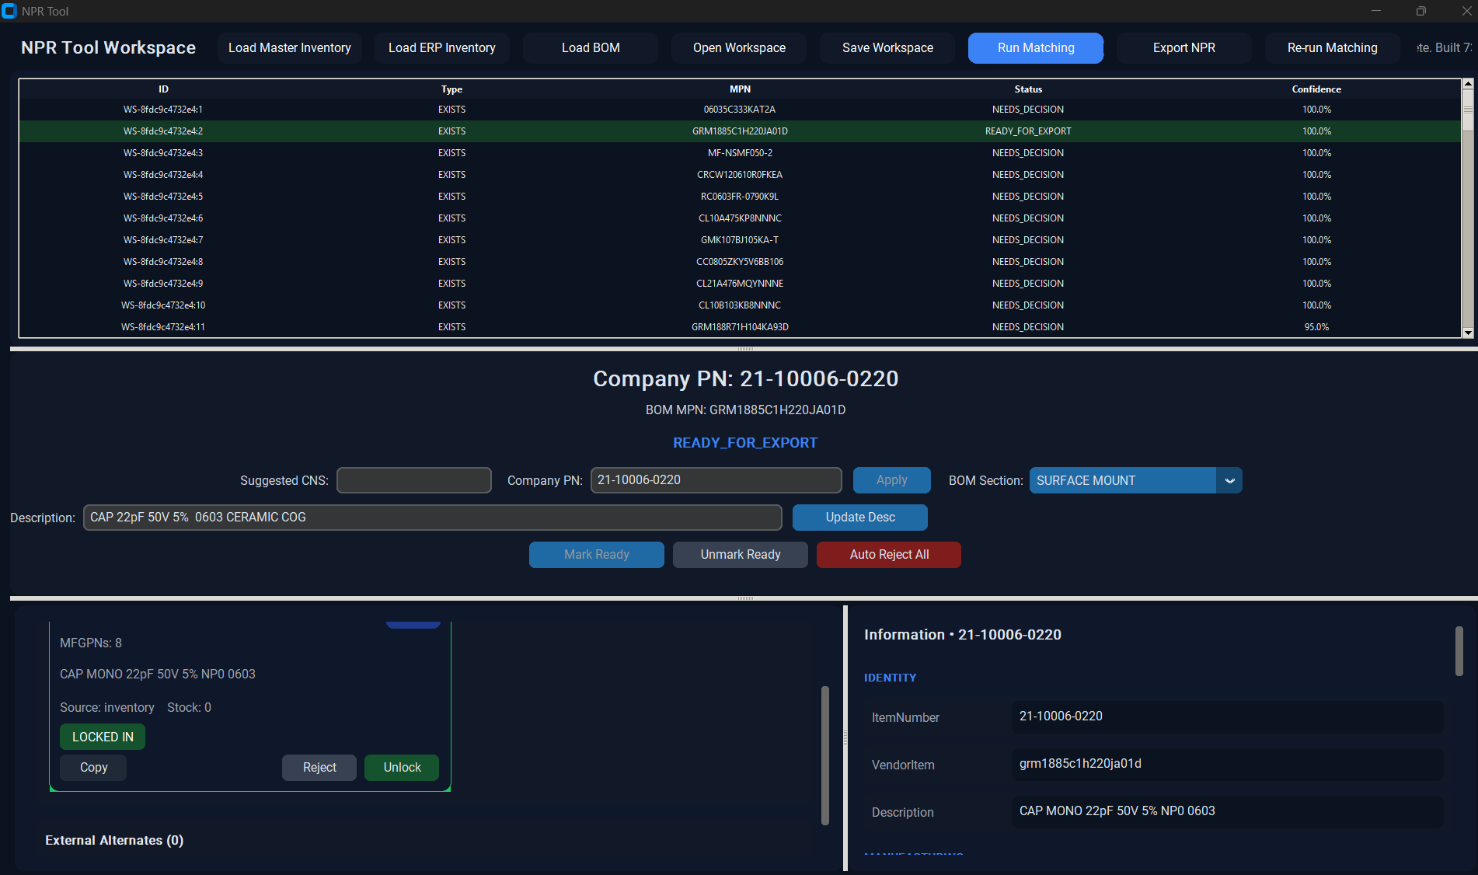

Do this with every part you have, and then click export NPR, name your output file, then save. All of the choices you made should be loaded into the file. The file will have 3 sheets, the NPR sheet, an alternates need approval sheet, and a BOM sheet with all of the choices you made It will prompt you to include any items that have 3 or more alternates to keep in your npr export. You can say yes to all of them, or no, either way all your choices will still be saved into the BOM sheet of the excel file. The BOM excel sheet is unformatted right now, so it wont be formatted per the ELAN BOM file, and will just be a list ( I was working on this the other day to fix exporting logic). One thing I’m working on is the description logic, you will notice the description of the item saved in the BOM sheet will be your BOM description and not the description from inventory, even if it was a full match. I broke the logic trying to implement that description UI changer that makes that happen. So you will have to manually copy and past those description yourself in this test version.
That’s the entire functionality of this so far. It functionally works but still requires a lot of fiddling with.

