# EE6227: Programming Assignment 2

**Wei Zhifeng G2002825F**

## Algorithm Description and Implement

1. **Random Forests**

Random Forest is a kind of ensemble classifier, it contains n decision trees that trained either independently or sequentially. And its output is gained by weighting votes from all these decision trees.

The main idea of training a random forest is to perturb the training dataset and inject some randomness in each decision tree, aggregate them in a suitable way to gain a better output.

The first step of training a random forest is to generate different training data sets. We use bagging method to extract data from training data. In other words, we sample from the original training data with replacement, if we want to train n trees, we perform n times bagging to obtain n different data sets.

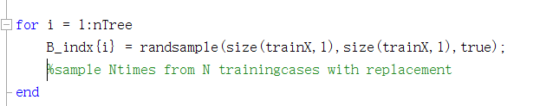

After having n data sets, we begin to train n decision tree with corresponding dataset. In each trees, we randomly choose mtry features to split the data in each node. Normally, mtry is the square root of total features.

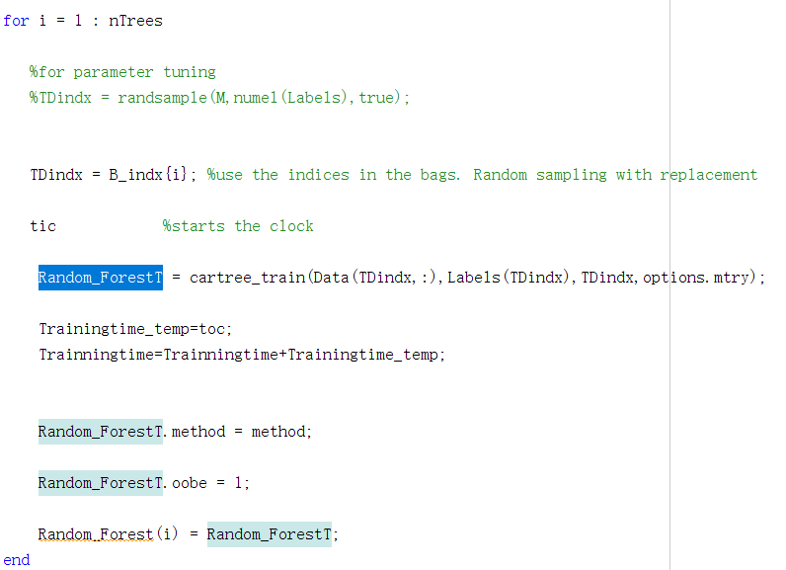

When the node is not a pure node, we randomly pick mtry features as criterion to split the data at this node. And we use axis_parallel_cut method to split the data. Every time, we use one feature to split the data and calculate its gini_impurity. Comparing these gini_impurity, we pick the maximum one to split the data and build two child nodes.

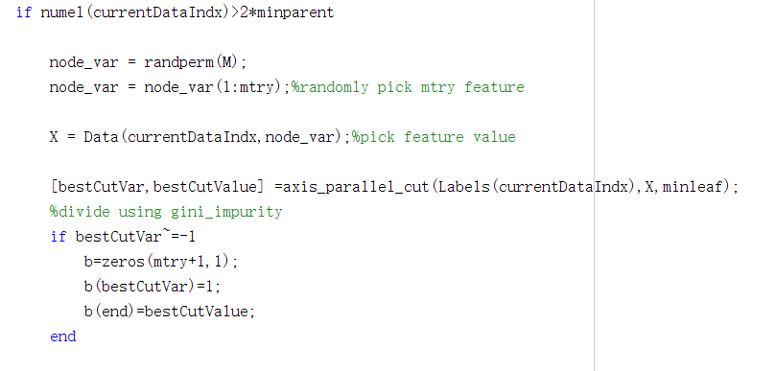

When all the nodes are a pure node, we have complete the training of a decision tree. And we repeat the preceding procedure to train n decision trees and aggregate them together to form a random forest.

If we want to use the random forest to predict, just input the data to every decision tree and select the label that appear most time in these trees.

1. **Random Vector Functional Link(RVFL)**

Random Vector Functional Link is a special neural network, whose weight in hidden layer nodes are appropriately and randomly generated and keep fixed during the training procedure. Its input layer nodes are also connected to output layer nodes directly. The structure is shown as the picture below.

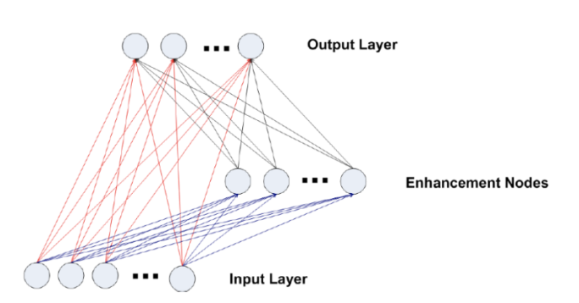

In the hidden layer nodes(enhancement nodes), the feature is computed as the formula below

$$h\left(x\right)=g\left(wx+b\right)$$

g denotes a non-linear activate function, and w is the fixed weight we randomly defined previously. b is the bias for the enhancement layer.

In the output layer, the input features are concatenated with the output of hidden layer to improve the performance. The formula is shown below

$$f\left(x\right)=β∗d$$

d denotes the combined features and $β$ denotes the weight in output layers.

The d is shown as the picture shown below.

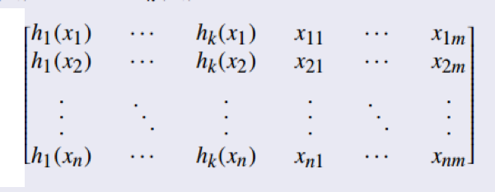

Therefore, to optimize this network, we should solve the following problem

$$\min_{β}\left\|β∗d−Y\right\|+{γ∗\left\|β\right\|}^{2}$$

Matric d represents the combined features; matric Y represents the expected output; $γ$ is the regularization parameter.

The solution of the above problem can be summarized as below:

* In the prime space(if the number of training samples is larger than total feature):
$$β={(γI+d^{T}d)}^{−1}d^{T}Y$$

* In the dual space(if the number of training samples is larger than total feature):

$$β=d^{T}{(γI+d^{T}d)}^{−1}Y$$

The following matlab code realizes the procedure of training a RVFL network.

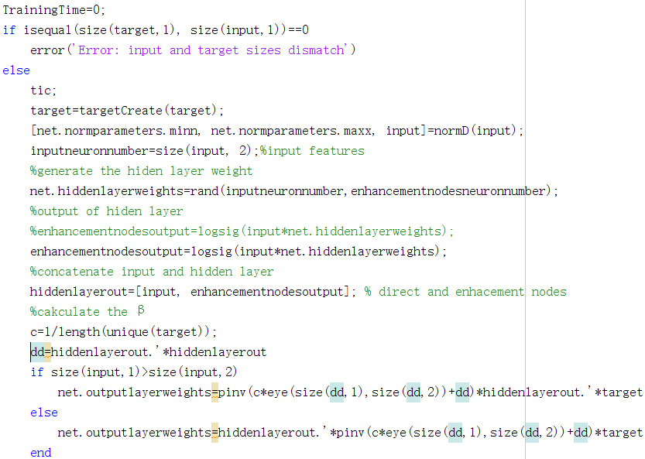

## Parameters Description and Tuning

1. **Random Forests**

In Random Forests algorithm, there are two important parameters for tuning. One is the ntree, which denotes the number of trees in a forest; the other one is mtry. Mtry is the number of features randomly chosen to split in each non-leaf node, a suitable mtry could raise the final accuracy.

The range of mtry is from 1 to the total features that a input variable has. In our tuning experiments, we run exhaustive trial to test these mtry to find a suitable mtry for this dataset.

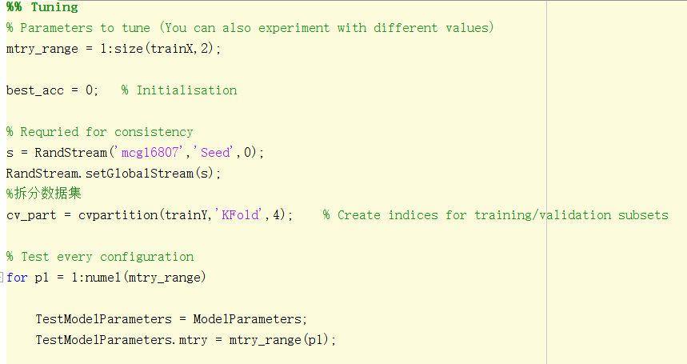

In the previous code, we try every mtry to test its performance, and use the best one to train our random forest.

Because we don’t have enough training data, and in order not to over fit these training data. We use k-fold algorithm to tuning this parameter to tune mtry.

We divided the training data to 4 parts. Each time ,we take 1 part as validation data,other 3 parts as training data. Average these four times validation accuracy as the final training accuracy to find the better mtry.

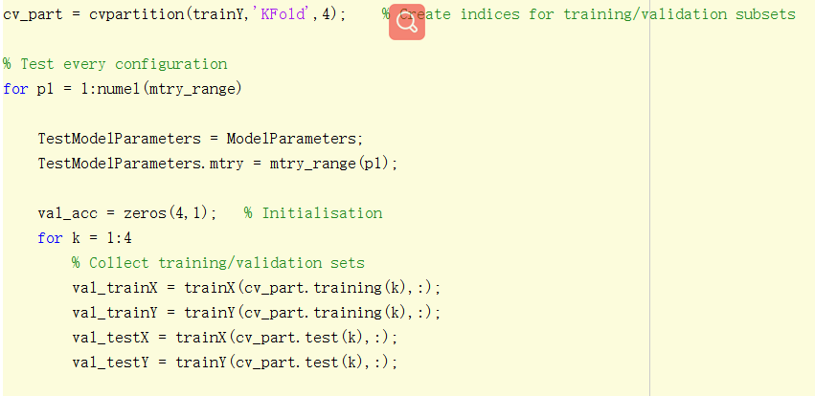

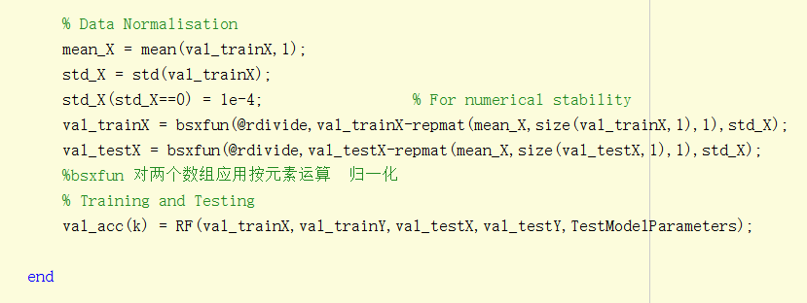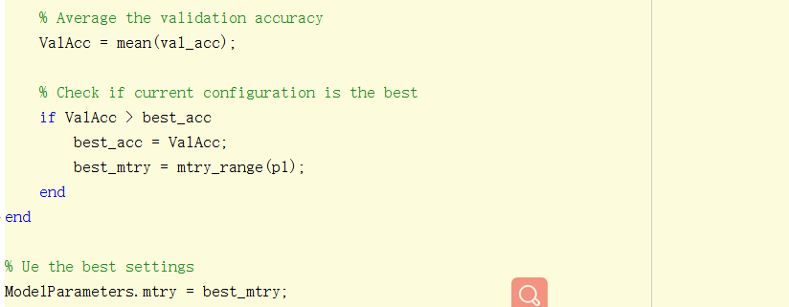

The tuning code is shown as above pictures.

We run this algorithm in 2 datasets, and the result in shown as follow table.

|  |  |  |  |  |
| --- | --- | --- | --- | --- |
| **Dataset** | **Best_mtry** | **Feature_num** | **Val_acc** | **Test acc** |
| **cardiotocography-3clases** | **17** | **21** | **0.934705882352941** | **0.953051643192488** |
| **image-segmentation** | **8** | **18** | **0.968073593073593** | **0.976190476190476** |

According to this result,we could find that this method has a good performance, therefore, we use this method in the following experiments.

Ntree is another important parameter in random forest, too many trees require too much calculation time while less tree could not show the advantage of random forest. What’s more, using more trees can prevent the overfitting in some way. But when the number of trees exceed a certain number, it might not improve the accuracy so much

We use the the k-fold method and set ntree range from 1 to 500 to find the best ntree parameter in a dataset, the result is shown as below

|  |  |  |  |
| --- | --- | --- | --- |
| **Dataset** | **Best_ntree** | **Val_acc** | **Test acc** |
| **cardiotocography-3clases** | **453** | **0.945823655324891** | **0.965304313198484** |
| **image-segmentation** | **492** | **0.97807359023483** | **0.979047196509476** |

1. **Random Vector Functional Link(RVFL)**

RVFL is a simple neural network, which has few parameter to tune.

$γ$ is the regularization parameter,when $γ$ is zero, the solution becomes the Moore-Penrose pseudoinverse. When $γ$ is not zero, it is the Ridge Regression.

In order test the effect that $γ$ has on the performance of RVFL, we test these two situation in 8 datasets using k-fold algorithm, as the following table show:

|  |  |  |  |
| --- | --- | --- | --- |
| **Dataset** | **Test_acc** | **Val_acc** | **Best $γ$** |
| **cardiotocography-3clases** | **0.875586854460094** | **0.884117647058824** | **0** |
| **image-segmentation** | **0.896103896103896** | **0.904220779220779** | **0** |
| **molec-biol-splice** | **0.804075235109718** | **0.786442006269593** | **1/c** |
| **ozone_Train** | **0.982283464566929** | **0.968441814595661** | **1/c** |
| **semeion** | **0.852664576802508** | **0.806874864454565** | **1/c** |
| **spambase** | **0.890336590662324** | **0.892119565217391** | **1/c** |
| **steel-plates** | **0.890336590662324** | **0.709407216494845** | **0** |
| **waveform-noise** | **0.865000000000000** | **0.839500000000000** | **1/c** |

The testing code is shown as follow:

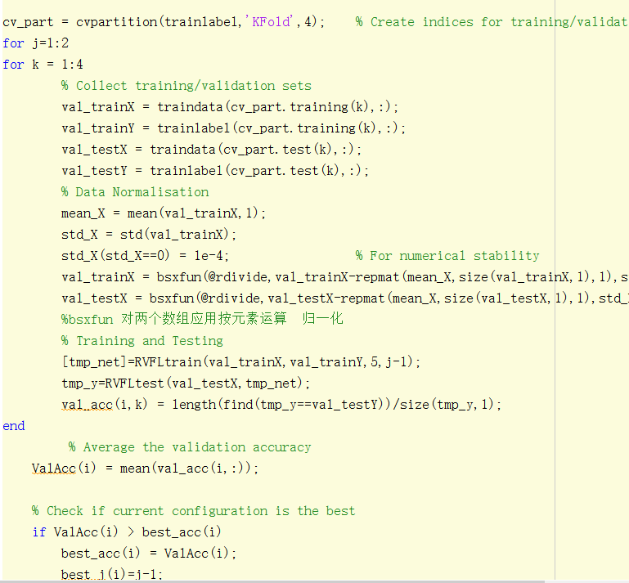

According to the test result, we could see that these two kind of $γ$ has similar accuracy. In fact, Ridge Regression performs a little better than Moore-Penrose pseudoinverse. Therefore, we set $γ$ =1/c in the following experiments.

The number of hidden neurons might also influence the performance of RVFL. Cause more numbers of neurons will boost the model complexity. However, the increasing number of neurons could compensated the problem that bring by the randomization range. Scaling down the range could avoid saturating the neurons but might degenerating the discrimination power of the random feature. Scaling up the range to enhance the discrimination power might risk at saturating the neurons.

In order test the effect that the number of neurons has on the performance of RVFL, we test 3 situation in 8 datasets, as the following table show:

|  |  |  |  |
| --- | --- | --- | --- |
| **Dataset** | **Acc($num$ =5)** | **Acc($num$ =50)** | **Acc($num$ =500)** |
| **cardiotocography-3clases** | **0.880281690140845** | **0.873239436619718** | **0.880281690140845** |
| **image-segmentation** | **0.887445887445888** | **0.898268398268398** | **0.896103896103896** |
| **molec-biol-splice** | **0.805642633228840** | **0.816614420062696** | **0.777429467084639** |
| **ozone_Train** | **0.982283464566929** | **0.982283464566929** | **0.982283464566929** |
| **semeion** | **0.846394984326019** | **0.843260188087774** | **0.836990595611285** |
| **spambase** | **0.890336590662324** | **0.890336590662324** | **0.890336590662324** |
| **steel-plates** | **0.688946015424165** | **0.683804627249357** | **0.717223650385604** |
| **waveform-noise** | **0.871000000000000** | **0.865000000000000** | **0.841000000000000** |

According to the test result, we could find that different number of neurons has similar performance. In order to reduce the model complexity,we use neurons =5 in the following experiments.

## Final Result

In this section, we will evaluate the performance of Random Forest algorithm and RVFL algorithm base on 8 UCI open-source datasets. The datasets is shown as follow:

**Training data:**

|  |  |  |  |
| --- | --- | --- | --- |
| **Dataset** | **Num of samples** | **Num of features** | **Num of classes** |
| **cardiotocography-3clases** | **1700** | **21** | **3** |
| **image-segmentation** | **1848** | **18** | **7** |
| **molec-biol-splice** | **2552** | **60** | **3** |
| **ozone_Train** | **2028** | **72** | **2** |
| **semeion** | **1274** | **256** | **10** |
| **spambase** | **3680** | **57** | **2** |
| **steel-plates** | **1552** | **27** | **7** |
| **waveform-noise** | **4000** | **40** | **3** |

**Test data:**

|  |  |  |  |
| --- | --- | --- | --- |
| **Dataset** | **Num of samples** | **Num of features** | **Num of classes** |
| **cardiotocography-3clases** | **426** | **21** | **3** |
| **image-segmentation** | **462** | **18** | **7** |
| **molec-biol-splice** | **638** | **60** | **3** |
| **ozone_Train** | **508** | **72** | **2** |
| **semeion** | **319** | **256** | **10** |
| **spambase** | **921** | **57** | **2** |
| **steel-plates** | **389** | **27** | **7** |
| **waveform-noise** | **1000** | **40** | **3** |

1. **Evaluation of RF**

We use the previous UCI datasets to evaluate the Random Forest algorithm, the testing result is shown below:

|  |  |  |  |  |  |
| --- | --- | --- | --- | --- | --- |
| **Dataset** | **Val_acc** | **Test_acc** | **Test_time** | **Train_acc** | **Train_time** |
| **cardiotocography-3clases** | **0.945823655324891** | **0.965304313198484** | **0.0402697** | **0.975294117647059** | **1.15429870** |
| **image-segmentation** | **0.97807359023483** | **0.979047196509476** | **0.0222719** | **0.987012987012987** | **1.761447500** |
| **molec-biol-splice** | **0.975369665361965** | **0.965367965367965** | **0.0657639** | **0.986677115987461** | **3.042648600** |
| **ozone_Train** | **0.988073590361965** | **0.982283464566929** | **0.0612958** | **0.986686390532544** | **2.880692900** |
| **semeion** | **0.897010819665217** | **0.884012539184953** | **0.0687514** | **0.992935635792779** | **5.057426300** |
| **spambase** | **0.905303030521730** | **0.926167209554832** | **0.1688671** | **0.977173913043478** | **5.673265300** |
| **steel-plates** | **0.749716494845361** | **0.699228791773779** | **0.0283885** | **0.941365979381443** | **2.898149300** |
| **waveform-noise** | **0.853050750536121** | **0.797000000000000** | **0.1000839** | **0.968250000000000** | **13.38071670** |

From the result, we could find that Random forest has high accuracy, but it seems to have many time to train the trees.

1. **Evaluation of RVFL**

We then use the previous UCI datasets to evaluate the Random Vector Functional Link(RVFL) algorithm, the testing result is shown below:

|  |  |  |  |  |  |
| --- | --- | --- | --- | --- | --- |
| **Dataset** | **Val_acc** | **Test_acc** | **Test_time** | **Train_acc** | **Train_time** |
| **cardiotocography-3clases** | **0.872941176470588** | **0.896713615023474** | **0.0067908** | **0.883529411764706** | **0.0751494** |
| **image-segmentation** | **0.905303030303030** | **0.891774891774892** | **0.0076045** | **0.905844155844156** | **0.0781588** |
| **molec-biol-splice** | **0.786833855799373** | **0.808777429467085** | **0.0051370** | **0.813871473354232** | **0.0781588** |
| **ozone_Train** | **0.967948717948718** | **0.982283464566929** | **0.0042550** | **0.968934911242604** | **0.0072802** |
| **semeion** | **0.808449655961042** | **0.849529780564263** | **0.0042162** | **0.961538461538462** | **0.0242737** |
| **spambase** | **0.897010869565217** | **0.890336590662324** | **0.0072676** | **0.897554347826087** | **0.0067334** |
| **steel-plates** | **0.719716494845361** | **0.709511568123393** | **0.0061098** | **0.76159793814433** | **0.0890862** |
| **waveform-noise** | **0.850750** | **0.866000** | **0.0083969** | **0.866250** | **0.0050514** |

We could find that RVFL also have a good performance in these datasets,what’s more, its takes less time to train the model.

1. **Wilcoxon rank sum test**

We use Wilcoxon rank sum test to check if there are significant difference between the accuracy in RF and RVFL

|  |  |  |
| --- | --- | --- |
| **p** | **h** | **stats** |
| **0.396891996891997** | **0** | **76.5000000000000** |

The result shows that there is a nearly 40% percent chance of being equal on average accuracy. And the h is 0 also means there is no significant different between these two algorithm.

## Conclusion

Comparing these two algorithm, we can find that both of these algorithm have a good classification ability. However, RF perform better in some datasets while RVFL is easily computed and also out perform in some datasets. Therefore, we should choose a better classifier according to the reality problem and consider the requirement.

## Reference

1. Tin Kam Ho, "Random decision forests," Proceedings of 3rd International Conference on Document Analysis and Recognition, Montreal, QC, Canada, 1995, pp. 278-282 vol.1, doi: 10.1109/ICDAR.1995.598994.
2. Le Zhang and P.N. Suganthan. 2016. A comprehensive evaluation of random vector functional link networks. Inf. Sci. 367, C (November 2016), 1094–1105. DOI:https://doi.org/10.1016/j.ins.2015.09.025
3. P. N. Suganthan, “Random Vector Functioanl Link (RVFL) Neural Networks,” Course Slides of EE6227, School of EEE, Nanyang Technological University, Singapore, 2020.
4. D. Husmeier, “Random Vector Functional Link (RVFL) Networks,” Neural Networks for Conditional Probability Estimation, Springer, London, pp. 87-97, 1999.
5. R. Katuwal, P. N. Suganthan, and M. Tanveer, “Random Vector Functional Link Neural Network based on Ensemble Deep Learning,” arXiv preprint, arXiv:1907.00350, 2019