# SOLUTION

**Name: WEI ZHIFENG**

**Matriculation Number: G2002825F**

1. **Question 1**

Cut-off frequency: $\frac{π}{(d_{0}+2)}= \frac{π}{7}$

Length: 21

Coefficients:

0xFFFF

0xFFF8

0xFFEE

0x0001

0x008A

0x0221

0x054E

0x0A10

0x0F78

0x13D9

0x158A

0x13D9

0x0F78

0x0A10

0x054E

0x0221

0x008A

0x0001

0xFFEE

0xFFF8

0xFFFF

1. **Question 2**
2. An input signal is quantized to ($d_{1}+1=3$) binary fractional bits

So the quantization step is : $Q= \frac{1}{2^{3}}=\frac{1}{8}$ = 0.125

1. Variance of the quantization error is : $σ^{2}= \frac{Q^{2}}{12}$ = $\frac{1}{768}=0.0013$
2. The output noise variance is: $σ^{2}= \frac{1}{7}*{σ_{q}}^{2}=\frac{1}{5376}$
3. **Question 3**

The recursive filter is $y\left(n\right)=\frac{5}{6}x\left(n\right)-\frac{1}{3}y(n-1)$

$y\left(n-1\right)=\frac{5}{6}x\left(n-1\right)-\frac{1}{3}y(n-2)$

So the output y(n) without using y(n-1) for such a pipelining is :

$$y\left(n\right)=\frac{5}{6}x\left(n\right)-\frac{5}{18}x\left(n-1\right)+\frac{1}{9}y\left(n-2\right)$$

1. Pipelining structure

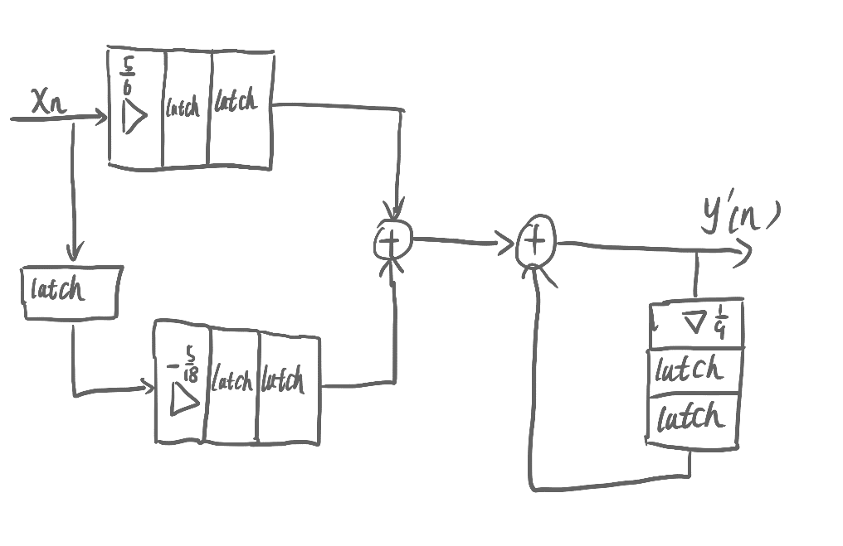

$$y\left(n\right)=\frac{5}{6}x\left(n\right)-\frac{5}{18}x\left(n-1\right)+\frac{1}{9}y\left(n-2\right)$$

$$y^{'}\left(n\right)=\frac{5}{6}x\left(n-2\right)-\frac{5}{18}x\left(n-3\right)+\frac{1}{9}y^{'}\left(n-2\right)$$

So the output is : $y^{'}\left(n\right)$ = $y\left(n-2\right)$