# Histogram and Its Applications

**Wei Zhifeng G2002825F**

1. **The definition and properties of histogram**

Histogram is a two-dimensional statistical chart that shows you the probability distribution of a set of continuous data. Generally, the x-coordinate is the data value, and the y-coordinate is the frequency (or probability). This allows us to inspect its distribution, outliers and skewness. What’s more, we can determine whether the data is stable or to analyze the data.

In the field of image processing, we use histogram to count the frequency (or times) of different gray level (or image value). As the formula shown below.

$$P_{f}\left(f\right)=\frac{n_{f}}{n}$$

f is the gray level range from 0 to L, $n_{f}$ is the number of pixels with gray level f, n is the total number of pixels. And obviously:

$$\sum_{f=0}^{L}{P_{f}\left(f\right)=1 and P_{f}\left(f\right)≥0}$$

The histogram counts the number of pixels for each gray value, therefore, a narrowly distributed histogram indicates the gray level concentrates in a similar range. So it is a low-contrast image, and a widely distributed histogram shows high-contrast image.

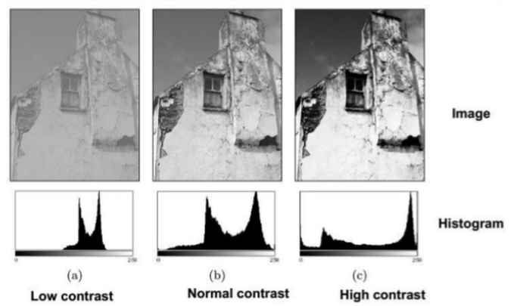

What’s more, the shape of histogram also gives us many information to analyze the characteristics of the image. We can observe that the histogram components are concentrated in the low gray value region in a dark image, and bright image concentrates in the high gray value region.

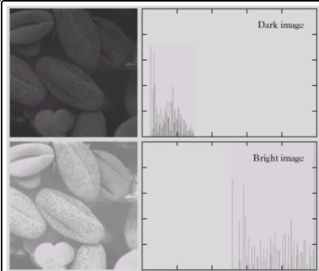

Using these characteristics, we can analyze images and realize image enhancement, visual quality improvement and information extraction, etc.

However, histogram only reflects the frequency of grayscale value in the image, but does not reflect the position of the pixel of a certain grayscale value. That is to say, it only contains the probability of the occurrence of a pixel of a certain gray value in the image, but loses the information of its position

1. **Principle of histogram equalization, its merits and limitations**

Histogram equalization is a commonly used technique which aims to uniform the gray level histogram so that the image could obtain better contrast or enhance contrast. A picture after histogram equalization is shown below.

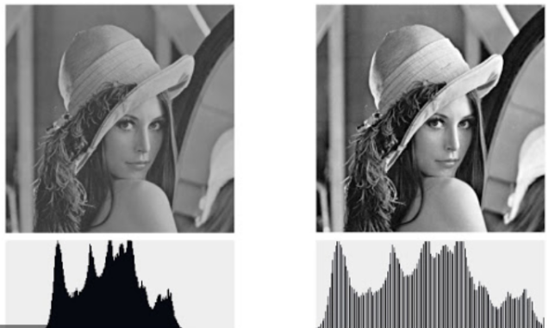

We could observe that we improve the quality and contrast of the image without adding any information. Therefore, histogram equalization is widely used in image enhancement.

The histogram equalization algorithm is shown below:

$$c\left(f\right)=\sum_{t=0}^{f}{\frac{n_{f}}{n}}$$

$$g=T\left(f\right)=round[ \frac{c\left(f\right)−c_{min}}{1−c_{min}}∗L ]$$

c(f) is the cumulative probability so it is monotone increasing; T is a transform that can map a grey value f to another value g. After mapping, the value g is approximately uniformly distributed and ranges in 0 to L.

A histogram after histogram equalization is shown below:

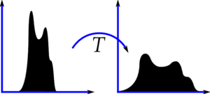

This principle could be proved by the following formula.

In the probability theory, if we know the pdf of grey value (the histogram) and the transform T (1 to 1 mapping and monotonically increasing), the pdf of g can be calculated as below because probability doesn’t change.

$$p_{g}(g)=p_{f}(f)\frac{df}{dg}$$

And for continuous variants;

$$g=T\left(f\right)=L∗\int_{0}^{r}{p_{f}(f)df}$$

so

$\frac{dg}{df}=L$ $p_{f}(f)$

*

Therefore

$$p_{g}\left(g\right)=p_{f}(f)\frac{df}{dg}=\frac{1}{L}$$

When the pdf of g is a constant number, we can assume that g is uniformly distributed. And for discrete variants, we will replace the integral with the accumulative sum. However, the transform formula for histogram equalization is set as

$$g=T\left(f\right)=round[ \frac{c\left(f\right)−c_{min}}{1−c_{min}}∗L ]$$

We don’t directly use c(f) is to avoid that f doesn’t begin from 0. In other word, to normalize f. When g is uniformly distributed, the histogram could cover a wide range of gray value so that it could have better contrast.

Histogram equalization is widely used to improve contrast. It is intuitionistic and we don’t have to tune the parameters or do other calculation. What’s more, we could reverse this transform because the transform procedure is known. And it works relatively well on different types of images

However, histogram is an approximation of pdf and we don’t create new grey value, so we rarely see flat histogram in practice. Sometimes, the transform is not strictly 1 to 1 mapping so it might be not exactly uniformly distributed. But we can still use it to enhance contrast. What’s more, histogram equalization merges a large number of gray value which will lose many local details. Another limitation of HE algorithm is that it doesn’t consider the position information.

To avoid these limitations, there are many improved algorithms such as Local Histogram Equalization, Bi-Histogram Equalization, brightness preserving bi- histogram equalization and so on.

1. **Applications of histogram**

Histogram also has many applications in the field of image processing, Histograms of Oriented Gradients (HOG) is a good example.

HOG was proposed by Dalal and Triggs in CVPR in 2005. It is a descriptor that could extract features of an image, which outperform existing feature sets for human detection. The feature extraction procedure is shown as the picture below.



For an input image, we first perform gamma normalization to modify the image contrast. Then we compute the gradients of each pixel. The formula is shown below:

$$G\left(X,Y\right)=\sqrt{{(f\left(x+1,y\right)−f\left(x−1,y\right))}^{2}+{(f\left(x,y+1\right)−f\left(x,y−1\right))}^{2}}$$

$$θ\left(x,y\right)=\tan^{−1}(\frac{f\left(x,y+1\right)−f\left(x,y−1\right)}{f\left(x+1,y\right)−f\left(x−1,y\right)})$$

$G\left(X,Y\right)$ is the gradient magnitude and $θ\left(x,y\right)$ is the gradient orientation. Using this gradient, we could easily find the edge in an image.

After calculating the gradient, we will divide the image to several cells, each cell is made up of n*n pixels. We then form a histogram of this gradient in a cell, the x-coordinate is gradient orientation range, the y-coordinate is the weighted vote of gradient magnitude. As the fig shown below(we equally divide 0°-180° to 9 bins).

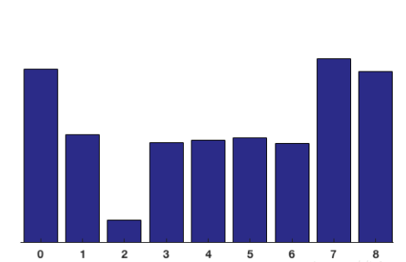

Therefore, we obtain a histogram vector for each cell (dimension is 1*9). We then use n*n cells to form a block, concatenate their histogram vector and normalize it as the feature of this image block (dimension is 1*36 if block is 2*2). What’s more, we slide the block through the window to get the feature of the whole image by concatenate the blocks feature.

The feature extraction procedure is shown as the picture below. Using this feature, we can perform object detection and many other practice.

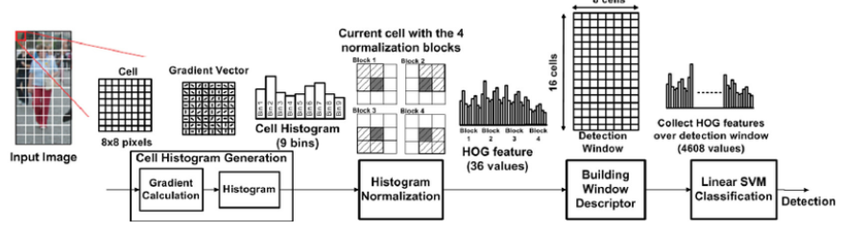

HOG feature performs well in human detection and vehicle detection, and it was applied to many algorithms. What’s more, HOG operate image in local cells, so the geometric deformation and optical deformation might not influence the final result. That is to say, this feature is stable. And this feature extract the information about edge, which could in some way suppresses the effect of rotation and translation.

However, HOG is a high dimensional feature and the calculation of Hog is slow and time consuming. When there is occlusion occurred, this feature could not handle it well. And due to the characteristic of gradient, HOG feature is sensitive to noise. Therefore, there is still some limitations of HOG.

In the paper "Human Detection by Quadratic Classification on Subspace of Extended Histogram of Gradients," it proposes a ExHOG feature for human detection, which reduces the dimension using APCA and fixed some problem cause by HOG.

There are also some excellent features widely used now are based on HOG like fast HOG and so on.

1. **References**
2. Rafael C. Gonzalez and Richard E. Woods. 2006. Digital Image Processing (3rd Edition). Prentice-Hall, Inc., USA.
3. N. Dalal and B. Triggs, "Histograms of oriented gradients for human detection," 2005 IEEE Computer Society Conference on Computer Vision and Pattern Recognition (CVPR'05), San Diego, CA, USA, 2005, pp. 886-893 vol. 1, doi: 10.1109/CVPR.2005.177.
4. Satpathy, X. Jiang and H. Eng, "Human Detection by Quadratic Classification on Subspace of Extended Histogram of Gradients," in IEEE Transactions on Image Processing, vol. 23, no. 1, pp. 287-297, Jan. 2014, doi: 10.1109/TIP.2013.2264677.
5. DING Chang, DONG Lili, XU Wenhai. Review of “histogram” equalization technique for image enhancement. CEA, 2017, 53(23): 12-17.