Seminar 2

Comp 2130

Eric Petryshyn

T00229613

**Problem #1 File:**

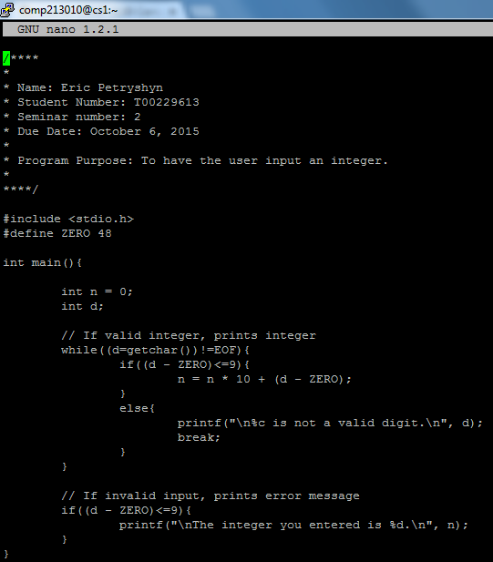

**Problem #1 Output:**

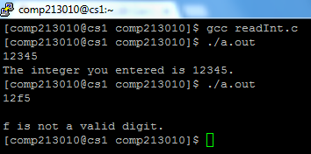

**Problem #2 File:**

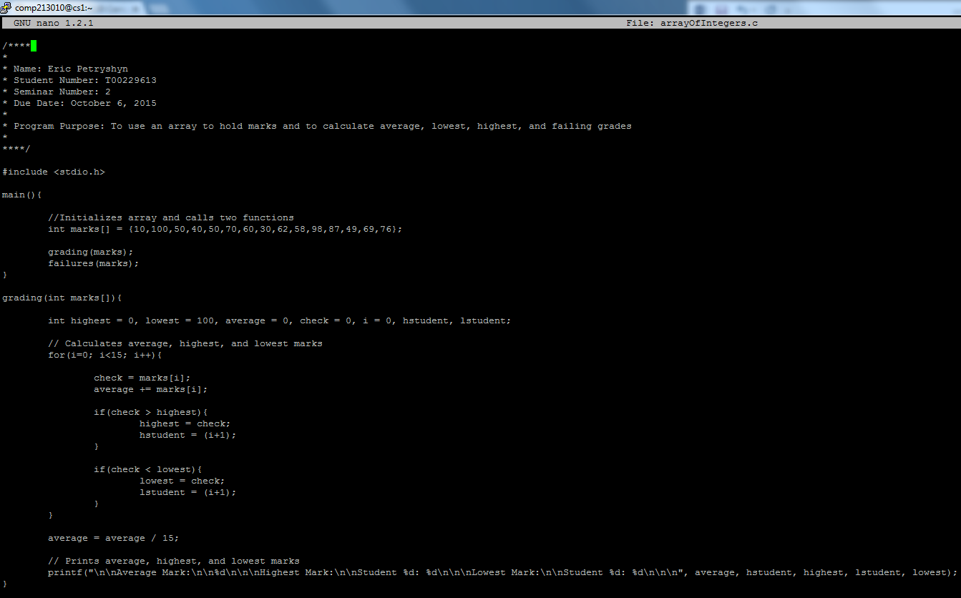

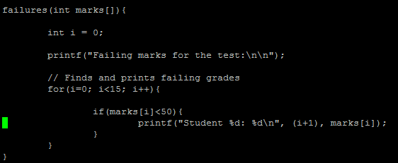

**Problem #2 Output:**

