**Problem 1 & 2:**

**XYZ Health Club:**

This picture shows the tab order of XYZ Health Club.

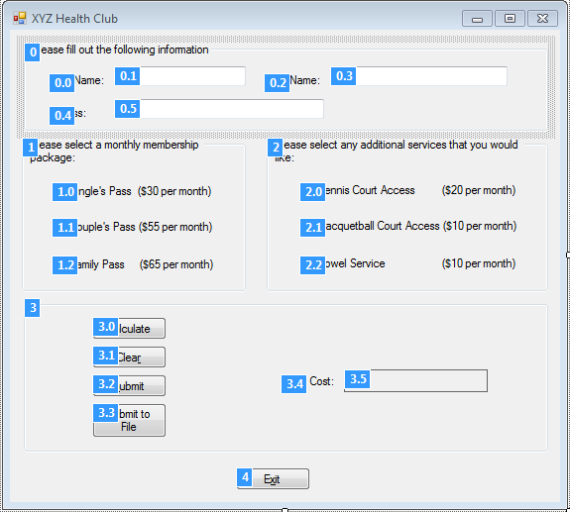

This picture shows that the submit button submits and clears the data.

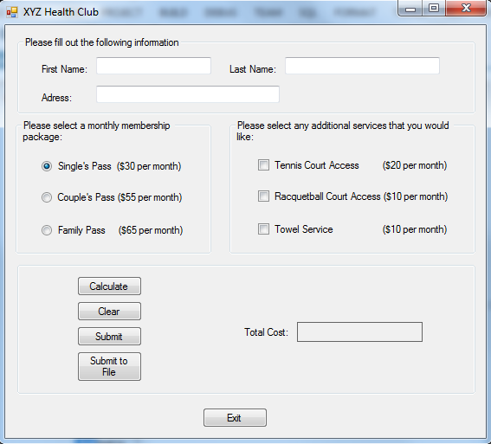

This picture shows the submit button when there isn’t enough information or the calculate button hasn’t been pressed.

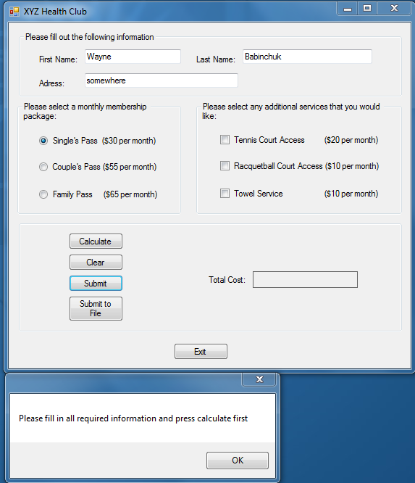

These pictures show the submit to file button at work and the end result of saving threee sets of data to the file “List.txt.

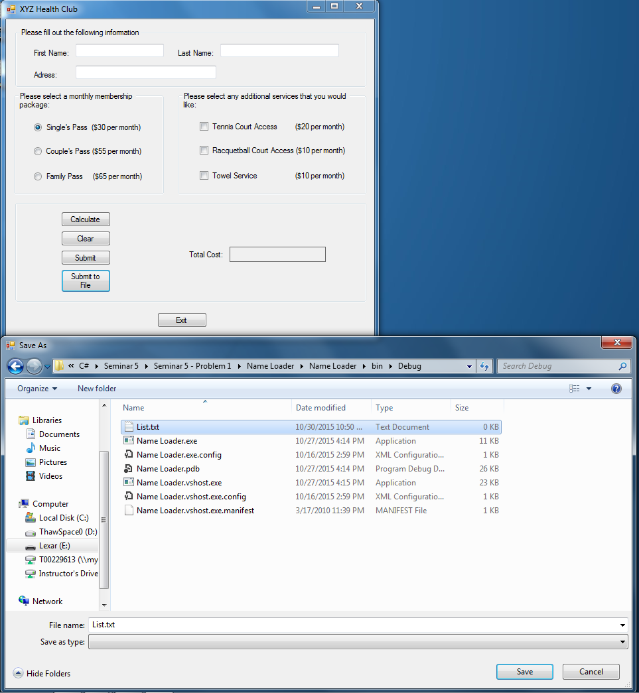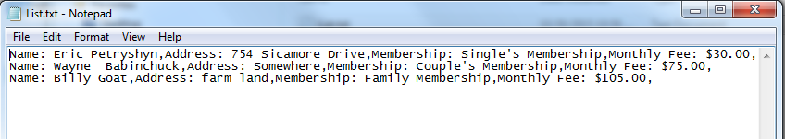

**Name Loader:**

This Picture shows the tab order of Name Loader.

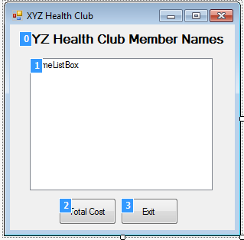

This picture shows how Name Loader starts up.

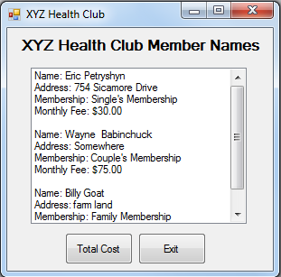

This picture show the result of pressing the total cost button.

