**Smart Gym Monitoring System**

Rode, Eric

Leon, Jorge Renato

Genckaya, Goktug

Università degli Studi dell'Aquila

Software Engineering For Internet of Things

## Contents

1. Introduction  
2. Objectives  
3. Functional Requirements  
4. Non-Functional Requirements  
5. Technologies Used  
6. System Architecture  
7. System Functionality  
8. Data Visualization using Grafana  
9. Conclusion

## 1. Introduction

The Smart Gym Monitoring System leverages Internet of Things (IoT) technologies to enhance the operational efficiency and user experience in gym environments. By monitoring key metrics such as occupancy, temperature, equipment status and air quality, this system provides actionable insights for gym staff to improve customer satisfaction and ensure safety as well as giving to the customers directly to ensure a good training experience. The system integrates real-time data from sensors, advanced analytics, and alert mechanisms to enable rapid responses to critical situations such as overcrowding, overheating, or equipment malfunction.

## 2. Objectives

## - *Reliable IoT system for real-time monitoring of gym environments*: develop a robust IoT system capable of tracking metrics like occupancy, temperature, equipment health and air quality. - *Automated detection and alerts*: identify abnormal conditions (e.g., overcrowding, overheating) and notify staff in real-time. - *User-friendly dashboard for real-time insights*: Provide a Grafana-based dashboard for staff to monitor the gym environment at a glance.

## 3. Functional Requirements

|  |  |  |
| --- | --- | --- |
| **Identifier** | **Name** | **Description** |
| SGMS-FR001 | Data Generation | Simulate real-time sensor data for occupancy, temperature, equipment and air quality. |
| SGMS-FR002 | Data Collection | Collect and transmit data from all sensors to a centralized server. |
| SGMS-FR003 | Alerts | Detect abnormal conditions and notify staff. |
| SGMS-FR004 | Monitoring Interface | Display real-time environmental data through a dashboard. |
| SGMS-FR005 | Notification System | Send alerts via Telegram for critical conditions. |

## 4. Non-Functional Requirements

|  |  |  |
| --- | --- | --- |
| **Identifier** | **Name** | **Description** |
| SGMS-NFR001 | Response | Alerts should trigger within 10 seconds of detecting an abnormal event. |
| SGMS-NFR002 | Reliability | Ensure system uptime with minimal downtime for maintenance. |
| SGMS-NFR003 | Scalability | Support additional sensors and areas as needed. |
| SGMS-NFR004 | Usability | Provide intuitive dashboards and clear visualizations for easy monitoring. |

## 5. Technologies Used

- Python - Paho MQTT: Used for generating synthetic data simulating occupancy, temperature, and equipment status sensors. Data is published to MQTT topics.  
- MQTT - Mosquitto: Facilitates data communication between sensors and Telegraf.  
- Telegraf: Collects data from MQTT topics and forwards it to InfluxDB for storage.  
- InfluxDB: Stores time-series data for historical and real-time analysis.  
- Grafana: Visualizes sensor data and alerts in an intuitive dashboard.  
- Node-RED + Telegram: Processes data and triggers Telegram alerts for critical conditions.

## 6. System Architecture

The architecture consists of:  
1. Sensors: Simulated data sources for occupancy, temperature, and equipment health.  
2. MQTT Broker: Handles real-time data communication.  
3. Telegraf: Connects to the MQTT broker and transfers data to InfluxDB.  
4. InfluxDB: Stores time-series sensor data.  
5. Node-RED: Processes data from InfluxDB to detect anomalies and send Telegram alerts.  
6. Grafana Dashboard: Displays real-time sensor metrics and alerts.

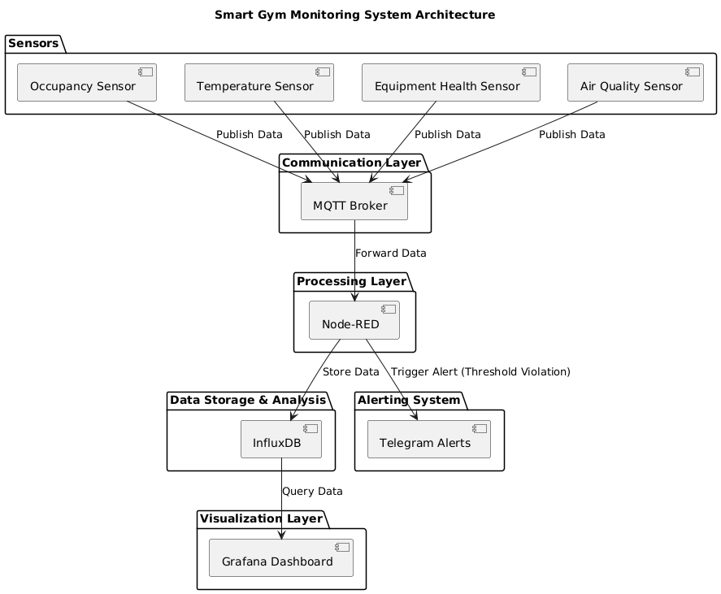

## 7. System Functionality

Data Generation: Simulated occupancy, temperature, equipment health data and air quality.  
Data Communication: Sensors publish data to MQTT topics structured as /gym/{area}/{sensor}.  
Data Storage: Telegraf forwards data to InfluxDB for storage and analysis.  
Alerts: Node-RED analyzes InfluxDB data and sends alerts via Telegram for conditions like high occupancy or overheating.  
Visualization: Grafana displays real-time metrics and historical trends, aiding decision-making.

## 8. Data Visualization using Grafana

Grafana dashboards provide a clear visualization of gym conditions, including:  
- Real-time temperature trends.  
- Occupancy levels per area.  
- Equipment health status.  
- Air quality score  
These intuitive dashboards enable staff to quickly identify and address issues, enhancing the gym's safety and operational efficiency.

## 9. Conclusion

The Smart Gym Monitoring System not only demonstrates the transformative potential of IoT in enhancing gym management but also contributes to a more sustainable future. By optimizing energy usage through real-time monitoring of occupancy and environmental conditions, the system reduces unnecessary energy consumption in lighting, heating, and cooling. Additionally, predictive maintenance of equipment minimizes waste and extends the lifecycle of gym assets, reducing the environmental impact associated with frequent replacements. The system also promotes healthier indoor air quality and user well-being, aligning with sustainable living principles. By integrating advanced analytics and intuitive dashboards, this solution empowers gym owners and users to make informed decisions, fostering a culture of efficiency and environmental responsibility. Continuous development can further expand its impact, making it a scalable model for sustainability in other domains.