# Statistical Inference Project 1

EricRybicki

## A Simulation Excercise

The exponential distribution can be simulated in R with rexp(n, lambda) where lambda is the rate parameter. The mean of exponential distribution is 1/lambda and the standard deviation is also 1/lambda. For this simulation we will investigate the distribution of averages of 40 exponentials over a thousand observations, assuming the lambda = 0.2

### Simulations

We start by doing a thousand simulated averages of 40 exponentials.

lambda <- 0.2  
 n <- 1000  
 s.size <- 40  
 simulation <- matrix(rexp(n*s.size, rate=lambda), n, s.size)  
sample.means <- rowMeans(simulation)

### Sample Mean versus Theoretical Mean

We find that the sample mean is centered at 4.981 which is very close to the theoretical mean of 5. 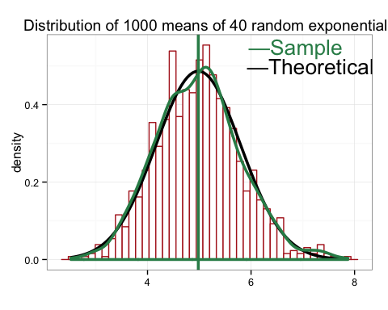

round(mean(sample.means), 3)

## [1] 4.981

1/lambda

## [1] 5

### Sample Variance versus Theoretical Variance

We find the standard deviation of our sample

sd(sample.means)

## [1] 0.8198767

And our predicted standard deviation

(1/lambda)/sqrt(s.size)

## [1] 0.7905694

Next we can find the variance of our sample mean

var(sample.means)

## [1] 0.6721978

Then we can find the theoretical variance of our distribution.

((1/lambda)^2)/s.size

## [1] 0.625

This show us that our distribution of sample means, which is centered around the population mean of 5, has a variance of 0.672 which is in accord with the theoretical variance of 0.625 as predicted by the Central Limit Theorem.

### Distribution

The Q-Q plot below shows two probability distributions where any point (X,Y) denotes a data point from our sample distribution plotted against our theoretical distribution. The linearity suggests that normality is a good approximation.

gg_qq(sample.means)

