# Statistical Inference Project 2

by EricRybicki

# Basic inferential data analysis

In this case we will explore the effect of Vitamin C on tooth growth in Guinea Pig.

## Load and Exploratory Analysis

library(datasets)  
?ToothGrowth

### Description

The response is the length of odontoblasts (teeth) in each of 10 guinea pigs at each of three dose levels of Vitamin C (0.5, 1, and 2 mg) with each of two delivery methods (orange juice or ascorbic acid).

#### Format

A data frame with 60 observations on 3 variables.

[,1] len numeric Tooth length

[,2] supp factor Supplement type (VC or OJ).

[,3] dose numeric Dose in milligrams.

tooth <- ToothGrowth  
str(tooth)

## 'data.frame': 60 obs. of 3 variables:  
## $ len : num 4.2 11.5 7.3 5.8 6.4 10 11.2 11.2 5.2 7 ...  
## $ supp: Factor w/ 2 levels "OJ","VC": 2 2 2 2 2 2 2 2 2 2 ...  
## $ dose: num 0.5 0.5 0.5 0.5 0.5 0.5 0.5 0.5 0.5 0.5 ...

head(tooth)

## len supp dose  
## 1 4.2 VC 0.5  
## 2 11.5 VC 0.5  
## 3 7.3 VC 0.5  
## 4 5.8 VC 0.5  
## 5 6.4 VC 0.5  
## 6 10.0 VC 0.5

## Provide a basic summary of the data.

library(knitr)  
kable(summary(tooth))

|  |  |  |  |
| --- | --- | --- | --- |
|  | len | supp | dose |
|  | Min. : 4.20 | OJ:30 | Min. :0.500 |
|  | 1st Qu.:13.07 | VC:30 | 1st Qu.:0.500 |
|  | Median :19.25 | NA | Median :1.000 |
|  | Mean :18.81 | NA | Mean :1.167 |
|  | 3rd Qu.:25.27 | NA | 3rd Qu.:2.000 |
|  | Max. :33.90 | NA | Max. :2.000 |

library(ggplot2)  
g <- ggplot(tooth, aes(as.factor(dose), len, fill = supp))  
g <- g + geom_bar(stat="identity", position = "dodge") + theme_bw()  
g <- g + scale_fill_manual("Teams",values = c("#ff6666", "#33cc33"), guide = guide_legend(title = "Supplement"))  
g <- g + xlab("Dose in milligrams") + ylab("Tooth Length")  
g

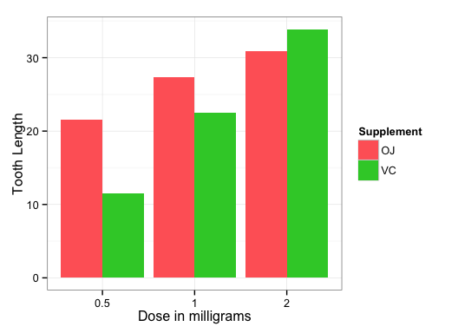

## Use confidence intervals and hypothesis tests to compare tooth growth by supp and dose.

t.test(len ~ supp, data = tooth)

##   
## Welch Two Sample t-test  
##   
## data: len by supp  
## t = 1.9153, df = 55.309, p-value = 0.06063  
## alternative hypothesis: true difference in means is not equal to 0  
## 95 percent confidence interval:  
## -0.1710156 7.5710156  
## sample estimates:  
## mean in group OJ mean in group VC   
## 20.66333 16.96333

From confidence intervals containing zero and p-value of 0.06, we cannot assume that there are differences in tooth growth due to OJ and VC supplements.

tooth_0.5_1.0 <- subset(tooth, dose %in% c(0.5, 1.0))  
t.test(len ~ supp, tooth_0.5_1.0)

##   
## Welch Two Sample t-test  
##   
## data: len by supp  
## t = 3.0503, df = 36.553, p-value = 0.004239  
## alternative hypothesis: true difference in means is not equal to 0  
## 95 percent confidence interval:  
## 1.875234 9.304766  
## sample estimates:  
## mean in group OJ mean in group VC   
## 17.965 12.375

tooth_0.5_2.0 <- subset(tooth, dose %in% c(0.5, 2.0))  
t.test(len ~ supp, tooth_0.5_2.0)

##   
## Welch Two Sample t-test  
##   
## data: len by supp  
## t = 0.9216, df = 35.105, p-value = 0.363  
## alternative hypothesis: true difference in means is not equal to 0  
## 95 percent confidence interval:  
## -3.10849 8.27849  
## sample estimates:  
## mean in group OJ mean in group VC   
## 19.645 17.060

tooth_1.0_2.0 <- subset(tooth, dose %in% c(1.0, 2.0))  
t.test(len ~ supp, tooth_1.0_2.0)

##   
## Welch Two Sample t-test  
##   
## data: len by supp  
## t = 1.8397, df = 31.273, p-value = 0.07533  
## alternative hypothesis: true difference in means is not equal to 0  
## 95 percent confidence interval:  
## -0.3166175 6.1666175  
## sample estimates:  
## mean in group OJ mean in group VC   
## 24.380 21.455

From the selection of t.tests on dosage pairs we can note the low p-values and non-zero confidence values. As a consequence we can confirm that the key component of tooth growth, with regard to supplements, is dosage.

## Conclusion

To recap, based on the analysis above, we can conclude that across both supplements a higher dosage will have a higher tooth growth rate. However, we cannot say that orange juice and vitamin C have obvious different impact on tooth growth.