Using Putty download PuTTY Key Generator

Select your choice of key, in this case SSH-2 RSA.

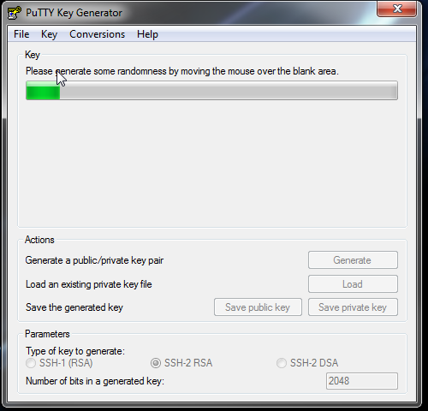

Then Click Generate, and a green task bar will pop up. This will take a few minutes.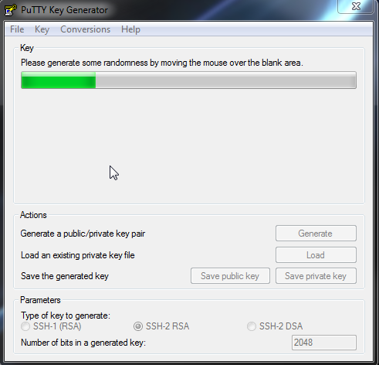

Moving the mouse around the grey screen will speed up the process.

Key in your passphrase.

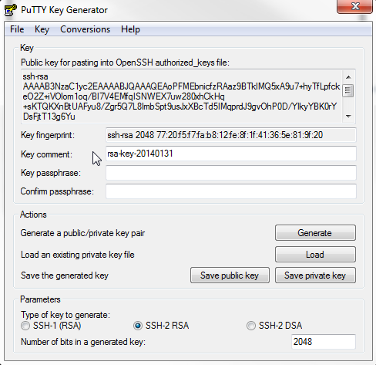

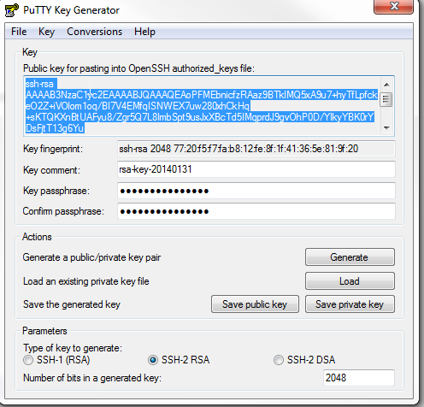

Copy your public key for pasting !

Then Save. Public key and private.

After go to github.com, sign in and go to the settings panel



Then SSH Panel

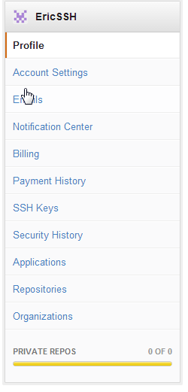

Add your SSH Key



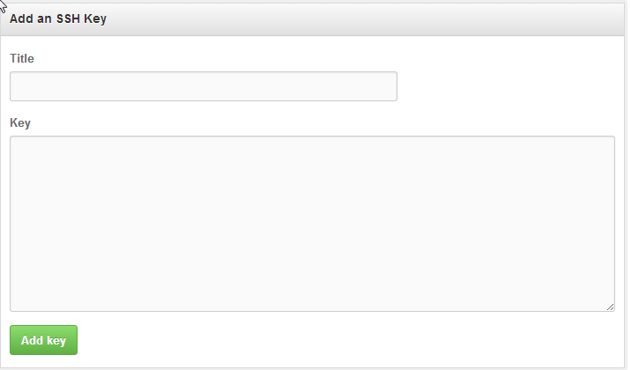

Done