Generic Priority Stack

Your task is to complete the implementation of the class below.

// You are not allowed to use complex data structures such as ArrayList, HashMap, etc.  
// You are also not allowed to use Collections and Arrays \*classes\*.  
// You are allowed to use arrays, of course.  
// Only submit your own original work.

public class PriorityStack<T> {  
  
 class Container<T> {  
  
 T value;  
 boolean hasPriority;  
 Container<T> nextBelow;  
 }  
  
 private Container<T> top; // top of the stack element  
  
 private int size;  
  
 public void push(T value) {  
   
 }  
  
 public void push(T value, boolean hasPriority) {   
   
 }  
  
 public T pop() {  
 // remove and return the top item  
 // if no item found (size == 0) then throw NoSuchElementException  
   
 }  
  
 public T popPriority() {  
 // find item with priority starting from the top, remove it and return it  
 // if no priority item found then remove and return the top item  
 // if stack is empty then throw NoSuchElementException  
   
 return pop();  
 }  
  
 public int hasValue(T value) {  
 // returns -1 if value is not on the stack  
 // this code only looks for the \*first\* occurence of the value, starting from top  
 // WARNING: you must call value.equals(item.value) to determine whether  
 // two values are equal, just like you would do for a String  
 // returning value 0 means the value is on top of the stack,  
 // 1 means 1 below the top, and so on...  
   
 return -1; // not found  
 }  
  
 public T removeValue(T value) {  
 // removes the first item from top containing the value and returns the value  
 // if item with value is not found throw NoSuchElementException  
   
 throw new NoSuchElementException();  
 }  
  
 public int getSize() {  
 return size;  
 }  
  
 public void reorderByPriority() {  
 // reorder items (re-create a new stack, if you like)  
 // where all priority items are on top and non-priority items are below them  
 // Note: order within the priority items group and non-priority items group must remain the same  
 // Suggestion: instead of reordering the existing stack items  
 // it may be easier to re-create a new stack with items in the order you need  
   
 }  
  
 @Override  
 public String toString() {  
 // return string describing the contents of the stack, starting from the top  
 // Use value.toString() to convert values kept in the stack to strings.  
 // Format exactly like this (assuming T is a string to keep it simple):  
 // "[Jerry:N,Terry:N,Martha:P,Tom:P,Jimmy:N]"   
 // N means item has no priority, P means item has priority  
 // For full marks you must use StringBuilder, no + (string concatenation) allowed.  
   
 }  
   
  
 public T[] toArrayReversed(Class<T> type) { // Note: this is "the twist"  
 // return array with items on the stack  
 // WARNING: element 0 of the array must be the BOTTOM of the stack  
 // Collect items on your way back, just before returning.  
 }  
  
 // NOTE: you are only allowed to add private methods and private fields (if needed)



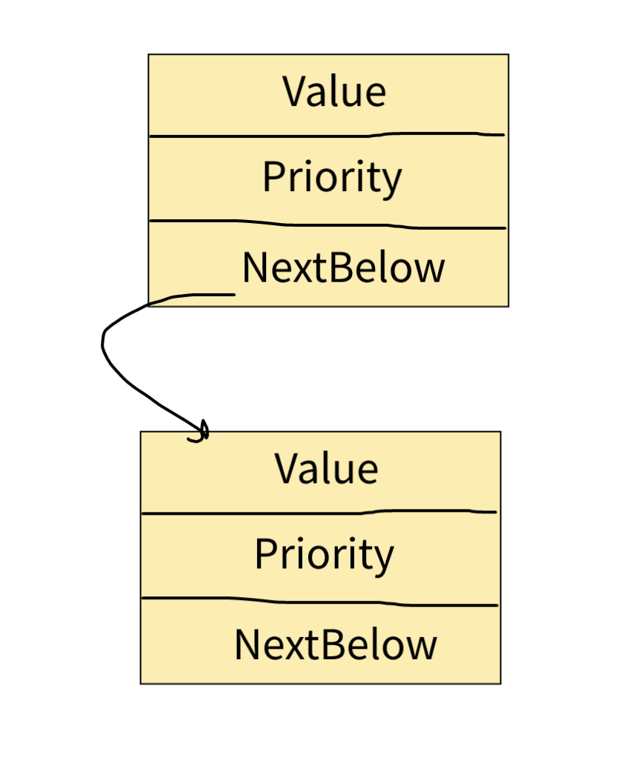



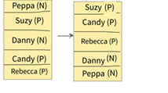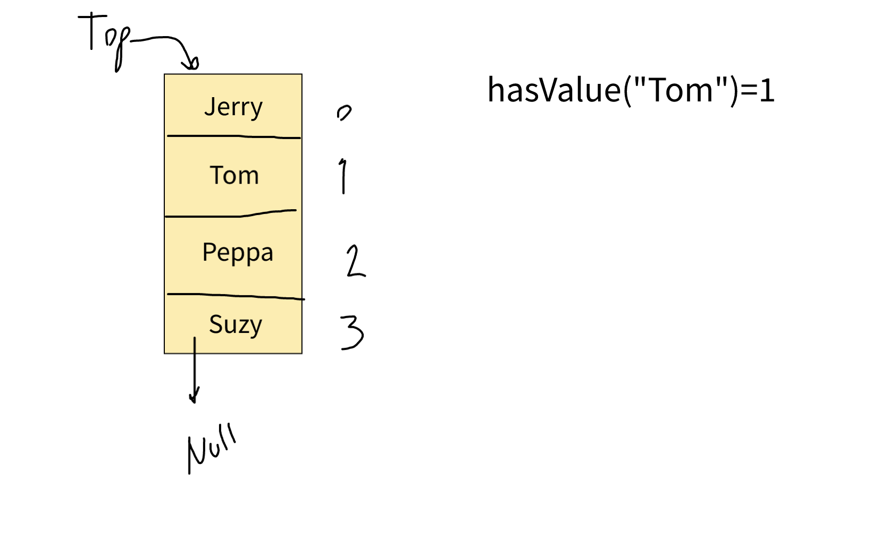

Reorder