Chapter 1

By Eric Schles

1.1 Name and illustrate five operations that can be applied to pointers.

- Increment pointer
- compare addresses
- compare values that pointers are pointing to
- dereference
- assignment

Increment pointer:

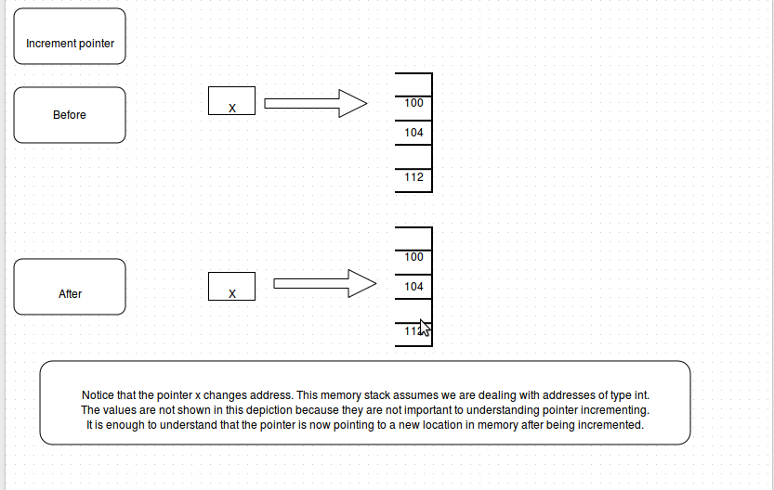

- Compare addresses
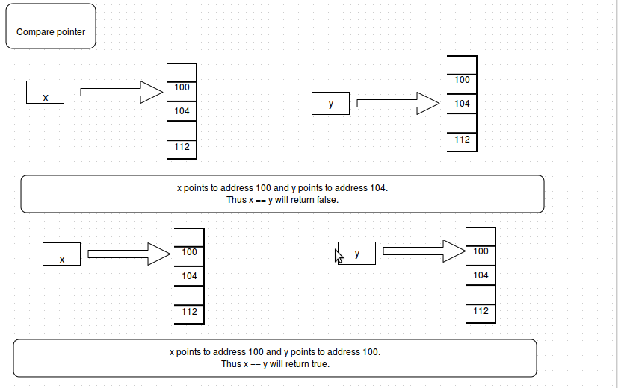

- Compare values
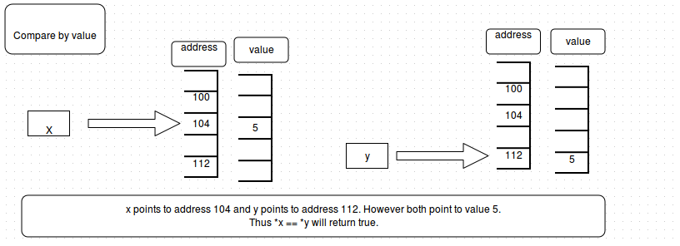

- dereference
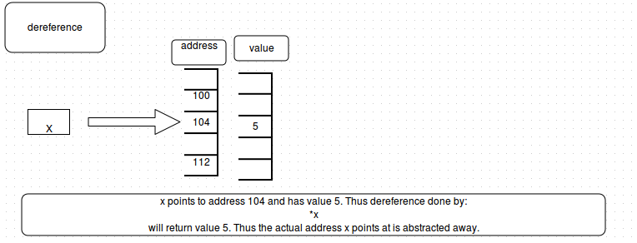
- assignment
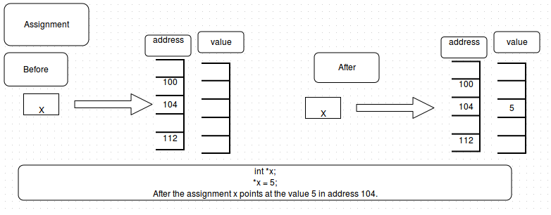
  - Consider

int a,b;
int *ptr;
int **ptrPtr;

ptr = &a;
ptrPtr = &ptr;

a. Is this code legal?

It is legal however it is discouraged. This is because a and b are not initialized with values. In addition, if ptr is deleted for some reason, it will have unintended consequences on ptrPtr. Also, the variable b is never even used, which is simply wasteful.

b. What are the values of *ptr and **ptrPtr?

ptr points to the address of a which is an uninitialized variable, thus *ptr points to junk.
Since ptrPtr points to address of ptr **ptrPtr also points to junk.

- Using no other objects besides those already declared, how can you alter ptrPtr so that it points at a pointer to b without directly touching ptr?
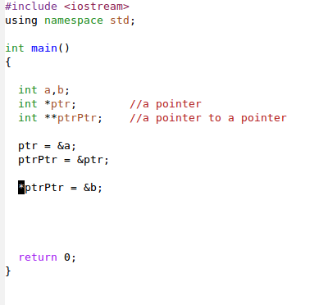

- Is the following statement legal?

ptrPtr = ptr;

No, this is not legal, because ptrPtr is a pointer to a pointer where as ptr is just a pointer. Thus you need to provide an address-of operator (&) in order for the above statement to make sense. Thus

ptrPtr = &ptr;

is the only valid statement.

1.3

a. Is *&x always equal to x? If not, give an example.

Yes it is, because address-of and then dereference will undo the address-of operation. In this sense we can think of these operations as inverses. Thus there is a natural bijection from the set of addresses to the set of values. Of course the space of addresses is by definition larger then the set of values, at least in modern computation, thus this is not a true bijection.

b. Is & *x always equal to x? If not, give an example.

No, if x is not a pointer than & *x will have no meaning.

Example:

#include <iostream>
using namespace std;

int main()
{

int a = 6;
bool truth_value;

truth_value = ( ( & *a) == a);
cout << truth_value;

return 0;
}

This program will not even compile because *a has no internal meaning.

1.4

For the declarations

int a = 5;
int *ptr = &a;

what are the values of the following?

a. ptr

This should be the address-of a.

b. *ptr

This should be 5.

c. ptr == a

This will return false.

d. ptr == &a

This will return true.

e. &ptr

This gives us the address of the pointer.

f. *a

This has no meaning since a is not a pointer type.

g. *&a

This will output 5.

h. **&ptr

This will output 5 as well.

1.5 Give the type of each identifier declared here and the types of the expressions. Is any expression illegal?

a. struct S { int a; S *b; };

The S is of type S, a is of type int and b is a pointer to S.

b. S z;

z is a struct of type S. It has z.a of type int and z.b which is a pointer to the struct z of type S.

c. S *x;

*x is a pointer to a structure of type S. If dereferenced it can access a via x->a and a pointer to S, b via x->b.

d. vector<S> y(10);

This declares a vector y of type structure S. y has 10 elements. Each element has a int a associated with it and a pointer b of type S. To access elements of S simply do the following y[ i ].a or y[ i ].b

e. vector<S *> u(10);

This declares a vector u of pointers to structures of type S. u has 10 elements. In order to access elements from vector first you must declare a new struct S. Then you must assign elements to each position of the vector.

The syntax is:

u[ 0 ] = new S;
u[ 0 ] -> a = 5;

This initializes u[ 0 ] to a struct S and then assigns 5 to a in struct S.

f. x-> a

This makes sense. This is because x is a pointer to S and a is an element of S. It returns the value of a from struct S.

g. x->b

This makes sense as well. It is true for the same reasons as f. It returns the address of b.

h. z.b

This makes sense. z.b returns b, a pointer to z. This is because z is of type S.

I. z.a

This makes sense as well. This will return the value of a, which is a member of z, a structure of type S.

j. *z.a

This does not make sense. z is a struct of type S not a pointer to S, thus it cannot be dereferenced.

K (*z).a

This also does not make sense for the same reason as j.

l. x->b-z.b

x->b and z.b makes sense as well as x->b – z.b because pointer subtraction is defined. None the less this produces a segment fault when attempted in a real program.

- y->a

This is illegal because y is not a pointer.

n. y[ 1 ]

This will work. It gives access to a struct of type S with members, int a and pointer b.

o. y[ 1 ].a

This will work. It accesses int a from the struct.

p. y[ 1 ].b

This will work. It accesses pointer b from the struct.

q. u[ 2 ]

This will work. There will be no output however, since this references no specific part of the structure. It is simply a reference to the structure in the third position of the vector.

r. *u[2]

This will work. However in order for meaningful output to be produced the structure must reference some specific element of type S.

s. u[2]->a

This will be meaningful and output the value of a.

t. u[2]->b

This will be meaningful and output the address-of u[2]

u. u[10]

This will not be meaningful, however it is not illegal since vectors have no error checking. None the less, there is nothing in position 10 since the vector is of length 10. Only 0-9 are meaningful entries in this sense.

v. &z

meaningful. It outputs the address-of z.

w. &x

This is meaningful, it will output the address-of x, which works even though x is a pointer. Keep in mind this will not print out the address that x points to. To do that you need x; not &x;

- u
This is only meaningful if it is passed to a function. However, this is the address-of u[0]

y. y

This has the same meaning as part x. It is useful for passing to a function and it means the address of y[0].

1.6 Draw a picture that illustrates the results after processing of each of the following statements, which are executed sequentially.

(picture beneath)
a. int a = 3;

There is now memory called “a” that stores the value of 3.

b. int & b = a;

There is now memory called “b” that stores a copy of a, including its address and value, namely 3.

c. int & c = b;

There is now memory called “c” that stores a copy of b, including its address and value, namely 3.

d. b = 5;

Since b is a copy of a, a and b now have value of 5.

e. c = 2;

Since c is a copy of b, a b and c now have value 2.

Picture on next page.

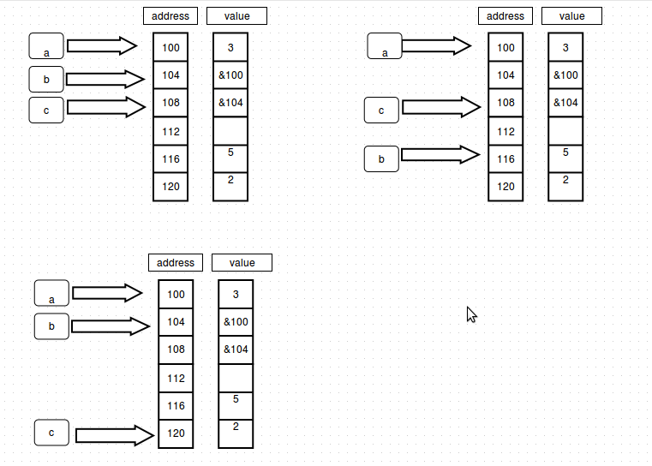

1.7 Is the following code legal? Why or why not?

int a = 3;
const int & b = a;

This code is legal. const creates a constant reference of a, named b. You can still manipulate a however you like, however b cannot be changed directly.

1.8 What is wrong with ommitting spacing in *x/*y ?

Because the compiler will think you are starting a comment with /*.

