Chapter 12 – Data structures
By Eric Schles

12.1
Show the result of running the balanced symbol program on
a. }
b ( }
c [ [ [
d. ) (
e. [ ) ]

Answer:

algorithm:
- Make an empty stack
- Read symbols until the end of the file
  - if the symbol is an opening symbol, push it onto the stack
  - if it is a closing symbol do the following
    - if the stack is empty, report an error
    - otherwise pop the stack. IF the symbol popped is not the corresponding opening symbol, report an error
- at the end of the file, if the stack is not empty report an error.

a.

Make an empty stack
Reads '}' symbol.
Report an error

b.
( }

Make an empty stack
Reads '(' symbol.
Push '(' symbol onto the stack

Reads '}' symbol.
Pop stack, report error.

c.
[ [ [

Make an empty stack
Reads '[' symbol.
Push '[' symbol onto the stack

Reads '[' symbol.
Push '[' symbol onto the stack

Reads '['
Push '[' symbol onto the stack

at end of file, stack is not empty, report error.

d.
) (

Make an empty stack.
Read ')'
stack empty, report error

e.
[ ) ]

Make an empty stack.
Read '['

Read ')'
pop the stack, no corresponding openning symbol, report error

12.2
Show the postfix expression for.
a. 1 + 2 – 3 ^ 4

12+34^-

b. 1 ^ 2 – 3 * 4 = 1 – 12

12^ 34* -

c. 1 + 2 * 3 – 4 ^ 5 + 6 = 1 + 6 – 1024 + 6

1 2 3 * + 4 5 ^ - 6 +

d. ( 1 + 2 ) * 3 - ( 4 ^ ( 5 – 6) ) = 9 – 4

1 2 + 3 * 4 5 6 - ^ -

12.3
For the infix expression a + b ^ c * d ^ e ^ f – g – h / ( i + j ), do the following.

a. Show how the operator precedence parsing algorithm generates the corresponding postfix expression.

Algorithm:
operands: immediately output
close parenthesis: pop stack symbols until an open parenthesis appears.
Operator: pop all stack symbols until a symbol of lower precedence or a right associative symbol of equal precedence appears. Then push the operator.
End of input: pop all remaining stack symbols.

a + b ^ c * d ^ e ^ f – g – h / ( i + j )
Input | Stack | output
A |  | a
+ | + | A
B | + | ab
^ | +,^ | Ab
C | +,^ | A B c
* | +,* | A b c ^
D | +,* | A b c ^ d
^ | +,*,^ | A b c ^ d
E | +,*,^ | A b c ^ d e
^ | +,*,^,^ | A b c ^ d e
F | +,*,^,^ | A b c ^ d e f
- | - | A b c ^ d e f ^ ^ * +
G | - | A b c ^ d e f ^ ^ * + g
- | - | A b c ^ d e f ^ ^ * + g -
H | - | A b c ^ d e f ^ ^ * + g - h
/ | -, / | A b c ^ d e f ^ ^ * + g - h
( | -, /, ( | A b c ^ d e f ^ ^ * + g - h
I | -,/,( | A b c ^ d e f ^ ^ * + g - h i
+ | -,/,(, + | A b c ^ d e f ^ ^ * + g - h i
J | -,/,(,+ | A b c ^ d e f ^ ^ * + g - h I j
) | -,/ | A b c ^ d e f ^ ^ * + g - h I j +
 |  | A b c ^ d e f ^ ^ * + g - h I j + / -

b. Show how a post fix machine evaluates the expression

algorithm: when an operand is seen, it is pushed onto a stack. When an operator is seen, the appropriate number of operands are popped from the stack, the operator is evaulated, and the result is pushed back onto the stack.

Operand: pushed onto stack
operator: appropriate # operands popped from the stack – evaulated
result pushed onto stack

A b c ^ d e f ^ ^ * + g - h I j + / -
Input | Stack
A | a
B | A b
C | A b c
^ | A b^c
D | A b^c d
E | A b^c d e
F | A b^c d e f
^ | A b^c d e^f
^ | A b^c d^e^f
* | A (b^c * d^e^f )
+ | ( A + (b^c * d^e^f ) )
G | ( A + (b^c * d^e^f) ) g
- | (A + ( (b^c) * d^e^f) ) - g
H | ( (a + ( (b^c) * d^e^f ) - g) h
I | ( (a + ( (b^c) * d^e^f ) - g ) h I
J | ( (a + ( (b^c) * d^e^f ) - g ) h I J
+ | ( (a + ( (b^c) * d^e^f ) - g ) h (I + J)
/ | ( (a + ( (b^c) * d^e^f ) - g) h /(I + J)
- | ( (a + ( (b^c) * d^e^f ) - g) - h /(I + J)

Part c)

a + b ^ c * d ^ e ^ f – g – h / ( i + j )

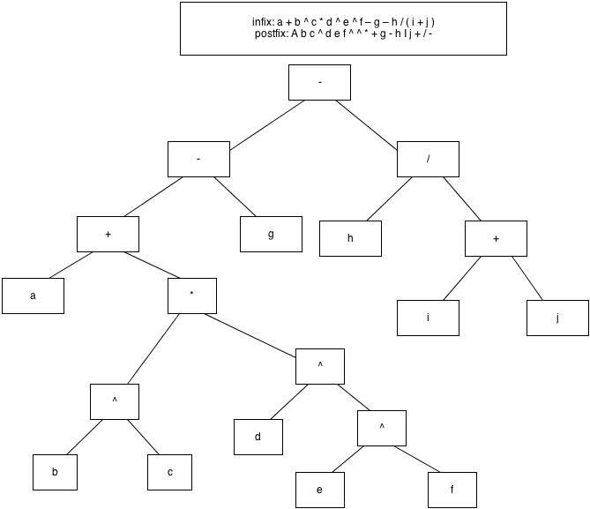

12.4

In order to do this, you give various error conditions numbers. Then you set a flag to false for error found. Set flag to true if error found. Print appropriate error message based on switch statement.

12.5

Unary operators are evaluated immediately with the following operand. They do not flush the stack however.

Errors are unary operators followed by binary operators, unary operators or non compatible symbols.

12.6

