Eric’s Sept Monthly Letter
Strat Plan Milestones:
Work is continuing on modeling account assignments for the Fortune 1000. We are using the NAICS system to classify a company’s primary business focus. Using NAICS codes will help the CSU's business development team spot which industries actually need their programs and where they're missing opportunities in their current partner mix. It also makes everyone's life easier by giving the whole team a common language to talk about which companies connect to which programs and student pathways
CSU Industry Sector Categories
Transportation & Logistics
Energy & Utilities
Government & Public Administration
Healthcare & Medical
Financial Services
Professional Services
Manufacturing
Education & Training
Hospitality & Tourism
Retail & Consumer Goods
Technology & Information Services
Media & Entertainment
Defense & National Security
Construction

Here is a first look at account assignments by Industry Sector Groupings for the Fortune 500.
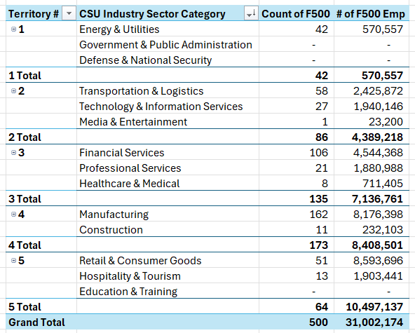
I will finalize these assignments and models by the end of October.
- Territory Models
  - Fortune 500: NACIS codes completed
  - Fortune 1000: in process
- MOU Forecast Model: draft
- Job Descriptions: drafting
- Marketing Plan: drafted
Richmond CLO follow up - ongoing
Benefit Companies Prep: Completed: Tony and Eric are travelling to Chicago, Austin and Tampa next week for the top Benefit Company site visits. Final agendas set and attached.
Personal Networking: I am doing outreach to personal contacts in my network to explore partnership opportunities.
- NCCER: Chief Product Officer
- Lincoln Tech: Senior Admissions Leader
- UTI: COO
COE AI – I am defining data product for DIAS team that will represent end to end student journey data. I will circulate to the entire AR team before submitting to DIAS.
Exploring Growth Strategies:
Columbia Southern University may be able to generate annual recurring revenue by licensing its specialized curriculum content, assessment instruments, and anonymized learning analytics to AI companies like OpenAI, Anthropic, and Scale AI—who are actively paying universities for educational training data that cannot be obtained through web scraping. CSU's unique positioning in adult education with 30 years of career-focused online programs in underrepresented domains (fire science, occupational safety, emergency management, criminal justice) and 100% digital learning environment creates differentiated data assets that command premium pricing, with conservative projections ranging from $200 - $3M in non tuition generated annual revenue. I will share two draft proposals at the end of the month:
- CSU Data Monetization Opportunities
- Building A CSU Expert-Led AI Data Work Practice
Eric

