Manual

1. Login Screen

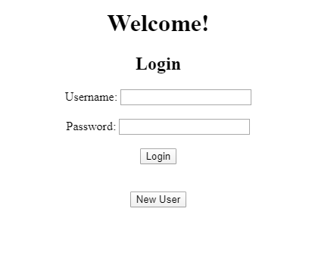

There are 2 accounts predefined for testing purposes, you can find account information in userinfo.db, which is the database to handle user information. There is a field for access level, which is meant to separate users and managers.

1. New user

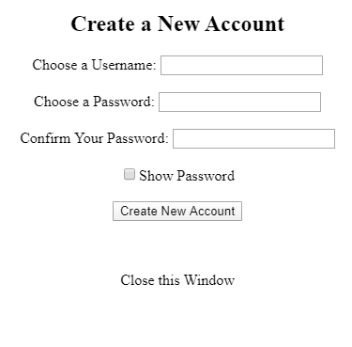

This should be able to allow you to create a new account. The new account is a non-member one by default, and the license plate field will be NULL.

1. Main Window

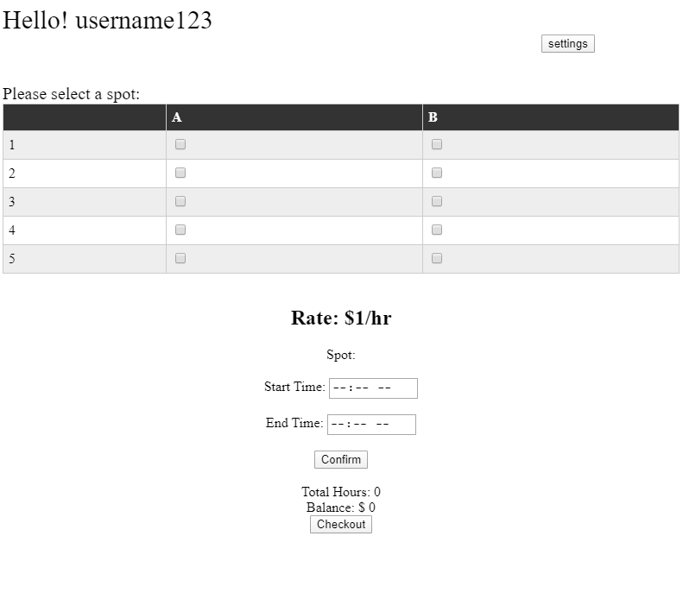

The major problem of this window is that the checkout functionality is basically useless.

It only saves the current selected sopt, start time, end time, and license plate into parkinginfo.db. If the user is not a member, the license plate saved will be NULL

As for now, the application cannot resolve duplicate reservation due to a primary key issue of SQL database. This might be able to got resolved by a more carefully designed database.

1. Settings window

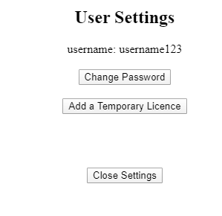

This window should allow you to change password, add tmp license, join or quit membership.

The user settings window for members or non-members will be slightly different, there are some minor bugs due to html format which cause buttons not showing correctly. Unfortunately, I have no idea how to fix it.