Camel coaxing, affect, and the offering of milk in Mongolia

This paper presents the outline of an argument concerning milk, offerings, and the ritual creation of an “affective environment” in Mongolia. I draw on the example of the “camel coaxing ritual”, which was inscribed in December 2015 on the UNESCO List of Intangible Cultural Heritage in Need of Urgent Safeguarding. The Mongolian “coaxing ritual” (*töl avakhuulakh*, *inge khööslökh*, *ivlekh*) involves using song and music to stimulate affective response in livestock who refuse to allow their offspring to suckle. If the ritual is successful, the mother animal succumbs to tearful emotion and gives selflessly of her milk to her calf, thereby allowing herself to be milked by the herder. Since I have personally been involved in several UNESCO intangible heritage nomination processes in Mongolia (though not with this specific nomination), I take particular interest in this case and in the anthropological insights we might bring to it.

**Background: camels and pastoralism in Mongolia**

Mongolian pastoralism involves the mobile tending of livestock – sheep, goats, horses, cattle, and camels – in steppe and Gobi desert regions.

Today approximately a third of the three million people in Mongolia live as commercial or subsistence-level herders.

Nearly all herders keep multi-species herds, and milk at least one type of livestock.

Camels are almost exclusively limited to the arid Gobi region covering the southern half of the country, where they are used for milk, wool (camel hair), and transportation.

The number of camels in Mongolia declined with the dissolution of state-organized Collectives in the early 1990s, which had maintained herds of thousands of camels, but has rebounded in recent years ( Figure 1) – at least partly due to efforts to efforts to reposition the camel as a cultural symbol.

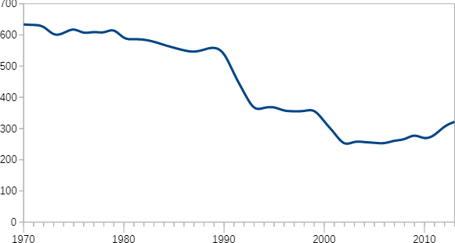

*Figure 1: Camels in Mongolia (thousands). Data source: Mongolian Statistical Information System (MONSIS), National Statistics Office of Mongolia.*

**Communicating with livestock**

Although the ritual I am describing here relates specifically to camels, the indigenous knowledge and practices involved in Mongolian pastoralism encompass a broad range of means for communicating with all species of livestock.

These practices include separate calls for each type of livestock: for instance, *chai* to tell sheep and goats to change direction; *öökh* to tell sheep and goats to be alert; a whistle and *khai* to tell them to speed up; and so on (these are documented effectively by Fijn 2011b in her audiovisual “[Vocalisation Dictionary](https://vimeo.com/13447497)”, see also Fijn 2011a.).

Human-animal communicative practices are not limited to such simple commands – which are by no means unique to Mongolian herders – but encompass other forms that position livestock as fully sentient beings.

Coaxing rituals, in particular, assume that animals are capable of emotional response, which can be stimulated by vocalizations, music, and song.

The coaxing ritual may be performed to encourage an animal to recognize her own offspring, or alternatively to persuade her to adopt an orphaned calf.

Sheep are coaxed with melodic calls of *toig toig*, goats with *cheeg cheeg*, cows with *ööv ööv*, and camels with *khöös khöös*, along with appropriate instrumental melodies or song (Figure 2).

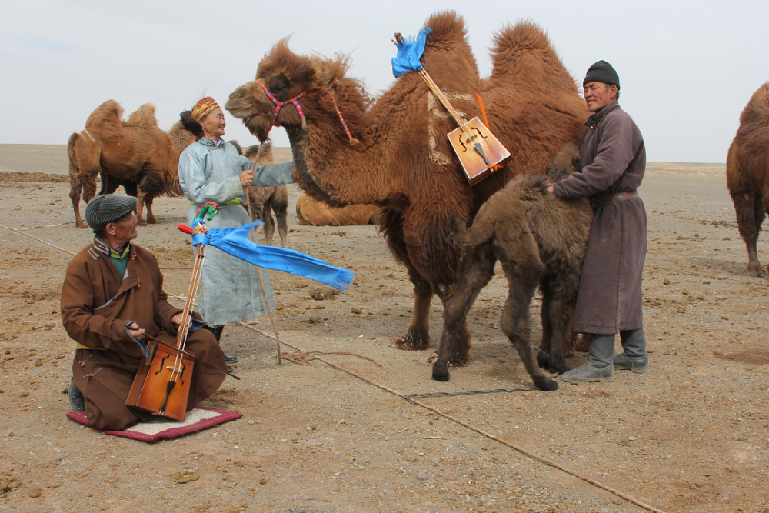

*Figure 2:* [*Camel coaxing*](https://www.youtube.com/watch?v=kHhseWLhKhY&feature=emb_imp_woyt)*. Extract from the UNESCO nomination, video by B. Yündenbat.*

Although most herders are capable of basic coaxing, more difficult cases may require the engagement of skilled singers and musicians, typically performers of the *morin khuur* (horse-head fiddle) or flute.

The ritual can also involve offerings of milk and dairy products, rubbed or sprinkled on the back of the animal.

Pegg positions these practices of “musical remedies” alongside methods of “placating livestock with music of the wind”, which she points out is viewed as organically related to whistling, overtone singing (*khöömii*), and other indigenous Mongolian musical forms (Pegg 2001; 1992).

To the extent that they reflect the “sounds of nature”, indigenous music and song are in effect said to be comprehensible to non-human species.

In this sense, such practices are indicative of a relational/animist ontology that presupposes the possibility of cross-species communication through a common (Mongolian) language, of which human speech and music are only a sub-set.

The following free translation of part of a popular song variant directed at camels illustrates the appeal to the camel’s emotion (this version is published in various sources, e.g., Tsolmon et al. 2014; Mend-Ooyoo 2011):

Why do you mistakenly reject  
Your dear little calf—  
Born to suckle and taste  
Your deep yellow colostrum—  
Who rises in the morning and waits with pursed lips?  
Let her suckle your rich milk!  
*Khöös khöös khöös khöös…*

Here the camel is praised for her “deep yellow colostrum”; gently told that she is “mistaken” in rejecting her calf; and encouraged to feel pity and sorrow for the “dear little calf” that stands waiting expectantly for her mother, early in the morning, driven *naturally* by birth toward her mother’s teat.

The exhortative statement at the end of the verse, continuing into the refrain *khöös khöös khöös khöös…*, urges the camel to share freely of her milk.

**Milk offerings and affectional bonds**

This use of musical melodies and calls intended to induce heightened emotions draws on the understanding that milk production is related to a special emotional state associated with the mother–infant bond.

This view of maternalism is not limited to livestock: the concept of *khökh goridokh*, an illness in lactating human mothers who are denied an expected gift, similarly reflects the understanding that milk production in humans is directly related to affective state.

Significantly, this affective state is not ascribed to individual psychology, but exists in the relational space between actors – activated, in these cases, by the offering of milk or the gift.

The offering of milk, both by the mother to her child and as a gift by humans, epitomizes the selfless offering underpinning the intersubjective relations that enable pastoralism as a body of reproductive practices.

Milk is the most widely used element of ritual offerings in Mongolia, being provided daily to local mountains and spirits through the practice of *tsatsal örgökh* (“sprinkled offerings”), or presented to the non-physical beings that inhabit sacred natural sites.

Mongolians frequently attribute their entire subsistence to the “bounty” of livestock – an interpretation that directly acknowledges the agency of animals in offering their milk, wool, and selves to humans.

As Kettel has pointed out in relation to pastoralists elsewhere, a “symbiotic relationship” between women and livestock emerges through milking:

In order to yield well, livestock – particularly cattle – require familiarity with the people who milk them. The milking relationship that develops between the milker and the cow is a continuing context of animal domestication in pastoral production. (Kettel 1992, 26)

The Mongolian herders with whom I worked agreed strongly with this description, asserting moreover that *negative* relations between a herder and her livestock can produce tangible negative effects.

I was told for instance that one household had very bad karma, or “had curses” (*kharaaltai*), meaning that anything they touched was afflicted: milk would spoil, a cow’s udder would dry up before the calf had been weaned, livestock would be stillborn, healthy animals would die…

Several of the pastoral women with whom I worked asserted that dairying, in “pure” spirits, is *ikh buyantai ajil* – work possessing great virtue.

“Buyan”, a religious term, is used to mean both “wholesomeness” (or “virtue”) and “merit”, encompassing any action, speech, or thought that helps others or reduces suffering.

Indeed, milk is widely seen by these women as deriving from a close, trusting (e.g., maternal) relationship.

Mongolian dairying practices are thus grounded in the idea that the mother’s continued giving of milk is contingent on her ongoing maternal care for her offspring: young livestock are not weaned until winter, when the cattle stop producing milk in preparation for spring birth, and calves are always allowed to suckle briefly before the cow is milked by humans.

**Applications: Heritage safeguarding in relational terms**

In describing coaxing rituals as linked to the maintenance of positive affectional relations among humans and livestock, I aim to refocus discussion of these practices on their role in maintaining *relational well-being*, cautioning against their reduction to decontextualized signifiers of “cultural heritage” in urban-centred nationalist discourse.

Mongolia’s culture policy in the area of “intangible cultural heritage” reads as a salvage ethnography program, organized by a documentation and research focus and coordinated by universities and research institutes.

Mongolia’s initial 2011 application for recognition of the camel coaxing ritual was in fact withdrawn upon cautioning in this regard by UNESCO, on the grounds that the proposed safeguarding measures focused “primarily on academic research and formalized apprenticeship” rather than involving pastoral communities (UNESCO 2011).

While the revised nomination has been welcomed for its increased attention to community involvement (UNESCO 2015), the proposed efforts remain formalized, contingent on external funding for training in district Culture Centres, and involve only nine “heritage bearers” from three of the Gobi provinces.

Acknowledging the pragmatic reasons for this strategy, I suggest that culture and development policy needs to address the resilience of relationships between humans, livestock, the ecological environment, and indigenous knowledge and practices, beyond the substantive “authenticity” of specific cultural and technological practices.

Asserting the well-being value of relational practices such as the coaxing ritual can provide a strong incentive for safeguarding efforts in the face of the broader shift from “pastoralism” to value chain-directed “livestock production”.

**Gloss of an *inge khööslökh* ritual poem variant**

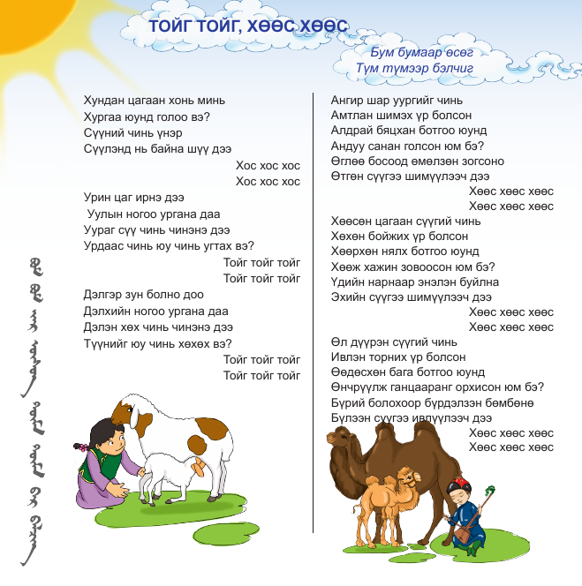

*Figure 3: Page from the 2014 Mongolian Grade IV civics Ethics Reader, presenting toig and khöös ritual poems (Tsolmon et al. 2014, 16).*

The female camel is coaxed with a ritual song known as *inge khööslökh*:

Ангир шар уургыг чинь

Angir shar uur[a]g-yg chini

reddish yellow colostrum-INS you.POSS

"Your deep yellow colostrum"

Амтлан шимэх үр болсон

Amt-la-n shim-[e]kh ür bol-son

taste-V-PROG nourishment-V.INF seed become-PST

"An infant born to suckle and taste"

Алдрай бяцхан ботгоо юунд

Aldrai byatskhan botg[o]-oo yuund

dear little camel calf-POSS what-DAT

"For what [do you reject] your dear little calf"

Андуу санан голсон юм бэ?

Anduu sanan gol-son yum be?

Wrong think-PROG reject-PST EMP Q

"Why [do you] mistakenly reject"

Өглөө босоод өмөлзөн зогсoно

Öglöö bos-ood ömölzö-n zogs-[o]no

Morning rise-PERF purse-PROG stand-PRS

"[She] rises in the morning and waits with pursed lips"

Өтгөн сүүгээ шимүүлээч

Ötgön süü-g-ee shim-üül-eech

Thick milk-INS-POSS nourishment-CAUS-EXH

"Let [her] suckle your rich milk!"

Хөөс хөөс хөөс хөөс...

Khöös khöös khöös khöös...

**References**

Fijn, Natasha. 2011a. *Living with Herds: Human-Animal Coexistence in Mongolia*. Cambridge University Press.

———. 2011b. “Living with Herds: Vocalisation Dictionary.” <https://vimeo.com/13447497>.

Kettel, Bonnie. 1992. “Gender Distortions and Development Disasters: Women and Milk in African Herding Systems.” *NWSA Journal*, 23–41.

Mend-Ooyoo, G. 2011. “Монгол яруу найргийн арга билиг [Yin and Yang of Mongolian Poetry].” <http://www.mend-ooyo.mn/news/99.html>.

Pegg, Carole. 1992. “Mongolian Conceptualizations of Overtone Singing (Xöömii).” *British Journal of Ethnomusicology* 1 (1): 31–54.

———. 2001. *Mongolian Music, Dance, & Oral Narrative: Performing Diverse Identities*. University of Washington Press.

Tsolmon, Sh, U Tuyaa, O Purev, S Batsukh, and G Tsevelmaa. 2014. *Иргэний боловсрол IV: Ёс суртахууны унших эх [Civic Education IV: Ethics Reader]*. Ministry of Education; Science, Mongolia.

UNESCO. 2011. “Recommendations of the Consultative Body for the Inscription on the List of Intangible Cultural Heritage in Need of Urgent Safeguarding in 2011: Document ITH/11/6.COM/CONF.206/.” <http://www.unesco.org/culture/ich/doc/src/ITH-11-6.COM-CONF.206-8+Corr.+Add.-EN.pdf>.

———. 2015. “Decision of the Intergovernmental Committee: Document 10.COM 10.A.5.” <http://www.unesco.org/culture/ich/en/decisions/10.COM/10.A.5>.