Axle ridges over 1 millimeter off.

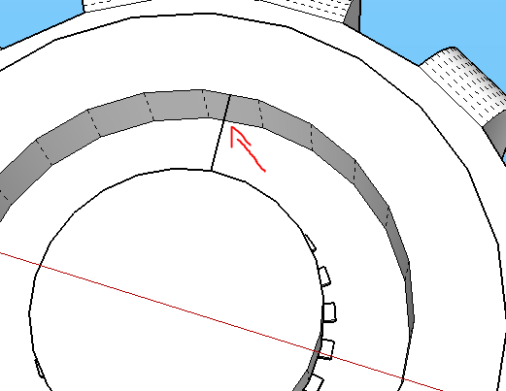

This measurement is about 1.5 off

I believe you have the diameter of the hole off as well. Not sure if that was purposed.

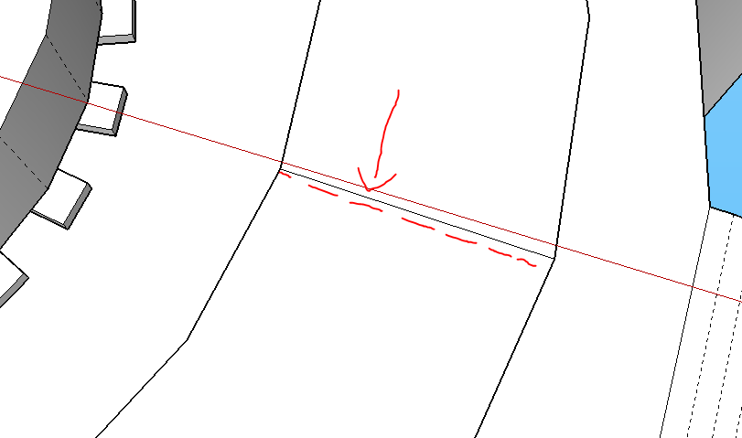

Another millimeter long

Wheel ridge height about half a millimeter off as I measure it.

Check other measurements