Eric Tweedie

CSC 6302 Project 7 write up

Questions on Final project:

1. The part of the project that I believe will be the most difficult is getting the presentation layer to work accordingly to what I am trying to achieve. I had some issues with the week 6 project but was able to sort it all out but it took a good amount of work. I plan on trying to mitigate that by having a better idea of exactly what I am trying to achieve in that layer so I know where to start and what I am looking to get out of it, that was a part of my issue from the week 6 project with not knowing how I exactly wanted to implement the presentation layer.
2. The theme of my final project is going to be a toy store (Tweedies Toys) and the database is going to keep hold of the customers, the orders, and the shipping information. When it comes to the tables, what is going to be in them is:

* Customers table it will have customer ID (primary key), first name, last name, phone number, email address, and address.
* Orders table there will be order ID (primary key), customer ID (foreign key), the item(s), quantity and price.
* Shipping table it will have the package ID (primary key), weight of the package, package handler, customer ID (foreign key) and order ID (foreign key).

1. ERD diagram:

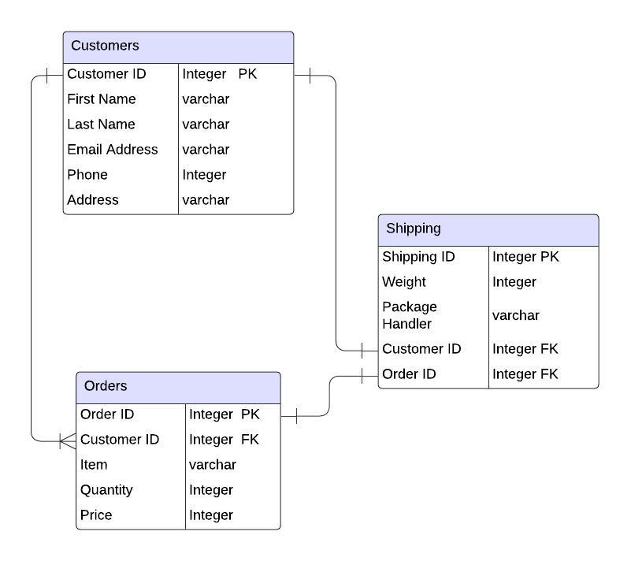

1. My read procedures will be showing all the orders that have been done, show the customers of the store. The modification procedures will add customers to the store, add the orders, and who is shipping them.
2. I will be using PySimpleGUI for the view layer
3. Yes, I will be including a README for how to run the program.
4. I will be testing the project as I go making sure everything runs with no errors. I will be testing to make sure that all the SQL syntax is correct by dropping the database and everything each time I am running a test after adding a new part. I will also be continuously testing the application as it is coming together. Then once it is all put together will be testing it with as many as many error prone tests I can do. Will also be including plenty of error handling within the project itself.
5. Timeline for the project:
   1. 12/8/24 – start of development, aim to have SQL database files planned
   2. 12/9/24 – SQL files completed and tested fully, start application layers
   3. 12/10/24 – have application layers set up, start testing
   4. 12/11/24 – application completed, testing complete
   5. 12/12/24 – full run through testing, submission
6. I do not have any questions currently about the project