**FFT/IFFT, Heart Rate Analysis, and Game Development**

1. **FFT/IFFT Audio Signal Processing**

**\*\*\*\*\*\*\*\*\*\*\*\*\*\*\*\*\*\*\*\*\*\*\*\*\*\*\*\*\*\*\*\*\*\***

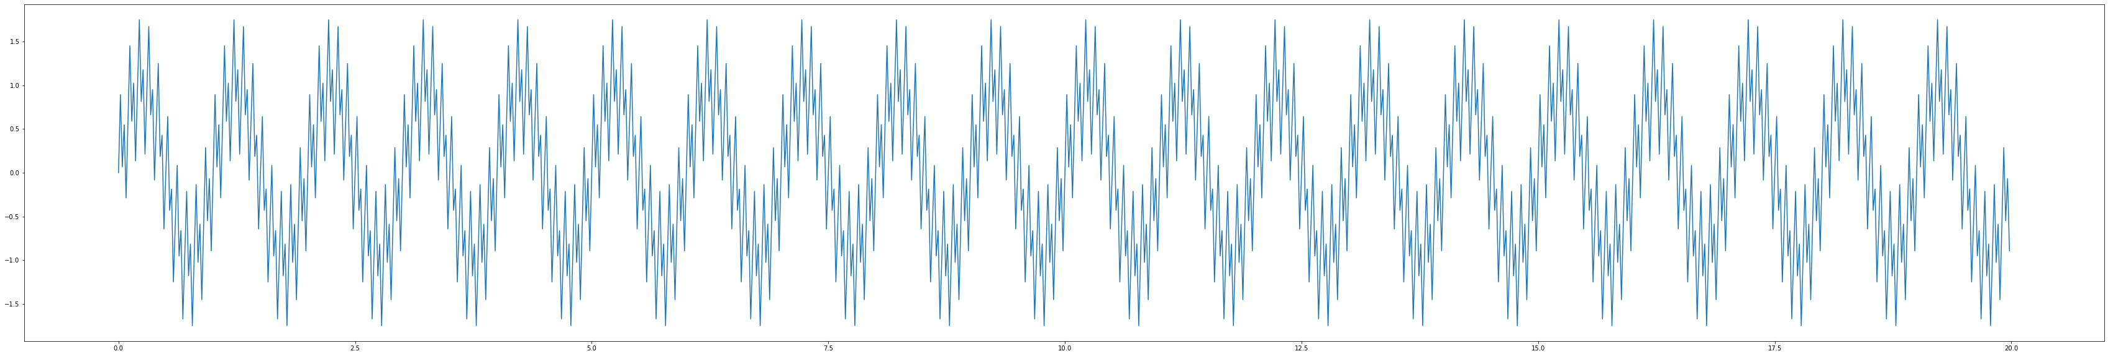

Figure 1: Combinations of three signals with different frequencies.

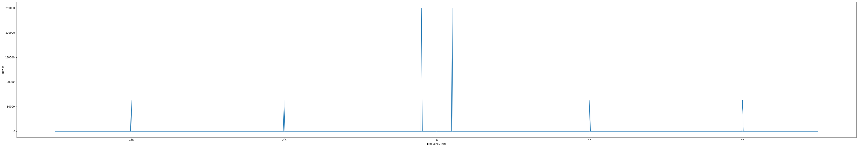

Figure 2: Plot of FFT power with low and high frequencies.

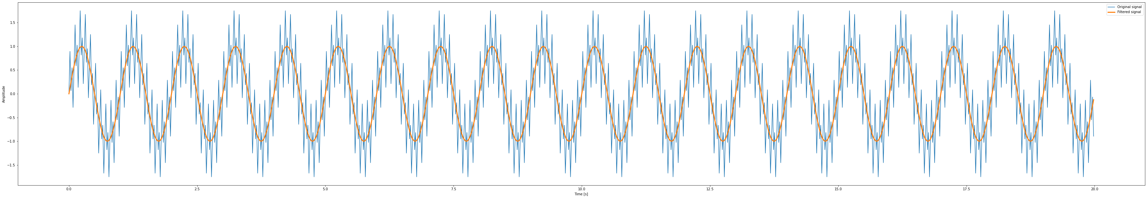

Figure 3: Signals after filtering out higher frequencies.

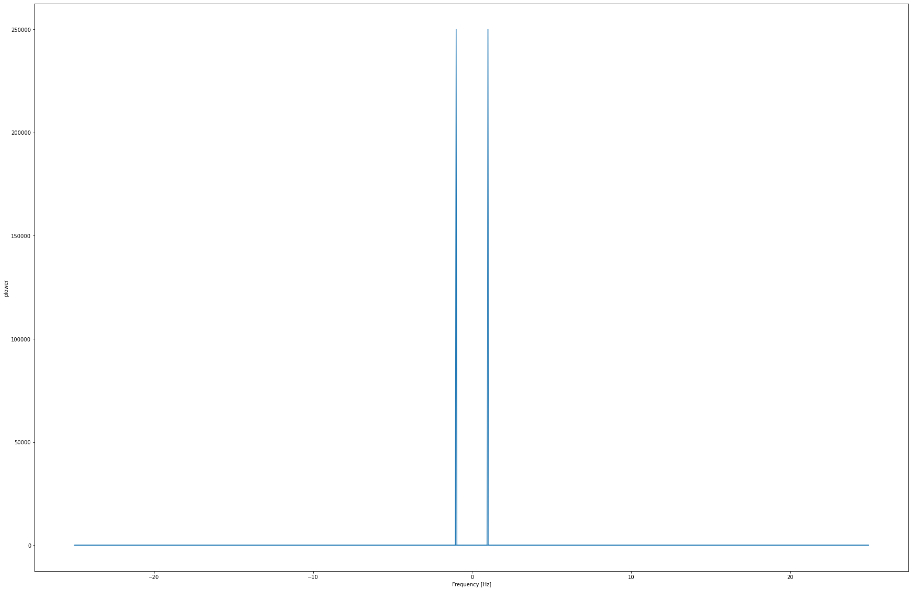

Figure 4: Plot of FFT power without high frequencies

1. **Heart Rate Analysis**

**\*\*\*\*\*\*\*\*\*\*\*\*\*\*\*\*\*\*\*\*\***

* In this program, you need to install the “heartpy” package.
* Run the program with the csv file name “HB_2nd_filtered_Output_mono”

Figure 5: Plot of heartbeat from HB_2nd_filtered_Output_mono.csv

Figure 6: Display computed measures

Figure 7: Visualize in plot of custom size

1. **Game Development: Red Alert**

**\*\*\*\*\*\*\*\*\*\*\*\*\*\*\*\*\*\*\*\*\*\*\*\*\*\*\*\*\*\***

When the game begins, two snowflakes appear and start moving down the screen. Also, snowflakes will be shuffled every second.

You need to click on the red snowflake before the snowflakes reach the bottom of the screen. Each time the red snowflake is clicked, the game moves on to the next level. With each level, more green and blue snowflakes are added, and they move faster than before. If You click on any snowflake other than the red one, or if the snowflakes reach the bottom of the screen, the game ends.

If the game ends, you will have 2 options for choosing. First is close the game, and second is replay the game by pressing on the “space” bar of the keyboard.

Figure 8: Game playing screen

**References**

**********

<https://www.kaggle.com/datasets/kinguistics/heartbeat-sounds>

**Author**

******

Hung Vuong