Project Identification

Project: | Social Recruitment Website
Prepared By: | Sunny Arun, Yoo Kyung Baek, Tan Loi Ngo, Xiaolin Wang, Ke Wang
Document Version: | 1st
Published Date: | October 02, 2021

Contributors
The following individuals contributed to this document.
Name | Title
Sunny Arun | Programmer
Yoo Kyung Baek | Programmer, communications
Tan Loi Ngo | Programmer
Xiaolin Wang | Programmer, communications
Ke Wang | Programmer

Distribution
This document is distributed to all the following people.
Name | Title
Sunny Arun | Programmer
Yoo Kyung Baek | Programmer, communications
Tan Loi Ngo | Programmer
Xiaolin Wang | Programmer, communications
Ke Wang | Programmer
Referenced Documents
This document refers to the following materials
Version number | Title | Author | Date | Source / Location
1 | Project Summary Template | Yoo Kyung Baek  Xiaolin Wang  Ke Wang | Oct 02, 2021 | /capstoneproject/sprint1/project_summary
2 | Project Vision Template | Yoo Kyung Baek | Oct 04, 2021 | /capstoneproject/sprint1/project_vision

Revision History

Version Number | Revision Date | Summary of Changes | Modified by
1.0 | Oct 02, 2021 | Primary Document | Yoo Kyung Baek, Xiaolin Wang,  Ke Wang
TABLE OF CONTENTS
1. Business Context Diagram 3
2. REquirements Scope Statements 4
3. High Level Business Requirements (HLR) Traceability 4
4. High Level Business Requirements Sign-Off 4

- 1. Business Context Diagram
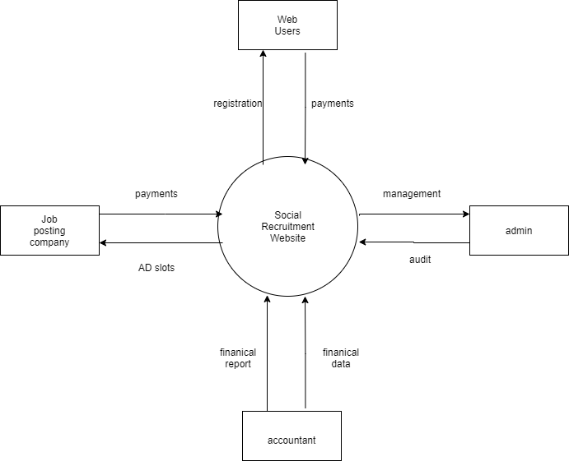

Requirement Scope Area | Description
All adults | As the burden of living increases, adults will have higher and higher demands for salary.

External Entity | Description
Web users | All users of the site
Job posting company | All companies that work on website publishing
Admin | The tasks of the administrative department include the promotion of the website, etc.
Accountant | The accounting department keeps accounts, settle accounts, reimbursements, etc. of the company's capital status

Information Flows | Description
Web users & Social Recruitment Website | Website users achieve the purpose of using the website by registering for payment on the website.
Job posting company & Social Recruitment Website | Other companies pay to post work and place advertisements on the website.
Admin & Social Recruitment Website | The administrative department manages and audits everything in the company
Accountant & Social Recruitment Website | The accounting department provides the company with financial reports, financial data, etc.

2. Requirements Scope Statements
HLR# | Description | Priority  (H, M, L)
 | Promotion of the website | H
 | Database update and security issues | M
 | Posting of work abroad | L

3. High Level Business Requirements Sign-Off
The undersigned acknowledge their agreement with the contents of Version <1.0> of the High-Level Requirements document for <Recruitment Application>.

Following approval of this document, requirements changes will be governed by the project’s change management process, including impact analysis and appropriate reviews and approvals, under the general control of the Project Plan and according to company policy. Approved Change Request Documents, if present, will be attached to this Requirements Document as updates.

Name | Project Role and  Functional Area | Date Signed
Sunny Arun | Programmer | October 08, 2021
Yoo Kyung Baek | Programmer, communications | October 08, 2021
Tan Loi Ngo | Programmer | October 08, 2021
Xiaolin Wang | Programmer, communications | October 08, 2021
Ke Wang | Programmer | October 08, 2021

* Note: physical signatures are not required. Email approvals are acceptable and should be appended to project documents.

