Students
Eric Rogers, Justin Liles, and Brandon Demello

QTerminal

Project Objective
This software project allows teachers to create and grade tests along with allowing students to partake in the test. In doing this it allowed our team to give back to the education community with a well commented and documented test taking software. This program will be open sourced under the GPL 2 license on GitHub. Link: https://github.com/EricWRogers/SoftwareEngineeringClass

Project Methodology
- Well-defined Classes.
- Sensible variables names.
- Clearly commented functions.
- Safe and reusable data Storage. “Json”
- Cross platform source control using Git.

User requirements:
- Determine if the user is a student or administrator.
- Support multiple choice, T/F, and open response questions.
- If the user is a student then they need to be able to choose the test they want to take.
- If the user is an administrator they need to be able to either change a current test or be able to make a new one altogether.

System Requirements:
- Store test
- Store questions and type of questions
- Load Selected Test
- Write and save to files (Questions, Name, User Selection etc.)
- DotNet Core 2.2 installed.

Report on Testing

Testing Strategies/Plans:
- Found functions that work better with unit testing
- Evaluated different testing solutions and settled with ‘XUnit’ for its open source unit testing solutions.
- After evaluations we settled with static functions that had a consistent, concise, and reproducible outcomes.
- After finding flaws used try/catch statements to try and return a statement even if it failed.

Workload
- Eric Rogers: Backend, User Interface, and Set up Unit Testing.
- Justin Liles: Researched and implemented Unit Testing, and Documentation.
- Brandon Demello: User Interface, researched other User Interface options, and Documentation.

Feature Improvement
- Graphical User Interface.
- Implement network access using either a web basted portal or local client that uses internet access.
- Higher quality security.

Lessons learned
- Research documentation on libraries and api’s before implementing them.
- Plan how classes and functions will interact before implementation (drawing board).
- Time management / Crunch.

UML Class Diagrams
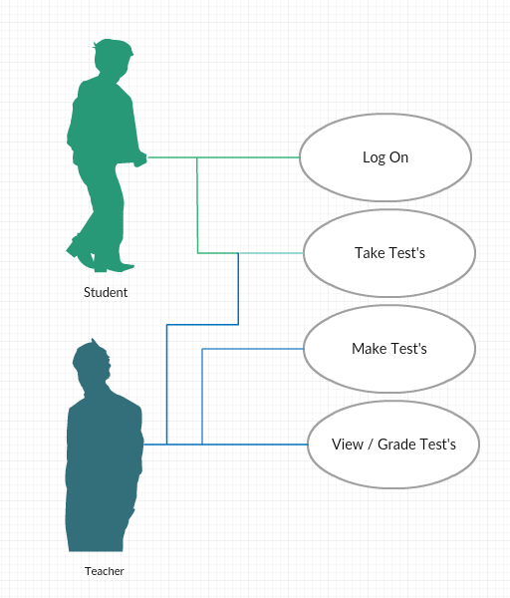

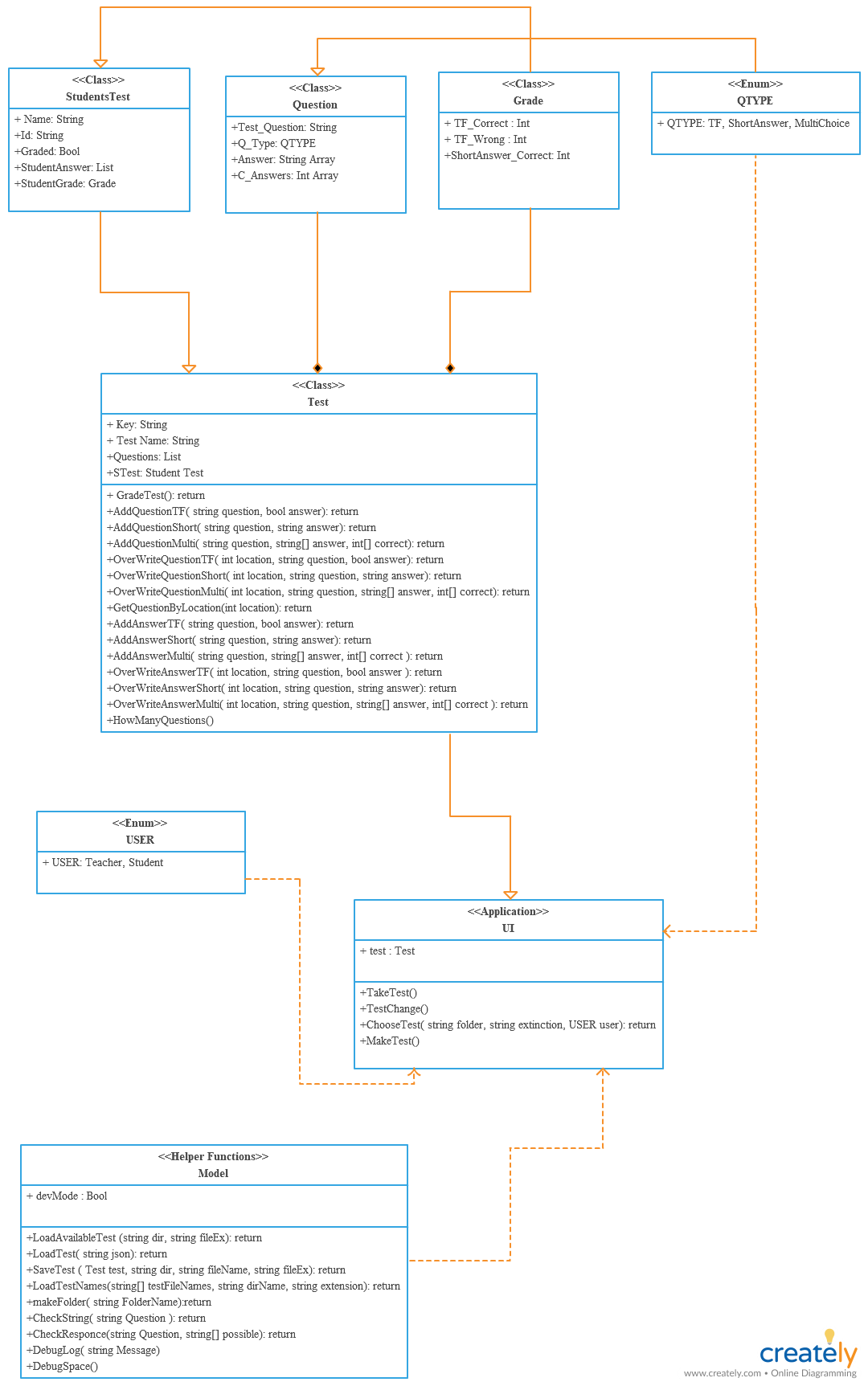
UML Case Diagrams

