《实验9》实验报告

学号：18281218 姓名：王子龙 上机日期时间：Nov 30th

1．[实验目的]
（1）理解和掌握一维二维数组的使用
（2）掌握string.h的部分操作

2．[实验内容、算法、流程图及主要符号说明]
实验1. 从键盘输入10个排好序的整数，用折半查找法查找某个数是否出现。
实验步骤：
- 编写一个函数int search(int nArray[], int n, int x)，进行多项式运算
- 编写一个主函数，输入十个数，调用search函数，并进行计算。
3．[完整的程序清单]
#include <stdio.h>
int search(int nArray[], int n, int x);
int main() {
int a[10] = {1,2,3,4,5,6,7,8,9,10};
int x;
printf("Please input 10 nums in order:");
scanf("%d%d%d%d%d%d%d%d%d%d",&a[0],&a[1],&a[2],&a[3],&a[4],&a[5],&a[6],&a[7],&a[8],&a[9]);
printf("Please input the num which is you want to find:");
scanf("%d",&x);
printf("is:%d\n",search(a,10,x));
return 0;
}
int search(int nArray[], int n, int x){
int low = 0, high = n-1,mid;
while (high - low >= 0){
mid = (low+high)/2;
if (x > nArray[mid]){
low = mid+1;
} else if (x < nArray[mid]){
high = mid-1;
} else {
return 1;
}
}
return 0;
}

4．[输入数据及运行结果]
Please input 10 nums in order:1 2 3 4 5 6 7 8 9 10
Please input the num which is you want to find:8
is:1

Process finished with exit code 0
Please input 10 nums in order:1 2 3 4 5 6 7 8 9 10
Please input the num which is you want to find:12
is:0

Process finished with exit code 0

5．[调试分析、体会及存在的问题]
测试时出现小错误导致程序一直无法调通，因此调试需认真！

实验2写一个函数，统计某字母（不区分大小写）在字符串中出现的次数。
- 实验步骤：
（1）编写一个函数count(char str[],char c)，将字符串和需要检索的char全部转换为大写，方便统计
（2）编写一个主函数，输入字符串，和要找出个数的char，调用count函数，并运算。
[完整的程序清单]
#include <stdio.h>
#include <string.h>
int count(char str[], char c);
int main() {
char flag[1000],b;
printf("please input a string:");
gets(flag);
printf("please input the word you want to count:");
scanf("%c",&b);
if (b >= 'a') b -= 32;
printf("have %d same letter\n",count(flag, b));
return 0;
}
int count(char str[], char c){
int a = 0;
int i = 0;
while (str[i] != '\0') {
if (str[i] >= 'a') str[i] -= 32;
i++;
}
i = 0;
while (str[i] != '\0') {
if (str[i] == c) a++;
i++;
}
return a;
}

4．[输入数据及运行结果]
please input a string:warning: this program uses gets(), which is unsafe.
Beijing Jiaotong Uninversity
please input the word you want to count:J
have 2 same letter

Process finished with exit code 04

5．[调试分析、体会及存在的问题]
macOS系统下的string.h内不含有strlwr,strupr函数，因此纠结了好久，最后决定放弃自己写。

实验3. 3. 写一个函数squeeze(char s1[], char s2[])，它从字符串s1中删除所有出现在串s2里的字符，并保证不改变原字符串s1的先后顺序。
- 实验步骤：
- 编写一个函数void squeeze(char s1[], char s2[])，进行对比删除
（2）编写一个主函数，输入s1 s2。
3．[完整的程序清单]
#include <stdio.h>
#include <string.h>
void squeeze(char s1[], char s2[]);
int main() {
char ss1[1000],ss2[1000];
printf("please input s1:");
gets(ss1);
printf("please input s2:");
gets(ss2);
squeeze(ss1,ss2);
puts(ss1);
return 0;
}
void squeeze(char s1[], char s2[]){
int i = 0,j = 0;
while (s2[i] != '\0'){
j = 0;
while (s1[j] != '\0'){
if (s1[j] == s2[i]) s1[j] = 127;
j++;
}
i++;
}
}

4．[输入数据及运行结果]
please input s1:warning: this program uses gets(), which is unsafe.
_{abcdef}
_{please input s2:cf}
_{abde}

Process finished with exit code 0

实验4.回文是从前向后和从后向前读起来都一样的句子，如英文的level，amannama，请写一个函数，它能够判断一个字符串是否为回文。另外，考虑如果该字符串为中文字符时（如：落叶秋深秋叶落）如何处理。
- 实验步骤：
- 写函数BTT_CN,BTT_EN,BIT，功能分别为判断中文回文，英文回文，字符串位数
- 写main判断中文or英文？传入字符串
3．[完整的程序清单]
#include <stdio.h>
int BTT_EN(char *str);
int BTT_CN(char *str);
int BIT(char *str);
int main() {
int a;
char test[1000] = {0};
printf("Please set MODE(EN:0,CN:1):");
scanf("%d",&a);
printf("Please input your string:");
scanf("%s",test);
if(!a) {
if (BTT_EN(test)) printf("Yes!\n");
else printf("No!\n");
} else{
if (BTT_CN(test)) printf("Yes!\n");
else printf("No!\n");
}
return 0;
}
int BTT_EN(char *str){
int a = BIT(str);
for (int i = 0; i < a/2; ++i) {
if (str[i] != str[a-i-1]){
return 0;
}
}
return 1;
}
int BTT_CN(char *str){
int a = BIT(str);
for (int i = 0; i < a/2; i+=3) {
if (str[i] != str[a-i-3]){
return 0;
}
}
for (int i = 1; i < a/2; i+=3) {
if (str[i] != str[a-i-1]){
return 0;
}
}
for (int i = 2; i < a/2; i+=3) {
if (str[i] != str[a-i+1]){
return 0;
}
}
return 1;
}
int BIT(char *str){
int i = 0;
while (str[i]!= '\0') i++;
return i;
}

4．[输入数据及运行结果]
Please set MODE(EN:0,CN:1):0
Please input your string:bananab
Yes!

Process finished with exit code 0
Please set MODE(EN:0,CN:1):0
Please input your string:abcdefg
No!

Process finished with exit code 0
Please set MODE(EN:0,CN:1):1
Please input your string:落叶秋深秋叶落
Yes!

Process finished with exit code 0
Please set MODE(EN:0,CN:1):1
Please input your string:王子龙最帅
No!

Process finished with exit code 0

5．[调试分析、体会及存在的问题]
在macOS系统下，一个中文占字符串数组的三位，而提示说的是两位

实验5. 5. 写一个程序，它从键盘读入多行字符（用gets），直到遇到字符串“ctrl+z”，读入结束，输出读入的多行字符中最长的词（词以空格、标点符号分割）。
- 实验步骤：
- 编写main函数，在函数输入并进行判断
3．[完整的程序清单]
#include <stdio.h>
int BIT(char *str);
int main() {
char a[100][1000],b[1000];
int i = 0,j = 0,max = 0;
while (gets(b) != NULL){
gets(a[i]);
i++;
}
for (j = 0; j < i; ++j) {
if(BIT(a[j]) > BIT(a[max])) max = j;
}
printf("The longest is:");
puts(a[max]);
return 0;
}
int BIT(char *str){
int i = 0;
while (str[i]!= '\0') i++;
return i;
}
}

4．[输入数据及运行结果]
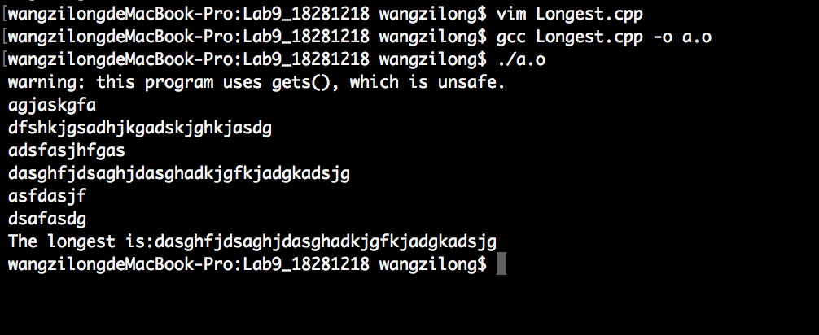

5．[调试分析、体会及存在的问题]
macOS系统下，结束为“control+d”，另外IDE不支持输入NULL，通过在terminal中使用vim与gcc解决。

实验6. 借助二维数组打印杨辉三角实验步骤：
- 编写main函数，并通过杨辉三角定义进行计算，最后输出
3．[完整的程序清单]
#include <stdio.h>
int main() {
int flag[100][100] = {1},line;
printf("How many lines would you like to print?\n");
scanf("%d",&line);
for (int i = 1; i < line; ++i) {
for (int j = 0; j < i+1; ++j) {
if (j == 0 || j == i){
flag[i][j] = 1;
} else {
flag[i][j] = flag[i-1][j-1] + flag[i-1][j];
}
}
}
for (int k = 0; k < line; ++k) {
int i = 0;
while (flag[k][i]!=0){
printf("%d ",flag[k][i]);
i++;
}
printf("\n");
}
return 0;
}

4．[输入数据及运行结果]
How many lines would you like to print?
5
1
1 1
1 2 1
1 3 3 1
1 4 6 4 1

Process finished with exit code 0
How many lines would you like to print?
9
1
1 1
1 2 1
1 3 3 1
1 4 6 4 1
1 5 10 10 5 1
1 6 15 20 15 6 1
1 7 21 35 35 21 7 1
1 8 28 56 70 56 28 8 1

Process finished with exit code 0

5．[调试分析、体会及存在的问题]
数组的0和现实的1的关系！

实验7. 自定义函数找出二维矩阵的鞍点，如果没有鞍点打印相应信息。
实验步骤：
- 编写main函数，逐行寻找鞍点，找到即return 0，因为经我通过数学反证法推算，一个矩阵至多只有一个鞍点：
Let a[m][n]&a[p][q]（m≠p，n≠q）be saddle points
Cause a[m][n] is a saddle point:
a[m][n] > a[m][q]
a[m][n] < a[p][n]
Because a[p][q] is also a saddle point
So a[p][q] >a[p][n]
So a[p][q] >a[m][n]>a[m][q]
Because a[p][q] is a saddle point, so a[p][q] < a[m][q]

3．[完整的程序清单]
#include <stdio.h>
int main() {
int a[1000][1000],line,row;
printf("Please input the lines of this matrix:");
scanf("%d",&line);
printf("Please input the rows of this matrix:");
scanf("%d",&row);
for (int i = 0; i < line; ++i) {
printf("please input the line%d number:",i+1);
for (int j = 0; j < row; ++j) {
scanf("%d",&a[i][j]);
}
}
for (int i = 0; i < line; ++i) {
int m = 0,max = 0;
for (int j = 0; j < row; ++j) {
if (a[i][j] > a[i][max]) max = j;
}
for (int k = 0; k < line; ++k) {
if (a[i][max] > a[k][max]) m = 1;
}
if (!m) {
printf("(%d,%d)=%d is a saddle point\n",i+1,max+1,a[i][max]);
return 0;
}
}
printf("No saddle point!\n");
return 0;
}

4．[输入数据及运行结果]
Please input the lines of this matrix:3
Please input the rows of this matrix:3
please input the line1 number:1 2 3
please input the line2 number:2 3 4
please input the line3 number:3 4 5
(1,3)=3 is a saddle point

Process finished with exit code 0
Please input the lines of this matrix:3
Please input the rows of this matrix:3
please input the line1 number:1 2 3
please input the line2 number:1 2 4
please input the line3 number:3 5 1
No saddle point!

Process finished with exit code 0

