MIDDLE EAST TECHNICAL UNIVERSITY

**EE564**

**DESIGN OF ELECTRICAL MACHINES**

**PROJECT #3**

MODELLING 3-PHASE INDUCTION MACHINE IN MAXWELL 2D

Aycan AYDOĞDU

1496983

# INTRODUCTION

In this project, a 3-phase wind turbine induction motor which is designed in Project #2 with given specifications below is analyzed using RMXpert and Maxwell 2D.

* Rated power: 250 Kw
* Rated wind speed: 14 m/s
* Rated turbine speed: 24.3 rpm
* Gear ratio: 31.2
* Number of poles: 8
* Line to line voltage: 400 V
* Frequency:50 Hz
* Rated speed: 758 rpm
* Insulation class: F

Expected outputs of the projects:

* Model your design to RMxprt.
* In the RMxprt get the performance metrics such as: (torque vs. speed, flux in the airgap, cogging torque etc).
* Export your design into Maxwell 2D (don’t bother with 3D simulations)
* In 2D FEA show the flux density distribution, flux vectors. Calculate the flux densities in the critical parts (tooth, back core etc)
* Comment on general design considerations that you learnt throughout the course.

# ANALYSIS

1. **Modeling the Design in RMxprt**

Analysis result is presented in the appendix part. Design parameters which are determined in Project #2 are used design input to RMxprt. Comparison of basic parameters is given for Project#2 results and RMxprt analysis in .

Table - Results

|  |  |  |
| --- | --- | --- |
|  | **Results of Project #2** | **RMxprt Results** |
| **Magnetization current** | 139.03 A | 145.31 A |
| **Phase current** | 445.49 A | 460.15 A |
| **Stator resistance** | 0.011 ohm | 0.0082 |
| **Rotor resistance reflected to stator** | 0.0047 ohm | 0.0061 |
| **Magnetizing reactance** | 1.62 ohm | 0.47 ohm |
| **Stator winding loss** | 6570 W | 7471.2 W |
| **Rotor cage loss** | 2786 W | 3622.05 W |
| **Stray loss** | 2500 W | 1233.33 W |
| **Total core loss** | 7388 W | 7385 W |
| **Total loss** | 21244 W | 23712 W |
| **Efficiency** | 0.92 | 0.91 |
| **Rated shaft torque** | 3217.94 Nm | 3227.78 W |
| **Power factor** | 0.90 | 0.89 |

Performance curves for RMxprt design is given in figures below. Rated values can be detected where speed is at 740 rpm (reference speed in analysis) for speed curves and where output power is at 250 kw for power curves.

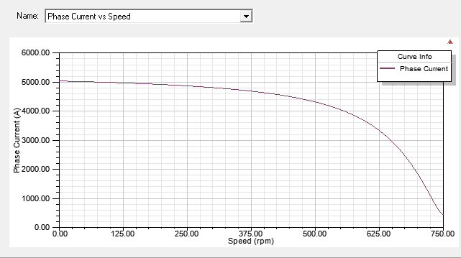

*Figure 1 – Phase Current vs. Speed*

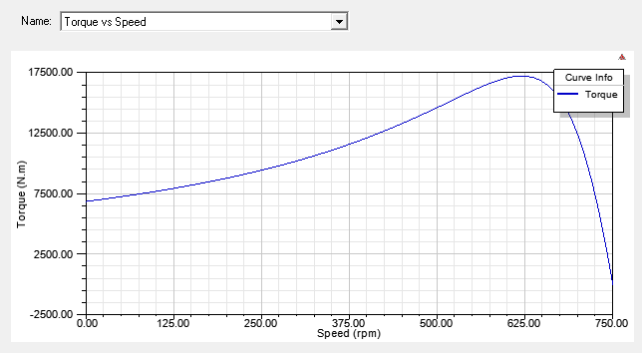

*Figure 2 – Torque vs. Speed*

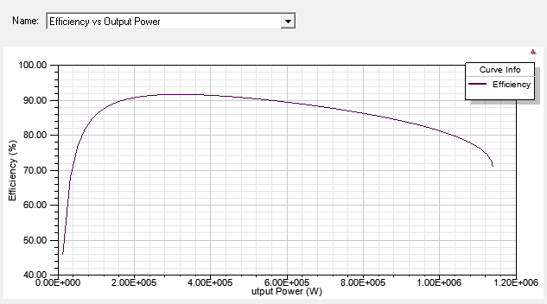

*Figure 3 – Efficency vs. Output Power*

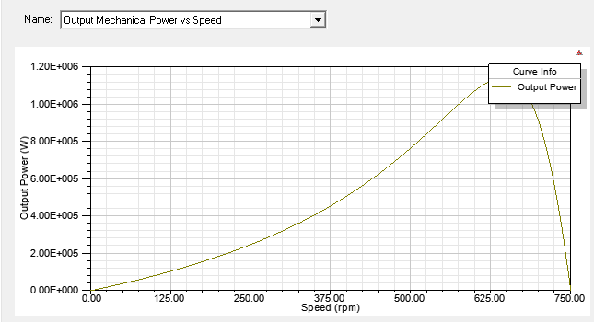

*Figure 4 – Output Mechanical Power vs. Speed*

1. **Maxwell 2D Design**
   1. Transient Analysis

Maxwell 2D design is conducted for the original design. Results are presented below:

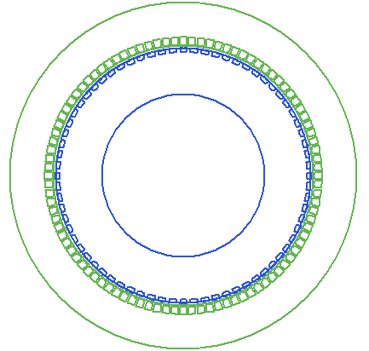

*Figure 5 – Motor main view*

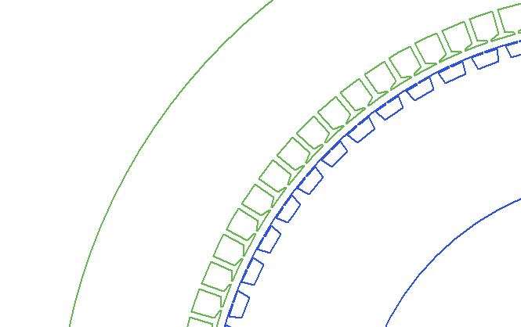

*Figure 6 – Stator and rotor slots*

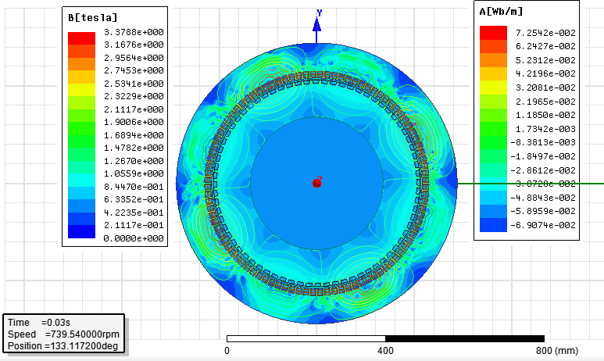

*Figure 7 – Flux lines and magnetic field*

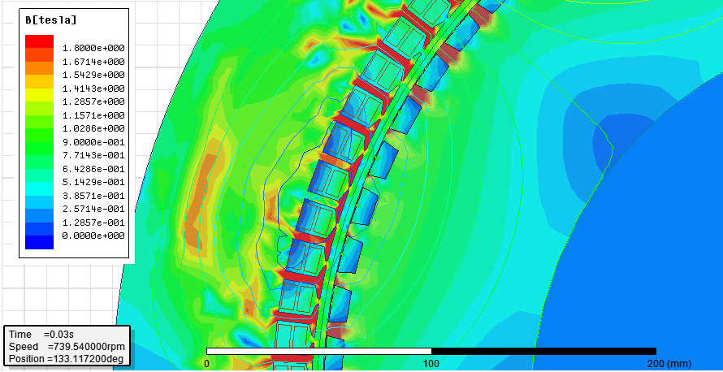

*Figure 8 – Magnetic field in slots and tooth*

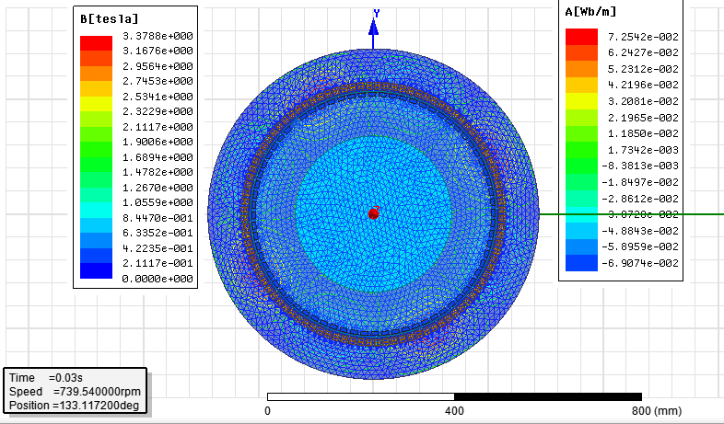

*Figure 9 – Mesh plot*

High value of magnetic field is located in rotor and stator tooth ~ B = 3.37 T. For design iteration, stator and rotor slot dimensions are reduced in width and also sharp edges are smoothed. Lower level of magnetic field is obtained as expected. Results with new slot dimensions are given below.

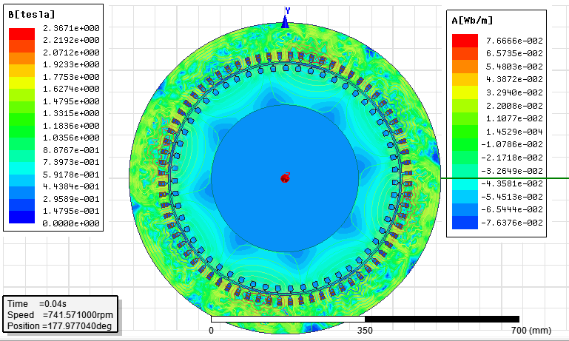

*Figure 10 - Flux lines and magnetic field with new slot dimensions*

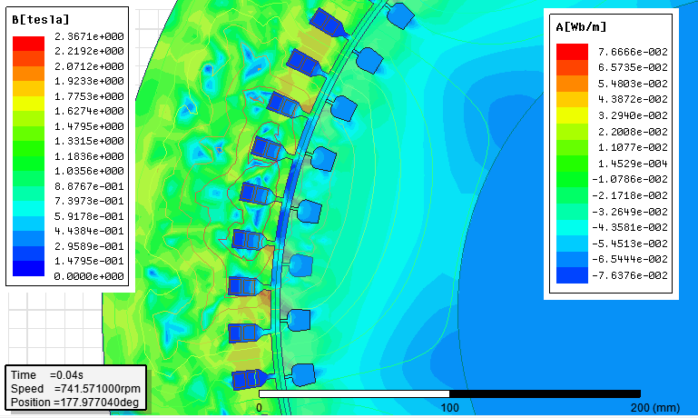

*Figure 8 – Magnetic field in slots and tooth for with new slot dimensions*

* 1. Magnetostatic Analysis

Magnetostatic analysis is carried out for the motor with original parameters. Flux lines and magnetic field can be seen in the figure below. Magnetostatic magnetic field values are much lower than transient analysis.

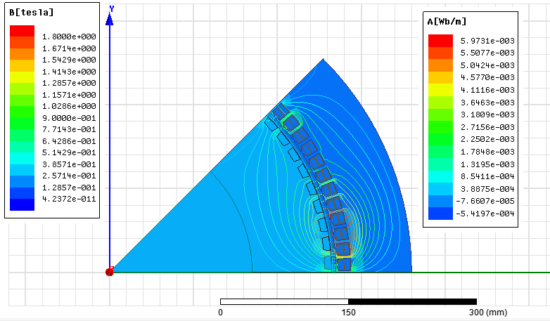

*Figure 11 - Magnetostatic flux lines and B field*

# APPENDIX

Following data is obtained from RMxprt:

GENERAL DATA

Given Output Power (kW): 250

Rated Voltage (V): 400

Winding Connection: Wye

Number of Poles: 8

Given Speed (rpm): 738

Frequency (Hz): 50

Stray Loss (W): 1233.33

Frictional Loss (W): 0

Windage Loss (W): 6063.55

Operation Mode: Motor

Type of Load: Constant Power

Operating Temperature (C): 75

STATOR DATA

Number of Stator Slots: 96

Outer Diameter of Stator (mm): 720

Inner Diameter of Stator (mm): 540

Type of Stator Slot: 3

Stator Slot

hs0 (mm): 1

hs1 (mm): 2

hs2 (mm): 14.6

bs0 (mm): 2.5

bs1 (mm): 14.1

bs2 (mm): 15

rs (mm): 0

Top Tooth Width (mm): 3.77198

Bottom Tooth Width (mm): 3.82786

Length of Stator Core (mm): 330

Stacking Factor of Stator Core: 0.92

Type of Steel: M19_24G1

Number of lamination sectors 0

Press board thickness (mm): 0

Magnetic press board No

Number of Parallel Branches: 2

Type of Coils: 21

Coil Pitch: 10

Number of Conductors per Slot: 4

Number of Wires per Conductor: 42

Wire Diameter (mm): 1.16

Wire Wrap Thickness (mm): 0

Wedge Thickness (mm): 0

Slot Liner Thickness (mm): 0.3

Layer Insulation (mm): 0.3

Slot Area (mm^2): 231.53

Net Slot Area (mm^2): 186.521

Slot Fill Factor (%): 121.199

Limited Slot Fill Factor (%): 75

**** Warning - Result is Unfeasable ****

Slot Fill Factor is beyond its limited value.

Wire Resistivity (ohm.mm^2/m): 0.0217

Conductor Length Adjustment (mm): 0

End Length Correction Factor 1

End Leakage Reactance Correction Factor 1

ROTOR DATA

Number of Rotor Slots: 72

Air Gap (mm): 5

Inner Diameter of Rotor (mm): 340

Type of Rotor Slot: 4

Rotor Slot

hs0 (mm): 0.5

hs1 (mm): 0

hs2 (mm): 8

bs0 (mm): 1.5

bs1 (mm): 17

bs2 (mm): 14

rs (mm): 0

Cast Rotor: Yes

Half Slot: No

Length of Rotor (mm): 330

Stacking Factor of Rotor Core: 0.92

Type of Steel: M19_24G1

Skew Width: 0

End Length of Bar (mm): 0

Height of End Ring (mm): 26.7

Width of End Ring (mm): 42.7

Resistivity of Rotor Bar

at 75 Centigrade (ohm.mm^2/m): 0.0172414

Resistivity of Rotor Ring

at 75 Centigrade (ohm.mm^2/m): 0.0172414

Magnetic Shaft: No

MATERIAL CONSUMPTION

Armature Copper Density (kg/m^3): 8900

Rotor Bar Material Density (kg/m^3): 8900

Rotor Ring Material Density (kg/m^3): 8900

Armature Core Steel Density (kg/m^3): 7650

Rotor Core Steel Density (kg/m^3): 7650

Armature Copper Weight (kg): 96.7219

Rotor Bar Material Weight (kg): 26.3801

Rotor Ring Material Weight (kg): 32.0238

Armature Core Steel Weight (kg): 362.087

Rotor Core Steel Weight (kg): 280.666

Total Net Weight (kg): 797.879

Armature Core Steel Consumption (kg): 695.847

Rotor Core Steel Consumption (kg): 518.212

RATED-LOAD OPERATION

Stator Resistance (ohm): 0.00997477

Stator Resistance at 20C (ohm): 0.00820505

Stator Leakage Reactance (ohm): 0.0243198

Rotor Resistance (ohm): 0.00746315

Rotor Resistance at 20C (ohm): 0.00613904

Rotor Leakage Reactance (ohm): 0.0240306

Resistance Corresponding to

Iron-Core Loss (ohm): 108.406

Magnetizing Reactance (ohm): 0.477372

Stator Phase Current (A): 460.145

Current Corresponding to

Iron-Core Loss (A): 1.98734

Magnetizing Current (A): 145.306

Rotor Phase Current (A): 402.213

Copper Loss of Stator Winding (W): 7471.2

Copper Loss of Rotor Winding (W): 3622.05

Iron-Core Loss (W): 1284.46

Frictional and Windage Loss (W): 6101.58

Stray Loss (W): 1233.33

Total Loss (W): 23712.6

Input Power (kW): 273.686

Output Power (kW): 249.973

Mechanical Shaft Torque (N.m): 3227.78

Efficiency (%): 91.3358

Power Factor: 0.895153

Rated Slip: 0.0139472

Rated Shaft Speed (rpm): 739.54

NO-LOAD OPERATION

No-Load Stator Resistance (ohm): 0.00997477

No-Load Stator Leakage Reactance (ohm): 0.0243325

No-Load Rotor Resistance (ohm): 0.0074631

No-Load Rotor Leakage Reactance (ohm): 0.0240576

No-Load Stator Phase Current (A): 460.158

No-Load Iron-Core Loss (W): 1334.4

No-Load Input Power (W): 15372.2

No-Load Power Factor: 0.0443492

No-Load Slip: 0.000333698

No-Load Shaft Speed (rpm): 749.75

BREAK-DOWN OPERATION

Break-Down Slip: 0.17

Break-Down Torque (N.m): 17146.8

Break-Down Torque Ratio: 5.31225

Break-Down Phase Current (A): 3354.02

LOCKED-ROTOR OPERATION

Locked-Rotor Torque (N.m): 6836.36

Locked-Rotor Phase Current (A): 5024

Locked-Rotor Torque Ratio: 2.11798

Locked-Rotor Current Ratio: 8.11442

Locked-Rotor Stator Resistance (ohm): 0.00997477

Locked-Rotor Stator

Leakage Reactance (ohm): 0.0236677

Locked-Rotor Rotor Resistance (ohm): 0.00769048

Locked-Rotor Rotor

Leakage Reactance (ohm): 0.0196853

DETAILED DATA AT RATED OPERATION

Stator Slot Leakage Reactance (ohm): 0.0143497

Stator End-Winding Leakage

Reactance (ohm): 0.00801364

Stator Differential Leakage

Reactance (ohm): 0.00195649

Rotor Slot Leakage Reactance (ohm): 0.015453

Rotor End-Winding Leakage

Reactance (ohm): 0.00288642

Rotor Differential Leakage

Reactance (ohm): 0.00569119

Skewing Leakage Reactance (ohm): 0

Stator Winding Factor: 0.925031

Stator-Teeth Flux Density (Tesla): 3.41425

Rotor-Teeth Flux Density (Tesla): 2.40952

Stator-Yoke Flux Density (Tesla): 0.775016

Rotor-Yoke Flux Density (Tesla): 0.647834

Air-Gap Flux Density (Tesla): 0.675425

Stator-Teeth Ampere Turns (A.T): 1308.99

Rotor-Teeth Ampere Turns (A.T): 228.139

Stator-Yoke Ampere Turns (A.T): 1.18274

Rotor-Yoke Ampere Turns (A.T): 0.706202

Air-Gap Ampere Turns (A.T): 2753.91

Correction Factor for Magnetic

Circuit Length of Stator Yoke: 0.7

Correction Factor for Magnetic

Circuit Length of Rotor Yoke: 0.7

Saturation Factor for Teeth: 1.55816

Saturation Factor for Teeth & Yoke: 1.55885

Induced-Voltage Factor: 0.932885

Stator Current Density (A/mm^2): 6.9744

Specific Electric Loading (A/mm): 70.0729

Stator Thermal Load (A^2/mm^3): 488.716

Rotor Bar Current Density (A/mm^2): 7.95317

Rotor Ring Current Density (A/mm^2): 2.50577

Half-Turn Length of

Stator Winding (mm): 637.6

WINDING ARRANGEMENT

The 3-phase, 2-layer winding can be arranged in 12 slots as below:

AAAAZZZZBBBB

Angle per slot (elec. degrees): 15

Phase-A axis (elec. degrees): 97.5

First slot center (elec. degrees): 0

TRANSIENT FEA INPUT DATA

For one phase of the Stator Winding:

Number of Turns: 64

Parallel Branches: 2

Terminal Resistance (ohm): 0.00997477

End Leakage Inductance (H): 2.55082e-005

For Rotor End Ring Between Two Bars of One Side:

Equivalent Ring Resistance (ohm): 3.31446e-007

Equivalent Ring Inductance (H): 3.79419e-009

2D Equivalent Value:

Equivalent Model Depth (mm): 330

Equivalent Stator Stacking Factor: 0.92

Equivalent Rotor Stacking Factor: 0.92

Estimated Rotor Inertial Moment (kg m^2): 19.9394