lütfi boyacı-1813799

traın tractıon motor design

v1

Ee564 – report/Project.3

15/06/2016

İçindekiler

1. maxwell-rmXPRT analysıs 2

1.1. INPUTS 2

MACHINE: 2

STATOR: 2

STATOR SLOTS: 3

STATOR WINDINGS: 4

ROTOR: 4

ROTOR SLOTS: 4

1.2. OUTPUTS 5

2. maxwell – 2D analysıs 10

2.1. INPUTS 10

Mesh ınputs: 11

2.2. OUTPUTS 12

3. conclusıon 18

3.1. Personel opInIon about the lecture 19

# maxwell-rmXPRT analysıs

## INPUTS

### MACHINE:

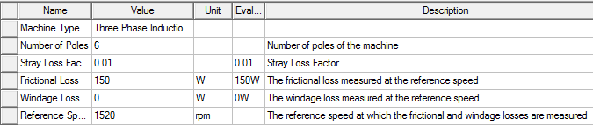

Figure 1: machine inputs

### STATOR:

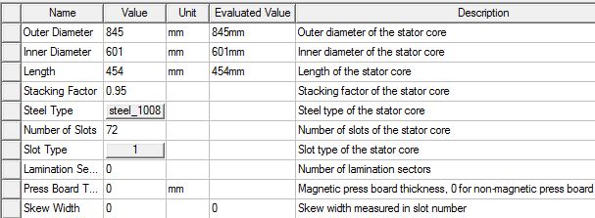

Figure 2: stator inputs

Steel_1008 is chosed as a core material. Figure 3 shows B-H curve of Steel_1008.

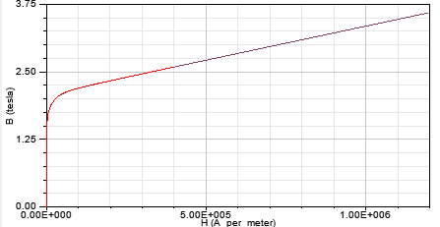

Figure 3: Steel_1008 B-H curve

### STATOR SLOTS:

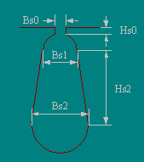

Figure 4: stator slot type:1

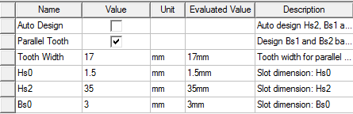

Figure 5: stator slots inputs

By chosing parallel tooth option and entering the tooth width value, program assigns the appropriate bs1 and bs2 values.

### 

### STATOR WINDINGS:

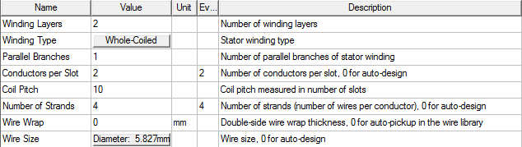

Figure 6: stator winding inputs

### ROTOR:

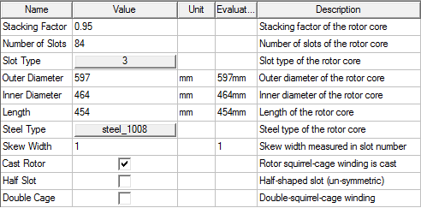

Figure 7: rotor inputs

### ROTOR SLOTS:

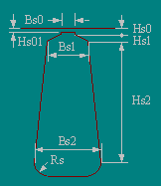

Figure 8: rotor slot type:3

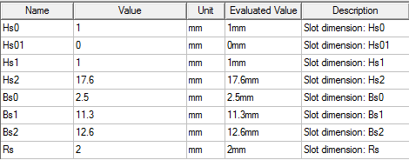

Figure 9: rotor slot inputs

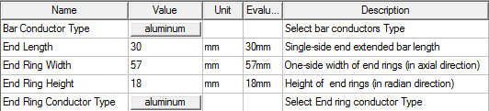

Figure 10: rotor winding inputs

## OUTPUTS

|  |  |
| --- | --- |
| Given Output Power (kW): | 1280 |
| Rated Voltage (V): | 1350 |
| Winding Connection: | Wye |
| Number of Poles: | 6 |
| Given Speed (rpm): | 1520 |
| Frequency (Hz): | 78 |
| Stray Loss (W): | 12800 |
| Frictional Loss (W): | 150 |
| Windage Loss (W): | 0 |
| Operation Mode: | Motor |
| Type of Load: | Constant Power |
| Operating Temperature (C): | 75 |

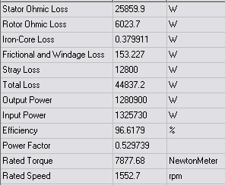

Figure 11: rated performance outputs

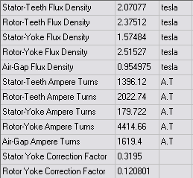

Figure 12: rated magnetic data outputs

As shown in Figure 11, magnetic data and power factor are problematic compared with the calculated and assigned values in the project-2. Especially, stator-teeth, rotor-teeth and rotor yoke flux densities seem to be high. Therefore, they need to be decreased. The main idea behind the changes is more the flux area less the flux in corresponding area. Therefore:

* stator tooth width decreased to decrease the stator-teeth flux density.
* Rotor inner diameter is decreased to decrease rotor yoke flux density.
* Rotor slot area is decreased to increse the rotor tooth width.

Some values are changed as folllows:

Stator tooth width: 

Rotor inner diameter: 

Hs2, Bs1, Bs2 of the rotor: 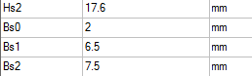

New magnetic data outputs:

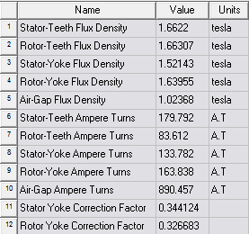

Figure 13: new(corrected) rated magnetic data outputs aftor some changes

New performance data outputs:

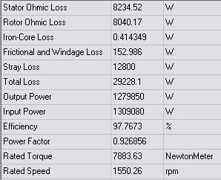

Figure 14: New(corrected) performance data outputs

Now, problematic values are corrected and close to calculated values

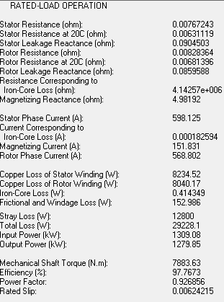

Figure 15: Rated load operation outpus

Generally, calculated values and simulation outputs are not so much different than each other. However, loss values are smaller in the simulation and therefore simulation efficiency output is 1% higher than that of calculated.

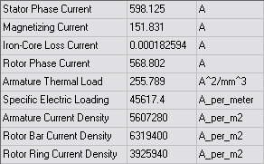

Figure 16: Rated electric data output

Current density values are in the appropriate range.

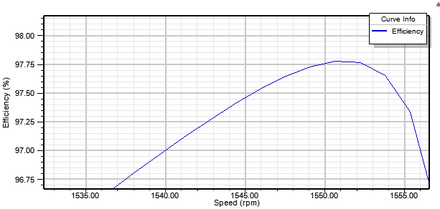

Figure 17: efficiency v.s speed curve @rated speed

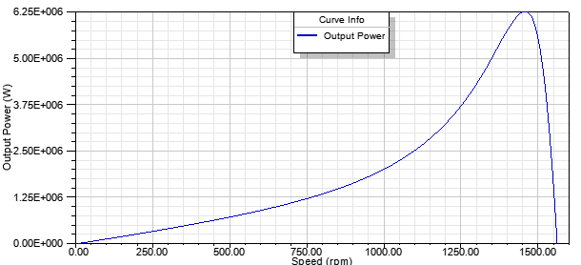

Figure 18: output power vs. speed curve

# maxwell – 2D analysıs

## INPUTS

Design was imported to 2D analysis and some results are as follows:

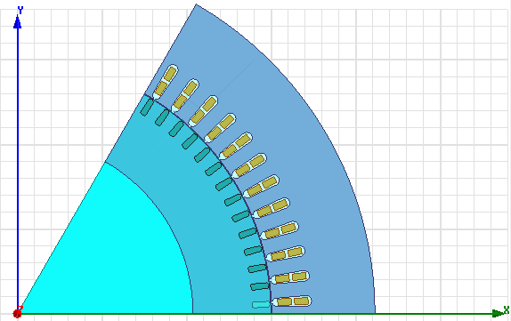

Figure 19: motor pole in XY plane

Lines are added to stator tooth, rotor tooth, gap and yokes to observe the fluxes in corresponding areas.

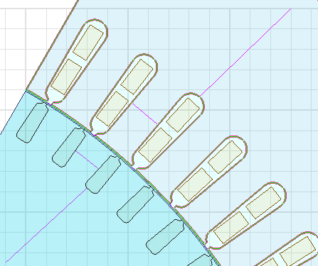

Figure 20: added lines

### 

### Mesh ınputs:

Mesh dimensions are assigned as below. Lower the mesh area means higher the accuracy of simulation result however longer simulation time. By trial and error method, mesh dimensions are decided as follows:

Lenght_bar= 5mm

Length_coil= 7mm

Length_main= 24.6mm

SurfApprox_Bar= 1mm

SurfApprox_Main= 1mm

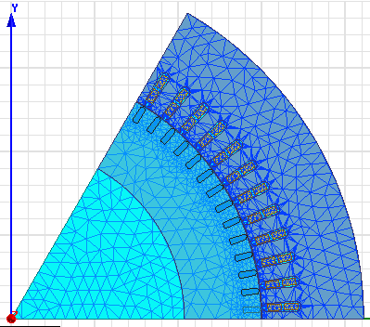

Figure 21: meshes

## OUTPUTS

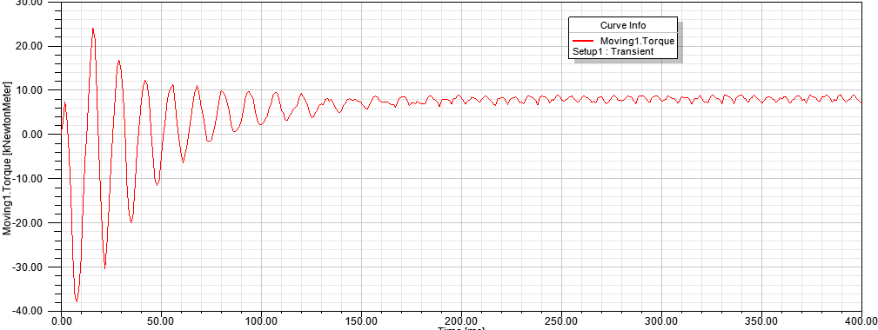

Figure 22: Torque vs time

As seen from above figure, mean torque is close the designed value. However, it has some ossilations on it and that is the cogging torque. We assigned skew width=0 as in Figure 2. By adding some skew to motor, this cogging torque can be aliminated.

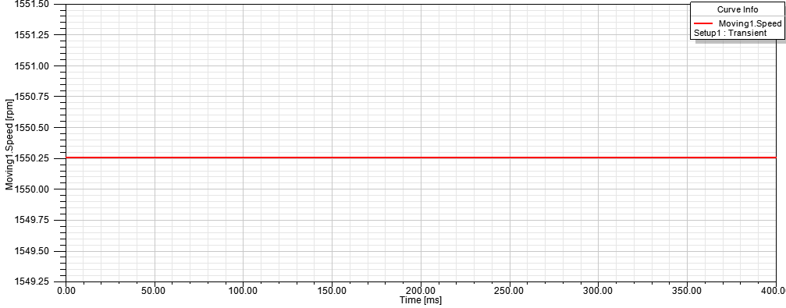

Figure 23: speed vs time

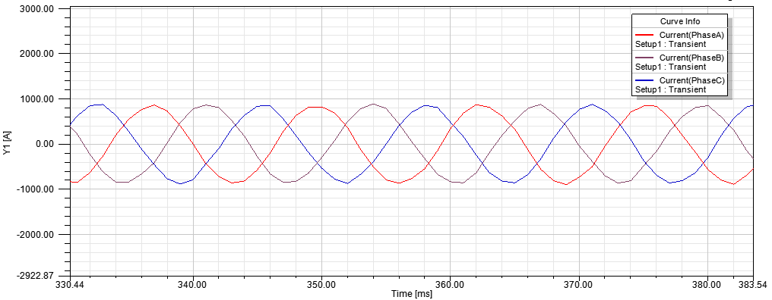

Figure 24: phase currents

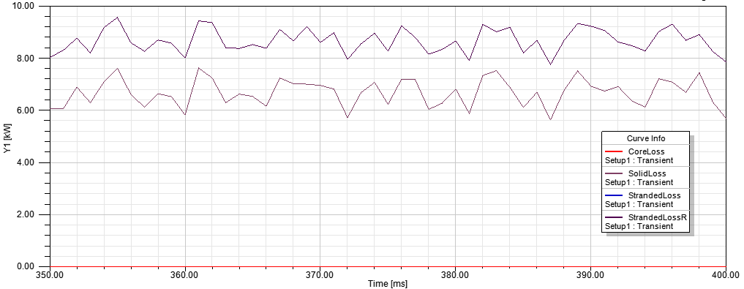

Figure 25: losses in kW

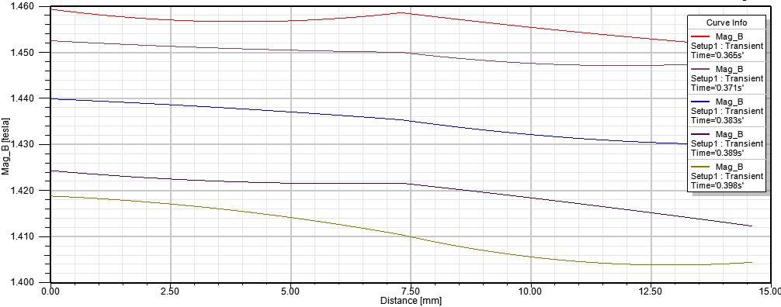

Figure 26: rotor teeth magnetic flux

Figure 26 shows rotor teeth magnetic fluxes for five different time instant. Maximum value is about 1.45 Tesla.

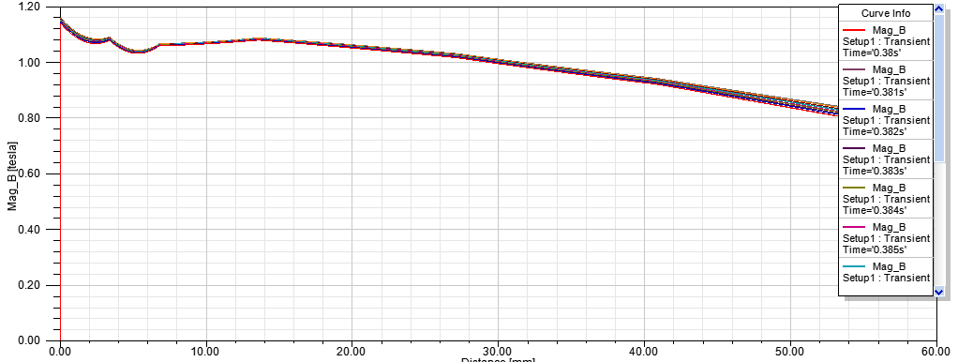

Figure 27: rotor yoke magnetic fluxes

In the first part of the report it is shown that designed values results in high magnetic flux densities in the teeth and yokes. Than, designed values are changed to decrease the high flux to appropriate range. According to RMxprt report rotor yoke is about 1.64 Tesla. However, 2D analysis report gives us a little bit lower magnetic flux density, 1.2T.So be it, there is no probability of saturation.

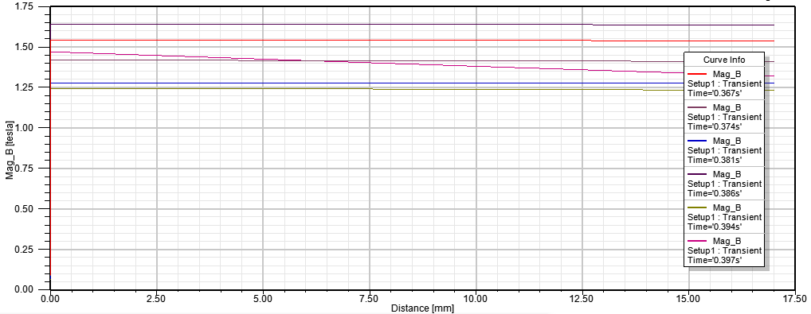

Figure 28: stator teeth magnetic flux densities for different time instants

Maximum magnetic flux density value in stator teeth is about 1.65T

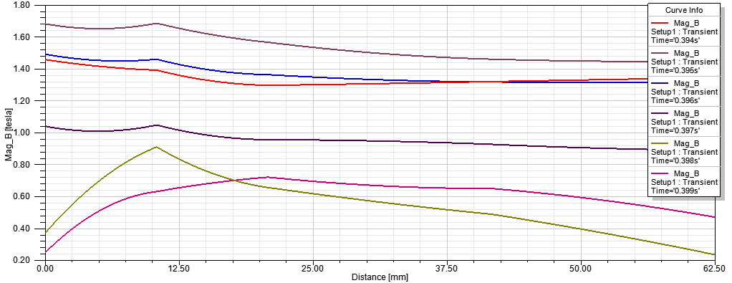

Figure 29: stator yoke magnetic flux densities for different time instants

Maximum magnetic flux density value in stator yoke is about 1.7T

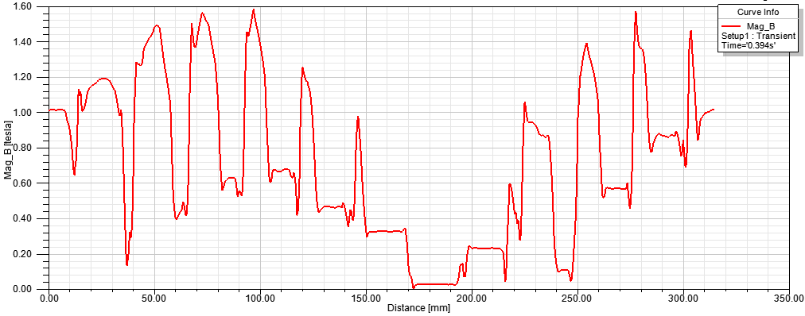

Figure 30: air gap magnetic flux density at time: 0.394s

Magnetic flux density values in teeth, yoke and gap are below the saturation value of the steel_1008 chosen as a core material. Airgap flux density seems abnormal compared with the others. Reason is the lack of meshes in the airgap. Higher number of meshes in gap would solve this problem.

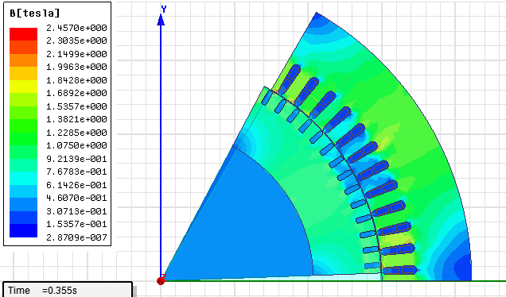

Figure 31: magnetic flux density

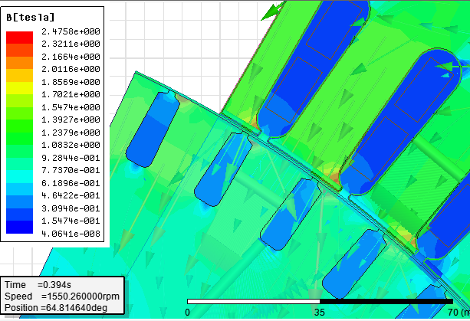

Figure 32: intensive magnetic flux densities at nook of the teeth

Some small areas have criticial values of magnetic flux densities, 1.8-2 T. That can be solved by increasing the hos values of the stator slots or putting smoother edges to slots near that areas.

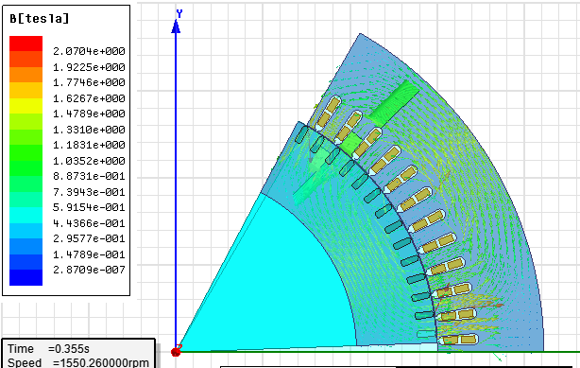

Figure 33: Magnetic flux vectors

# conclusıon

In the second project, a train traction motor (an induction motor) with some specifications was designed. In third project, design is implemented in the Maxwell simulation program to control whether designed values are proper for the design specifications. In this report, simulation inputs and outputs are given as simplificative.

* How is it designed?

Firstly, according to motor’s power specification, appropriate Cmech value is assigned. Basically, power level and the torque demand determine the dimentions of motor. For rational sizing, an aspect ratio is calculated and then motor dimentions(outer-inner diameters, gap) are assigned. Outer to inner diameter ratio is depend on the pole number. After that, considering maximum and minimum slot pitches in induction machines, number of phases and rule of thumb in the reference book, stator slot number is assigned as 72. Small number of slots can lead to İncreased leakage inductance , reduced breakdown torque and larger MMF harmonics. On the other hand, large number of slots can lead to high cost. Then, it is assigned two layer winding with chorded coils 5/6 to eliminate the 5th harmonic mainly and some other harmonics. Number of winding in phase is determined by considering voltage, flux and frequency. Then, number of rotor slots is stated by the rules mentioned in the book to avoid harmful torques at positive speed, harmful mechanical vibrations and harmful synchronous torques. Skin depth depends on the frequency and affects the resistance in high frequencies. Skin depth is calculated and proper awg cable is chosed. Cable number and size directly affects the copper loss. Therefore, efficiency andtermal design issue are effected by the this cable selection.

Slot sizing is another important issue. Because slot sizing affects both teeth area and yoke area it also affects the magnetic flux densities in that areas. Generally they are assigned about 1.6 T in teeth and yokes not to saturate the core. Stator conductors are chosed as copper wire and rotor slots are filled with aluminium bars. Aluminium has higher resistance compared with the copper, so it’s loss is higher. But, it is cheaper and improves the starting torque. In thermally criticial applications, copper can be used in the rotor to decrease the loss.

* How is it simulated?

First of all, RMxprt model is implemented. Design values(dimensions, slots, wires, core type) are inserted to program. First results were not proper in terms of magnetic flux density and power factor. Generally, magnetic flux density was really high and above the saturation value of the material. Therefore, slot areas and yoke areas are chnged to adjust the magnetic flux density. The main idea behind the changes was higher the area for flux to flow means lower flux density in that area. After changing the some dimesions, problems are solved. Rated load operation, rated magnetic data and rated performance data outputs show favorable results.

Then, Rmxprt values are transferred to 2D analysis. Magnetic flux densities are observed by putting lines to neccesary places. They are all below the saturation level. Speed and torque values are close the designed values. However, torque has some oscillation on it named as cogging torque. This cogging torque would be eliminated by adding some skew to motor.

## Personel opInIon about the lecture

I though that it was very intense, rich and useful semester. In spite of that we took the courses EE361 and EE362, motor concept was still blur in my mind until this semester. To be honest, In these lectures, for being succesful, it was somehow enough to be familiar with the earlier year’s exam question. However, in EE564, system and evaluation is changed. I think especially projects helped us to be engaged in motor issue more. Also, they pushed us to learn new programs: iphyton-maxwell.presentations and the final exam concept was also useful for us. On the other hand, visiting the firm, ELSAN, helped us to realize the our designs in mind. Lastly, I am glad to take this course in this semester.