**EE-564 DESIGN OF ELECTRICAL MACHINE**



**PROJECT-3**:

MODELLING 2nd PROJECT DESIGN (Train Traction Motor) IN FEA

**Insturctor:**Ozan KEYSAN

**Due Date**:15.06.2016

Prepared by Berk İNCE

TABLE OF CONTENTS

A) INTRODUCTION 3

B) OUTLINE OF PROJECT 3

C) RMexprt DESIGN OF MOTOR 3

C.1) Stator 3

C.2) Rotor 7

D) RMxprt DESIGN RESULTS 9

E) MAXWELL 2-D DESIGN OF MOTOR 16

F) MAXWELL 2-D DESIGN RESULTS OF MOTOR 18

G) MAXWELL 3-D MOTOR GEOMETRY 25

H) CONCLUSION 26

# INTRODUCTION

In this Project, induction motor which is designed in project-2 “Train Traction Motor” is implemented in ANSYS Maxwell. RMxprt design and Maxwell 2D design are explained in detail. Specifications of “Train Traction Induction motor are listed below:

* Rated Power Output: 1280 kW
* Line-to-line voltage: 1350 V
* Number of poles: 6
* Rated Speed: 1520 rpm (72 km/h) (driven with 78 Hz inverter)
* Rated Motor Torque: 7843 Nm
* Cooling: Forced Air Cooling
* Insulating Class: 200
* Train Wheel Diameter: 1210 mm
* Maximum Speed: 140 km/h
* Gear Ratio: 4.821

# OUTLINE OF PROJECT

* RMxprt Design of Motor
* Rmxprt Design Results of Motor
* Maxwell 2D Design of Motor
* Maxwell 2D Design Results of Motor
* Maxwell 3D Motor Geometry
* Conclusion

# RMexprt DESIGN OF MOTOR

## C.1) Stator

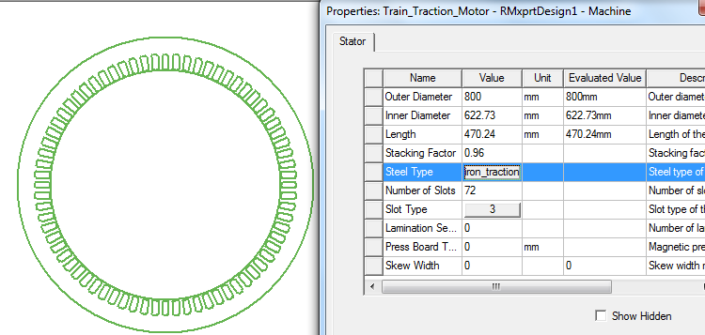

Figure- 1 Stator Dimension Parameters

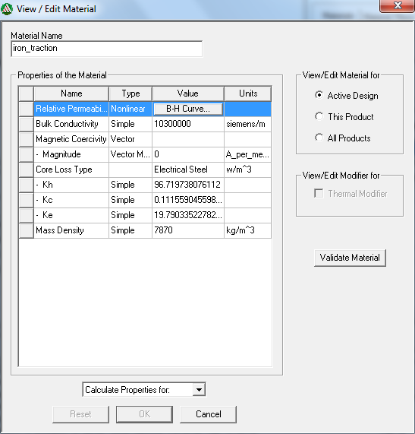

Figure- 2 Stator Material Parameters

New iron material is created for stator. In order to calculate core loss, core loss coefficients are calculated by Steinmetz's equation at 78 Hz. Note that this material has 2 W/kg core loss at 1 Tesla and 50 Hz.

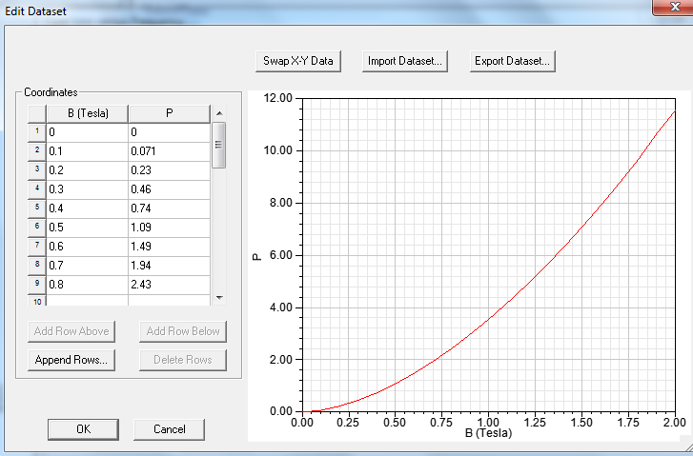

Figure- 3 Core Loss of Material- Flux Density vs Power(W/kg) ) at 78 Hz

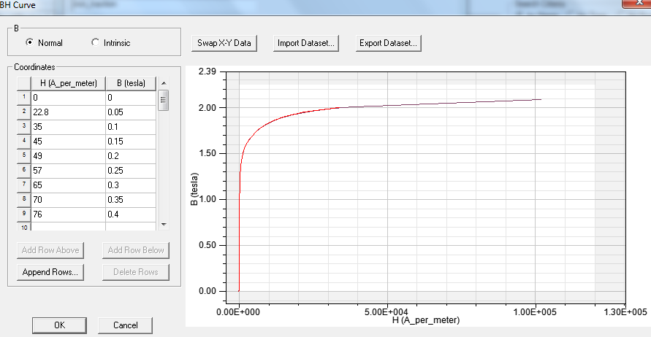

Figure- 4 Stator Material B-H Curve

B-H curve of material is entered to RMxprt with respect to Project-2.As shown in Figure-4, around 1.7-1.8 Tesla is saturation point of this material. Therefore, magnetic loading should not be higher than these values. It is very critical for induction motor design since dimension parameters is chosen by this magnetic loading.

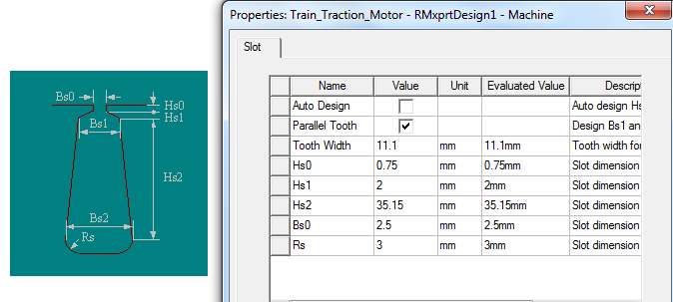

Figure- 5 Stator Slot Dimensions and Stator Slot Geometry

Stator dimensions are entered to program almost same as in Project-2.

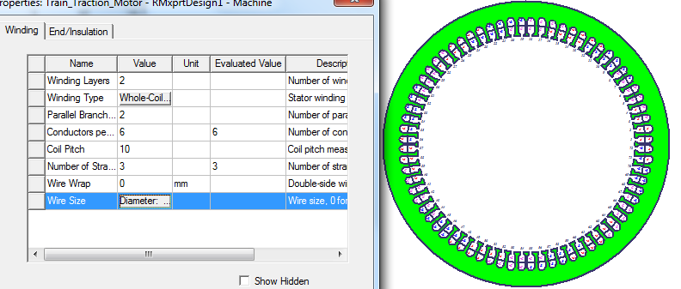

Figure- 6 Winding Diagram of Stator

For double layer: Winding Layers are entered “2”.

For 5/6 pitch: Coil pitch is entered 10 which means that 10 /12=5/6

Number of strand:3 means that 3 parallel AWG-5 cable is used as same as Project-2

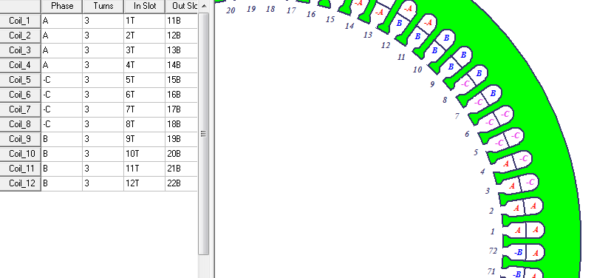

Figure- 7 Stator Winding Diagram for One Pole

As shown in Figure-7, slot span number is 2.This means that +A is placed Slot-1 and –A is placed in slot 11 instead of slot 13(Full Pitch Condition.).Also turns number per phase can be verified in Figure-7. For one pole pair , there are 3 turns x 4 slots (for phase A )=12 turns and for three pole pairs, there are 12 x 3=36 turns per phase as same as in project-2.

## C.2) Rotor

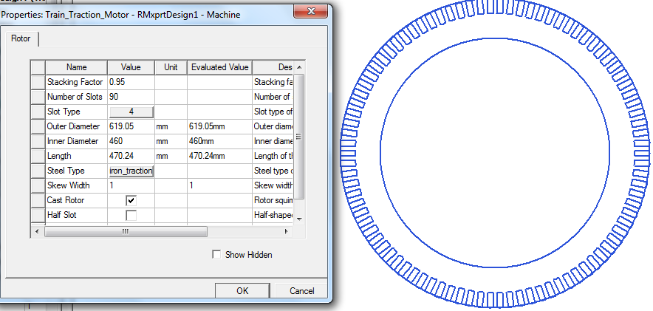

Figure- 8 Rotor Dimensions

Rotor slot number was 88 in Project-2.However, 90 slots are used in project-3 since Maxwell 2-D analysis is FASTER if slot numbers of rotor and stator are 6*k where k is integer. In other words, if 2-D design uses 6 frictions(1/6 of motor), it is faster than 2 frictions(1/2 of motor).

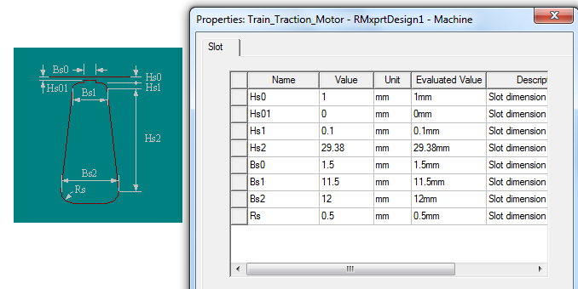

Figure- 9 Rotor Slot Dimensions and Rotor Slot Geometry

Bs1 and Bs2 is decreased in project-3 with respect to Project-2 since in this project slot number is increased to 90.Therefore, in order to satisfy magnetic loading at rotor teeth, width of rotor slots(Bs1 and Bs2) are decreased.

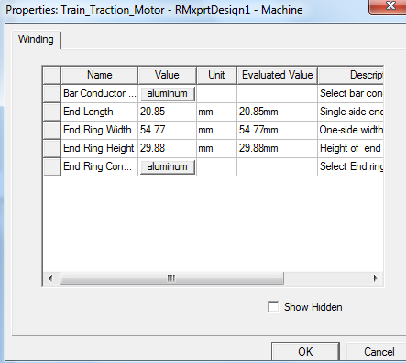

Figure- 10 End Ring Connection Parameters of Rotor

End Ring Connection Parameters are entered to RMxpert as same in Project-2.

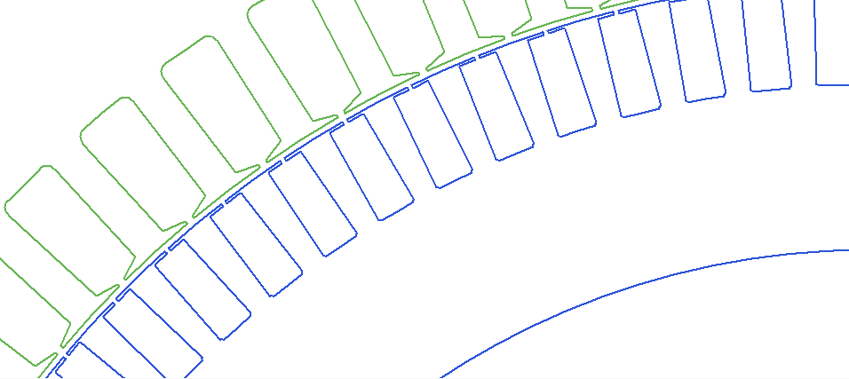

Figure- 11 Stator and Rotor Slot Geomtery

# RMxprt DESIGN RESULTS

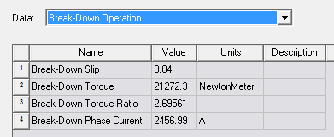

Figure- 12 Break Down Operation

Breakdown operation is corresponding to maximum torque value which motor can generates. If motor is running at this load torque condition, it is called over-load condition. However, this motor is designed for steady state conditions around 7900 Nm and if operates at this conditions continuously , it can burn motor due to high phase currents.

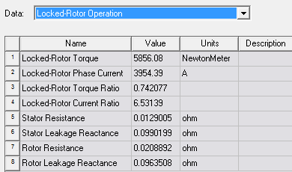

Figure- 13 Locked-Rotor Operation

Locked rotor operation is corresponding to starting torque characteristic of motor. At this condition motor speed is 0 and slip is equal to 1.Note that stator current is almost equal to 6.5 times steady state current(600 A) and it can be damage motor.This damage possibility can be decreased by applying starting methods.

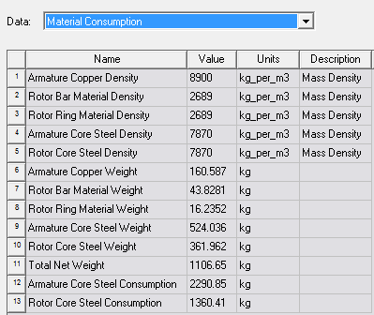

Figure- 14 Material Consumption

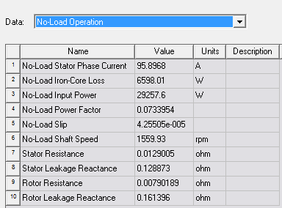

Figure- 15 No Load Operation

No load operation is corresponding to 0 torque condition. At this condition, speed is almost equal to synchronous speed (if there are no iron and frictional loss, it will be equal to synchronous speed).

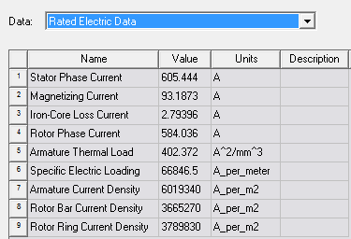

Figure- 16 Rated Electric Data

These results are very close to Project-2 results which were calculated analysis on Github. For example, Stator phase current was 633 A, magnetizing current was 113 A in Project-2.

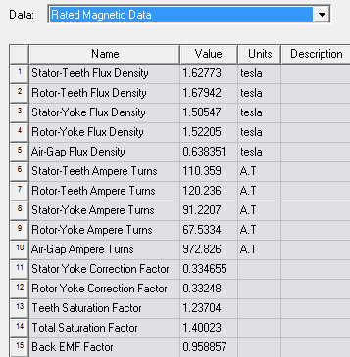

Figure- 17 Rated Magnetic Data

This result is very important since this is directly related to magnetic loading.According B-H curve of this motor, after 1.7 Tesla, motor material is saturated.These values are very close to Project-2 values. For example, Air –Gap was calculated 0.62 Tesla(0.638 Tesla in this figure) and stator teeth flux density was aimed 1.6 Tesla(1.6277 Tesla in this figure),Stator back core(yoke) was calculated 1.63 Tesla (1.5 Tesla in this figure),rotor teeth was aimed to 1.6 Tesla(1.68 Tesla in this figure) and Rotor yoke was aimed to 1.6 Tesla(1.52 Tesla in this figure).Therefore, analytical results in Project-2 and RMxprt simulation results are almost same and aimed motor is designed in terms of magnetic loading.

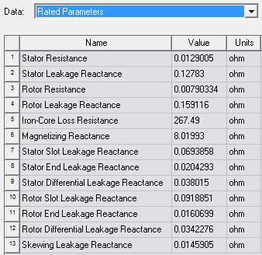

Figure- 18 Rated Parameters

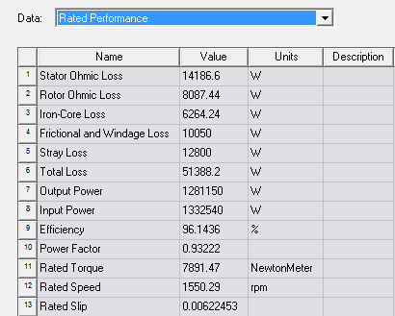

Figure- 19 Rated Performance

According to IEC standards, if motor power is higher than 1000 kW ,Motor efficiency should be higher than 95 % for induction motor. Designed motor has 96.14% efficiency at rated performance as shown in Figure-19.

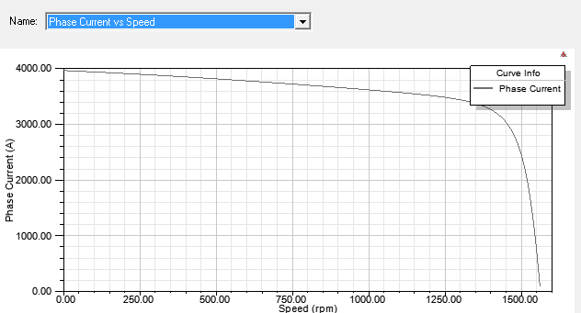

Figure- 20 Phase Current (A) vs Speed (rpm)

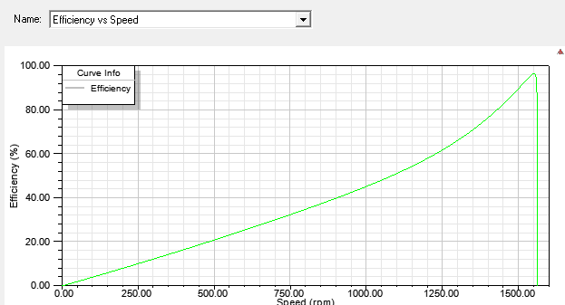

Figure- 21 Efficiency (A) vs Speed (rpm)

The aim of designed motor is to be higher efficiency at rated speed. As shown in figure 21, at rated speed (1520 rpm) motor has almost highest efficiency. This means that designed motor is implemented correctly.

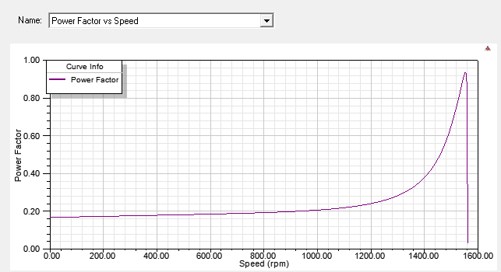

Figure- 22 Power Factor vs Speed (rpm)

The aim of designed motor is to be higher power factor at rated speed. As shown in figure 22, at rated speed (1520 rpm) motor has almost highest power factor. This means that input power is converted to mechanical output power as soon as possible.

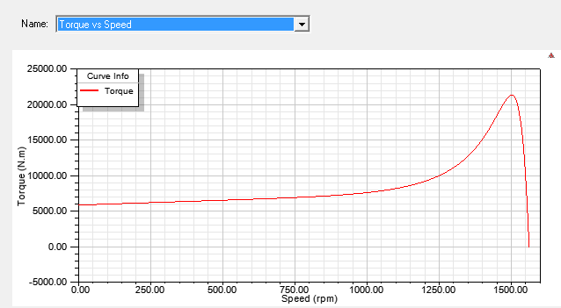

Figure- 23 Torque (Nm) vs Speed(rpm)

Figure -23 shows that motor has 5800 Nm starting torque and 21000 Nm breakdown torque. Note that this motor generates rated torque (around 7900 Nm) at rated speed.(around 1520 rpm)

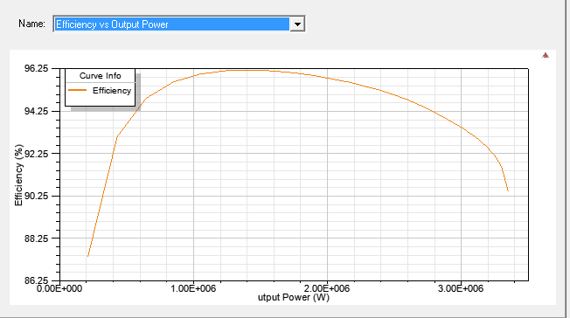

Figure- 24 Efficiency (%) vs Output Powr (W)

Figure -24 is similar to Figure-21.It shows that motor has highest efficiency at rated power.(around 1280 kW)

# MAXWELL 2-D DESIGN OF MOTOR

* Solution type is chosen “Transient Solution”.
* Motion setup is adjusted to rated speed in RMxprt 1550.29 rpm.
* X-axis is chosen by Master Boundary, 60 degree from X –axis counter clockwise axis is chosen by Slave Boundary(due to 6 fractions 360/6=60 degree) and outer diameter is chosen by Vector Control Potential Boundary

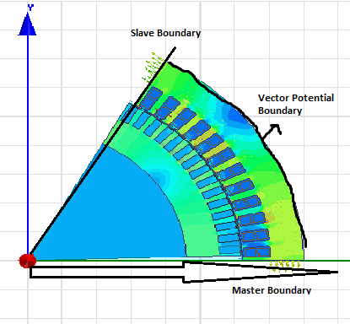

Figure- 25 Boundaries of Motor on 2D-Analysis

* End Connection and Phase excitations with respect to coil position is applied. Figure -26 represents excitation phase A and other phases has similar excitations.

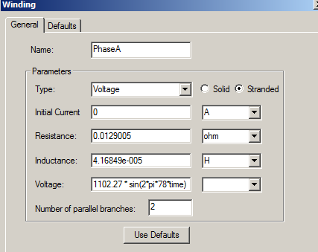

Figure- 26 Phase Excitation

* Mesh Operations are applied for Rotor Bar,Stator Coils and remaining part of motor.
* Analysis is started. Simulation step time is 1 s and time step 0.001 s. It took around 20 minutes and system reached steady state after 0.3 s on Computer which has 16 GB RAM. If time step decreases and simulation time increases, more accurate solution can be obtained. However, it takes a lot of time and we need powerful computer.

# MAXWELL 2-D DESIGN RESULTS OF MOTOR

In 2-D results, simulation is operated with 0.001 s time step and 1s stop time.After 0.4 s, motor reaches steady state condition. Since rotor is rotating, flux density on selected stator yoke line ,stator teeth line, rotor yoke line, rotor teeth line and air-gap line are changed with time like a sinusoidal. Therefore, I obtained results at the peak of this sinusoidal waveforms since I designed machine for these peak values in Project-2 and Project-3.

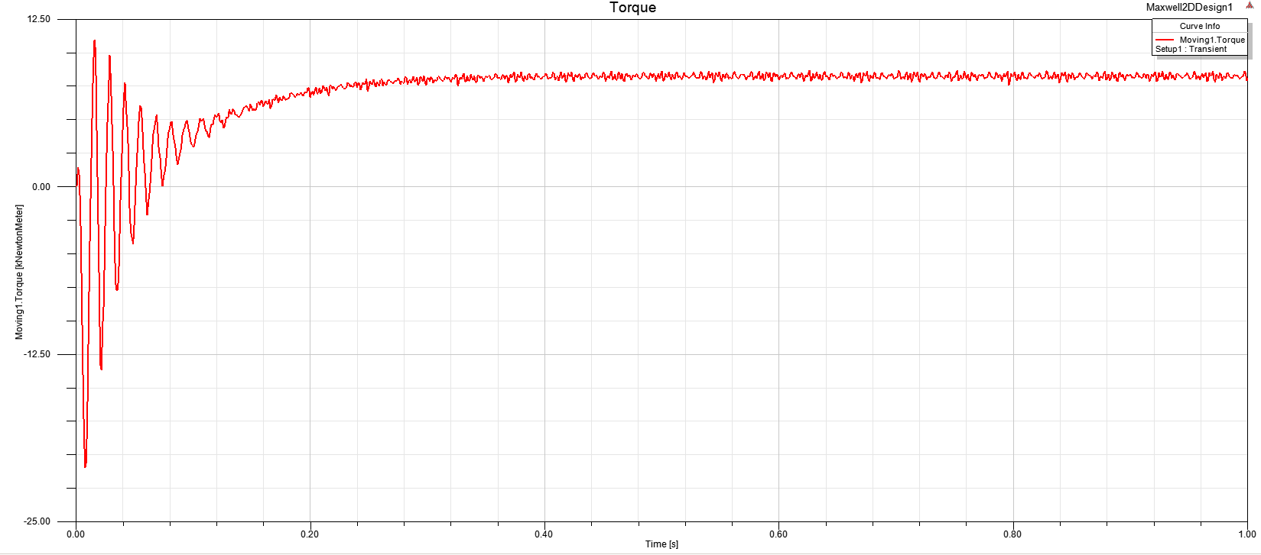

Figure- 27 Torque(kN.m) vs time

Before 0.4 s motor has dynamic torque characteristics.After 0.4s (steady state condition), Motor generates torque around 7900 Nm which is almost(7843Nm) corresponding to rated torque.

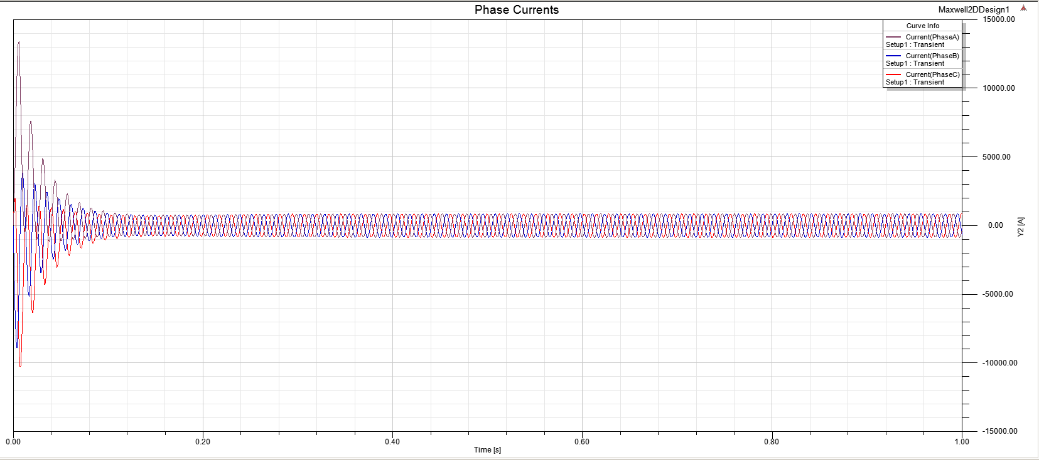

Figure- 28 Phase Currents vs Time

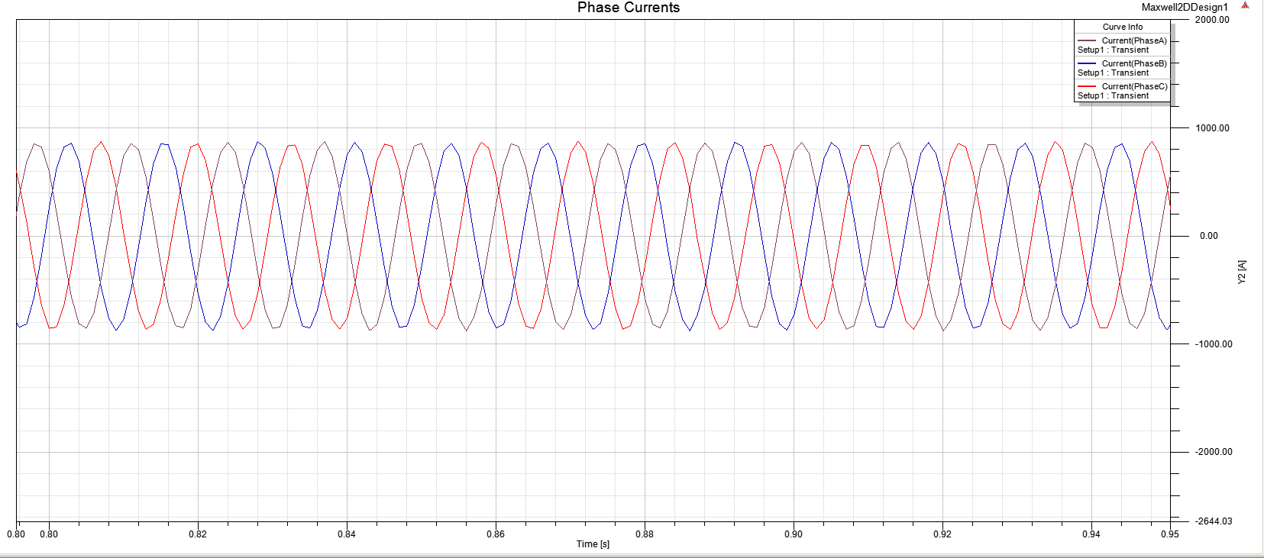

Figure- 29 Phase Currents at Steady-State

Before 0.4 s, current waveforms has dynamic characteristic as shown in Fiure-27. After 0.4 s, motor current reaches steady state condition which is equal to 855 A peak.(855/)

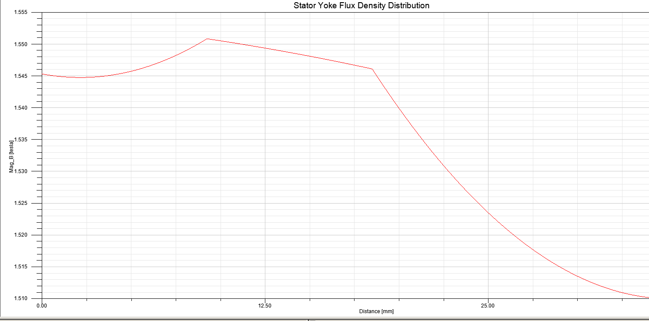

Figure- 30 Stator Yoke Flux Density Distribution

I drew a line from stator slot to outer diameter to calculate stator yoke (back core) flux density. This flux density is changed with time since rotor is rotating and flux vectors are not placed at same point. When we analyze stator yoke flux density at higher flux vectors, it is equal to 1.55 Tesla which is very close to RMxprt result(1.5 Tesla) in Figure 27.This is lower than magnetic saturation condition.(around 1.7 Tesla)

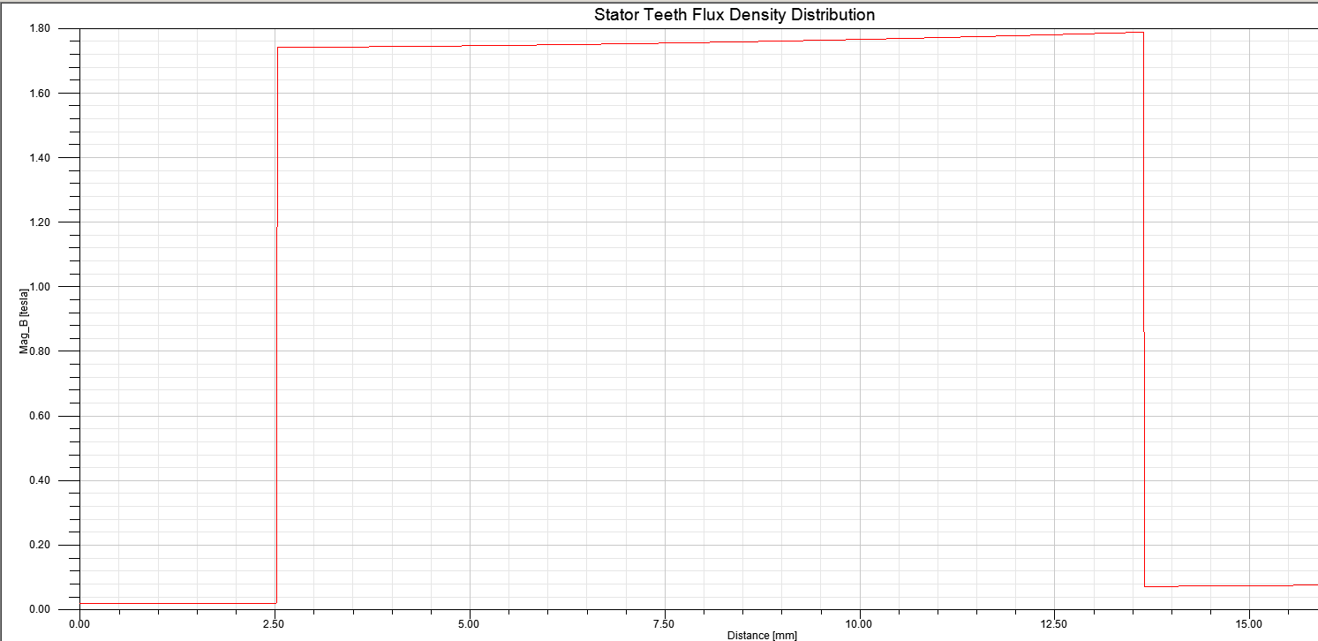

Figure- 31 Stator Teeth Flux Density

I drew a line between two stator slots to calculate stator teeth flux density. This flux density is changed with time since rotor is rotating and flux vectors are not placed at same point. When we analyze stator teeth flux density at higher flux vectors, it is equal to 1.7 Tesla which is very close to RMxprt result(1.63 Tesla) in Figure 27. This is equal to magnetic saturation condition.(around 1.7 Tesla).It can be cause problem.

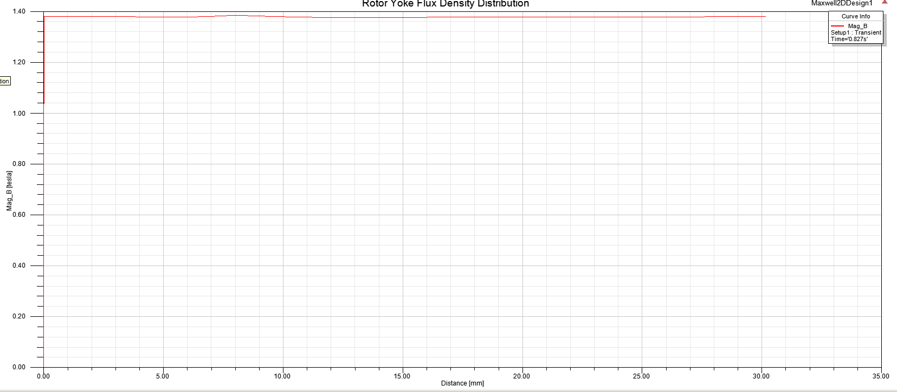

Figure- 32 Rotor Yoke Flux Density Distribution

I drew a line from rotor slot to shaft of motor to calculate rotor yoke (back core) flux density. This flux density is changed with time since rotor is rotating and flux vectors are not placed at same point. When we analyze rotor yoke flux density at higher flux vectors, it is equal to 1.4 Tesla which is very close to RMxprt result(1.52Tesla) in Figure 27.This is lower than magnetic saturation condition.(around 1.7 Tesla)

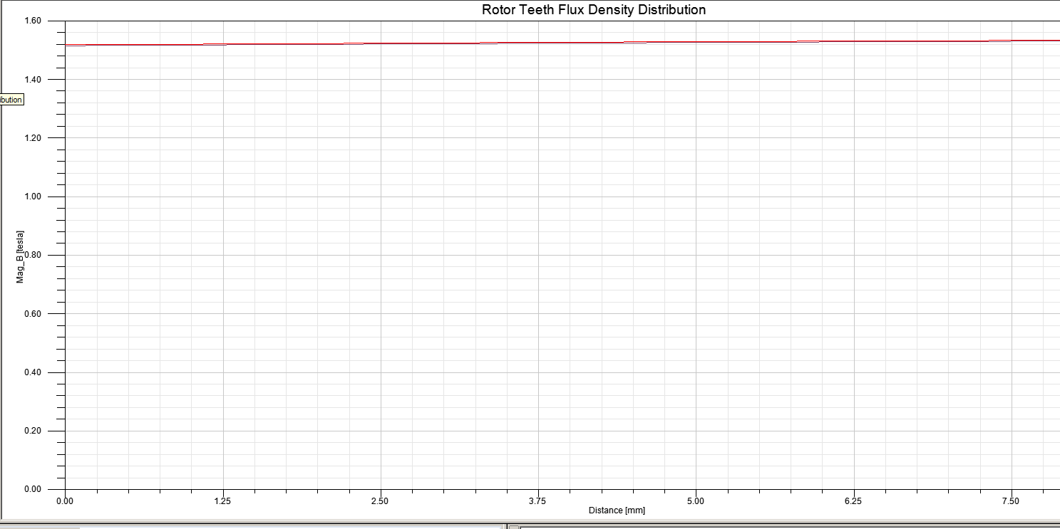

Figure- 33 Rotor Teeth Flux Density Distribution

I drew a line between two rotor slots to calculate rotor teeth flux density. This flux density is changed with time since rotor is rotating and flux vectors are not placed at same point. When we analyze stator teeth flux density at higher flux vectors, it is equal to 1.55 Tesla which is very close to RMxprt result(1.67 Tesla) in Figure 27. This is equal to magnetic saturation condition.(around 1.7 Tesla).

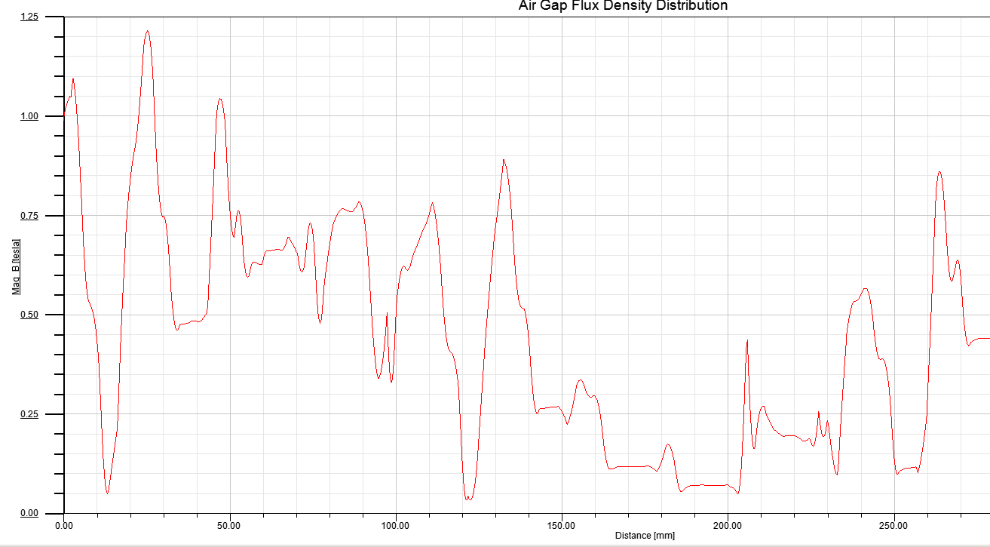

Figure- 34 Air-Gap Flux Density Distribution

I drew a center point arc along air-gap to calculate air-gap flux density. Flux density changes along air-gap distance. However, there is inapprehensible issue on Figure-34 since maximum value of air gap flux density is 0.63 Tesla with respect to Project-2 and RMxprt results. In this figure, average of air-gap flux density is also around 0.63 Tesla but maximum value of air-gap flux density reaches 1.2 Tesla. I think that if mesh analysis is applied tighter and if time step is decreased we can get more accurate results.

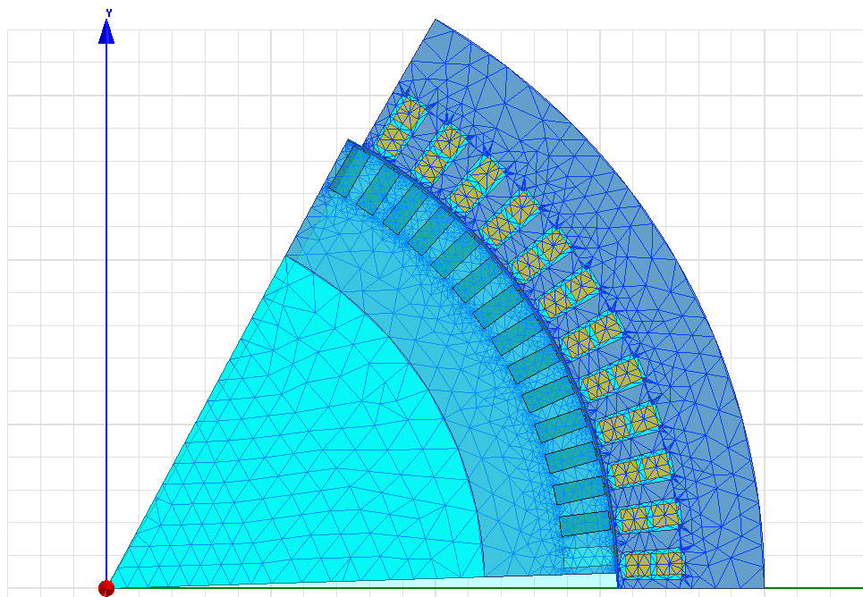

Figure- 35 Mesh Plots Analysis

Figure-35 shows applied mesh on 2D-Maxwell design. We can apply tighter mesh analysis to accurate results. However, tighter mesh analysis means that convergence is very slower and simulation can take hours although you have very powerful computer

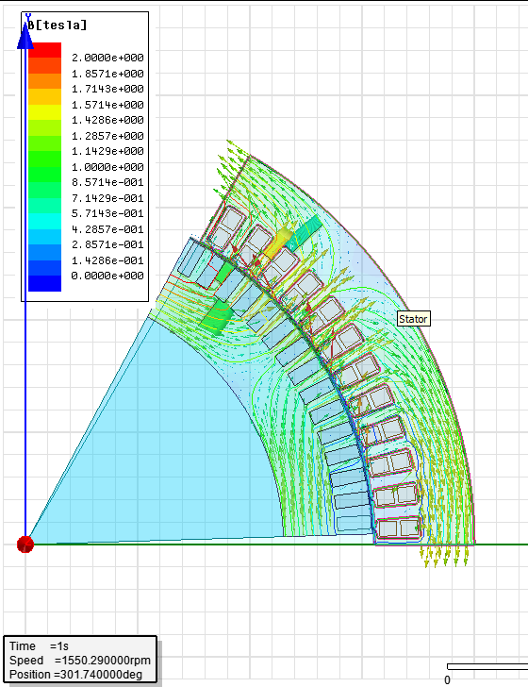

Figure- 36 Flux Density Vector Analysis

Figure-36 shows flux density vector distribution. There are a lot of flux density vector at the right side and top side of Figure-36 since return path of air-gap flux is edge of poles of motor and it causes high value flux density as shown Figure-37.

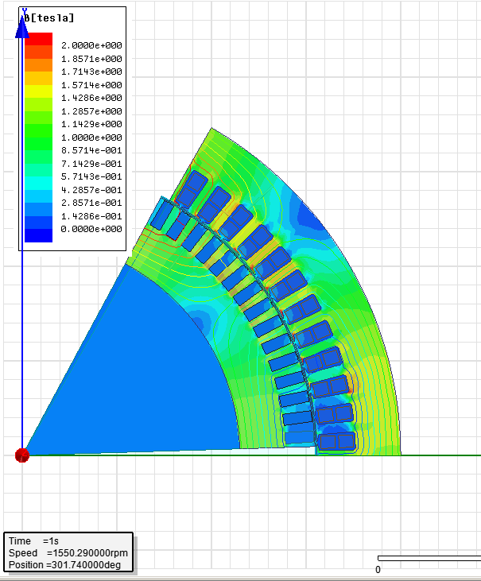

Figure- 37 Flux Density Magnitude Analysis

Figure 37 shows Flux Density magnitude of one pole of motor. When we look at the flux lines vector, if flux lines increases, flux density increases. According to this figure, stator and rotor yoke flux density is around 1.5 Tesla at flux lines region and rotor and stator teeth flux density is around 1.7 Tesla due to smaller area. Note that in this design, slot is almost rectangular and it causes higher flux density at the corner of slots which is represented by red color (2 Tesla).If slots are chosen more circular, we can decrease flux density at the corner of slots. Therefore, it is clear that motor dimensions (rotor, stator slots dimensions, outer diameter etc.) plays very crucial role for magnetic loading.

# MAXWELL 3-D MOTOR GEOMETRY

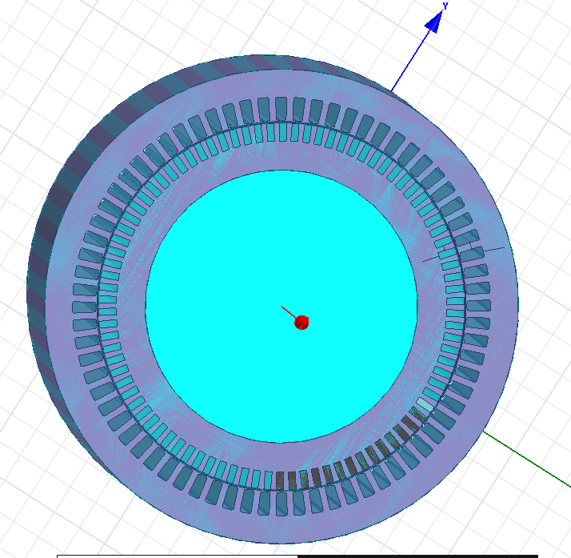

Figure- 38 Maxwell 3-D Motor Geometry z direction

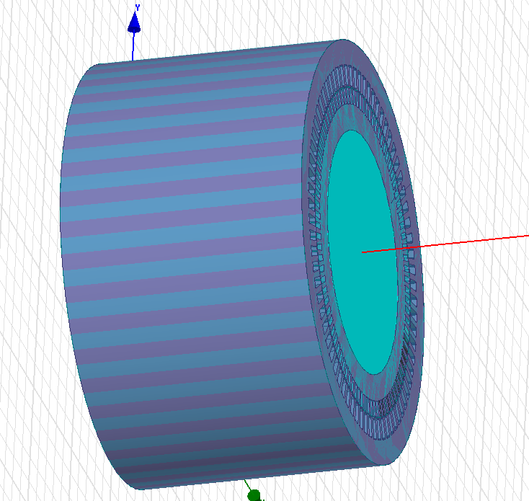

Figure- 39 Maxwell 3-D Geometry y direction

# CONCLUSION

* This project includes implementation of “Train Traction Motor” that is designed in Project-2 in ANSYS Maxwell. ANSYS Maxwell is Finite Element Analysis (FEA) program. During Project-3, Maxwell is learnt in detail and this is very useful program for implementation electro-mechanical devices.
* The starting point of designing motor is to determine dimensions of motor. Length and diameter of motor (volume of motor) is directly related to output power and output torque of motor. In other words, larger dimensions means that motor can have larger power and torque capability. Also note that effect of diameter is higher than length of motor since output power is proportional to square of diameter in mathematically. However, it does not mean larger diameter can generate unlimited output power. There is a ratio which specifies before with respect to experimental results between diameter and length called “Aspect Ratio”. Note that smaller diameter should be used to obtain good speed response since smaller diameter means smaller inertia. In addition, if power demand of motor increases, air gap distance of motor increases.
* There is also ratio between inner diameter and outer diameter of motor. This ratio depends on pole number of motor since if pole number increases, flux vectors will be divided with respect to pole number and flux vector density decreases at back core. Therefore, more pole number means smaller outer diameter for same power motors.
* Stator slot and rotor slot dimensions are very critical to determine stator and rotor teeth flux density. Since flux lines has to flow stator and rotor teeth, magnetic loading is highest at these teeth. Therefore, slot number and tooth distance is calculated carefully to operate non-saturated condition or to satisfy proper magnetic loading. In conclusion, it is clear that all motor dimensions (outer, inner diameter, stator rotor slot dimensions) play very crucial role for magnetic loading case.
* Another important issue for designing motor is to determine slot number. Stator slot number is determined by phase number and pole number. For example if motor is 3-phase and 6 pole, stator pole number is equal to 18*k (where k is integer).Also realize that there are advantages and disadvantages of using lower or higher number slot number. If lower number slot is used, there will be higher leakage inductance, lower breakdown torque, larger MMF harmonics and worse cooling conditions but manufacturing cost is reduced. If higher number slot is used, there will be higher overload capacity, better cooling and lower tooth pulsation but manufacturing cost is high. Rotor slot number and shape are also very important design parameters since if rotor slot number is not chosen carefully it can cause noisy, vibrations, cusps in torque speed curve, cogging problems. In addition, rotor shape is directly related to duty of motor. For example, different rotor shape should be used for required high starting torque motor and standard continuous type of motor. Moreover, stator and rotor dimensions are directly related to effective air-gap calculation which is also called Carter Coefficient.
* Stator winding design is other design issue. Different winding pitch is used to eliminate harmonics. For example, 5/6 pitch design eliminates huge part of 5th and 7th harmonics. However, fundamental component of flux is decreased due to pitch and distribution factor. In addition, there is relationship between number of turns per phase and flux or flux density. If number of turns per phase increases, flux density will decrease and more proper magnetic loading condition can be obtained.
* Determination of coil winding conductor size depends on some parameters such as skin effect and cooling type. Skin Effect is not effective for high power motor at lower than 100 Hz applications. However, skin effect is dominant at higher frequencies and it can be very critical to satisfy electrical loading condition. Therefore, conductor size should be chosen with respect to skin depth. Another issue to satisfy electrical loading condition is cooling. Cooling limits maximum capability of electrical loading. For example, higher power motor should be designed with water cooling motor instead of air-cooling motor. The reason of this is that if there is better cooling method, motor will have higher efficiency and its temperature can stay at range of limits. Note that these cooling methods are conventional cooling type and conventional cooling type is dominant for induction motors. Therefore, cooling strategy actually thermal design is one of the most important issue for motor design.
* Thermal design depends on losses of motor. Motor has some losses such as copper losses, aluminum losses, and core losses. Copper losses are directly related to coil winding resistance. If number of turn per phase increases, resistance increases and losses increases. This loss is also related to coil type. If round conductors are used, there will be smaller losses instead of rectangular coils. Rotor bars are generally made up of aluminum since it is cheap and light. However, aluminum has larger resistivity than copper. In order to decrease this loss, copper may be used at rotor bars. Core loss is another factor on thermal design. If core is saturated, core loss increases very much so magnetic loading limits are determined carefully or higher magnetic loading capability material should be chosen for motor core. Core loss is generally given by W/kg and this means that heavier motor has more core loss so dimensions are optimized to decrease core losses. Note that core losses also depends on magnetic flux density and frequency of supply and this losses are calculated by help of Steinmetz’s equation.
* Leakage flux occurs due to two main reason. First reason is that flux does not cross air gap and second reason is that flux crosses air gap but it does not link the winding. Second reason consists of zig-zag flux leakage and skewing leakage. In order to decrease skewing leakage rotor should be have 1 slot skewing.1 slot skewing leads to decrease harmonics and it provides lower leakage flux or leakage inductance.