**Software Testing Homework3: Test for Stutter**

學號：310551135 姓名：張宇辰

Use the class Stutter for questions a-d. A compliable version is available in <https://cs.gmu.edu/~offutt/softwaretest/java/Stutter.java>. A line-numbered version is in <https://cs.gmu.edu/~offutt/softwaretest/java/Stutter.num>.

1. Draw control flow graphs for the methods in Stutter.

(Main)

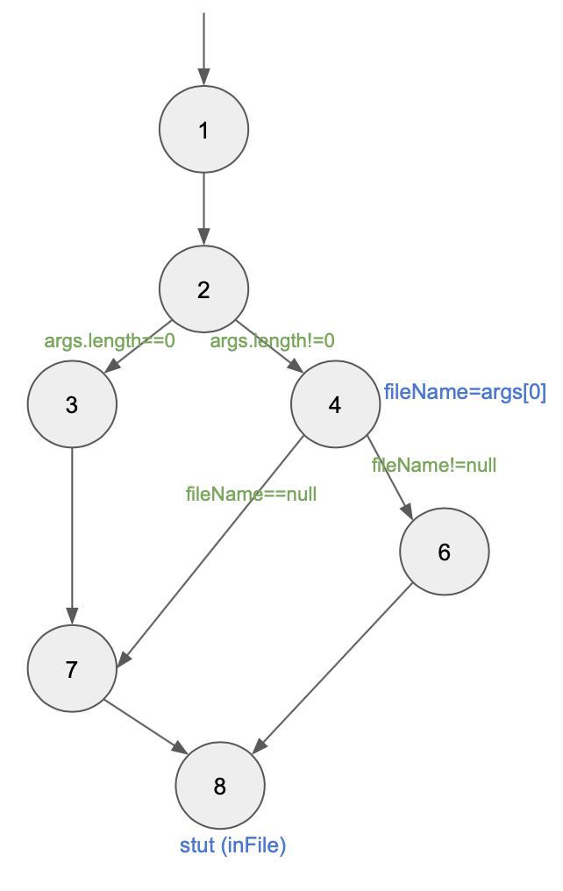

(Stut)

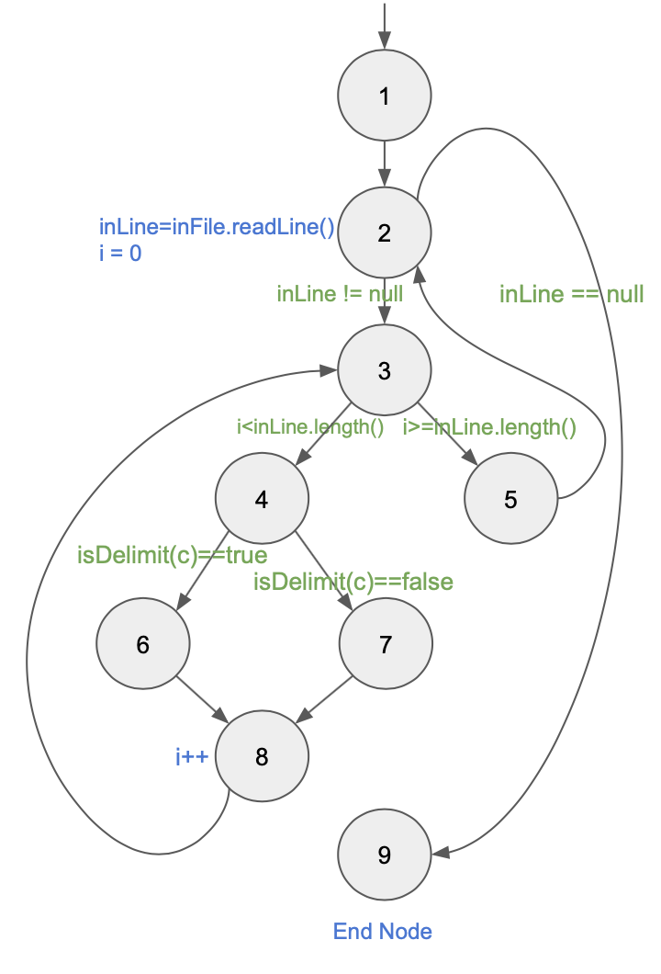

(checkDupes)

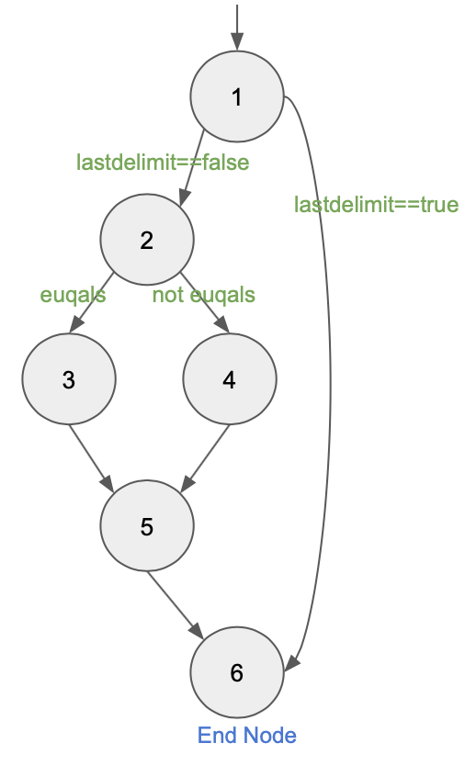

(isDelimit)

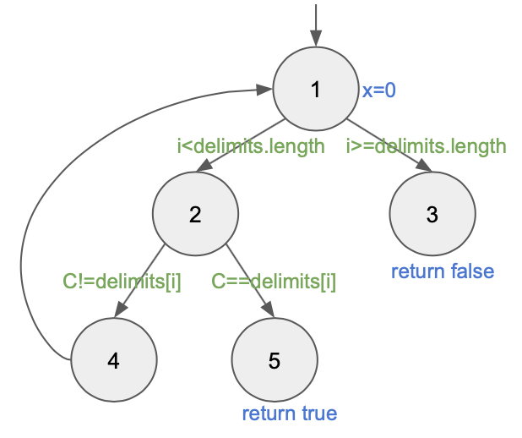

1. List all the call sites

（以<https://cs.gmu.edu/~offutt/softwaretest/java/Stutter.num>的行數說明）

|  |  |
| --- | --- |
| 行數 | Call name |
| 46 | stut(inFile) |
| 63 | isDelimit(c) |
| 65 | checkDupes(linecnt) |
| 73 | checkDupes(linecnt) |

1. List all coupling du-pairs for each call site.

|  |  |  |
| --- | --- | --- |
|  | Last-Def | First-Use |
| 1 | (main(), inFile, 30) | (stut(), inFile, 56) |
| 2 | (main(), inFile, 37) | (stut(), inFile, 56) |
| 3 | (main(), inFile, 42) | (stut(), inFile, 56) |
| 4 | (stut(), c, 61) | (isDelimit(), C, 102) |
| 5 | (stut(), linecnt, 55) | (checkDupes(), line, 88) |
| 6 | (stut(), linecnt, 74) | (checkDupes(), line, 88) |
| 7 | (isDelimit, 無變數名稱, 103) | (stut(), 無變數名稱, 63) |
| 8 | (isDelimit, 無變數名稱, 104) | (stut(), 無變數名稱, 63) |

1. Create test data to satisfy All-Coupling User Coverage for Stutter

|  |  |  |  |
| --- | --- | --- | --- |
|  | args.length | args[0] | inFile |
| 1 | 0 |  | “abc def” (System.in) |
| 2 | 1 | null | “abc def” (System.in) |
| 3 | 1 | “testFile” | “abc def” (From file) |
| 4 | 1 | “testFile” | “abc def” (From file) |
| 5 | 1 | “testFile” | “abc+def” (From file) |
| 6 | 1 | “testFile” | “abc \n def” (From file) |
| 7 | 1 | “testFile” | “abc+def” (From file) |
| 8 | 1 | “testFile” | “abcdef” (From file) |