PCCT Scanner Qualification — Statistical Method & Results
Gate 3 (quantitative reproducibility) — cross-scanner PCCT vs EID vs the B.1P Delta Validation OQ (730-CVV-040). Canonical vessel-overlap region, length-normalized, N = 25 paired patients. Two data vintages: v1 (original) and v2 (2026-07-07 re-work). Preliminary (target N ≥ 30).

1. Purpose & scope
Establish, on a like-for-like basis with the validated B.1P inter-operator reproducibility, whether cross-scanner (PCCT vs EID) quantitative reproducibility is non-inferior to the OQ limits. The systematic modality difference (bias) is separated from random dispersion and assessed in Gate 4; this document covers the Gate-3 reproducibility (wCV) method and the scanner-attributable variance decomposition.

2. Measurement model
For patient i, scanner s ∈ {PCCT, EID}, reader r, on the log(x+1), length-normalized scale:
Y_isr = μ + P_i + S_s + (PS)_is + R_r + e_isr
Term | Meaning | Role
P_i | patient (between-subject) effect | not part of within-subject reproducibility
S_s | scanner main effect (systematic modality bias) | FIXED → Gate 4 (not variance)
(PS)_is | patient × scanner interaction | σ²_scanner — the scanner-attributable variance
R_r | reader (inter-operator) effect | σ²_R — measured by the OQ
e_isr | residual / repeat error | σ²_e — measured by the OQ
Only one read per patient·scanner is available, so only the paired difference d_i = Y_PCCT − Y_EID is observed. P_i cancels, giving d_i = Δ + [(PS) difference] + [R − R′] + [e − e′], hence Var(d)/2 = σ²_PS + σ²_R + σ²_e.

3. Estimators & acceptance
wCV (within-subject CV) — variance-component / random-effects estimator per Quan & Shih (1996), matching the OQ (730-CVV-040 §11: log(x+1) + linear mixed model). For paired (k=2) data the within-subject variance component is σ²_w = mean(d²)/2.
Quantity | Formula | Purpose
Systematic bias Δ | mean(d) (log scale) | Gate 4 (BA bias)
σ²_total | mean(d²)/2 = σ²_random + Δ²/2 | within-subject var incl. bias
σ²_random (scanner term) | Var(d)/2 | bias-removed dispersion (Gate 3 basis)
σ²_OQ,within | ln(1 + (OQ_logCV/100)²) | reader+repeat, imported from OQ
σ²_scanner | Var(d)/2 − σ²_OQ,within | scanner×patient interaction
wCV (log) | √(exp(σ²)−1)·100 | report/compare on log scale
wCV (untransf.) | √σ²_w / grand-mean · 100 | report on untransformed scale
95% CIs: 2000-sample bootstrap over patients (seed 42). Acceptance — Gate 3: PCCT wCV 95% CI OVERLAPS the delta-OQ wCV CI (scanner-term basis). Scanner-attributable: (a) scanner wCV ≤ OQ inter-observer limit, and (b) σ²_scanner 95% CI includes 0 (not distinguishable from zero). The scanner-attributable subtraction is done on the log scale (there the CV↔variance relation is mean-independent, so the OQ term is transportable across studies).

4. OQ reference (730-CVV-040 / ATTACHMENT 2, patient level)
Endpoint | OQ log-wCV [95% CI] | OQ untransf-wCV [95% CI]
Lumen | 7.5% [5.9, 9.3] | 9.32% [7.09, 11.58]
Wall | 13.1% [10.2, 16.0] | 23.5% [17.88, 29.71]
Vessel | 8.7% [6.8, 10.6] | 10.18% [7.83, 12.38]
CALC | 4.5% [3.5, 5.4] | 25.78% [18.7, 35.75]
LRNC | 5.4% [4.1, 6.9] | 78.8% [48.09, 163.4]
NonCALC Matrix | 13.6% [10.8, 16.4] | 32.61% [24.87, 41.94]
Total Plaque | 13.2% [10.4, 16.0] | 27.08% [20.68, 34.74]

5. Results — variance decomposition (log scale), SUB-SEGMENT (extent-matched)
v1 sub-seg (N=25):
Endpoint | Δ bias | σ²_total | σ²_rand | σ²_OQ | σ²_scan | wCV_tot | wCV_scanT | wCV_attrib
Lumen | -0.089 | 0.01354 | 0.00996 | 0.00561 | 0.00435 | 11.7 | 10.0 | 6.6
Wall | -0.058 | 0.01540 | 0.01431 | 0.01702 | -0.00270 | 12.5 | 12.0 | 0.0
Vessel | -0.083 | 0.01126 | 0.00815 | 0.00754 | 0.00061 | 10.6 | 9.0 | 2.5
CALC | +0.079 | 0.00577 | 0.00275 | 0.00202 | 0.00073 | 7.6 | 5.2 | 2.7
LRNC | +0.043 | 0.00937 | 0.00879 | 0.00291 | 0.00588 | 9.7 | 9.4 | 7.7
NonCALC Matrix | -0.167 | 0.04140 | 0.02866 | 0.01833 | 0.01033 | 20.6 | 17.1 | 10.2
Total Plaque | -0.068 | 0.02274 | 0.02129 | 0.01727 | 0.00402 | 15.2 | 14.7 | 6.3
v2 sub-seg (N=24):
Endpoint | Δ bias | σ²_total | σ²_rand | σ²_OQ | σ²_scan | wCV_tot | wCV_scanT | wCV_attrib
Lumen | -0.014 | 0.01040 | 0.01075 | 0.00561 | 0.00515 | 10.2 | 10.4 | 7.2
Wall | -0.172 | 0.03160 | 0.01751 | 0.01702 | 0.00050 | 17.9 | 13.3 | 2.2
Vessel | -0.069 | 0.01026 | 0.00825 | 0.00754 | 0.00071 | 10.2 | 9.1 | 2.7
CALC | +0.003 | 0.00407 | 0.00425 | 0.00202 | 0.00222 | 6.4 | 6.5 | 4.7
LRNC | +0.009 | 0.00395 | 0.00409 | 0.00291 | 0.00117 | 6.3 | 6.4 | 3.4
NonCALC Matrix | -0.289 | 0.07440 | 0.03396 | 0.01833 | 0.01563 | 27.8 | 18.6 | 12.6
Total Plaque | -0.228 | 0.05046 | 0.02551 | 0.01727 | 0.00824 | 22.7 | 16.1 | 9.1
Results are on the sub-segment (extent-matched) region for v1 and v2. σ²_random / σ²_scanner are small (the extent term is removed by the sub-segment intersection) and stable v1→v2 — the 07-07 re-work changed the systematic bias (Gate 4), not the random reproducibility (Gate 3). Gate 4 bias (§8) is assessed on the canonical length-normalized scale to match the OQ.

6. Gate 3 acceptance — scanner-term wCV vs OQ (95% CI overlap; P=pass/F=fail)
Log scale — process outputs (primary) + plaque:
Endpoint | OQ wCV | v1 sub-seg | v2 sub-seg
Lumen | 7.5 [5.9,9.3] | 10.0 P | 10.4 P
Wall | 13.1 [10.2,16.0] | 12.0 P | 13.3 P
Vessel | 8.7 [6.8,10.6] | 9.0 P | 9.1 P
CALC | 4.5 [3.5,5.4] | 5.2 P | 6.5 P
LRNC | 5.4 [4.1,6.9] | 9.4 P | 6.4 P
NonCALC Matrix | 13.6 [10.8,16.4] | 17.1 P | 18.6 P
Total Plaque | 13.2 [10.4,16.0] | 14.7 P | 16.1 P
Untransformed scale — plaque (reported on both scales):
Endpoint | OQ wCV | v1 sub-seg | v2 sub-seg
CALC | 25.78 [18.7,35.75] | 18.6 P | 23.7 P
LRNC | 78.8 [48.09,163.4] | 109.6 P | 95.1 P
NonCALC Matrix | 32.61 [24.87,41.94] | 35.5 P | 45.1 P
Total Plaque | 27.08 [20.68,34.74] | 25.7 P | 35.3 P
Cells: scanner-term wCV% and overlap verdict; 95% CIs are in §5 / gate3_comparison.csv.

7. Scanner-attributable variance vs OQ — SUB-SEGMENT (a: wCV≤OQ, b: CI∋0)
Endpoint | OQ limit | v1 sub-seg | v2 sub-seg
Lumen | 7.5 | 6.6 P/P | 7.2 P/P
Wall | 13.1 | 0.0 P/P | 2.2 P/P
Vessel | 8.7 | 2.5 P/P | 2.7 P/P
CALC | 4.5 | 2.7 P/P | 4.7 F/P
LRNC | 5.4 | 7.7 F/P | 3.4 P/P
NonCALC Matrix | 13.6 | 10.2 P/P | 12.6 P/F
Total Plaque | 13.2 | 6.3 P/P | 9.1 P/P
Cells: scanner-attributable wCV% a/b (P/F), on the extent-matched sub-segment. σ²_scanner = Var(d_log)/2 − σ²_OQ; with reader+repeat (OQ) and extent (sub-segment) removed, the residual scanner-attributable variability is ≤ OQ / CI-includes-0 for nearly all endpoints.

8. Gate 4 — systematic bias (untransformed) vs OQ
The OQ Bland-Altman bias reference (730-CVV-040 ATTACHMENT 2, "Untransformed analysis") is UNTRANSFORMED and LENGTH-NORMALIZED. So the like-for-like PCCT comparison uses the canonical length-normalized bias; length-normalization is not meaningful on the sub-segment (extent is already matched), so the sub-segment bias is shown as a raw-mm³ reference column. The OQ tabulates only the untransformed BA bias (transformed is plots-only), so no transformed-bias comparison is possible. Plaque endpoints.
8a. Untransformed bias (length-normalized) — OQ 95% CI vs PCCT canonical; overlap P/F.
Endpoint | OQ bias [95% CI] | v1 canonical bias [95% CI] | ov | v2 canonical bias [95% CI] | ov
CALC | +0.020 [-0.01, 0.05] | +0.017 [-0.075,+0.114] | P | -0.095 [-0.192,-0.004] | P
LRNC | -0.030 [-0.06, -0.01] | +0.037 [-0.021,+0.122] | P | -0.009 [-0.052,+0.043] | P
NonCALC Matrix | -0.070 [-0.19, 0.05] | -0.427 [-0.689,-0.189] | P | -0.626 [-0.876,-0.398] | F
Total Plaque | -0.050 [-0.19, 0.08] | -0.373 [-0.749,-0.018] | P | -0.730 [-1.106,-0.398] | F

Endpoint | PCCT vs EID raw bias (mm^3) | <10% of mean
CALC | -3.18 | Pass
LRNC | -4.18 | Fail
NonCALC Matrix | -109 | Fail
Total Plaque | -116 | Fail

8b. Sub-segment bias (raw mm³, extent-matched — length-norm not applicable), shown for reference alongside the canonical/OQ comparison above.
Endpoint | v1 sub-seg bias (mm³) [95% CI] | v2 sub-seg bias (mm³) [95% CI]
CALC | +24.9 [+14.5,+37.4] | +0.2 [-9.4,+9.4]
LRNC | +6.5 [-1.4,+16.8] | -1.4 [-11.1,+7.1]
NonCALC Matrix | -76.6 [-121.4,-33.6] | -114.8 [-161.9,-71.6]
Total Plaque | -45.2 [-94.7,+5.4] | -114.6 [-168.0,-66.7]
Note: canonical bias (length-normalized) is the OQ-comparable quantity; NonCALC Matrix and Total Plaque do not overlap the OQ bias CI (real modality bias). The systematic plaque bias grew v1→v2 (07-07 re-work) and is within the shared centerline, not the traced-extent tail — so it persists on the sub-segment (raw bias column) rather than shrinking.
8c. Per-patient v1→v2 shift (untransformed & log). v1 = light, v2 = dark; grey arrows show each patient's shift; dashed = v1 mean bias, solid = v2 mean bias.
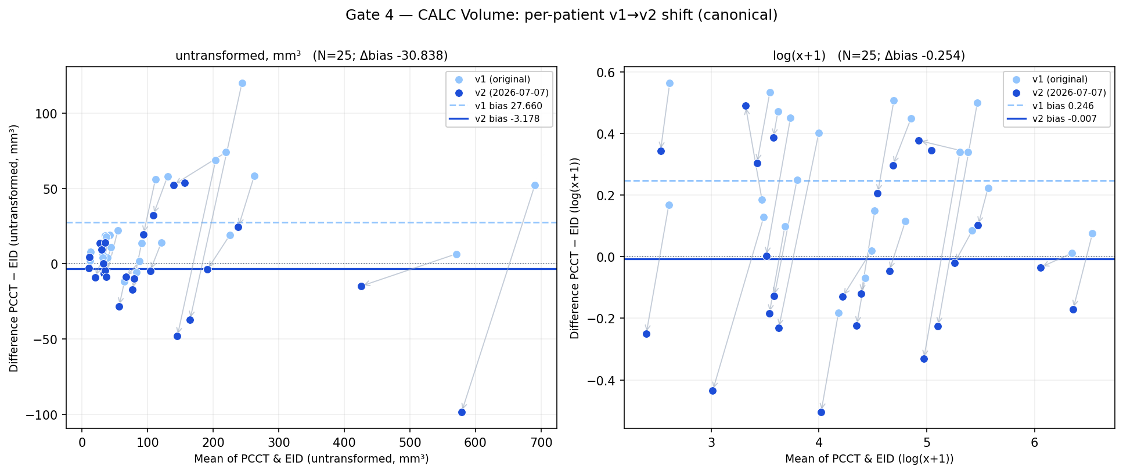
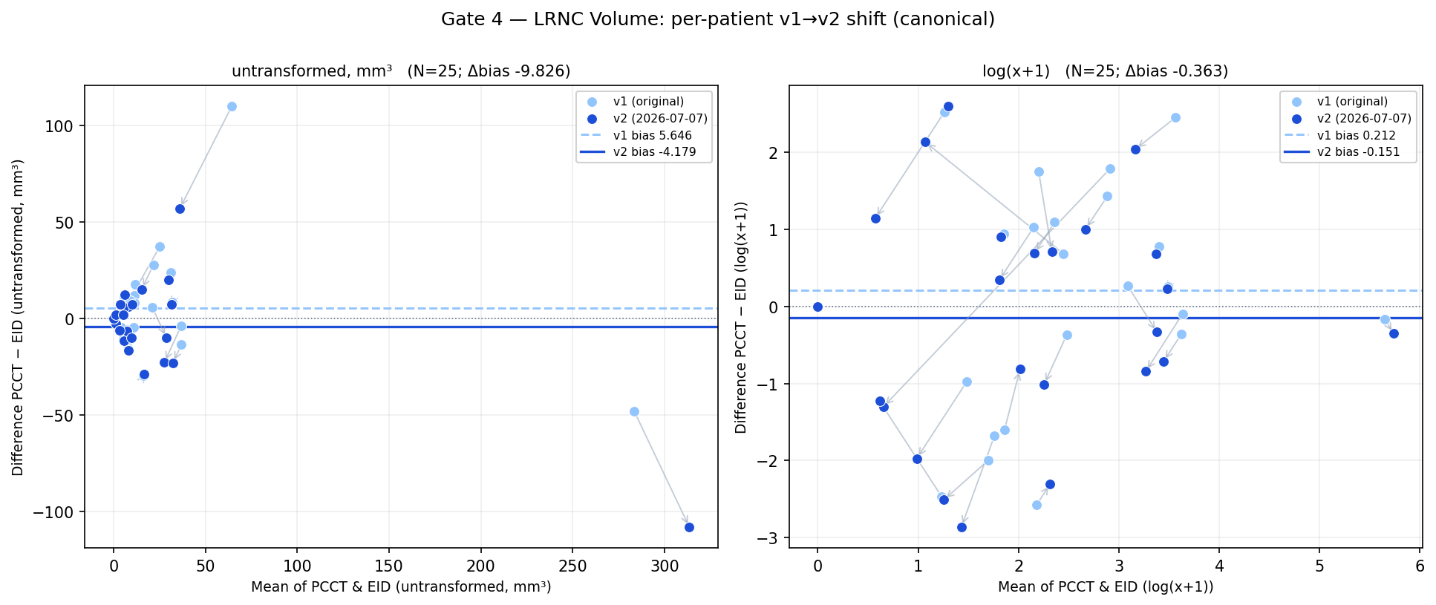
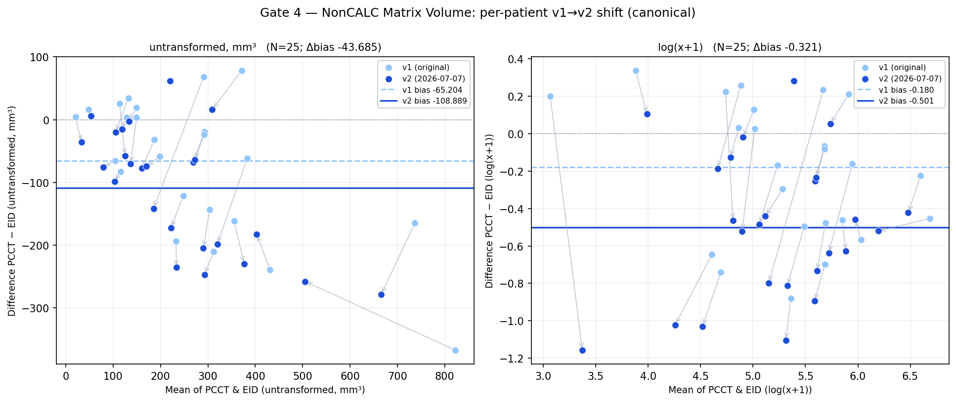
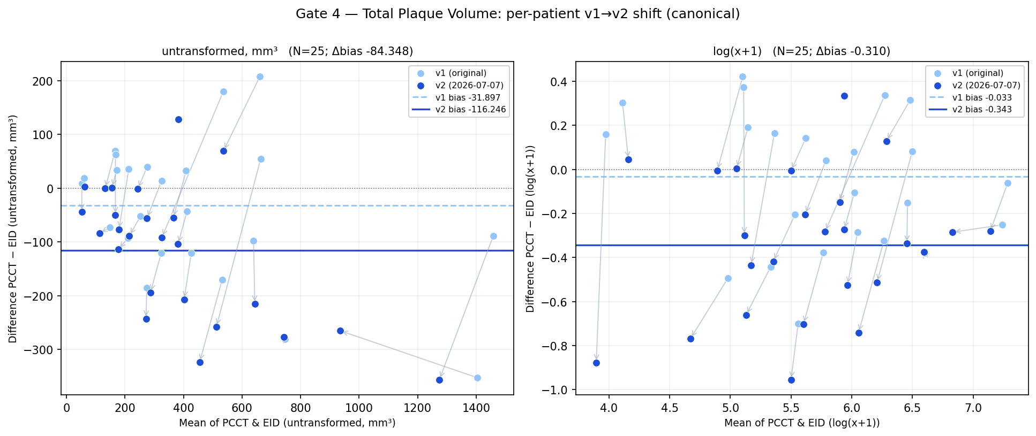
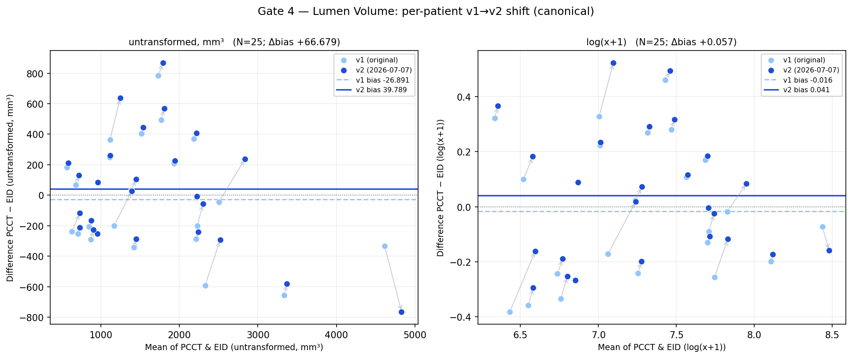
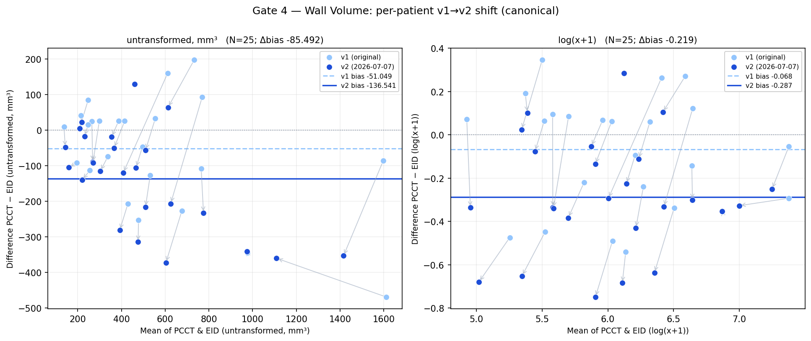
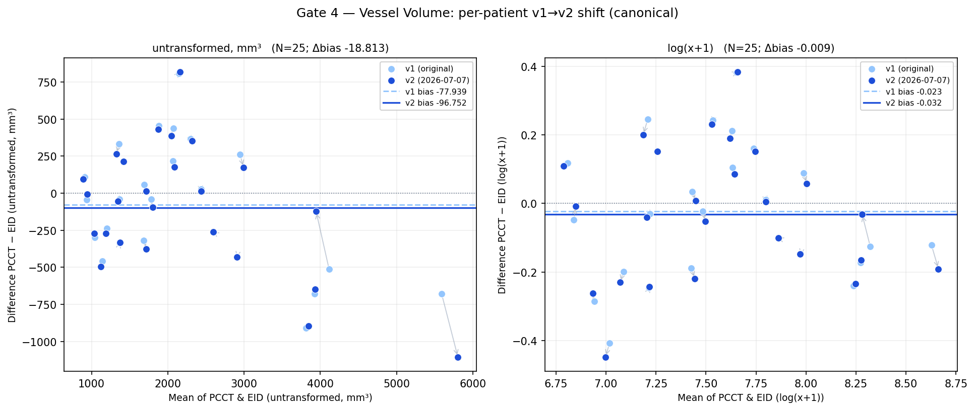

9. Interpretation
- With the scanner term (systematic bias removed), the process outputs (Lumen, Wall, Vessel) pass the OQ CI-overlap on BOTH data vintages, canonical region — no sub-segment alignment required. The essential ingredient is separating the systematic scanner bias into Gate 4.
- The variance decomposition shows σ²_random / σ²_scanner are vintage-stable; the 07-07 re-work increased the systematic bias Δ, not the random dispersion.
- Plaque reproducibility depends on scale: on the untransformed scale (wide OQ CIs) all plaque endpoints overlap; on the log scale the tightest-limit component (CALC) is borderline and just fails on v2. Both scales are reported.
- Scanner-attributable variance (Var(d)/2 − σ²_OQ) is ≤ the OQ limit / CI-includes-0 for most endpoints on the canonical region, and on the extent-controlled sub-segment region (regenerated on v2, N=24) it is ≤ OQ / CI-includes-0 for nearly all endpoints — i.e. after removing reader+repeat (OQ) and traced extent (sub-segment), the residual scanner-attributable variability is within the OQ envelope.

10. Caveats & future work
- N = 25 canonical / 24 sub-segment, preliminary (target ≥ 30); passes are CI-overlap-driven with wide CIs.
- Canonical region retains a traced-extent differential (PCCT traces ~+26% longer within shared vessels; Gate 2 REVIEW). The sub-segment (distance-from-ostium) intersection removes it; regenerated on v2 (2026-07-07) data, N=24 (PT-124 no vessel overlap, PT-136 duplicate LeftCoronary in workitem.json — both excluded). Pipeline: scripts/subsegment/.
- Scanner-attributable subtraction assumes the OQ reader+repeat variance is transportable to the PCCT setting, and that PCCT/EID reads are by independent readers (single read per patient·scanner; true scanner isolation would need replicate reads).

References
- 730-CVV-040 v0.1 — B.1P Delta Validation OQ Report (+ ATTACHMENT 2, patient-level results).
- 4-B1P-033 v2.0 — B.1P Operational Qualification Report.
- Quan H, Shih WJ (1996). Assessing reproducibility by the within-subject coefficient of variation with random effects models. Biometrics 52:1195-1203.
- Shoukri MM, Elkum N, Walter SD (2006). Interval estimation and optimal design for the within-subject coefficient of variation. BMC Med Res Methodol 6:24.

