Task 1: Create the HTML File

- 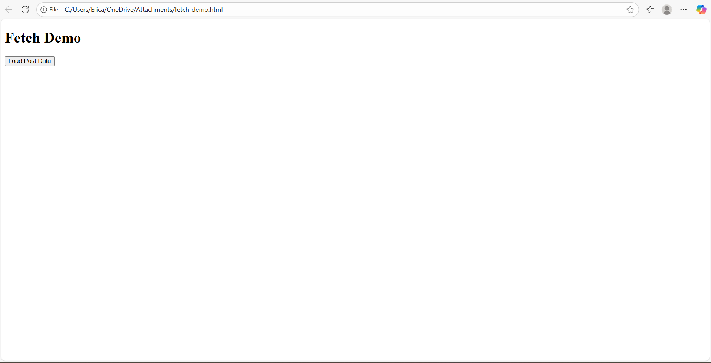

Task 2: Write JavaScript Code

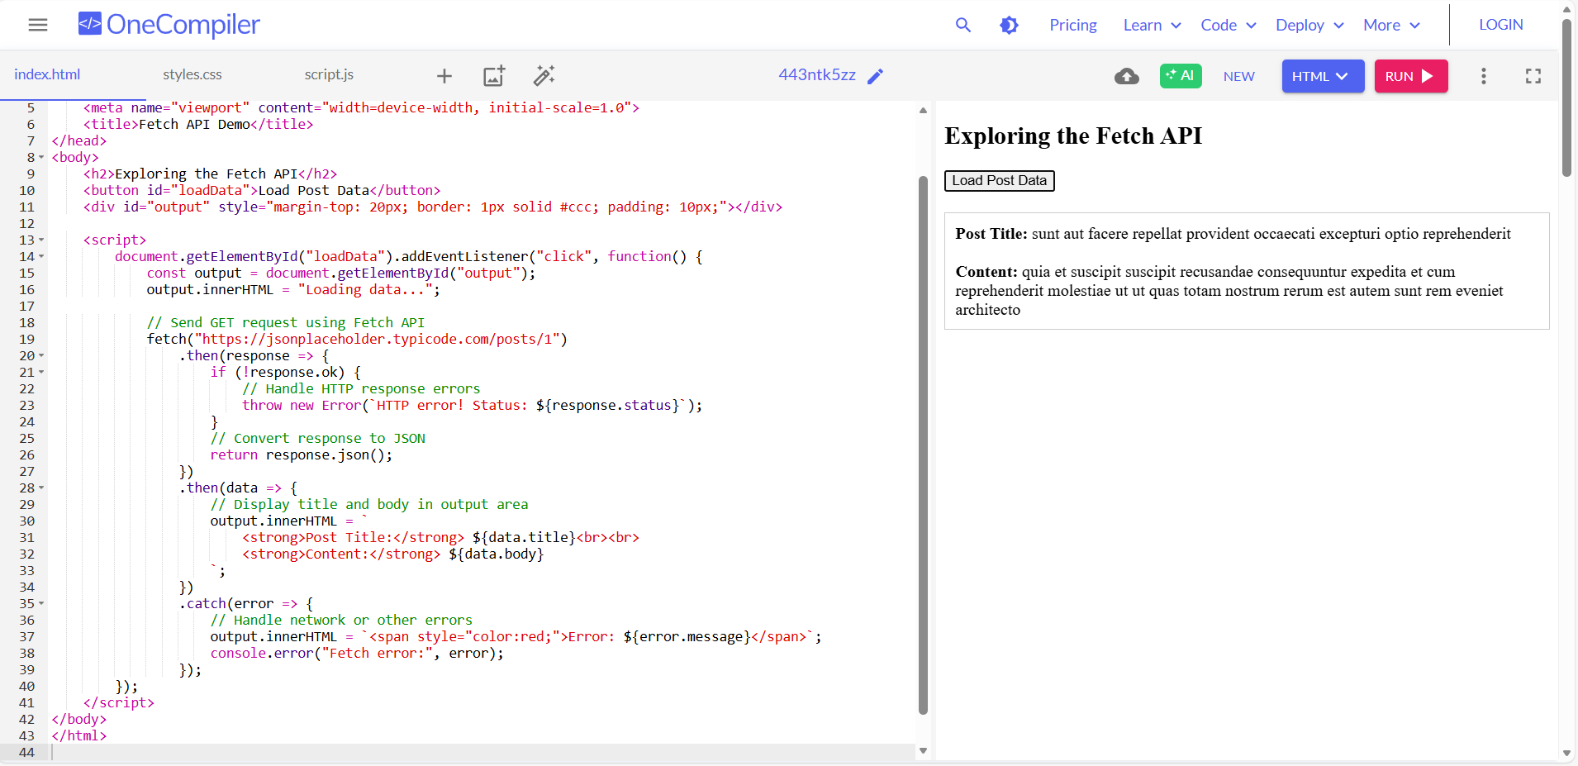

Task 3: Experiment with POST Request
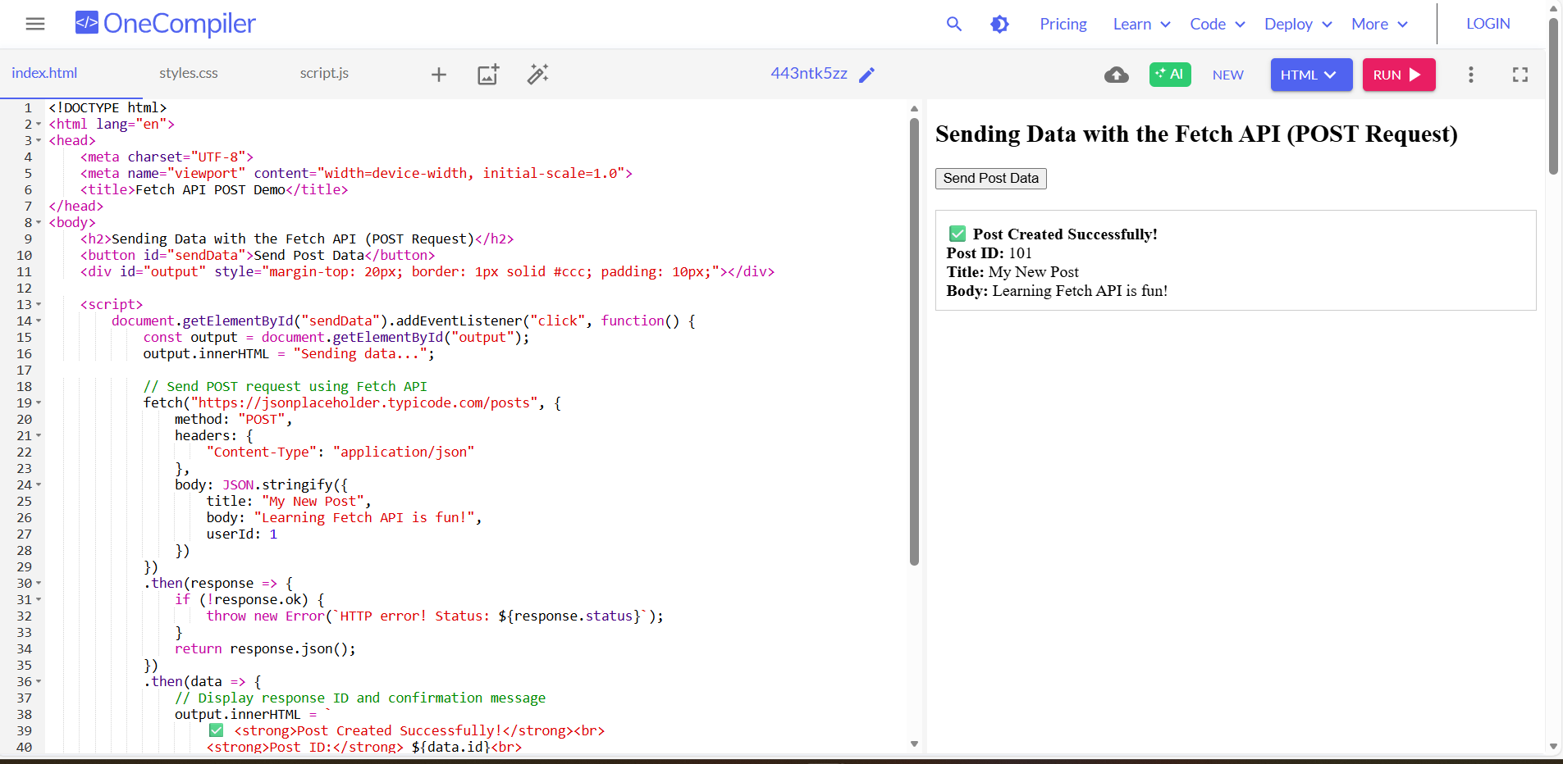

Submission Requirements

- fetch-demo.html – working code for both GET and POST
GET Code
<!DOCTYPE html>
<html lang="en">
<head>
<meta charset="UTF-8">
<meta name="viewport" content="width=device-width, initial-scale=1.0">
<title>Fetch API Demonstration</title>
</head>
<body>
<h2>Exploring the Fetch API</h2>
<button id="loadData">Load Post Data</button>
<div id="output" style="margin-top: 20px; border: 1px solid #ccc; padding: 10px;"></div>

<script>
document.getElementById("loadData").addEventListener("click", function() {
const output = document.getElementById("output");

// Using the Fetch API to send a GET request
fetch("https://jsonplaceholder.typicode.com/posts/1")
.then(response => {
if (!response.ok) {
throw new Error(`HTTP error! Status: ${response.status}`);
}
return response.json();
})
.then(data => {
output.innerHTML = `
<strong>Post Title:</strong> ${data.title}<br><br>
<strong>Content:</strong> ${data.body}
`;
})
.catch(error => {
output.innerHTML = `<span style="color:red;">Error: ${error.message}</span>`;
console.error("Fetch error:", error);
});
});
</script>
</body>
</html>

POST Code
<!DOCTYPE html>
<html lang="en">
<head>
<meta charset="UTF-8">
<meta name="viewport" content="width=device-width, initial-scale=1.0">
<title>Fetch API POST Demo</title>
</head>
<body>
<h2>Sending Data with the Fetch API (POST Request)</h2>
<button id="sendData">Send Post Data</button>
<div id="output" style="margin-top: 20px; border: 1px solid #ccc; padding: 10px;"></div>

<script>
document.getElementById("sendData").addEventListener("click", function() {
const output = document.getElementById("output");
output.innerHTML = "Sending data...";

// Send POST request using Fetch API
fetch("https://jsonplaceholder.typicode.com/posts", {
method: "POST",
headers: {
"Content-Type": "application/json"
},
body: JSON.stringify({
title: "My New Post",
body: "Learning Fetch API is fun!",
userId: 1
})
})
.then(response => {
if (!response.ok) {
throw new Error(`HTTP error! Status: ${response.status}`);
}
return response.json();
})
.then(data => {
// Display response ID and confirmation message
output.innerHTML = `
<strong>Post Created Successfully!</strong><br>
<strong>Post ID:</strong> ${data.id}<br>
<strong>Title:</strong> ${data.title}<br>
<strong>Body:</strong> ${data.body}
`;
})
.catch(error => {
output.innerHTML = `<span style="color:red;">Error: ${error.message}</span>`;
console.error("Fetch error:", error);
});
});
</script>
</body>
</html>

- fetch-answers.txt – answers to guide questions

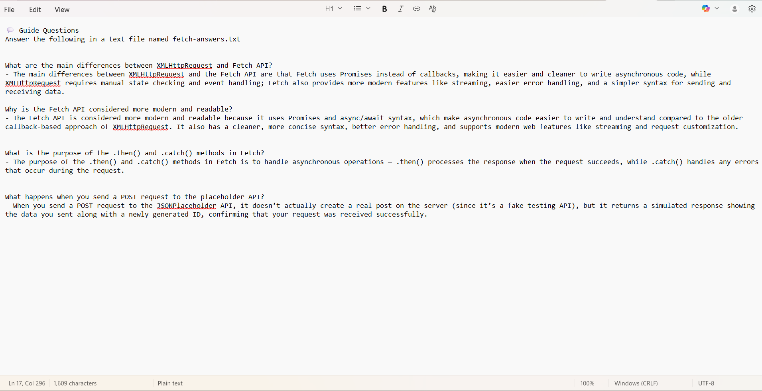

3. Screenshot of both GET and POST results in the browser console or webpage

