#Erica Guzman

#This program calculates user's weekly paycheck

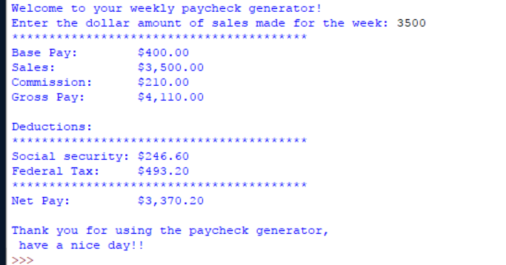

**Source code below!**

import math

#Define main

def main():

#Declare and initilaize float variables

weeklySalesAmount = commission = grossPay = netPay = socialSecurity = federalTax = 0.0

basePay = 400.00

#display Welcome message:

print("Welcome to your weekly paycheck generator!");

weeklySalesAmount = float(input("Enter the dollar amount of sales made for the week: "));

commission = weeklySalesAmount * .06

grossPay = weeklySalesAmount + basePay + commission

socialSecurity = grossPay * .06

federalTax = grossPay * .12

netPay = grossPay -(socialSecurity + federalTax)

#print paycheck

print ("*" * 40)

print("Base Pay:\t ${:,.2f}" .format (basePay));

print("Sales:\t\t ${:,.2f}" .format (weeklySalesAmount));

print("Commission:\t ${:,.2f}" .format (commission));

print("Gross Pay:\t ${:,.2f}" .format (grossPay));

print();

print("Deductions: ");

print ("*" * 40)

print("Social security: ${:,.2f}" .format (socialSecurity));

print("Federal Tax:\t ${:,.2f}" .format (federalTax));

print ("*" * 40)

print("Net Pay:\t ${:,.2f}" .format (netPay));

#display Goodbye

print();

print("Thank you for using the paycheck generator! \n Have a nice day!!");

main()