# Web Authoring Project - Planning and Preparation Template

## The 5 Planes

## Strategy

Include:

* Background of the business area
* Find target audience
* What does the target audience want out of the website?
* What are your aims for the website?
* List of business goals for the website

This website is to advertise myself and my skills. My target audience is small businesses who need a designer for their logos, posters, or characters for games. The function of the websites is for small businesses and small game designers to find someone who can help them with the design of their project. Some goals of this website are 1. so, people can find me and hire me, 2. so people who want to hire can see my work and skills.

Goals for the website:

1. Interesting to look at
2. Clear to read
3. Colorful
4. Displays all my work

## Scope

* List of what content and functionality (if any) will/will not be included in website

Functionality:

* Links to different pages
* Links to other sources
* Multiple pages

Content:

* Projects from college
* Things I did outside of college
* Page for each class
* Gallery page

## Structure

* How will your website be structured across all the site pages? Site map including main menu and local menus?
* How will you organize your content?
* What categories of information will you use?
* How will your content be presented (text, images, video etc.)?

I made a wire map of how I will structure my website

Picture of wire map:

I will organize my content into different pages with different headings for different projects

I will use categories like what the project was for, what we were asked to do, and progress photos throughout the project

My content will be presented in picture and text format ex: 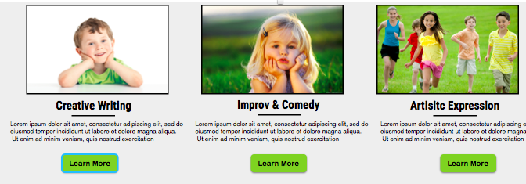

## Skeleton

* Wireframes/sketches of how your structure will be mapped to your website UI
* Show placement of logo, navigation (menus and links), header content and footer content
* Remember consistency, consistency, consistency

Wireframe of website:

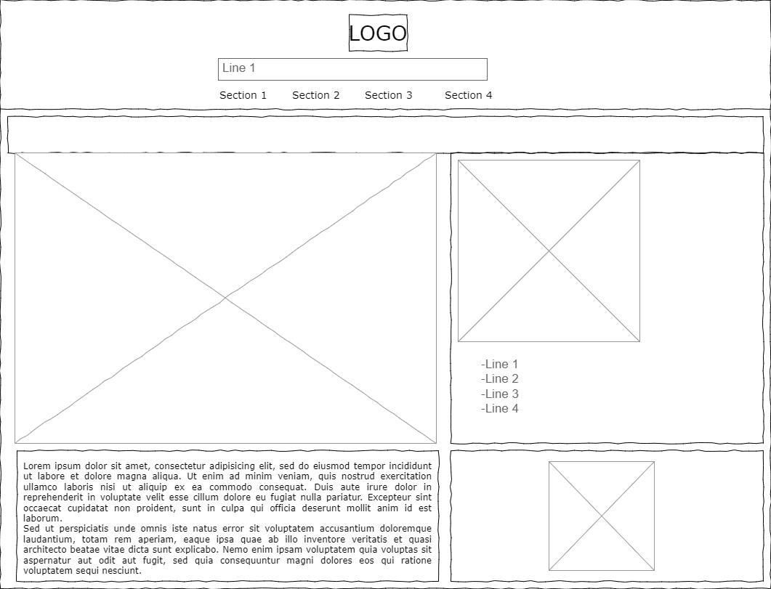

I have made a logo for the top of the website using Canva and one of their free templates:

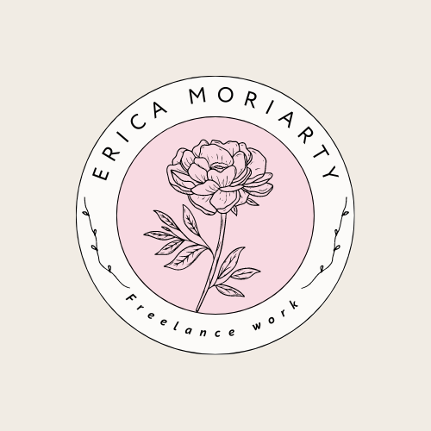

I used one of my illustrations for this logo, this will be at the top left of all the web pages

## Surface

* Style, brand, color scheme, typography etc.
* Consider C.R.A.P design

The style of my website is going to be colorful and have a lot of fantasy theming around it. I am going to use bright contrasting colors. I am going to use a font I found on google fonts called Caveat. I have also decided to use a decorative font for my name on the top of the website next to the logo called Nabla from google fonts

## Tool Selection

Show which tools you will use at each stage of your project i.e., e.g., requirements, design, development, testing, deployment, and maintenance