Theory:

* 1. Unity vs Construct. Unity is better than construct because there are lots of resources to learn from, it has an easy learning curve (structure and the use of high level languages), Can be used for Free, it is a great editor(GUI is very powerful).
  2. C# vs JavaScript. With C# the programmer has more control, more Resources, C# is more Strict, and it is a more structured language.
  3. ­­­­

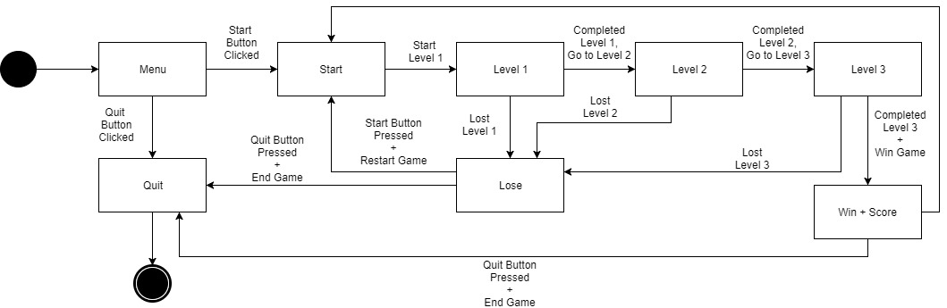

* 1. ­

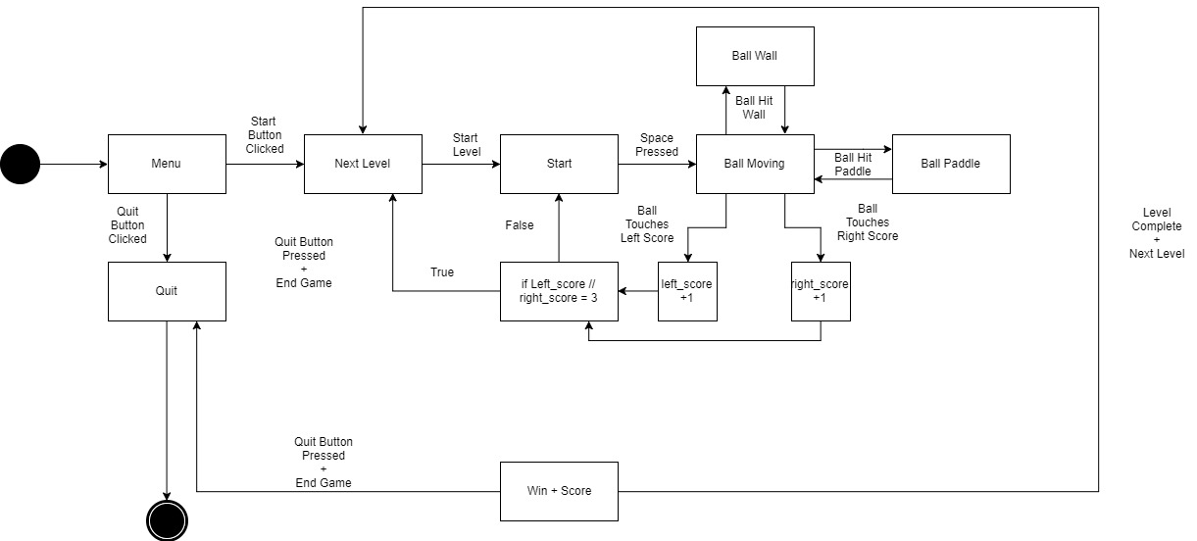

1. Compressing media files is useful as it doesn’t take as much memory space as it would if you weren’t to store the files in a compressed folder, as compressed files contain fewer “bits” of data unlike uncompressed files they use less bandwidth and therefore have a faster file transaction speed, the files in compressed files can be uncompressed when needed, won’t have the problem of sending large files in emails, costs for storing data are reduced as you can store more files in your available storage space. With compressed files you can use encryption to make the files only accessible by the users you want. 